**ENGLISH I**

**EVA RUDOLFOVA**

**Course information:**

* 1 credit = 25-30 hrs of work
* classes either in zoom (class sessions) or using Google Chat (individual and small group sessions, questions, requests)
* work-based course (there is no final test)
* use of language – individually: ROPOTs recommended, not obligatory, questions to be dealt with in individual sessions or using the G Chat
* vocabulary – according to your own needs, based on your projects, please note the vocab down)

**Course requirements:**

* Attendance
* Peer review (formal email + feedback to two emails of others, to be uploaded in IS, instructions will follow)
* IBM guest lecture (date and topic TBA)
* Final project and the work related to on the final project in three-people hubs (deadline last session, have your evidence ready)

**Suggested Topics:**

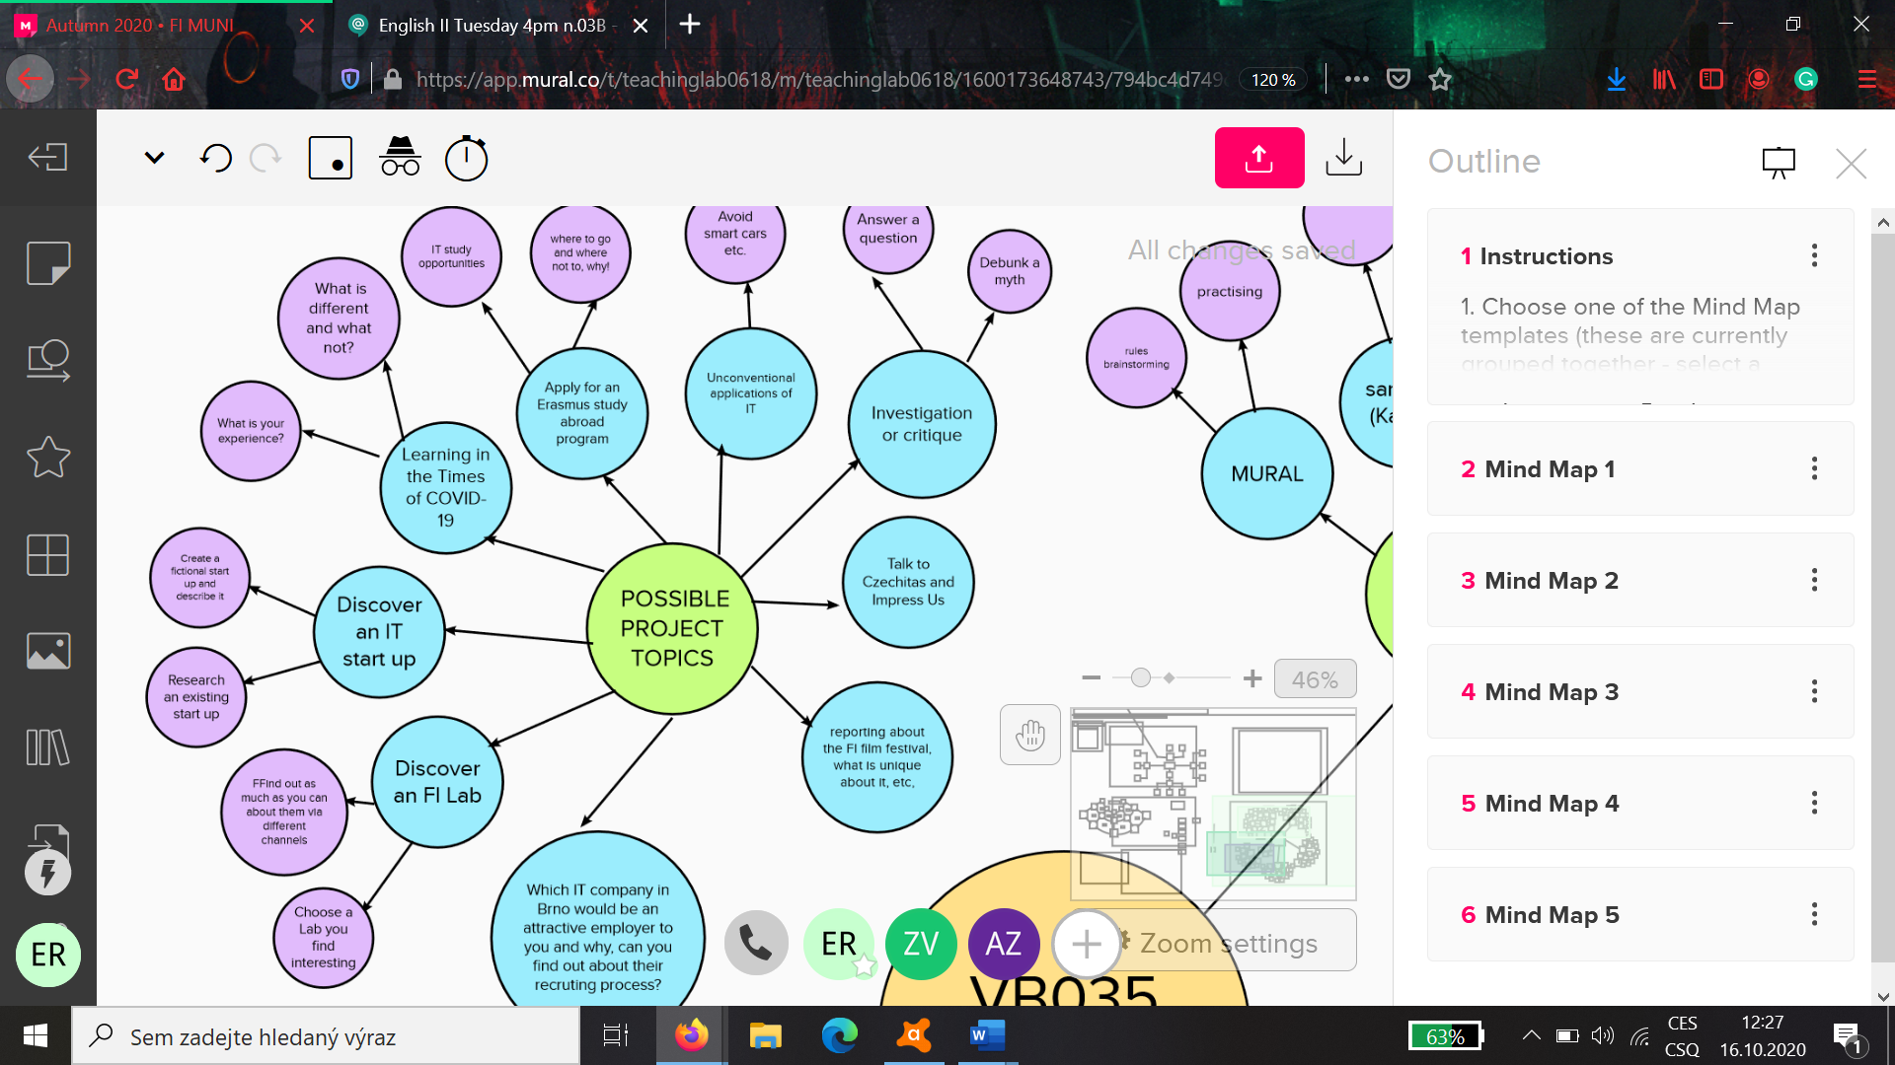

**Suggested Outcomes and Project Criteria:**

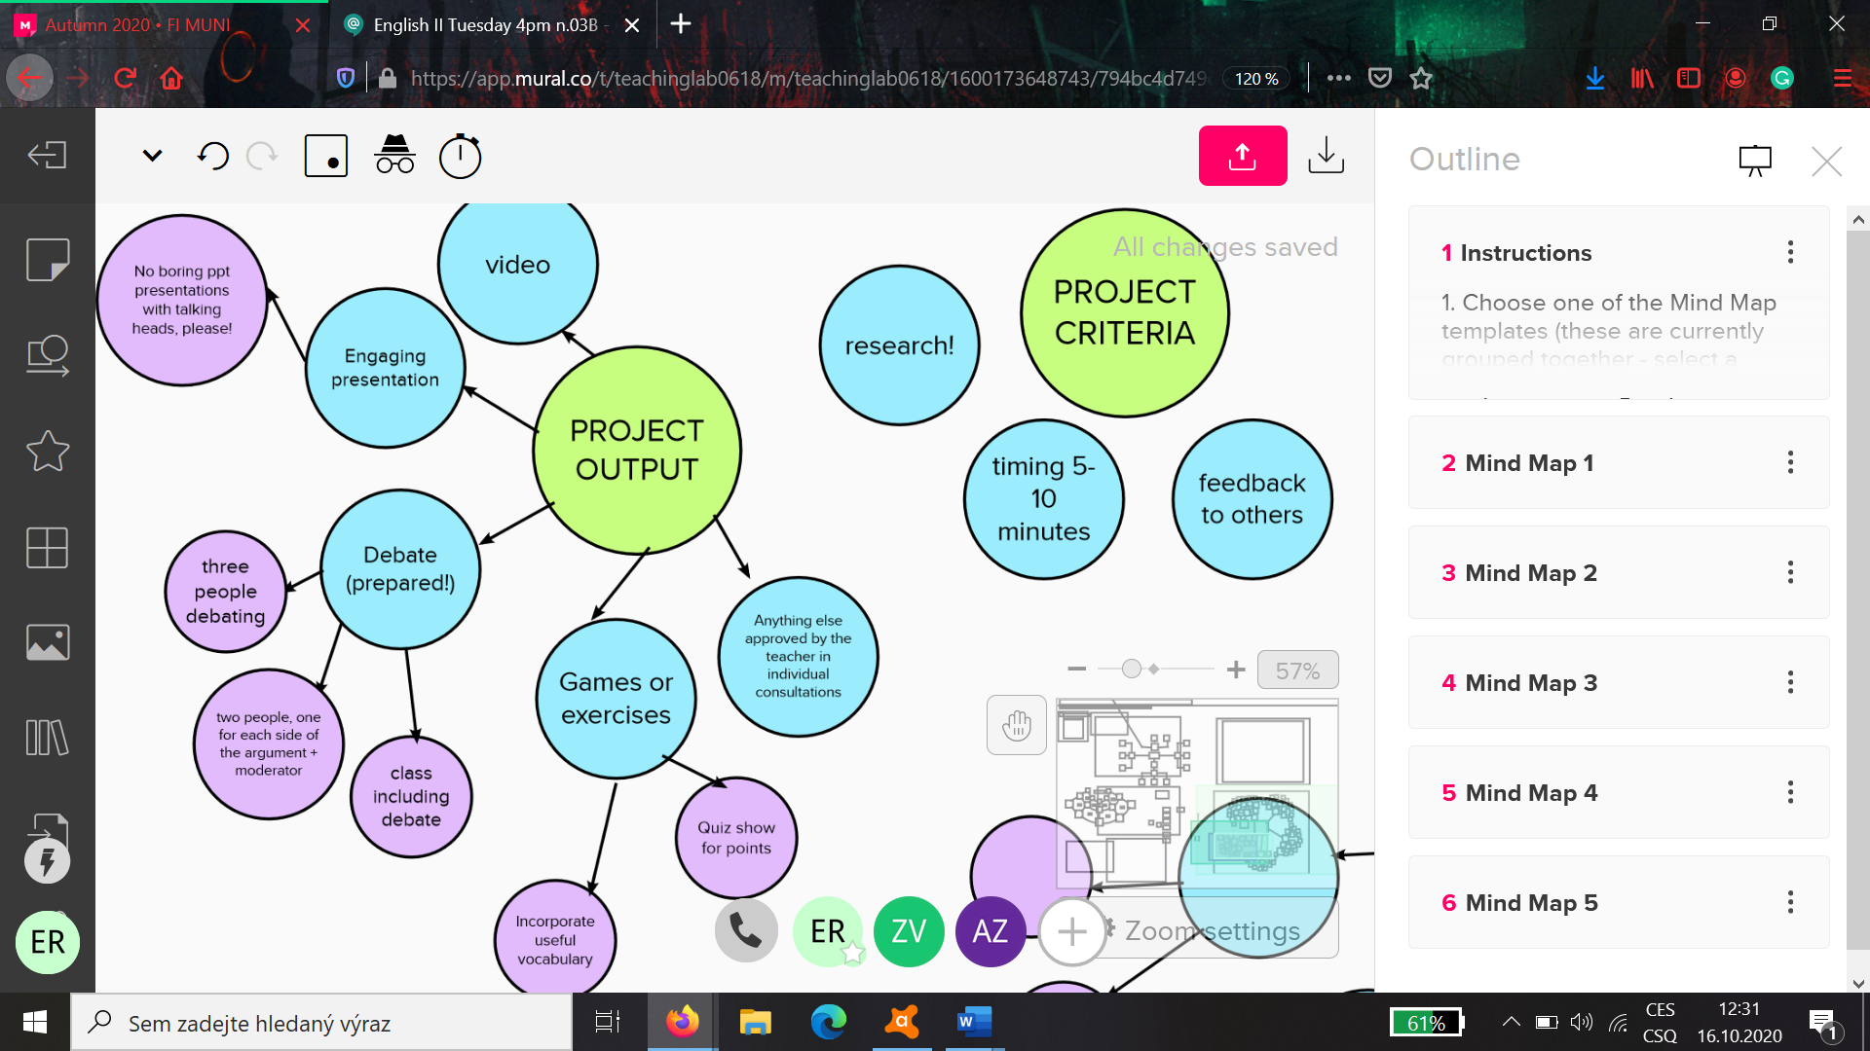

**Course outline:**

FIRST SESSION: Intro, getting to know each other, google chat, groups of three, topics and outputs for final project

SECOND SESSION: Individual. Be ready to talk about your chosen project in your small groups and how you want to improve your English that way. This session requires preparation in your groups!

THIRD SESSION: Group class on FORMAL EMAILS, formal language in general.

FOURTH SESSION: Group class on FEEDBACK/ IBM guest lecture – TBS

*Peer review*

FIFTH SESSION: Individual. Polishing your final projects. What need to be done before they get presented to the class.

SIXTH SESSION: Group class: Final projects show time.