Teamwork

**1 Study the picture. Does it represent teamwork? Why? Why not?**

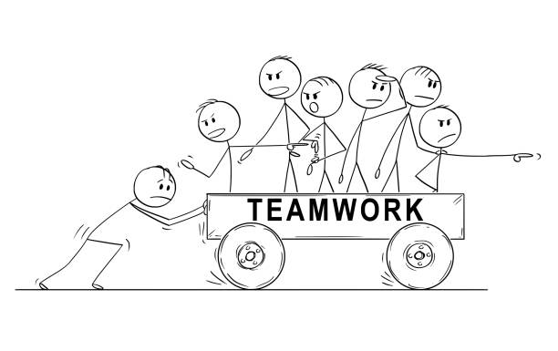

[Source](https://www.istockphoto.com/cs/ilustrace/bad-teamwork)

**2 Find a picture on the internet that for you symbolizes successful teamwork. Share it with your partner and explain your reasons.**

|  |
| --- |

**3 How do you feel when you are working together with other people?**

|  |
| --- |

**4 What do you think are the pros and cons of teamwork?**

| **PROS** | **CONS** |
| --- | --- |
|  |  |

**5 Can you think of some ideas that could make teamwork more effective? Or if you encounter problems (see CONS), how can you deal with them?**



**6 How can you personally contribute to effective collaboration?**

|  |
| --- |