Paragraphs
A Paragraph is a group of connected sentences that is generally made up of one main idea and a group of supporting sentences. Paragraphs are the basic unit for building longer pieces of writing, e.g. essays, reports, assignments etc.
Paragraphs contain three main parts:
- A topic sentence - contains the main idea of the paragraph. It's often but not always the first sentence of the paragraph.

Why?
- It helps the reader to understand quickly what the paragraph is going to be about.
- Allows the writer to clearly develop the paragraph that follows.
- Helps the writer check that they are writing about one topic only.
- Allows the writer to easily transfer information from a plan.

- Supporting sentences - these sentences develop or give details about the topic sentence. They can:
  - expand on the main point
  - offer explanations
  - give examples
  - give additional details.

- A concluding sentence which summarises the paragraph or may provide a link to the next paragraph. This sentence is not always necessary in a paragraph.
Below is a list of useful language that could be used in your concluding statement(s).
- Finally
- In conclusion
- In summary
- Therefore
- Thus
- As a result
- Indeed
- Clearly
- It is clear that

Paragraph unity — sentence connectors
All sentences need to relate to the main idea / topic sentence in the paragraph. The reader should be able to see how each sentence flows from the previous one and how each is connected to the topic sentence. Sentence connectors weave sentences together to create a cohesive paragraph. They order and sequence ideas, theory, data etc. The following tables list useful connectors.

Useful sentence connectors
Logical order  - firstly, secondly, thirdly etc  - next, last, finally  - in addition  - furthermore  - also  - at present / presently | Order of importance  - more importantly  - most significantly  - above all  - primarily
Contrast  - however  - on the other hand  - on the contrary  - by (in) comparison  - in contrast | Comparison  - similarily  - likewise  - also  - too

Useful connectors within paragraphs
Comparison  - like  - and  - both  - alike  - similar (to)  - the same (as)  - Not only  - compared to  - in comparison to  - so...that | Contrast  - although  - though  - while  - even though  - whereas  - yet  - but  - more than  - different / differ from  - unlike
The five most common paragraph structures can be seen as shapes in which the widest part is the topic sentence.
TYPE 1- THE UPSIDE DOWN TRIANGLE—Topic Sentence first (most common).
- Just as the triangle tapers off to a point, the paragraph tapers from the main idea to supporting details.
- This is most often used in informative writing. The author states a general idea and then develops it with detailed information.
EXAMPLE:
Niagara Falls has an irresistible lure for daredevils. A motley procession of foolhardy men have dared death by dancing above the chasm on a tightrope or plunging over the cataract in a barrel. Others have tried to swim the current and to shoot the rapids in boats.
TYPE 2-THE TRIANGLE—Topic sentence last (second most common).
- In this paragraph structure, authors present details first and then make the more general statement about the topic.
- Authors most often use this paragraph structure for one of three purposes:
  - To organize the details into a summary statement,
  - To present convincing details that lead readers to accept a more general claim than they might otherwise, or
  - To create suspense as they build to a climax.
EXAMPLE:
Costs were low that year and output was high. There was a good man for every job and the market remained firm. There were no losses by fire. All in all, it was the best year in the company's history.
TYPE 3: THE DIAMOND—The second sentence is the topic sentence.
- The first sentence most often serves as a transition. All other sentences develop the general idea expressed in the second sentence.
- Authors use this structure for one of three reasons:
  - To vary their style,
  - To provide a smooth transition from the last paragraph, or
  - To point out the relationship between ideas presented previously and those presented in this paragraph.
EXAMPLE:
There are deer in abundance here. The whole area is great country for hunters and fishermen. There are bear, occasional mountain lions and coyotes. To the east the streams are full of trout and there are ducks, geese and a few pheasants.
TYPE 4: THE HOURGLASS—First and last sentences are topic sentences. Authors use this paragraph structure for one of two purposes:
- To emphasize or clarify an important idea, in which case the two topic sentences make similar statements, or
- To present two opinions, to point out advantages and disadvantages or to show how two things are similar and/or different, in which case there is usually a signal word that alerts the reader to a change in perspective.
EXAMPLE OF FIRST PURPOSE:
Glaciers change the surface of the earth. They grind heavily as they move slowly along, much like fresh cement creeping down a gentle slope. They dig great holes in the sides of mountains and rub away the faces of rocks. A glacier pushes masses of loose soil and rock ahead of it. The loose soil and rocks form ridges when the ice melts or stops moving. A moving glacier also makes a valley wider as it pushes down through it. The earth looks quite different after a glacier has passed by.
EXAMPLE OF SECOND PURPOSE:
Penicillin is one of the greatest wonder drugs. It has saved thousands of lives already and will save many more in the future. But it has no effect whatever on the bulk of the ills of man and beast. Good as penicillin is, it is certainly not a cure-all.
TYPE 5: THE SQUARE—There is no topic sentence.
- All sentences contribute to the main idea which the author expects the reader to provide.
- This type of paragraph structure is used most often to describe, to list, or to show the sequence of events.
EXAMPLE:
The range of the Mule Deer is usually east of the Sierra Nevadas. It is the largest of the North American deer, sometimes weighing almost 400 pounds. The name has been given to the species because of the long ears and the mule-like tail. Owing to its rather large antlers, it is a valuable game animal.

Steps for paragraph writing

Step1 — write an outline
When writing a paragraph, first write an outline of the paragraph and include:
- the topic
- supporting information.

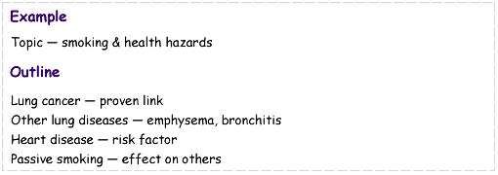

Step 2 — write the topic sentence
Write a topic sentence.
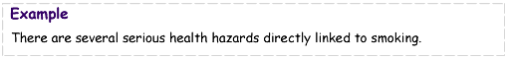

Step 3 — write supporting sentences
Next write a supporting sentence for each point. Use facts or examples to support your points.
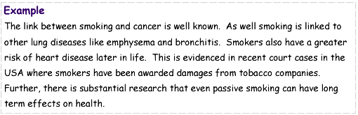

Step 4 — concluding sentence
Then write a concluding sentence to sum up.
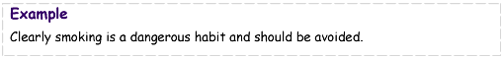

Step 5 — final paragraph
Write the final paragraph.
