Overview of the Rules/Outline of the Game
Object of the Game
To score more goals than the other team.
Scoring
When the whole puck goes between the goal posts and crosses the red goal line.
How to Score
A player uses his stick to get the puck over the line or deflects the puck with any part of his body or his skate. An attacking player cannot kick the puck into the net or deliberately knock the puck into the net with any part of his body. A puck that goes into the net via a defending player scores but not if deflected by a referee or linesman.
Scoring Points
The last attacking player to touch the puck before it scores a goal is credited with the goal and is awarded a point. One or two assist points can be awarded by the referee to the attacking players who made the passes immediately prior to the goal being scored. Leagues maintain lists of leading point scorers based on goals + assists = total points scored. Annual awards are made - in the case of the NHL the trophy for the top points scorer in the regular season is the Art Ross Trophy.
Length of Game
Ice hockey is a stop clock game - when the whistle blows the timekeeper will pause the clock. A full sixty minutes of action is guaranteed! Regular season games consist of three 20 minute periods with ice resurfacing taking place between the 1st/2nd periods and the 2nd/3rd periods.
Overtime Period
In some leagues, games that are tied at the end of regulation give rise to a 4th (overtime) period - in search of a winner. The length and rules for this overtime period vary from league to league. In the NHL, regular season overtime lasts until a goal is scored or a maximum of five minutes - it is also player with just four skaters per side.
Playoff Overtime
In the NHL Playoffs, overtime is played with the normal five skaters, lasts until a goal is scored and each overtime period is the usual 20 minutes. This can mean that there are several extra periods before a result is achieved.
Rosters
Each team can have two goalies and 20 skaters (a mixture of forwards & defenders) dressed for a game. They occupy the team bench and are normally grouped in lines - pairs of defencemen or trios of forwards who normally play together. A team can only have a maximum of six players on the ice at any one time - this is usually a goalie, two defenders and three attackers.
Substitutions
During the game players can be substituted as the game is in progress or at a stoppage in play. Players often have short shifts on the ice (less than a minute in some leagues) before returning to the bench to be replaced by a team mate. Goalies can be substituted for a skater - this happens when an opposing team is called for a delayed penalty or a team is pushing for a draw near the end of a game.
Infractions/Penalties
For violations or infringement of the rules, players are sent off the ice for 2, 5 or 10 minute penalties. If the penalty is serious, the player may be suspended for the remainder of the game. The referee signals a penalty by raising his arm and the penalty is delayed until the offending team gains control of the puck or a goal is scored. For a list of infractions see Officials' Signals.
The Rink
The rink can measure between 85-100 feet wide by 184-200 feet long. The playing surface is enclosed by boards and is divided in two halves by a red line across the centre of the ice. The rink is also divided into thirds by two blue lines, forming two end zones (see attacking zone & defensive zone) and one neutral zone. In each end zone, there is a goal cage and a red goal line, which runs the width of the rink. There are also nine face-off spots, four in each half of the rink and one in the middle.
Icing
Icing occurs when a player shoots the puck from within his own half of the rink across the opponent's goal line. Icing is waved-off if the team icing the puck is shorthanded or a player from the defending team could have played the puck before it crossed the goal line or if a player of the icing team plays the puck before it crosses the goal line.
Offside
A team is offside when any attacking player crosses the blue line of the offensive zone before the puck. The puck must always cross the blue line before an attacking player may enter the offensive zone. All players from the attacking team must have skate contact with the neutral zone at the instant the puck crosses the blue line. A face-off just outside the blue line results from an offside call.
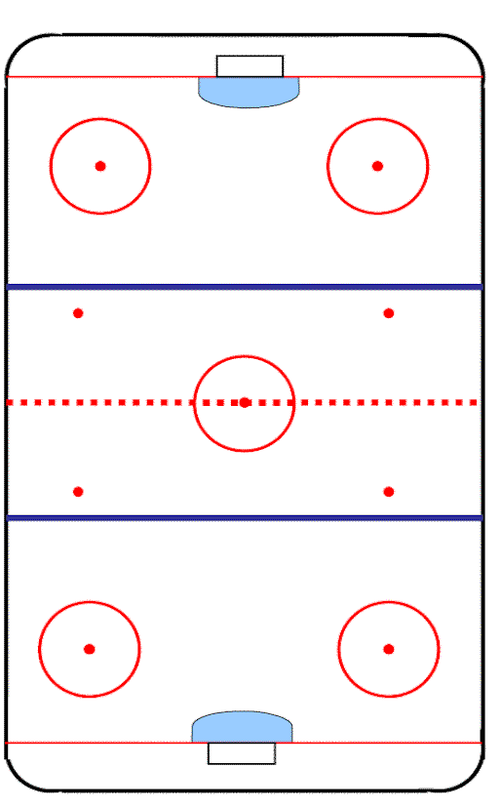
ICE HOCKEY RINK

