Paragraphs
A Paragraph is a group of connected sentences that is generally made up of one main idea and a group of supporting sentences. Paragraphs are the basic unit for building longer pieces of writing, e.g. essays, reports, assignments etc.
Paragraphs contain three main parts:
- A topic sentence - contains the main idea of the paragraph. It's often but not always the first sentence of the paragraph. It helps the reader to understand quickly what the paragraph is going to be about. Allows the writer to clearly develop the paragraph that follows.
- Supporting sentences - these sentences develop or give details about the topic sentence. They can:
  - expand on the main point
  - offer explanations
  - give examples
  - give additional details.
- A concluding sentence which summarises the paragraph or may provide a link to the next paragraph. This sentence is not always necessary in a paragraph.
Below is a list of useful language that could be used in your concluding statement(s).

Finally
In conclusion
In summary
Therefore
Thus
As a result
Indeed
Clearly
It is clear that

Paragraph unity — sentence connectors
All sentences need to relate to the main idea / topic sentence in the paragraph. The reader should be able to see how each sentence flows from the previous one and how each is connected to the topic sentence. Sentence connectors weave sentences together to create a cohesive paragraph. They order and sequence ideas, theory, data etc. The following tables list useful connectors.

Useful sentence connectors
Logical order  - firstly, secondly, thirdly etc  - next, last, finally  - in addition  - furthermore  - also  - at present / presently | Order of importance  - more importantly  - most significantly  - above all  - primarily
Contrast  - however  - on the other hand  - on the contrary  - by (in) comparison | Comparison  - similarily  - likewise  - also  - too

Useful connectors within paragraphs
Comparison  - like  - and  - both  - alike  - similar (to)  - the same (as)  - Not only  - compared to  - in comparison to  - so...that | Contrast  - although  - though  - while  - even though  - whereas  - yet  - but  - more than  - different / differ from  - unlike

Steps for paragraph writing

Step1 — write an outline
When writing a paragraph, first write an outline of the paragraph and include:
- the topic
- supporting information.

Step 2 — write the topic sentence
Write a topic sentence.

Step 3 — write supporting sentences
Next write a supporting sentence for each point. Use facts or examples to support your points.

Step 4 — concluding sentence
Then write a concluding sentence to sum up.

Step 5 — final paragraph
Write the final paragraph.
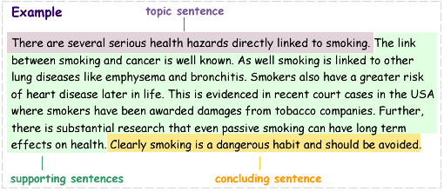

Activity - Identifying the paragraph structure:
Read the following paragraphs and find the topic sentences, the supporting sentences, and the concluding sentences:
Making the best use of study time is important. There are several ways to make the best use of the study time available. These include limiting interruptions, setting achievable goals, getting into a study „habit“. Another way to make study time more profitable is to set a time limit with regular breaks. All of these techniques help to maximise concentration.

Many people are afraid of snakes. However, snakes are shy creatures that avoid contact with humans. Snakes generally hide under logs or rocks. If approached they move away rapidly. In addition, snakes only attack when under threat. If snakes are left alone they are usually not a problem.

Many writers make grammatical errors when they experiment with different ways of putting sentences together. They may arrange words in the wrong order, use the wrong forms of particular words, or leave out important punctuation marks altogether. However, there is nothing wrong with making mistakes like these when you write your first draft, as long as you carefully edit your final copy.
TASK: write a paragraph on a chosen topic.

