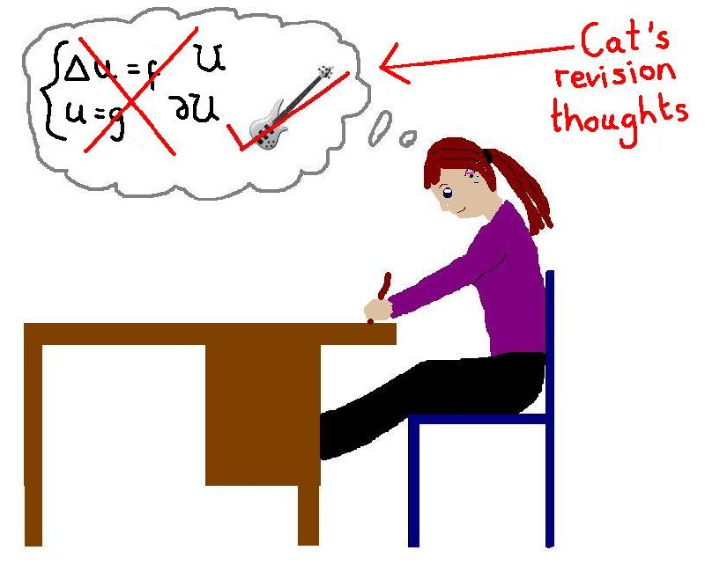
SEMINAR 12 SUMMER TERM REVISION
GRAMMAR
Tense revision:

There are seven mistakes in this letter. Correct them:

Dear Mr Aziz,
I would like to apply for the job of shop manager which I see advertised in the local paper.
I am twenty years old. I was born in France, but my family moved to England when I was twelve and I am living here ever since. I left school since three years and since then I am having several jobs in shops. For the past six months I am working in Halls Department Store. The manager has been saying that he is willing to give me a reference. I speak French and English fluently. I have also learnt German since I left school, so I speak some German too.
I hope you will consider my application.
Yours sincerely,
Louise Brett.

Conditionals:
If necessary, correct these sentences:
If Jack had been honest, he would return the money.
The video pauses if you press this button.
If Claire will continue to work hard, she should pass the exams easily.
I´d be able to visit Jim first thing in the morning if I stay in Manchester overnight.
You´d be surprised if I told you how much this cost.
If I had suddenly announced that the holiday was cancelled, the children had objected.

Adverbs, adjectives:
Fill in the gaps with a correct form of an adverb or adjective:
- He arrived late/lately.
- I haven´t seen him late/lately.
- We are flying direct/directly.
- It was raining hard/hardly.
- It hard/hardly matters now.
- I was deep/deeply hurt.
- Deep/deeply in my heart I know it´s over.
- Malaria can be a dead/deadly disease.
- Feel free/freely to look around.

Modals:
Complete the second sentence with must/n´t/, need/n´t/, should/n´t/, or don´t have to, so that it has a similar meaning to the first sentence:

- It is vital to wear a helmet when you ride a motorbike.
You..............................................................................
- I expect we´ll get the contract because we offered the best price.
We offered the best price, so we....................................................
- It was wrong of you to speak to my mother like that.
You..............................................................................
- She promised to phone me before lunch. It´s seven o´clock now.
She.........................................................................................by now.
- I made far more sandwiches than we needed.
I.....................................................................so many sandwiches.
- In my opinion it would be wrong for them to move house now.
I don´t think they ........................................................................

Passive voice:
Rewrite the following sentences in the passive. Omit the agent where possible.
1. Students must wear school uniforms at all times.
- School …………………………………………………………………………………..
2. Have the examiners announced the results yet?
- …………………………………………………………………………………………yet?
3. I don't like people teasing me.
- I ………………………………………………………………………………………….
4. They think she's talented
- She………………………………………………………………………………………..
5. Scientists once believed that the Earth was flat
-……………………………………………………………………………………….. .flat.
So, such, such a:
Transform the following sentences using so, such, such a. The second sentence must have the same meaning as the first one.

- The weather was so hot! It was such _____________________ !
- The curry was ______ hot that I had to ask for a large glass of water!
- There were 200 singing children waiting for him when he arrived. He certainly didn’t expect _________ welcome.
- The famine was so severe that thousands died. It was _______________ famine that thousands died.
- The bus was so crowded that I couldn't get on. There were so ____________________________ that I couldn't get on.
- Most people agree that changes to the voting system are needed. However, it will not be easy to get ________ reforms passed by the parliament.

Few and a few; little and a little:
Put in a where necessary. Write “OK” if the sentence is already complete.
- She’s lucky. She has few problems. __________________
- Things are not going so well for her. She has few problems. __________________
- There was little traffic, so the journey didn’t take very long. __________________
- I can’t give you a decision yet. I need little time to think. __________________
- I wonder how Sam is. I haven’t seen him for few months. __________________

VOCABULARY

Academic presentations
Complete this introduction with words from the list.

questions talk about look at points of view thank you
go along hear brief finally

Good morning and ________________ for being here today. My name’s Rebeca Pomponio and I’m responsible for student language programmes. What I’d like to do today is ________________ the new system of languages taught at this university. I´m going to be ________________ about ten minutes, not more. I’m going to ________________ the language programmes from three ________________: firstly, what languages we offer; secondly, the system of courses; and ________________, the exam requirements. If you have any ________________, just interrupt me as I ________________ . Your point of view may well be different, and we’d like to ________________ from you.

What is the structure of an academic presentation? Describe briefly.
……………………………………………………………………………………………………………………………
……………………………………………………………………………………………………………………………
……………………………………………………………………………………………………………………………
……………………………………………………………………………………………………………………………
……………………………………………………………………………………………………………………………
……………………………………………………………………………………………………………………………

Reporting verbs
Complete these sentences by choosing the correct verb.

- Could you _________ up? We can’t hear you at the back.
a) talk b) say c) speak
- I’ll have to _________ the place as I don’t have any photos with me.
a) explain b) describe c) present
- He’s going to __________ the latest results.
a) describe b) inform c) present
- Let me __________ why we need to cut costs.
a) explain b) describe c) talk
- We will __________ you when the project comes to an end.
a) say b) describe c) tell

Conjunctions
Choose the best conjunction/although, even though, in case, unless, as long as, provided (that), so that, in spite of, because, because of/ in the following sentences:
- ............................. it rained a lot, we had a great time.
- I did not go out ................................... I was feeling awful.
- You should have a spare wheel .................................... you have a puncture.
- We won´t be able to come ................................... the weather
- ................................. having no formal medical qualifications, my acupuncturist has helped me a lot.
- She stayed at work late .................................. she could complete the report.
- Travelling by car is convenient ....................................... you have somewhere to park.
- ....................................Tom doesn´t speak Spanish, I think he should still visit Madrid.
- You can´t enter .................................. you are a member of the club.
- You can borrow my umbrella ............................. you don´t lose it.

Conjunctions
Complete the sentences with your own ideas:

- Children are allowed to use the swimming pool provided…
- I´m playing tennis tomorrow unless…
- He passed the exam although…
- I´ll draw a map for you in case…
- She accepted the job in spite of…
- Please inform me immediately as soon as …
- Since I was hungry…

Collocations
Choose the correct collocation:

- Researchers raise/rise some important questions.
- We can´t take/draw any conclusion from what she said.
- Some schools lay/establish a heavy emphasis on school achievement.
- She has carried out/acknowledged research into renewable energy sources.
- Let us examine this idea in heavier/greater detail.
- You must take/give their age into consideration.
- We can arrange a course to fill/meet your requirements exactly.

Paragraph structure
Read the following paragraph and find the topic sentences(T), the supporting sentences(S), and the concluding sentences(C):

Many writers make grammatical errors when they experiment with different ways of putting sentences together. They may arrange words in the wrong order, use the wrong forms of particular words, or leave out important punctuation marks altogether. However, there is nothing wrong with making mistakes like these when you write your first draft, as long as you carefully edit your final copy.
Writing a summary
Original Passage:

The door opens. Dr. Michael DeBakey enters and walks quickly to the operating table. His assistants have already opened the patient’s chest and removed the diseased heart. With the skill and precision of a master, DeBakey transplants a healthy donor heart into the patient’s chest. It takes about an hour. When DeBakey finishes, he leaves the operating suite and goes to the scrub room. He takes off his operating clothes, scrubs down, and puts on clean, sterilized clothes. In a matter of minutes, he enters another operating suite, and the whole process starts over. In a normal working day, DeBakey operates on five to nine patients. He normally spends 12-15 hours a day, seven days a week, in the hospital and performs as many heart operations in one month as most surgeons do in a year. There is one more thing you should know about DeBakey. He is over 80 years old

There are two primary reasons Dr. Michael DeBakey functions so successfully in such a potentially stressful environment. The first is that he appraises these situations—doing complicated heart transplants—as challenges rather than as threats. The advantage of challenge appraisals is that they help a person focus on making particular decisions or solving particular problems. In turn, problem-focused coping brings out positive feelings and emotions, such as excitement and eagerness, which help reduce stress levels. In contrast, threat appraisals elicit negative emotional feelings, such as fear or anxiety, which raise levels of stress. Because emotion-focused coping is directed at managing negative emotional feelings, the person isn’t motivated to solve his or her problem. A second reason DeBakey functions so well is that he has a winning combination of personality factors that help him perform under great stress. Specifically, he has what is known as a hardy personality. (307 words)

Complete the Sample Summary

Ron Plotnick __________ two reasons why Dr. Michael DeBakey, a heart surgeon in his eighties, can work twelve-hour days every day. ___________, the doctor views his work of transplanting hearts as a challenge instead of a threat. Because he focuses on solving problems, he enjoys good feelings that relieve stress. People who perceive a circumstance as a threat focus on bad emotions, ____________, they create tension and do not improve the situation. ____________, Dr. DeBakey has a “hardy personality” or several emotional traits that allow him to withstand the stress of his difficult occupation. (94 words)
From Introduction to Psychology, 5e, by Ron Plotnick
San Diego Tribune, November 27, 1987

Parts of a summary

- Topic Sentence = Central point, the main idea of the passage.
- Transition Words = First, / Next, / Finally etc. Use these words in your summary.
- Reason = Major Support. This is a claim or opinion for believing the central point.
- Explanation and Example = Minor Support.

Gambling, ethics - crossword
