Diet and Age

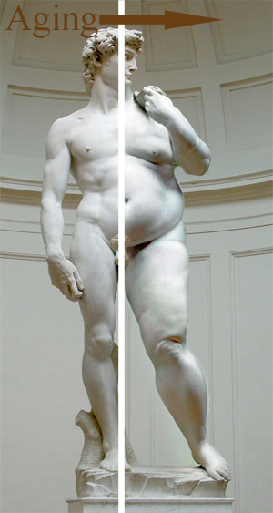
TASK 1 Discuss
Look at the picture - what does it imply?
Is it really inevitable to put on weight as we grow older?

TASK 2 Reading - WHAT DO WE MEAN BY NUTRITION?
Choose the correct prepositions: as, by, for, in, into, of, on
Nutrition is the science of food 1._____ relation to health. It has evolved from interest 2._____ clinical diseases caused 3._____ single nutrient deficiencies such 4._____ scurvy (lack of vitamin C) and from studies involving cardiac problems, diabetes and many others. Nowadays the focus 5._____ nutrition is based 6._____ a new definition of health as 'prevention of disease in which nutrition plays a key role'. The word 'nutrient' is a broad term to describe all dietary substances used 7._____ the body to ensure normal development and maintain good health. The term, however, can be divided 8._____ two distinct groups of dietary components:
macronutrients - macronutrients are those nutrients that together provide the vast majority of metabolic energy to an organism. The three main macronutrients are carbohydrates, proteins, and fat. Others include alcohol and organic acids.
micronutrients - micronutrients are essential elements needed for life in small quantities. They include microminerals and vitamins.

TASK 3 Reading - DIET THROUGHOUT LIFE
Go quickly through the article and decide whether the sentences below are true or false.
1. During the first 6 months of life infants should only have breast milk.
2. Vitamin supplements are not recommended for children.
3. The only source of calcium for children are dairy products.
4. Teenagers often suffer from low intake of protein.
5. The sufficient intake of calcium in younger age can prevent diseases like osteoporosis in older age.
6. Adults usually put on their weight because of their lifestyle.
7. Old people should ask for help when doing basic daily activities.

Infants: During the first 4 - 6 months of life, infants need only breast milk or formula to meet all their nutritional needs. Breast milk is the recommended feeding method for the first 6 months of life although a fortified formula can adequately meet an infant's needs.
Older children: Throughout childhood and adolescence, it is important that the diet include a variety of foods for proper development. After the age of 2, it is recommended that the diet be moderately low in fat, as diets high in fat may contribute to heart disease, obesity, and other health problems later in life. In areas where water is not fluoridated, fluoride supplementation is recommended. Healthy children should get all their nutrients from foods rather than vitamin supplements. The nutrients that are most likely to be deficient in a child's diet are calcium, iron, vitamin C, vitamin A, folic acid, and vitamin B-6. Children who consume little or no dairy products are at particular risk for calcium deficiency that can interfere with bone growth and development. Foods that are good sources of calcium include low-fat or non-fat milk, yogurt, and cheeses. Other foods such as broccoli, cooked greens, and canned salmon (with bones) will also provide a source of calcium in the diet, however it is often difficult to get children to consume adequate quantities of these foods.
Teenagers: Whatever your age, it's important to have a healthy balanced diet. This is particularly true when you are a teenager, because your body needs good supplies of energy and nutrients to support this period of dramatic growth. Teenagers need slightly more carbohydrate than adults because their energy needs are greater. Protein is essential for growth, repair and as a secondary source of energy. In Western countries most people eat more protein than they really need since many foods are very rich in it. A very important mineral is calcium. This is vital for the development of strong bones and teeth, so teenagers need more than adults. It is also essential for muscle contraction, blood clotting and conducting impulses along nerves. Calcium deficiency can lead to osteoporosis in later life - brittle bones and slumped posture. Adolescent girls will have increased iron needs due to menstrual losses.
Adults: As you age, your lifestyle may be less active; you may sit more and perform less vigorous exercises or physical labor. Also, your body's metabolism may be less efficient or slower. These lifestyle and metabolism changes may cause weight gain and less efficient absorption of nutrients. Select more nutrient-dense foods with lower amounts of fat and sugar. Most adults don't eat enough fibre. An increase in fibre should also go along with an increased fluid intake. Fibre is found in cereal foods, beans, lentils, fruit and vegetables. It comes in two forms, soluble fibre and insoluble fibre. Soluble fibre helps reduce blood cholesterol levels. Insoluble fibre acts as a bulking agent, so it helps prevent constipation and keeps the large intestines healthy.
Old: Good nutrition in the later years can help lessen the effects of diseases or improve the quality of life in people who have some diseases. They include osteoporosis, obesity, high blood pressure, diabetes, heart disease, certain cancers, gastrointestinal problems, and chronic undernutrition. Studies show that a good diet in later years helps both in reducing the risk of these diseases and in managing the diseases' signs and symptoms. This contributes to a higher quality of life, enabling older people to maintain their independence by continuing to perform basic daily activities. Poor nutrition, on the other hand, can prolong recovery from illnesses.
(www.iwant2bhealthy.com/youths/nutrition/nutritional_needs/basics.shtml)

Discussion
Version A:
In groups prepare the healthiest daily menu for these people:

1st group - 3 years old boy/girl
2nd group - 14 years old boy/girl
3rd group - 40 years old man/woman
4th group - 70 years old man/woman

Present your menu to the other groups.
Version B:
In groups prepare the healthiest daily menu for a 14-year old girl. In pairs (each student from a different group) persuade your partner that your menu is better than his/hers.

