Human body, Health and Illness
Task 1 Human Body
ankle  arm  navel  chest  chin |  | ear  elbow  eye  fingers  foot | hand  head  heel  hip  knee | leg  mouth  nose  neck  shin | shoulder  thigh  toes  waist  wrist
 | Ex. 1: Label the human body diagram using the word list above.

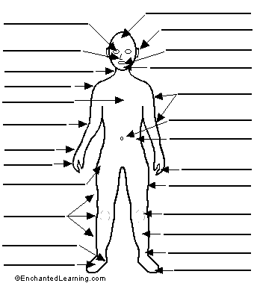

Exercise 2: How are the following things connected in the body?
Teeth – jaw
Diaphragm – abdominal cavity – thoracic cavity
Ribcage – heart
Skull - vertebral column – vertebrae – intervertebral discs
Palm – thumb
Ankle – foot - calf

Exercise 3: Match synonyms
Clavicle
Shoulder blade
Sternum
Spinal column
Phalanges
Thorax
Tibia
Femur
Patella

thigh bone
backbone
kneecap
shin bone
chest
finger bones
breastbone
collar bone
scapula

Exercise 4: Match the organs with their respective systems:

mouth - spinal cord – blood vessels (arteries, veins and capillaries) – nails – joints – liver –uterus (womb) – thyroid gland – hair – heart – kidneys – skin – muscles – brain – intestines – bones – bladder - lungs – nerves – sweat glands

Circulatory Respiratory Nervous Musculoskeletal

Digestive Urinary Reproductive Endocrine Integumentary

Exercise 5: Listening
Fun science: The human body
(http://www.videojug.com/interview/fun-science-the-human-body#what-is-my-body-made-of)
Listen and answer the questions:
- What´s my body made of?
- Why do we get “goose bumps”?
- Why do I get “brain freeze” when I eat ice cream?
- Why does my skin look like a wrinkled prune after I take a bath?
- Why do I sweat?
- How do my eyes see colour?
- What happens to food when I eat it?
- Why do I need food?

Task 2 Health and Illness
Exercise 1:
What is the difference between being healthy and being fit; between a disease and an illness?
What does it mean when somebody says that they are “sick”?

Exercise 2: Make adjectives from the nouns below:
Fitness Health Illness Sickness

Exercise 3: Choose the correct word to complete each sentence:
- Her condition …………….(deteriorated/improved) and she died.
- He ……………..(relapsed/recovered) and was allowed to go home from hospital.
- The patient made a full………………(recovery/remission).
- I have been in ………………(poor/good) health for months and feel very fit.
- It was a month before I …………(got over/ got better) the illness.
- He seems to be rather …………. (unhealthy/ unwell) – his diet is bad and he never exercises.
(adapted from Glendinning, Howard: Professional English in Use – Medicine. Cambridge University Press, 2007.)

Exercise 4: True or false?
- Mumps and chicken pox are childhood diseases.
- AIDS has been eradicated from the world.
- Diabetes is a contagious disease.
- Parkinson´s disease is hereditary.
- Flu is preventable.
- Migraine is an incurable disease.

Exercise 5: Give examples of
acute/chronic/ serious/ mild/ degenerative/ occupational/ mental/ obscure/ deadly diseases.

