Combative activities

Zdenko Reguli, Jitka Chvátalová

Content

Introduction 3
The origin of combative activities and martial arts (An introduction to combatives) 4
Combatives in sports systems 8
The level of combative pre-requisites: preparatory combatives 14
The level of combative system: combative sports 23
Level of combatives applications: Self-defence 27
Martial arts 32
Combatives and movement games 36
Combative aspects in gymnastics and gymnastics in combatives 40
Notes on the didactics of combatives 41
Conclusion 47
Czech-English dictionary 48
English-Czech dictionary 2
References 2
Test your knowledge 3

Introduction

This paper is an educational support for the class of Combative activities which takes place every term at Faculty of sport studies. It is meant not only for foreign students but also for everyone who is interested in the topic of combatives.
Purpos of this book i s to introduce combatives as a special group of exercises, explain systematics of combatives and give many examples of exercises readers to understant what combatives are. It also presents combatives in games and special gymnastics of combatives and gives some advice for teaching combatives in the classes at schools andsportsclubs.
It presents theoretical basics of combatives. Together with practical classes of combative activities it is a komplex introduction to all combative levels – preparatory combatives (games, pushes, pulls, oposites, combat conditioning etc.), combat sports and martial arts (box, wrestling, fencing, karate, judo, aikido, wing tsun, etc.) and selfdefence.

Motto:
“Even from prehistoric time, it seems that fighting has two faces. One of the faces is brutal action leading to kill opponent or making him disable to fight. Second one is full of honour of noble warriors and worthy knights. What are the processes leading to transformation from bad to good, from unmoral to ethical vision of fight and fighters?” (Z. Reguli)

The origin of combative activities and martial arts (An introduction to combatives)

Fighting has always been connected with humanity. If we consider the prehistoric origin of fighting we must come to the conclusion that, without developed martial arts, man was facing death and his tribe was in danger. Basic fight techniques and tactics came into being through hunting. The opinions of some palaeo-anthropologists even suggest that hunting is as old as mankind, since man is the only “animal” on the Earth that has no special natural organs adapted for hunting as the primary source of acquiring nourishment.
Despite this man had learnt to kill animals, even ones that outstripped him in physical strength and size. He had had to use his skills, to develop hunting and fighting technique and tactics. There had been the origins of various kinds of fighting an animal one-on-one or, in the case of hunting a larger animal, the hunters had had to co-operate. There were situations when he had to defend himself or his territory, which meant the development of skills for fighting an animal into techniques for fighting a human enemy. This meant that being a fighter was a way of life even though, in practice, the focus was on practical applications rather than the potential of the training as a generalised procedure (i.e. physical exercise).
With the gradual differentiation of human activities, as well as with the origin of social groups and the hierarchy within them, special groups focusing on fighting activities came into being and later these split into fighting groups focused on individual fighting activities (hunters, spearmen, bowmen…) Nevertheless, fighting activities, no matter whether we are talking about fighting for hunting or for fun, was not a part of life for all social groups in a society. It is known that all the ancient civilisations and cultures of the world saw sport as a useful and essential activity. They usually chose sports, which emphasised, in other words, strength and power activities of a fighting character. Artefacts of arts and crafts show the existence of fights and fist-fights as long ago as the great days of Mesopotamia, i.e. the 27th-26th century BC. There are Egyptian artefacts from about the 25th century BC showing fighters with a third person watching the fight – probably a referee or a coach, which seems to be a proof of organised training in fighting skills. Aegean culture even gave their fighters helmets that partially protected their faces.
Training fighters as well as taking part in fighting events was highly valued in many cultures. Most documents discovered from the ancient period are from the Hellenic era. The Olympic games in Ancient Greece also had various fighting competitions with long and noble antecedents, even in comparison with other disciplines. This would seem to be proof of the extreme popularity and the high respect in which the fighting disciplines were held. First there was παλη (palé) wrestling (which dates back to the 18th Olympic games in 706 BC), after that πιγμη (pigmé) boxing (the 23rd Olympic games in 688 BC) and eventually all-in fighting, the pankration (the 33rd Olympic games BC), a free form combination of all the other martial skills. Combat was also part of the classic pentathlon (from the days of the 18th Olympic games).
It is widely known that the Golden Era of the Olympic games was followed by their decline. One of the signs of the gradual decline of Greek sport was the slow penetration of professionalism. Division between the physical and spiritual part lead to strict sporting specialisations. The decline of combat (in the widest sense) came to its climax in the Roman gladiatorial fights. Even though they were possibly, from the point of physical performance, at the highest level, from the sporting standpoint, meaning as a part of culture in civilisation, they had practically no value.
Societies gave the individuals taking part in martial arts status and considered them heroes. The connection of the practical value of martial arts with their semi-mystical value lead to the fact that some societies elevated martial arts, putting them on a par with education and manners. For example Medieval Europe had the knightly septem probitates = the seven cardinal virtues, Japan had bunbu rjódó principle = unity of military and cultural education. From the ideological standpoint, we could say that it was consecrating military strength and martial ability. Therefore, fighting skills were not taught solely as military practice, but as a part of a general education (i.e. to the majority of the male population).
Knights not only underwent training in fighting skills but had also the opportunity get practice through various hunts and tournaments. Originally, tournaments displayed all the characteristics of real fighting, although this was later replaced by mock combat (specifically after the mortal injury of the French king Henry II in 1559). They used to have various props as the tournaments had an air of theatrical performance (similar to modern productions by groups of historical fencing enthusiasts).
Imitations of tournaments can also be found in bourgeois and folk culture. Many a folk play, likewise, contained a character who was a fighter. It showed not only a higher competence and superiority over others but also training skills needed for everyday life (practised in various pulling, poking, etc.). Fighting drills were probably a steady form, i.e. they had a simple form with rules.
The ideal of knighthood and physical preparation of a knight was kept alive later in so-called knight academies (schools for aristocrats in 17th and 18th century) as well as in philanthropies.
The 19th century gave rise to various sport groups in many places, among whom fighting exercises were much utilised. In Schnepfenthal philanthropinum (friends of man), there was between 1785-1839 a Johann Friedrich Guts Muths who used a system inspired by the ancient Greeks and based his training on the disciplines of the Olympic pentathlon. The Turner movement in 19th century Germany was based on linking the exercises and the ideological preparation. Documents and systems of the Turner movement (Friedrich L. Jahn and Ernst Eiselen) directly influenced the origin of systematics of physical education in the Czech lands (e.g. J. Malypetr, M. Tyrš) as well as in Slovakia (I. B. Zoch). Peter H. Ling, representative of the Swedish way inspired by the Dane Nachtegall, made a distinction between four kinds of martial artistics: military, pedagogical, health, and aesthetic. In France, it was Francesco Amoros who helped the development of martial arts.

The statute of SOKOL (19th century) is the recognised and documented starting point for the incorporation of the fighting arts into physical education here in the Czech Republic, but SOKOL was neither the first nor only organisation to employ such martial skills. Fencing and swordplay had been taught in the King’s regional professional fencing institute since 1659, and in 1886 The Czech Fencing Club was founded. A number of other institutes providing a combative curriculum were founded: Hirsch’s institute in Prague in 1830, Steffany’s (later Stegmayer’s) in 1843, Segen’s in 1845, Schmidt-Malypetr’s in 1848.
1842 was an important year for the Slovak lands, from the point of fighting activities and fencing (and also from the point of physical education), with the establishment of the first physical-education department for the College in Prešov. The first public institute to focus on fencing and swordplay was the F. Matineng School of fencing and physical education, founded in 1844. If you are interested in the syllabus of teaching fighting at schools, the earliest textbook giving this information is the one by I. B. Zoch from 1873.
After the Czechoslovak Republic came into being (in 1918) there was a rapid development in martial arts. The turning point seems to be the “discovery” of ju jutsu or judo. People interested in specific martial arts usually practised together and were interested in expanding their knowledge of other, at the time perhaps all, available disciplines. Wrestlers and weight-lifters were organised in clubs of track or field athletics.
Even after WW2 martial arts were included in the regular programmes of various groups of interest. The communist ideology, too, emphasised them, as they believed suchcould become the tools for the class struggle. Physical education reached its peak in the area of the National Service.
Nowadays, martial arts are rightfully included in the programmes of physical education at primary as well as secondary schools. There have been several studies demonstrating the beneficial effect of martial arts for the general health and fitness of students. Many a college (not only teacher training colleges, where martial arts form an essential component of the curriculum) also incorporates such martial arts into their courses of physical education.

Combatives in sports systems

The European sport charter (1992) defines sport as “all the forms of physical activities, which, either organised or not, should have the aim of improving physical as well as psychological condition, social relationships or achieving good results in competitions at all levels”.

Tyrš, a Czech teacher of physical education and the founder of SOKOL, seems to be the one who created the system of physical exercises for the newly established “SOKOL” association.
The basic criterion for the physical exercises was that it was possible to perform them either individually without help or with a partner and his/her support or resistance. Both the types of exercises can be performed with or without props.
The exercises were divided into:
- Exercises without props and without support of other people
- Exercises with props
- Group exercises
- Combatives

Combatives (úpoly in Czech), as the fourth group of the system of exercises, were further divided into two main classes and other subclasses (all the other groups of the system of exercises used the same division key):
- without props:
  - Opposition (resistance, pulling, pushing): without props, with props. The aim is to overcome the opponent’s resistance knowing the direction of resistance as well as knowing the activity in advance.
  - Wrestling (bowing, lifting, pull-downs, knock-downs, etc.): as you see this not only means to resisting the opponent but also defeating them, taking them down to the floor to prevent them putting up further meaningful resistance.
  - Boxing (arm attacks, kicks, defensives). The core lies in the attack with arms or legs as well as in blocking the opponent’s attacks.
- Fencing with weapons:
  - sabre
  - foil
  - short or quarter staff : short (80-100 cm), long (up to the fighter’s chin – a wooden stick, which is thicker on one end and thinner on the other end),
  - bayonet,
  - dagger.

The French fencing school provided the basis for work with a variety of weapons in a SOKOL system.
The specific naming units have to be understood in the context of the time period of their origin. Wrestling, for example, differed enormously from the current understanding of sport combat either in free or in Greco-Roman style. If we do not take account of the combat rules of the day, we could assess the Sokol style of combat to be something like free-style wrestling with elements of ju jutsu. The so-called Greco-Roman style was only “separated” by French wrestlers at the end of the 19th century. Boxing included a variety of techniques of strikes with the fist and arm, leg strikes as well as defending techniques (blocks), swerves, etc. It was completely different from the current system; we could possibly say, with a bit of imagination, that it was similar to kick-boxing or Thai boxing.
It is known that Tyrš invented many neologisms when creating his Sokol exercise system. It is understandable, as he did not have the language to describe individual exercises. He created and adapted about 800 neologisms by which he significantly enriched first Czech and later also Slovak general usage. This seems to be the reason why it is so difficult to translate these expressions into foreign languages (e.g. English).

Definition of combatives
Combatives (úpoly in Czech) are physical exercises aimed at the physical defeat of a partner. Combatives comprise specific exercises, which prepare a participant to overcome a partner by physical contact.

Combatives taxonomy
Combatives are a phenomenon of many dimensions and they go beyond mere sport, however broad the definition of such. In fact the question of combatives cannot simply be reduced to mere physical movements. We will endeavour to put the individual exercises into a systematic structure. It is known that no system is of absolute value; it should serve only as a tool to aid in the understanding of certain phenomena, i.e. providing a realistic context for fighting.
The systems of combatives derived from a hierarchy of three levels, as you can see below:
Combatives taxonomy
1. level of combatives pre-requisites

Preparatory combatives
⇩
2. level of combatives systems

Combative sports
⇩
3. level of combatives application

Self-defence
Fig. 1: Combatives taxonomy

The first level is the level of combatives pre-requisites. It comprises of the simplest combative activities (movement activities in contact with one or more partners), which are the necessary pre-requisite for the next two levels. The content is the basic fighting technique needed for all the fighting activities (posture, guard, falls, …). These activities are preparation and basics and we call them preparatory combatives.
The second level involves individual combative systems. Each of them is a comparatively independent unit and it fulfils the criteria of an independent combative branch. We call them combative sports and we can further subdivide them. The level of comabtive systems is the greatest and most important part of combatives.
The third level is the level of applied combative activities to be used in necessary self-defence with appropriate legal, ethical, social and other norms. This category is somewhat separate from the system of combative sports as it is closely linked with other, especially technical indicators that fall outside the field of sport (especially with the usage of firearms and other weapons).
The three levels are relatively independent although there is some overlap between them. Therefore it is difficult to categorise all the individual exercises in combatives, as they can fall into more than one category.

Fig. 2: Relationship and overlap of combatives levels

The following figure shows a brief summary of all the combatives systems. The later text speaks of their individual elements.

Fig. 3: Overview of combatives

The level of combative pre-requisites: preparatory combatives

Preparatory combatives are relatively simple exercises, which can be practices independently from all other fighting exercises. They are successfully used within school physical education at all levels and types of schools and institutions as well as free-time physical education. They are also used for developing movement pre-requisites for individual combative sports and for self-defence. All combative systems are in fact systems of highly polished techniques of specialised pulling (centrifugal movements), pushing (centripetal movements) or oppositions in a proper posture and making effective contact with appropriate movements of upper and lower extremities, torso, and so on. Preparatory combatives are the basis for individual combative systems. They are usually divided into basic combatives and basic combative techniques:
- basic combatives:
  - centrifugal
  - centripetal
  - opposition,
- basic combative techniques:
  - postures,
  - transitions (between postures),
  - arm movements,
  - leg movements,
  - turning the body,
  - transfers, changing position
  - contact establishment,
  - lifting, carrying and dropping of a live load (partner)
  - falling techniques.

Basic combative techniques
Basic combative technique is very rarely, with certain exceptions, performed with a partner. There are cases of training with a partner, but it is not fighting the partner only practising various specific movement skills. Mastering basic combative technique is necessary for individual combative systems and cannot be practised in any other exercises, and they are not part of any other movement systems. These are specifically:
  - postures:
    - stances,
    - sitting,
    - lying,
    - kneeling,
  - transitions (between postures),
  - arm movements,
  - leg movements,
  - turning the body,
  - changing positions (transfers),
  - contact establishment,
    - touch,
    - grip,
    - embrace,
  - lifting, carrying and dropping of a live load (partner)
  - falling techniques.

Fighting techniques can be implemented only in proper and sensible postures, which make their performance possible. In some fighting systems, postures are divided into natural (attacking) and defensive, e.g. in judo, other systems, the majority of them perhaps, show dozens of variations (karate, wu-shu, etc.). Posture usually start with both feet on the ground, although occasionally only one. A good posture must fulfil both principles: bio-mechanical as well as tactical. We encounter the expression “guard” (Japanese: kamae). Similarly to differentiation of postures we can differentiate right guard and left guard according to their orientation. Depending on the section of the body which we have to defend, we differentiate also lower guard (below waist), middle guard (torso level) and upper guard (neck and head level).
Significant fighting postures are, especially for fighting on the ground, are sitting, kneeling and lying down. Japanese systems use the transitional postures of kneeling, sitting on your heels with the feet flat on the ground, (in Japanese: seiza) and its fighting form (kiza) with the tip of the toes only touching the ground. Some systems (including weapon systems) use kneeling on one leg. They also use press-up and push-up on the knees, in fighting called (lower and upper) par terre (from French “near to the ground”). Ideally the martial artist should never fall down into lying position. If that happens, fighting offers lying guard on your back and side and, in exceptional circumstances, on your abdomen (especially in competitive combative sports, e.g. judo).
Transitions between individual positions are significant especially in the transitions from fighting standing into fighting lying on the ground. These are particularly sophisticated in wrestling, judo, ju jutsu, aikido, and other similar systems. There are also transitions into sitting from standing (suwarikata) and standing-up from sitting (tatchikata) and they have a significant position in the Japanese fighting systems (budo and bujutsu).
Hand and arm movements are practised individually in various ranges. There is a whole jutsu group of sports which focus on thorough training of various arm strikes, another group focuses on training various activities with weapons. Therefore, the thorough training of elementary arm movements has crucial significance in these fighting systems.
Similarly, leg movements are crucial for fighting systems using kicks. The term leg movements is generally used to signify basic steps. In fact, they are implemented by stepping or sliding in various directions. From the starting stance it can be either front or back leg, which starts the movement.
Turning the body mean turning along the longitudinal body axis. One of very frequent conditions of this movement is to preserve vertical stability (the longitudinal body axis is parallel with the vertical of centre of gravity). They use forward as well as backward turns around one or both legs. Rarely, they use also turns in jumps, especially in connection with strikes or kicks.
Changing position should be understood in relation to the partner. We divide it into relocating to or from the partner. It is possible to relocate oneself in front of the partner or behind the partner and the movements can be performed directly or with a turn. Rapid but often more risky relocations are those using jumps, i.e. jumping forward and backward (bounces).
Contact establishment seems to be the crucial part of any basic combative technique. The basic purpose of combatives is to overcome the opponent using body contact or a weapon. Contact can be established, with the exception of weapon combat, using any part of the body. Some cases show that in fighting systems possible points of contact can involve more than one half of the body surface. The combatant in Ancient Greece used to fight almost naked while nowadays martial artists fight more (e.g. Japanese traditional budó) or less (e.g. wrestling) dressed.
In some cases (when practising particular techniques or when deciding in a competition) it is important to differentiate with which part of the body the contact was made. We differentiate contact using: arms, legs, torso, and head. In a more detailed differentiation, we say with which particular body surface the contact was made: e.g. flat or heel of palm, knuckles, edge of palm (hand knife), back of hand, forearm (outer edge (ulnar), inner edge (radial), front or back “section”), elbow, etc.
The most important criterion seems to be the way in which the contact was effected. It can be: touch, grip, or embrace. Touch is usually effected using strikes or kicks. Grip contact utilises the hands, and they have a wide range of uses in the techniques for throwing and immobilising the opponent. Even a embrace (hug) or “lock” of either the torso, neck or other parts of the body are used to hold the opponent in place.
Lifting, carrying and dropping a live load (partner) is used more for practising the proper technique of these activities even though it has its indisputable significance for improving specific strength abilities via lifting, carrying, and dropping. In fighting, lifting, carrying and dropping of the partner is based on biomechanical principles, e.g. short lever usage, closeness of centres of gravity, etc. so that the participant wastes no unnecessary time and effort. We need to realise that it is not only the weight of the partner that the fighter has to deal with but also his/her inner forces. Specific training and techniques are therefore essential and they are the preparation especially for the techniques of throws and immobilisation.
Falls are a important component of any basic combat training system. They are significant not only for fighting but also in other movement activities (either as intentional or unintentional falls) but also in everyday life as protection against avoidable injury. Falls, meaning the intentional movements, are used also in many a sport which does not fall into the category of martial arts/combatives, mainly sport games (e.g. goalkeepers, in volleyball defence, in handball when throwing into the goal). The main aim of any fall technique is to prevent injury when falling or at least minimise the probability of injuring oneself.
The most practical categorisation seems to be the categorisation according to the direction of the fall: forward, backward, side, and combined falls. They are effected either as direct falls or falls with a turn (with rolling away or without it). We also differentiate falls with or without the flying phase. Slower falls with rolling away can be effected either by a break-fall or cushioning the blow.

That is to say that the basic fighting techniques are specific preparatory exercises, which do not have to be performed with a partner but are directly linked to the aim of overcoming a partner.
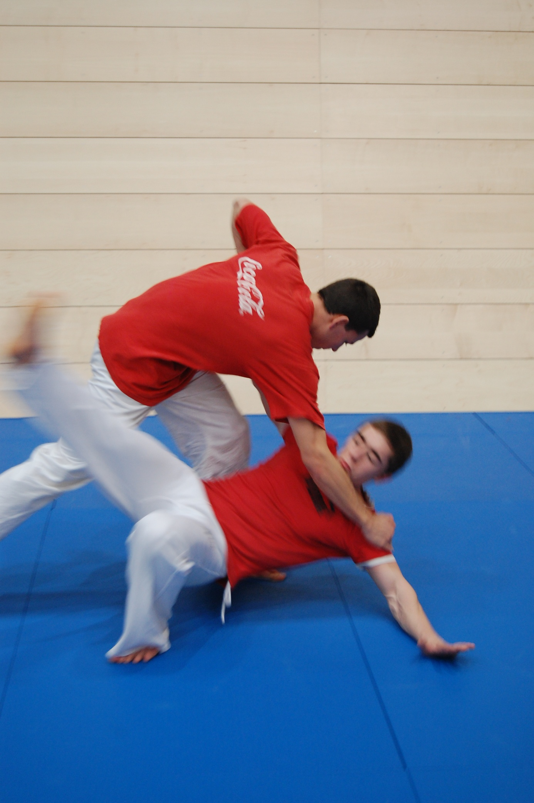
Basic combatives
Basic combatives are fighting exercises carried out by relatively simple movements. In fact, they do not have to be practised to any great degree before using them. They are so called basic combative relations. We differentiate them according to vectors of power and application and their bio-mechanical complexity:
  - centrifugal (pulls),
  - centripetal (pushes),
  - opposition (resistance):
    - pulling opposition,
    - pushing opposition,
    - own opposition.

Fig. 4 Relationship and overlap of basic combatives

Pulls and pushes are exercises of strength in various modifications. They are the simplest training of basic combatives. That means that they do not need any particular preparatory steps. They are dependent mainly on functional prerequisites, on movement abilities. Each fighter provides pressure only in one direction. In case of two fighters, the power vectors are opposite. We differentiate two ways of power:
- centrifugal← • →
- in pulls, fighter (or a pair of fighters or a group) tries to pull the opponent (individual, pair or a group) to their side or their part.
- centripetal→ • ←
- in pushes, fighter (or a pair of fighters or a group) tries to push the opponent (individual, pair or a group) away from or out of their side or their part.

Opposition presents the most wide-ranging group of basic combative techniques with the greatest number of possible exercises. Some of the exercises may require even higher co-ordination abilities, which makes room for greater application of tactics and make for improvements even in individuals with lower movement abilities as well as in individuals who are well versed in psychology, technique and tactics. Opposition is divided into:
    - pulling opposition,
    - pushing opposition,
    - own opposition.

Pulling opposition as well as pushing opposition are transitional forms between pushing and pulling on one side and opposition on the other. They are exercises which require mainly pulling or pushing activities, nevertheless, these are not the only activities.
An example could be a situation when one fighter is in a small circle and the other fighter tries to displace them. They can try to push the other out. They are allowed to change the direction of pushing , turn the opponent around, release the pushing and thus use the previous resistance, which changes the centre of gravity of the opponent and makes the following pushing easier. This is called pushing opposition (opposition with the nature of pushing).
The reverse procedure is to try to pull the adversary out of the circle using pulling opposition. Own resistance are exercises, which use various techniques to get the adversary out of the circle, i.e. pulling, pushing, carrying him/her out, move him/her out using a fighting technique (grip, holding, strike, etc.) as well as other specific exercises.
Opposition seems the most difficult basic technique. The aim of such techniques can vary as follows:
Translocation:
moving (catching the adversary off balance) (horizontally as well as vertically),
  - change the position of a predetermined body part (extremities, torso, head),
  - use an object held by the adversary as a lever,
Hold/grip:
Keeping the adversary in a position (horizontally as well as vertically),
  - Holding (“Locking”) an agreed part of the adversary’s body (extremities, torso, head)
  - Hold on to/ keep an object,
- Contact establishment:
  - Touch or grip the adversary (or his/her predetermined body part), or the object the adversary is holding,
- Preventing any contact:
  - Denying the adversary the opportunity to establish a contact or grip

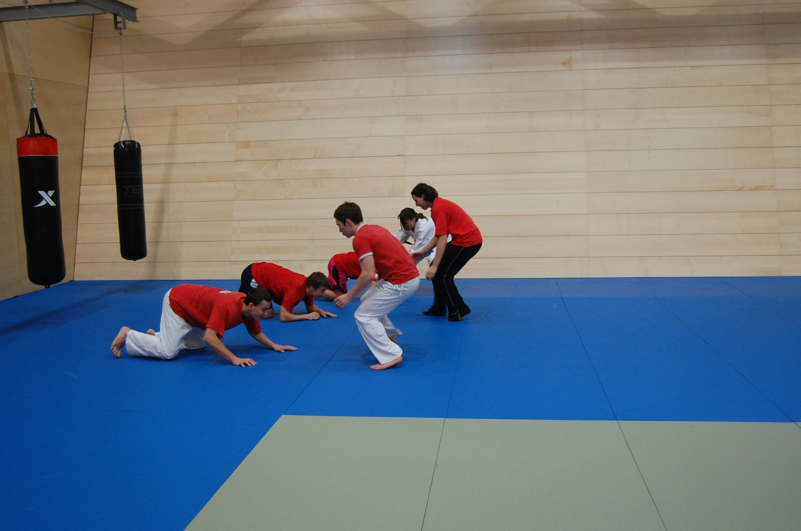

The level of combative system: combative sports

The most frequently used terms for combative (and related) systems vary, the usual are combatives, combative sports, combative activities, non-lethal combatives, martial arts, martial ways, hand-to-hand fighting, fighting arts, etc. The nature of combatives taxonomy considers the most suitable to be combatives and sport or martial arts as these term are closely related to the essence of the system. The term combative is linked not only with the physical exercises but also with the whole area of conducting a war and combat, meaning also the technical background of such. The term “arts” seems to be to broad and it seems to be only one way of looking at movement (the art of movement).
These are not only, as you can read in the European Charter, competitive activities (competitive sport) but all the movement activities, which should be frequently mentioned in order not to forget the fact. The individual sports (in the narrow sense of the term) differ from each other. They have their own:
- name (athletics, swimming, downhill skiing, ju jutsu),
- tools (technical, tactical, material),
- members and hierarchy,
- governing body and their system of national and regional organisations,
- methods and forms of training and education (more or less distinct, one from another),
- system of competitions and rules the competitive sports.

We also have to mention that not all the sports have all the listed attributes on the same level and some sports do not have even all the attributes. We use the combative sports for the level of combative systems. We can divide them according to various criteria. Individual groups define the aim they wish to achieve:
  - competitive combative sports (wrestling, boxing, kendó, etc.). The main characteristic of the system of these competitions and the preparations for them is the objective of achieving the top performance in the competitions within the limits of their rules.
  - self-defence combative sports (ju jutsu, goshin jutsu, krav maga etc.). Their main characteristic is focused on the application of a combatives to the need for self-defence.
  - complex developing combative sports (aikido, tai chi, etc.). Their main characteristic is their whole-life dimension and their development of a human being in more than one dimension, i.e. in the field of their body and soul, socially as well as spiritually.

Individual combative sports do not always fall neatly into a single category. Furthermore, some combative sports, within their full scope, allow the practitioner to work on various aspects in various periods of time. Judo was constructed as an educational tool in the field of the body (renshindo), morality (shushinho) and military (shoubuho) education. If we speak about focusing on individual combative sports, we speak about it in the context of a particular group of fighters. Fighters are usually members of an organisation which has aims set up as described above. It is possible to divide the sports differently if there is a need to focus on a particular characteristic of them. You will find below a possible division according to the tools employed and required:
    - combative sports which generally use weapons (fencing, kendó, iaidó etc.),
    - combative sports which generally employ “natural weapons”:
      - using mainly strikes and kicks (boxing, karate, tae kwon do, etc.),
      - using mainly throws and immobilising or neutralising the opponent (wrestling, sumo, judo, etc.).

Dividing combative sports according to their “tools” used seems to be advantageous especially in the field of competitive sports. The rules precisely state which pieces of equipment can be used in a particular competition and which are forbidden. Many of the combative sports are complex and use both weapons as well as contact using body parts. Nevertheless, there always seems to be a preference to use one group more.
From the point of different development and cause of origin of individual combative sports in various cultures, we divide them according to their cultural connotations:
- European (fencing, Greco-Roman wrestling, savate …),
- North American ( free-style (Olympic) wrestling, karate kempo, Jeet Kune Do …)
- South American (Gracie jiu-jitsu, capoeira …),
- Asiatic:
      - Chinese (tai chi, pakua, hunggar, …),
      - Korean (taekwondo, hwarangdo, hapkido …),
      - Japanese (aikido, judo, karate, sumo, kendo …),
      - Indian (vajramushti, kalaripayattu …),
      - Thai (muai thai or thai boxing …),
      - Indonesian (pentjak silat …),
      - Philippine (kali, arnis ...)

Nonetheless, in this case we speak rather of the place of origin as the majority of combative sports are now to be found all around the world. Different countries gave some of the sports different styles and schools as this is influenced by different level of the training process as well as the position of the art in the individual countries.

Level of combatives applications: Self-defence

Self-defence is a beneficial movement activity, even though some combative sports or combative systems emphasise self-defence as their priority. Self-defence, being a specific mode of the self-preservation is one of the oldest drives in humanity.
In the past, almost all the combative systems seem to have been constructed as self-defensive. They were supposed to be used in wars or duels. The application function of the combative system in self-defence shows that self-defence that can be used in individual fields of professional use as well as personal use must be complex and individual, but still an open system. The system should allow, on the basis of the circumstances (given by the participating individuals, situation, etc.), transformation of concrete fighting activities in such ways as to enable an adequate, effective and rapid self-defence, while respecting the limits of the law (preserving the person’s life and health).
Thus, the choice of techniques (technical tools) is conditioned by the above-mentioned factors. The technical tools must have the following qualities:
- Simple to use.
- Designed for a purpose.
- Accessible / comprehensible to (almost) all.
- Universally useable.
- Controllable.

An inseparable and significant part of self-defence training is the acquisition of strategy and tactical thinking. Tactical tools can include walls, everyday objects, spiritual superiority, fickleness of the self-defensive operation, etc., including the use of mechanical weapons or firearms, i.e. things “outside” fighting arts.
The practice as well as theory says that there is a difference between the individual kinds of self-defence, especially when thinking of self-defence used in professional life, where it serves as a “necessary skill”, in contrast with the use of self-defence in personal life.
Self-defence is divided into basic kinds according to a primary target group:
- personal
- professional.

Fig. 5: Self-defence division

All the kinds of self-defence are based on the system of fighting arts. Nevertheless, self-defence must also be understood as a wider category, where the aim of each human being is to prevent direct physical contact. Direct physical contact, which may lead to injury or even death of one or the other partner in the conflict, should be only the solution of last resort in a conflict situation.

Personal self-defence
Thinking of the corresponding laws concerning especially necessary self-defence, we do not speak of self defence as of self-defence in the literal meaning of the word but also in the sense that it should comprise also help when other people are attacked, help when protecting one’s property and generally in the prevention of illegal activities. (Here the term self-defence should be taken in a wider sense than just the individual, including all legally acceptable protection of property and person, whether one’s own or those in the vicinity.)
The technical part of training people interested in self-defence for personal purposes is determined by several factors. These are, in the first place, the corresponding legal norms (mainly those describing utmost need and necessary self-defence), which must be observed.
There are people with different levels of motoric abilities. Moreover, it is obvious that the majority of people feeling the desire or even necessity to start learning self-defence are those who do not feel themselves to be very strong. We cannot even count on any previous general physical training, never mind any special training. This restricts the possibilities of creating the proper movement templates.
When putting the project of self-defence into practice we have to consider that not all the adherents can get as involved in the lessons as we would wish. The reasons are: firstly, motivation – in self-defence clients usually want only a short and useful manual to know how to defend themselves, secondly, lack of time (profession, family, other interests, etc.), thirdly, their physical ability to undergo a demanding training course.
In the general population we have to separate specific courses of self-defence for women, as they are the most endangered group, and, in case of sexual aggression, there is a specific form of attack they suffer. This group need, above all, a very good psychological grounding. We use fighting activities, eliminating fear of contact, to raise self-confidence, to make them trust in their own abilities and believe they are able to defend themselves.

Professional self-defence
Professional use of fighting activities can be divided according to their use:
a) safety units,
b) military units,
c) other specific groups.

Safety units use combative activities for state, regional, general, railway, army, police, guards, civil defence, information and reception personnel, order and organisation services in restaurants and entertainment, etc. Fighting techniques mainly focus on immobilising the adversary. Other technical aspects (especially strikes and kicks) are used rarely and only for the aim of immobilisation (using arrest or restraint techniques). Professional self-defence successfully uses applications of techniques of striking weapons such as police batons, telescopic police batons, truncheons with a transverse hold (tonfa or night-stick).
The character of objectives in the military units (army) demands different fighting activities than those focusing on self-defence. The difference lies within the institution of war as a licence to kill. The techniques used are then focused on strikes, kicks, pressure points (vulnerable spots) and uses of strangulation and leverage mainly on the neck. There is a wide range of options for the use of “cold steel”, i.e. bayonet, knife, dagger, field trowel, etc. There is also the significant area of using weapons which accidentally come to hand in crisis situations (various objects, which can be thrown or which can be used to strike with, etc.). Everything is targeted at teaching and practising a technical approach, which leads quickly and safely to a complete (as well as clean, according to the needs) elimination of the adversary.
Other specific groups comprise a spectrum of professions, which need self-defence as almost part of their work as the working site or the work itself is so exposed that there is a higher risk of physical attack, e.g. medical staff – especially in fieldwork or in work with mentally handicapped, drug and other substances addicts, etc.; social workers, people working in homeless shelters, postal workers, those in “exposed” posts; e.g. petrol stations, drivers on night-shift or long-distance lines (also freight transport); those working in financial institutions, money transportation, etc.

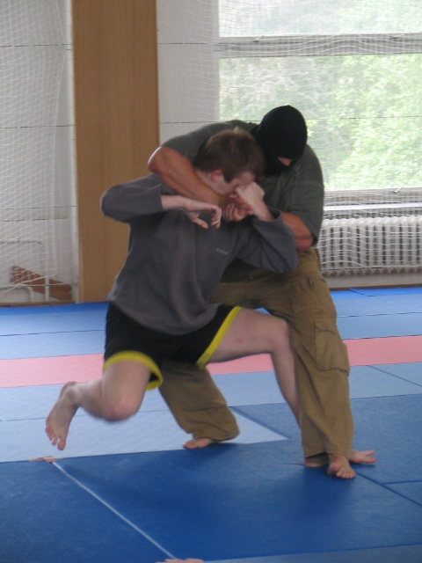

Martial arts

The expression “martial arts” or “eastern martial arts” usually means systems originating in Asia. The expression ”martial” is linked with fighting and war. The etymology of this word, which comes from Latin, speaks of its link to Mars (Ares in Greek), god of war. Art means competence, artfulness, mastery obtained in study and practice. Martial art is not only the physical part but also artfulness linked to one’s body. It also includes specific notions of martial skills, it deals with fighting in a wider sense, focusing on creating something new but not destroying the extant. The most highly developed as well as the most integral system of martial arts can be found in Japan. The Japanese expression budó is commonly translated as “martial arts”, or even better martial ways. Analysing the two ideograms which gave birth to that expression shows a wide, philosophic concept of the problem. Dó means way in the figurative sense; the trainee walks on the way, it is their path in life; bu is their life style or their part.
Our function definition lies in the four-dimensional characteristic of personality of a martial arts trainee, which involves biological, psychological, social and spiritual sphere. The basic functions of martial arts are bound to the individual components. Thus, they create bio-psycho-socio-noosphere stability. We differentiate the following functions:
- bodily (biosphere [B], complete development of the physical nature of a human being),
- psychical (psycho-sphere [P], psycho-hygiene, relaxation, self-fulfilment, etc.),
- social (socio-sphere [S], interaction, communication, social self-fulfilment),
- spiritual (noosphere [N], self-cognition, purity, transition beyond the perceptible world).

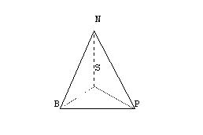
Fig. 6: Four-dimensional model of martial arts functions

Spiritual self-actualisation, the highest aim of the martial arts, is, in Zen Buddhism, called satori, i.e. knowledge (cognition). Satori makes no distinction between the known and the “knower”. There is no object and subject in satori. This fact reflects the philosophical problem of the possibility or impossibility of comprehending your mind using your own mind. They use an expression “kenshó”, which is something like the Ancient Greek instruction to “Know yourself”. Both the expressions do not formulate the proper nature of the problem as they are only words, which are limited when compared with the unlimited and eternal knowledge in satori or kenšó.
The listed facts from the theory of the martial arts seem to lead us astray from the martial-physical education theme. It only seems so due to a different point of view on practice and martial arts background in Asia. Furthermore, even Europe did not consider the martial techniques to be purely physical. Social attributes that were highly valued in Europe were almost always connected with the body, the physical nature of a human being, which differs from the Asian perspective.
The martial arts should ideally lead to non-violent ways of solving problems. This approach is promoted in Europe especially by innovative educational philosophies. Even the Waldorf school system criticises the opinion that martial activities can be bypassed, nevertheless, in this direction we should attempt to dispel the myths. Exercise, especially for children and the young, needs to teach them not only the technique, but also needs to use the technique to teach them the proper relation to their social surroundings.

Martial Arts and combatives
“Martial arts” is a wider expression than “combatives”. The expression “Martial arts” comprises all the activities linked with fighting that are upgraded to art. For example, in Ancient Japan they copied the so-called “36” arts. They sometimes differentiate military arts from martial arts, i.e. military arts is related with war as such, which means the questions of strategy, logistics, use of weapons, etc. As you can see from the information above, martial arts are more linked with practical skills. Martial arts comprise not only systems in which the opponents are in contact (directly or using weapons) but also those where the partner is only imaginary or is not required. For example fencing or kendó work directly in contact. The contact with the partner using a weapon in a particular manner is the aim. Nonetheless, iaidó, which uses the same techniques and weaponry, is practised without a partner. Archery, quite naturally, does not use a partner and the aim is to strike the target. The Japanese kjúdó does not even have the aim of striking the target. And all these systems are in one group, group called martial arts. Some martial arts are combatives, some are verge on them (they work with an imagined contact) and some are far away from combatives.
Combatives are linked with combat but in a different sense than martial arts. Some combatives do not have such wide categories of aims as martial arts. These are, e.g. competitive combative sports, where the aim of the sportspeople is to reach the highest possible performance level in their particular specialisation, e.g. boxing, sambo, fencing (however historical fencing falls undoubtedly within the category of martial arts).
Part of martial arts can be included into combatives but not all of them. For example archery (kjúdó), throwing various weapons, swimming with weapons or armour etc. cannot be included into combatives while being wide spread martial techniques. However, there is an overlap between the two categories of combatives and martial arts, in which we can find martial arts with the character of combatives, e.g. aikidó, karatedó, džódó, tchai ťi, capoeira, etc.

Fig.7: Relationship and overlap betveen martial ars and combative sports

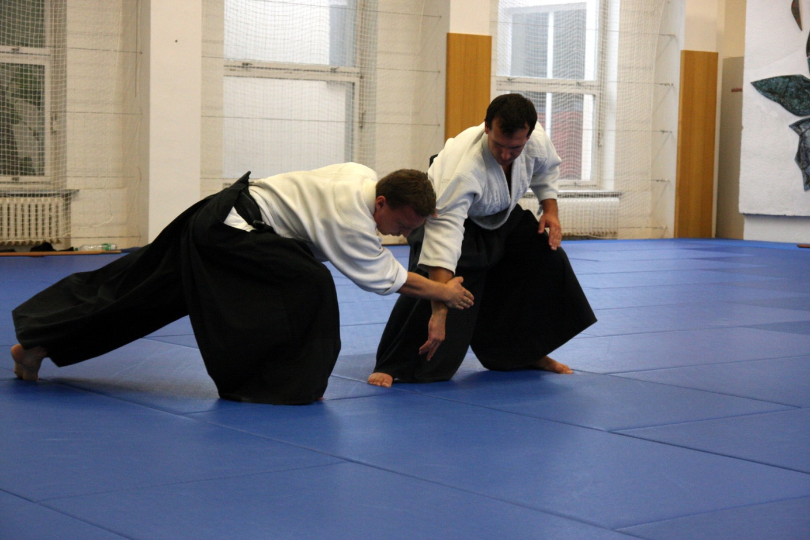

Combatives and movement games

Games undoubtedly are among the most important and basic of human activities. They play an important role not only in childhood, when children imitate various working activities, social roles, life situations, etc., but also in adulthood. They seem to give us a way of active relaxation with great compensatory and psychologically beneficial effects. Each human (as well as animal) activity demonstrates itself in its focus and achievement of purpose. It seems that the purpose does not always have to be conscious, keeping in mind the fact that a child plays for the sake of the game itself and not to learn, for example, to run, catch… and consciously develop their skills. This applies to almost all of us, regardless of age, to a greater or lesser degree.
To say which games are combative from the ranks of movement games is not easy and may not even be possible. Tag in the classical sense when one person runs after the others and by touching one they “transfer” the tag cannot, obviously, be called combative training. Nevertheless, a minor variation of this exercise, e.g. specifying a grip known from combatives then has, in its final phase, the character of a combative, and being thus linked, can be called a combative exercise. Similarly, touching another person in tag has no other role than communicating the signal while an exercise where one is supposed to touch another person using a specific technique from combatives (or to touch a specific part of a partner’s body) is a preparation for a combative.
Also many sports are closely linked to combatives. For example, football in its early forms, which are preserved in American football, Australian rules football and rugby, comprises a full range of combative activities. Some of works by M. Ďurech suggest using combatives to improve some games, e.g. in basketball and hockey. We have to add that many sport games do not have any link with combatives as any contact with another player is forbidden, in some they are even separated by a technical equipment (a net), e.g. in tennis.

There is an overlap between combatives, or rather exercises in basic, preparatory phases of combatives, and sport games. Some sports have, with the exception of their ultimate goal, almost all the feature of combatives, while other sport games more or less use combatives and eventually there are sport games, where the rules forbid any combative-like activities, or cannot allow them for technical reasons.
The primary distinction between combatives and sports, which make use of combative elements, is in their objectives. In combatives the objective is to overcome the opponent, physically and immediately, but in sports we generally employ some medium, whether a ball or puck or similar. For example, we spoke earlier of rugby.
Combative sports or self-defence cannot be called a game, as they are complex combative systems. The possible relationship between preparatory combatives and movements in a game we may discuss from slightly different points of view.

- All the preparatory combatives are movement games.
Considering definition of movement games and games as such we have to train a person to perform certain combinations of movements, in order to achieve specific goals. Such practice can be done in pairs, in groups, or in some cases even solo. Czech and Slovak textbooks categorise all the exercises in the preparatory phase in combatives under the general heading of combative games .

- Only some preparatory combatives are also movement games (or, we can say, can be so categorised).
  - Preparatory combatives, in which a group of several combatants or pairs participate in practising a combative movement, where a victory for one is a victory for all (meaning the group). The game here serves as a training system for combative techniques.
  - These are routines, the apparent aim of which is just to have fun (while only the leader needs to know the real aim). The game establishes the basic routines for acquiring the required skills.

- No preparatory combatives are movement games.
Combatives are decidedly not games. There is no element of fun involved. They evolved from combat itself and are a manifestation of the struggle, man against man, even if sometimes artificial “rules” are imposed on them, or they are practised in less than fatal circumstances. Some preparatory combatives are necessary prerequisites for combative sports. The training is not for pleasure but to enlarge the range of combat options available.
The most obvious distinction between training for combatives and for games lies in the target group. This lays the foundation for physical education and sports activities for children (pre-school and school) and young people of all ages. For those groups which do not plan to employ combatives even in a self-defence capacity, the purpose is purely recreational, even when there may be some useful movement training involved.
For those with an eye to serious practice, for sports or self-defence, of the preparatory combatives, these cannot be considered a game, even if, at the younger end of the age range, a “spoonful of sugar” helps the serious practice.
Combative games do not form part of the system of combatives per se. However, combatives can be practised in a manner very similar to a game. Thus we would define combative games as a recreational but integral part for basic training for combatives.
The figure below shows the relationship between combatives and movement games.

Fig. 8: Relationship and overlap of combatives and movement games

Here we would like to concentrate on military games, which, for general use, are often categorised with combatives. Military games are not part of combatives and do not share the same tools. Military games are only a imitation of combat, without the contact. They were and are used mainly in groups with strong links to the military, for example militias (like the Territorial Army), youth organisations like the Czech and Slovak Pioneers (in the era of Communism), scouts, etc. Nowadays, paintball, airsoft and other military games are highly popular among the young as well as adult.

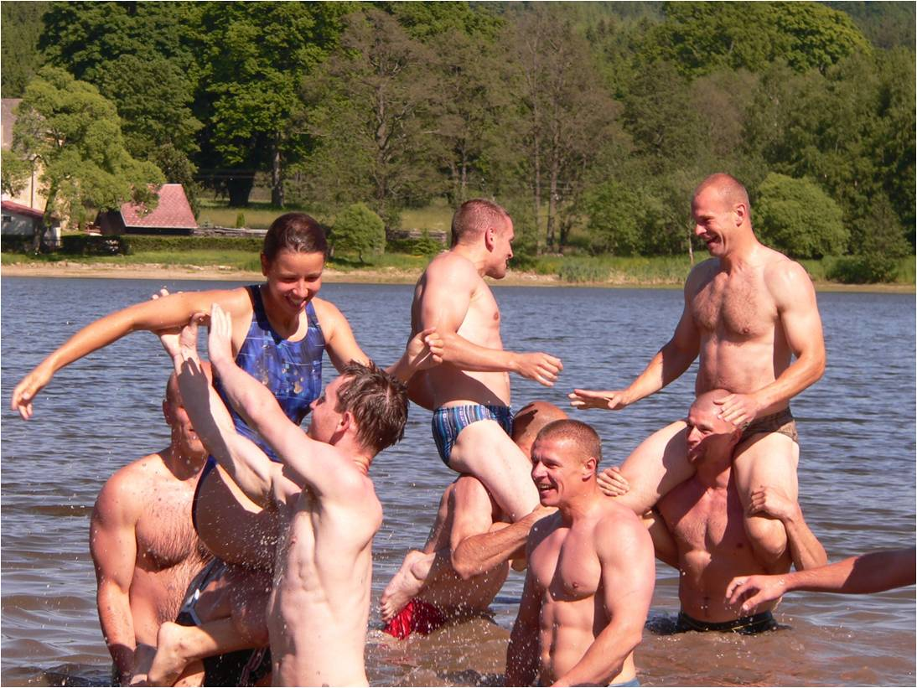

Combative aspects in gymnastics and gymnastics in combatives

There are places, in connection with combatives, where we meet expressions which are more often linked with gymnastics, due to the development of new disciplines such as tae bo or kick boxing aerobics. Elements of combatives can be found in many routines of modern sports, especially in fitness training or in aerobics. And, conversely, combative sports seem to have been influenced by gymnastics and dance, which gives us today such amalgams as the kata to music – complex gymnastic routines with technical exercises derived from martial arts. We can also find them in the performances of free style, combinations of acrobatics and staged performances combatives. Some combatives are closely allied to gymnastics, with a few even taking their basic form from combative sports. There is a very simple test to see if a certain exercise falls within the category of combatives or not, and that is its focus and aim. If the aim is contact leading to the defeat of an opponent or practising the routines to be used for defeating an opponent, we would speak of combatives. If, on the other hand, the primary goal is to expand or improve movement skills, dexterity, aesthetics of movement performance and the like, we would categorise it as gymnastics. You can see the relationship between combatives and gymnastics clearly in the following figure.

Fig. 9: Relationships and overlap between combatives and gymnastics

Where gymnastics and combatives meet there is a form of combative gymnastics. These are preparatory exercises (primarily acrobatic) for individuals, pairs or groups designed to improve certain movement skills, for example techniques for throwing, falling, etc. Where the two overlap there is a space for gymnastics with elements of combatives. These days this has become very popular and a definite growth area.

Notes on the didactics of combatives

Combatives, being a specific part of sport, are distinct from other sports in a number of particulars. These include certain methods of training and other factors, which we will now briefly address.
Simple combative exercises are grounded in human philogenesis. I have already mentioned that combatives have long and shared roots with the development of mankind. They seem to be an integral part of the deepest subconscious drives of humanity even though they are often suppressed during the educational process. You can see it most clearly in small children as combatives practices are a natural part of movement ontogenesis. The necessary precursor to walking safely is the art of falling safely. The children want to pull things they like towards them and push the things they do not like away. Any child will fight another child for their favourite toy, in the positive sense of the word. Social factors seem to play a very significant role in this. When practising combative routines it is important that the two opponents agree in advance on certain criteria. These include non-verbal forms of communication. There might be a problem as combatives lead to close contact between the two opponents, and for some people it might be problematic, as many of us allow only the closest of relatives to touch, for example, our stomach, chest or face or to hug us. Combatives often require this kind of contact. For these and other reasons, it is important to keep in mind the psychological aspect to combatives. When practising the routines, the participants, concentrating on the exercise and their performance, seem to lose part of their constructed self-image, which leads to the revelation of certain fundamental personal characteristics. Aggression needs to be focused and controlled, in order to be useful rather than destructive.
We must have a clear idea of our goal, and the most common of these are:
- To improve movement skills
- To expand movement capabilities
Basic combative technique comprises mainly closed cycles of movement skills. The structure of these is relatively stable. We are attempting to adopt the most precise of stances and positions and to move fluidly from one to another. We need the participants, as far as is suitable or necessary, given their age and other factors, to have some idea of why they are doing what they are doing, that is to say some appreciation of the technical, bio-mechanical, anatomical, physiological and strategic reasoning behind the design of the exercise.
Practising the basic combatives, their techniques or self-defence with a partner is a further and rather more complex step than mere practising of the basic combative technique per se. It is a duet, and the actions and movements of one´s partner must be taken into account. That is why we speak of the open movement skills. The movement structure of each technique is somewhat different in each specific case. As the exercises are performed with a partner, who employs complicated patterns of movement, it may not always prove possible to achieve the desired goal. The recognition of this fact leads us to the conclusion that adaptability is essential. Depending on the training level, we can categorise the exercises and performance of skills which are divided as follows:
- training (focusing on movement skills):
    - with a designated attacker and defender:
        - to practise specified techniques,
        - to practise improvised techniques (or sequences of techniques,)
    - without designated attacker or defender:
        - to practise specified techniques,
        - to practised improvised techniques (or sequences of techniques),
- performance (focused on fluent performance of movement skills):
    - sporting – following the appropriate rules of the competition or organisation
    - self-defensive – in a real threat situation, which requires appropriate levels of response, which we will discuss and practise

Combative sports most frequently practise combative skills in a context of their many forms and variations. Physical education in school also makes use of sport performance. As we mentioned above, games are the most frequent manner of acquiring the basic combative skills. A very accessible method of presenting these skills to all ages and abilities is wrapped up in a game. This also taps into the emotional dynamics, which expands the overall arena of training. The rules are laid down by the teacher or trainer, often in agreement with the group as a whole. The precise parameters can be varied. With these variations, the same basic exercise can serve both to repeat and enhance certain performance skills and, on the other hand, provide an exciting and engaging format for training. It is generally held that students should not repeat precisely the same exercise twice as each exercise should involve an element of surprise and therefore adaptation. All the exercises are divided based on the task, number of participants, focus body area, equipment, duration, and other factors.
Basic combatives are divided into the following categories based on tasks:
- when the task is designated (the role of attacker or defender is fixed throughout the exercise, and so the movements and manoeuvres practised are likewise set but different),
- without a designated task (both participants can fulfil either role, attacker or defender).

Depending on the number of participants (the tasks can but do not have to be designated), basic combatives are divided based on group size:
- pair
- group ( meaning any combination of three or more students):
  - free for all – each member of the group stands alone against the others,
  - group against group – the students fight together in groups against other similar groups, and within the group they must co-operate.

The basic combatives can be performed with the focus on specific parts of body:
- arms (and hands),
- legs (and feet),
- torso,
- head,
- combination of the above.

Basic combatives can likewise be divided into two groups based on the equipment used:
  - without equipment,
  - with equipment.

Time, place and technique are three factors which can also enhance the dynamic aspect of training:
1.
- with no set time limit (the exercise ends when a set goal is achieved),
- with a time limit (the exercise ends after a fixed period).
2.
- with no set space limit (the trainees can use all the available space),
- with a space limit (the trainees can use only a set limited area).
3. (mainly in centripetal and centrifugal exercises):
  - free use of technique (the trainee can utilise any known technique in pursuit of the specified goal),
  - with a specified technique.

Basic combatives can be used to develop particular movement abilities. This applies not only to combative sports, where the loading must be specific, but also in physical education in the school sense. Combatives used to be viewed mainly as a tool for developing strength capabilities. Today we recognise that there are a wide range of exercises which can improve a variety of movement abilities. We can divide training into categories based on movement abilities which they enhance:
- Overall fitness:
    - endurance
    - strength
- mixed
    - speed
- co-ordination
    - balance
    - rhythm

As these are natural exercises, they come naturally to the students. They express their emotions while exercising, i.e. both positive as well as negative. That is why combative exercises can seem quite noisy and chaotic. The teacher must be capable of analysing the situation and recognising when matters are getting out of hand. An essential of combatives training is the fact that it is voluntary. As today we are used to technology as the medium for communication, the older style, i.e. touch, is disappearing from our lives even in the earlier stages. That is why some trainees find it difficult to touch, even in a non-aggressive way, others while training. Under these circumstances, of course, we cannot put pressure on them to do so.
Not all forms of training are suitable for all age groups. Beyond the basic known principles of child physiology and ontogenesis of movement, children should not be involved in attacking and defensive exercises if the particular child is not clearly capable of distinguishing cause and effect. For example, patty cake is a game played among children and even with infants by parents. A similar exercise, trying to make contact with a partner’s cheek, is, however, suitable only for older children and adults as an excessive blow can hurt or even injure (and this is something children often fail to consider).

Conclusion
Combatives consists of all exercises stimulating development of individual motor skills and supporting development of physiological functions. These are the fitness exercises (for power, endurance and speed development) and coordinating (reaction, orientation, static and dynamic balance). Combative exercises are characteristic for emotional background in an effort to overcome the partner; the psyche is employed with motivation and the trainer performs more power then in fitness exercises repeated many times. This can be successfully employed in preparation of sportsmen, mainly children, who need some funny motivation during any action.

Czech-English dictionary

Bojová umění | Martial arts
Dotyk | Touch
Komplexně rozvíjející úpolové sporty | Complex developing combative sports
Navázání kontaktu | Contact establishment
Obejmutí | Embrace
Odpory | Opposition
Osobní sebeobrana | Personal self-defence
Pády | Falls
Pohyby nohou | Leg movements
Pohyby paží | Arm movements
Poloha | Posture
Postoj | Stance
Přemístění | Moves
Přemístění  Přemístění | Translocation  Transition
Přetahy | Pulls
Přetlaky | Pushes
Profesní sebeobrana | Professional self-defence
Průpravné úpoly | Preparatory combatives
Sebeobrana | Self-defence
Sebeobrana pro ženy | Self-defence for women
Sebeobranné úpolové sporty | Self-defence combative sports
Soutěžní úpolové sporty | Competitive combative sports
Střeh | Guard
Úchop | Grip
Úpolová gymnastika | Combative gymnastics
Úpolové činnosti | Combative activities
Úpolové dovednosti | Combative skills
Úpolové hry | Combative games
Úpolové sporty | Combative sports
Úpoly | Combatives
Základní úpolová technika | Basic combative techniques
Základní úpoly | Basic combatives
Zvedání břemena | Lifting of load

English-Czech dictionary

Arm movements | Pohyby paží
Basic combative techniques | Základní úpolová technika
Basic combatives | Základní úpoly
Combative activities | Úpolové činnosti
Combative games | Úpolové hry
Combative gymnastics | Úpolová gymnastika
Combative skills | Úpolové dovednosti
Combative sports | Úpolové sporty
Combatives | Úpoly
Competitive combative sports | Soutěžní úpolové sporty
Complex developing combative sports | Komplexně rozvíjející úpolové sporty
Contact establishment | Navázání kontaktu
Embrace | Obejmutí
Falls | Pády
Grip | Úchop
Guard | Střeh
Leg movements | Pohyby nohou
Lifting of load | Zvedání břemena
Martial arts | Bojová umění
Moves | Přemístění
Opposition | Odpory
Personal self-defence | Osobní sebeobrana
Posture | Poloha
Preparatory combatives | Průpravné úpoly
Professional self-defence | Profesní sebeobrana
Pulls | Přetahy
Pushes | Přetlaky
Self-defence | Sebeobrana
Self-defence combative sports | Sebeobranné úpolové sporty
Self-defence for women | Sebeobrana pro ženy
Stance | Postoj
Touch | Dotyk
Translocation | Přemístění

References
Bartík, P. (1999). Úpolové cvičenia a hry na 1. stupni základnej školy. Banská Bystrica, SR: Univerzita Mateja Bela.
Crudelli, C. (2011). Cesta bojovníka: Bojová umění a bojové techniky z celého světa (1.vyd.). Praha, ČR: Mladá fronta.
Ďurech, M. et al. (2000). Úpoly (2. doplnené vydanie). Bratislava, SR: Univerzita Komenského.
Desh Obi, T. J. (2008) Fighting for Honor : The History of African Martial Art Traditions in the Atlantic World. Columbia, South Carolina : University of South Carolina Press.
Ďurech, M. (2001). Využitie úpolových cvičení v basketbale: Metodická príručka pre školy, športové triedy, školské športové strediská a basketbalové kluby. Bratislava, SR: PEEM.
Ďurech, M. (2003). Spoločné základy úpolov (2. doplnené vydanie). Bratislava, SR: FTVŠ UK.
Fojtík, I. (1990). Úpoly pro 5. až 8. ročník základní školy. Praha, ČR: SPN.
Poliakoff, M. B. (1987). Combat Sports in the Ancient World. Yale, Connecticut : Yale University Press.
Reguli, Z. (2005). Úpolové sporty (distanční studijní text). Brno, ČR: Masarykova univerzita.
Roubíček, V. (1984). Kde s koho: Úpolová cvičení a hry. Praha, ČR: Olympia.
Young, D. C. (2004). A Brief History of the Olympic Games. Malden : Blackwell.

Test your knowledge
1.)
Kung fu is a martial art that has been developed in many centuries, from witch country does it origin?
- China
- Japan
- Korea

2.)
What is the name of the kung fu style founded by Bruce Lee?
- Wing Chun
- Shaolin
- Jeet Kune Do

3.)
Witch of the following kung fu styles is believed to be the only form invented by a woman?
- Shaolin
- Hi Tabi Tch
- Wing Chun

4.)
What is the name of the temple that is considered to be the birthplace of most Kung Fu styles?
- Shinang
- Wu Dang
- Shaolin

5.)
Karate is a martial art that origins from?
- Japan
- China
- Korea

6.)
What does the word karate mean?
- Empty hand
- Fist of fury
- Closed hand

7.)
There is an ancient book that contains information about the vital points of the body, fighting techniques, martial arts history, ancient medicines and ancient training philosophy. This book is considered the bible of karate, what is the name of it?
- Bubishi
- The art of war
- The process

8.)
What is name of the place you usually train karate (and other martial arts) in?
- Mojo
- Dojo
- Ohno

9.)
What is the name of the uniform you wear when you train karate (or other martial arts)?
- Fight Suit
- Bi
- Gi

10.)
Jujitsu is known as a martial art that is more than 2500 years old, from witch country?
- Brazil
- Japan
- Thailand

11.)
The Gracie family founded their own Jujitsu that became very popular. From witch country does it origin?
- USA
- Japan
- Brazil

12.)
The Gracie family also founded a fighting organisation where different type of martial artists could fight. This organisation became known all over the world, what is the name of it?
- UFC
- Pride
- MMA

13.)
From Jujitsu another martial art was developed, witch one?
- Karate
- Judo
- Kempo

14.)
In the Tokyo Olympics 1964, Witch of these martial arts became an Olympic event?
- Teakwondo
- Judo
- Jujitsu

15.)
Teakwondo is a martial art from?
- China
- Japan
- Korea

16.)
In witch year did teakwondo become an Olympic event?
- 2000 Olympics
- 1964 Olympics
- It is not an Olympic event.

17.)
Krav maga is a martial art developed in?
- Japan
- Usa
- Israel

18.)
The founder of krav maga Imrich Lichtenfeld was born in Budapest but where did he grew up?
- Bratislava
- Jerusalem
- Chicago

19.)
Krav Maga promotes finishing a fight as quickly as possible. Attacks are aimed at the most vulnerable parts of the body such as the eyes, neck/throat, face, solar plexus, groin, ribs, knee, foot, fingers, etc. What does the name Krav maga mean?
- Deadly punch
- hand-to-hand combat
- Dirty fighting

20.)
Krav maga is a self-defence martial art that involves techniques from?
- Karate, Muay thai and Jujitsu
- Kick-boxing, Boxing and Wrestling
- All of the above styles

21.)
In witch country does Capoeira origin?
- Portugal
- Brazil
- Angola

22.)
What is the the fundamental movement in capoeira(the swing) called?
- The ginga
- The macaco
- The macarena

23.)
What is the ancient Greek Martial art called?
- Pankration
- Wrestling
- Vale Tudo

24.)
What is the name of the wrestling form that forbids you to hold the opponent below the belt, to make trips, and to actively use the legs in the execution of any action?
- Italy-Greco
- Greco-Roman
- Freestyle wrestling

25.)
What is the name of the wrestling form that allows the use of the wrestler's or his opponent's legs in offence and defence?
- Greco-Roman
- Freestyle wrestling
- Itlay-Greco

26.)
One of the most well known wrestlers of all time is Alexander Karelin, where is he from?
- Ukraine
- Czech republic
- Russia

27.)
Witch of the techniques bellow is forbidden in grappling?
- Striking
- Throws
- Joint looks

28.)
What does MMA stand for?
- Max Martial Arts
- Mixed Martial Arts
- Most Martial Arts

29.)
In Brazil they have their own form of MMA, it´s called Vale tudo. What does it mean?
- Hard Punch
- Everything Kills
- Everything allowed

30.)
Witch is the biggest fighting organisation for MMA?
- UFC
- Pride
- Strikeforce

31.)
Mount is a position in MMA/grappling what does it mean?
- That you are sitting on your opponent in a dominate way
- That you both are standing
- That you are standing and your opponent is lying on the floor

32.)
Witch of the options bellow is not an submission technique?
- Armbar
- Rear naked poke
- Anaconda choke

33.)
Witch of the options bellow is not an submission technique?
- Omoplata
- Kneebar
- Freebar

34.)
What is a Tap-out?
- It´s a sign that says that you give up, for example when you are looked in a submission.
- It´s when you win a fight with one punch only
- It´s a submission

35.)
In MMA “ground and pound” is allowed, what´s the meaning of this?
- That you can choke your opponent
- That it is allowed to strike when you are on the floor grappling
- That you can poke your finger in your opponents eyes

36.)
What do you call a fighter that stands with his right arm and leg forward when fighting?
- Southpaw fighter
- Northpaw fighter
- Eastpaw fighter

37.)
What is the name of the fighting stance, where you have your right arm and leg behind your left arm and leg, thus having your weaker side closer to the opponent?
- Southpaw stance
- Orthodox stance
- Regular stance

38.)
How many minutes is a round in a boxing match?
- 5 minutes
- 2 minutes
- 3 minutes

39.)
Rope-a-dope is a boxing technique where you are passively leaning against the ropes and allowing your opponent to punch themselves out, so you can counter-attack. Rope-a-dope is associated with one fighter, witch one?
- Mike Tyson
- George Foreman
- Muhammad Ali (Cassius Clay)

40.)
Witch of these is not a boxing technique?
- Jab
- Clinching
- Kneeing
41.)
The cradle is a basic technique in?
- Karate
- Teakwondo
- Wrestling

42.)
In Judo chokeholds are knows as?
- Shime-waza
- Kanset-waza
- None of the abov

43.)
In Judo what does Nage Waza mean?
- Throwing techniques
- Hand techniques
- Standing techniques

44.)
How many basic categories of waza is there in Judo?
- 4
- 3
- 6

45.)
Witch one is not a grappling position?
- Side control
- Half guard
- Scramble

46.)
Combat sport is not
- Karate
- Rugby
- Wrestling

47.)
Martial art from Japan is not
- Karate
- Judo
- Tai chi

48.)
Falling technique is included in
- Preparatory combatives
- Combative systems
- Selfdefence

49.)
Selfdefence for women
- Is a special part of professional selfdefence
- Is a special part of personal selfdefence
- Is a special part of selfdefence

50.)
Fullcontact karate style is known as
- Kyokushinkai
- Shotokan
- Goju ryu

