Adam Rybakiewicz

2D and 3D Motion Analysis

Measurement of the first concerns of a basketball player jump. As a known distance I gave a basketball rim height above the ground.

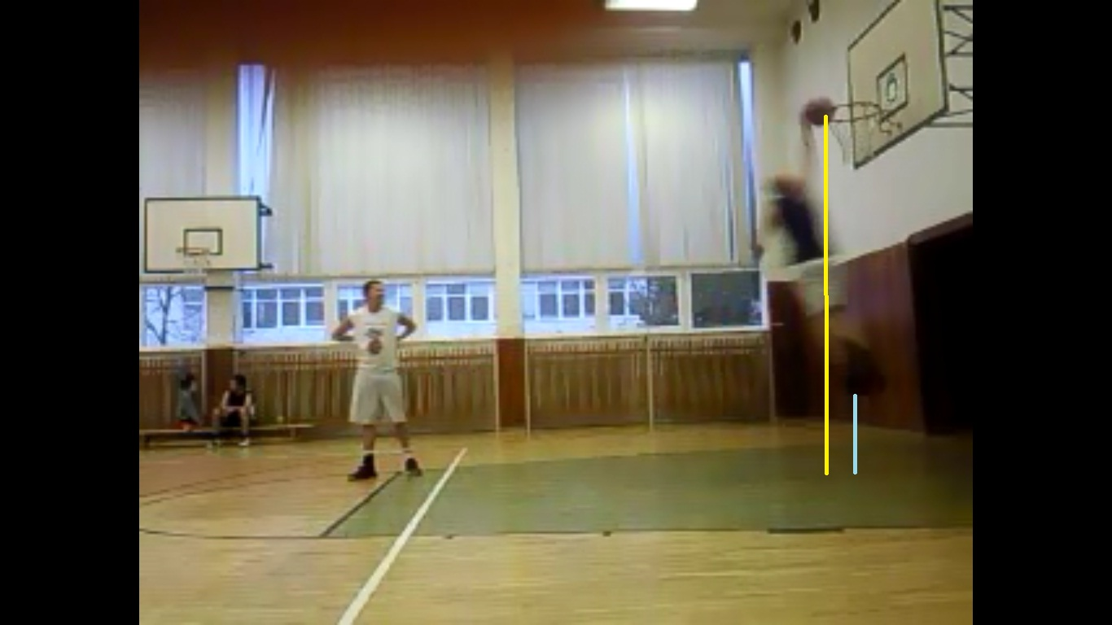

 | distance x | y
Point1 | 1050 | 486
Point2 | 1050 | 581
 | d= | 95,0 | pixel | 66,15 | cm
 |  | 1 pixel | 0,696345 | cm
 | calibration
 | x | y
Point1 | 1014 | 143
Point2 | 1015 | 581
 | d= | 438,0 | pixlu | 305 | cm

Another measure concerns the player's speed for a distance of 358cm. As a known distance was given a basketball rim height above the ground.

 | distance x | y
Point1 | 724 | 200
Point2 | 885 | 200
 | d= | 161,0 | pixel | 358,43 | cm
 |  | 1 pixel | 2,226277 | cm
 | calibration |  |  |  |  |  | time, speed
 | x | y |  |  |  |  |  | numer of frames
Point1 | 919 | 55 |  |  |  |  |  | 14 | .1/25 | 0,38 | s
Point2 | 919 | 192 |  |  |  |  |  |  | 0,04 |  | speed
 | d= | 137,0 | pixlu | 305 | cm |  |  | v=s/t |  |  | 9,43

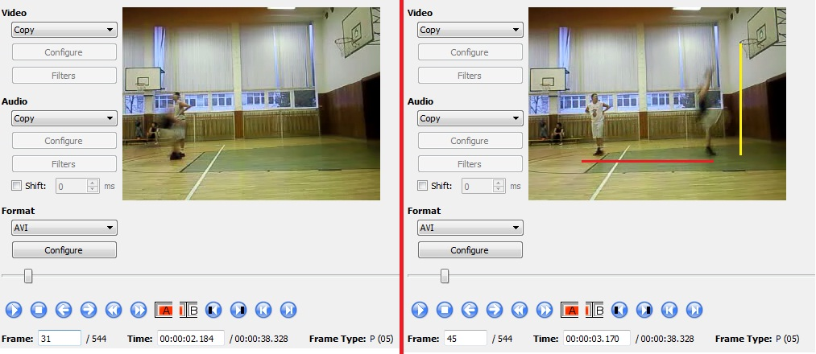

The third relates to the angle of measurement. Measured the angle of the legs in a standing position player.
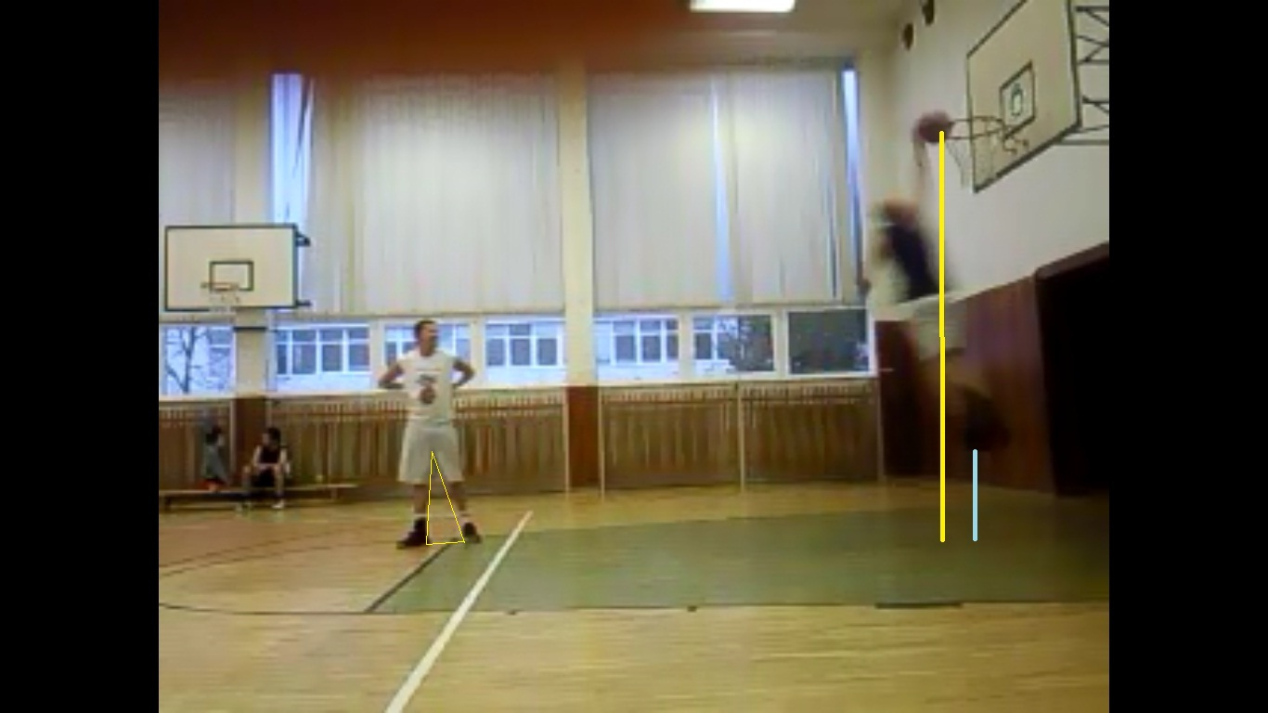

Point 1 |  |  | Point 3 |  |  | Point 1
x1 | 465 |  | x1 | 500 |  | x1 | 465
y1 | 487 |  | y1 | 583 |  | y1 | 487
Point 2 |  |  | Point 2 |  |  | Point 3
x2 | 458 |  | x2 | 458 |  | x2 | 500
y2 | 586 |  | y2 | 586 |  | y2 | 583
size | 99,2471662 |  | size | 42,1070065 |  | size | 102,18121
cos 2 = | 0,141 |  | cos 1 = | 0,913 |  | cos 3 = | 0,275
2 = | 81,87 |  | 1 = | 24,08 |  | 3 = | 74,05

