# Unit 3 - Physical Therapy Exercises

Exercising daily plays a main role in the process of healing and recovering from injury or disease. This is the goal of physical therapy exercises. Stretching and strengthening activities are only a few types of physical therapy exercises. Balance, joint control, and muscle re-training are other types of important physical therapy exercises.

**Task 1**

**Fill the gaps with the correct word chosen from below.**

*increase joints recovery health immune regular cardiovascular*

Physical exercise is the performance of some activity in order to develop or maintain physical fitness and overall _____________. Frequent and _______________exercise is an important component in the prevention of the diseases such as heart disease, cardiovascular disease, Type 2 diabetes and obesity.

Exercises are generally grouped into three types depending on the overall effect they have on the human body:

1. Flexibility exercises such as stretching improve the range of motion of muscles and

________________.

2. Aerobic exercises such as walking and running focus on increasing ________________ endurance.

3. Anaerobic exercises such as weightlifting or sprinting ______________muscle strength.

Physical exercise is important for physical fitness including healthy weight, building and maintaining healthy bones, muscles and joints; and strengthening the ____________ system.

Proper nutrition is at least as important to health as exercise. When exercising it becomes even more important to have good diet to ensure the body has the correct ratio of micro and macronutrients to help the body with the ________________ process after exercising.

Adapted from: http://www.sciencedaily.com/terms/physical_exercise.htm

**Task 2 Speaking**

## Fitness - Exercise Myths

Although some old fitness fictions, such as “no pain, no gain” are fading fast, plenty of popular exercise misconceptions still exist. Here are some of the most common myths as well as the not-so-common facts based on current exercise research. Discuss them. Do you consider them myths? Support your arguments.

1. **If You’re Not Going to Work Out Hard and Often, Exercise Is a Waste of** **Time.**
2. **Yoga Is a Completely Gentle and Safe Exercise.**
3. **If You Exercise Long and Hard Enough, You Will Always Get the Results You Want.**
4. **Exercise Is One Sure Way to Lose All the Weight You Desire**.
5. **Overweight People Are Unlikely to Benefit Much From Exercise**.
6. **Home Workouts Are Fine, But Going to a Gym Is the Best Way to Get Fit.**

Adapted from: <http://www.ideafit.com/fitness-library/10-exercise-myths>

**Task 3:**

**Here are some pictures of various physiotherapy exercises. First study the pictures properly, then choose 4 pictures and describe how to perform the exercises**:

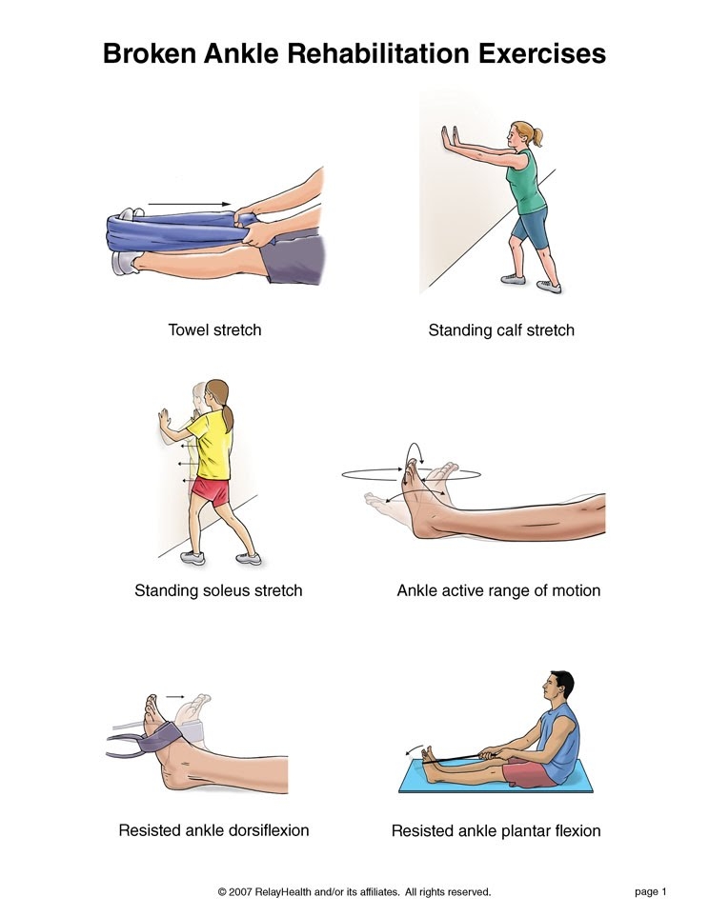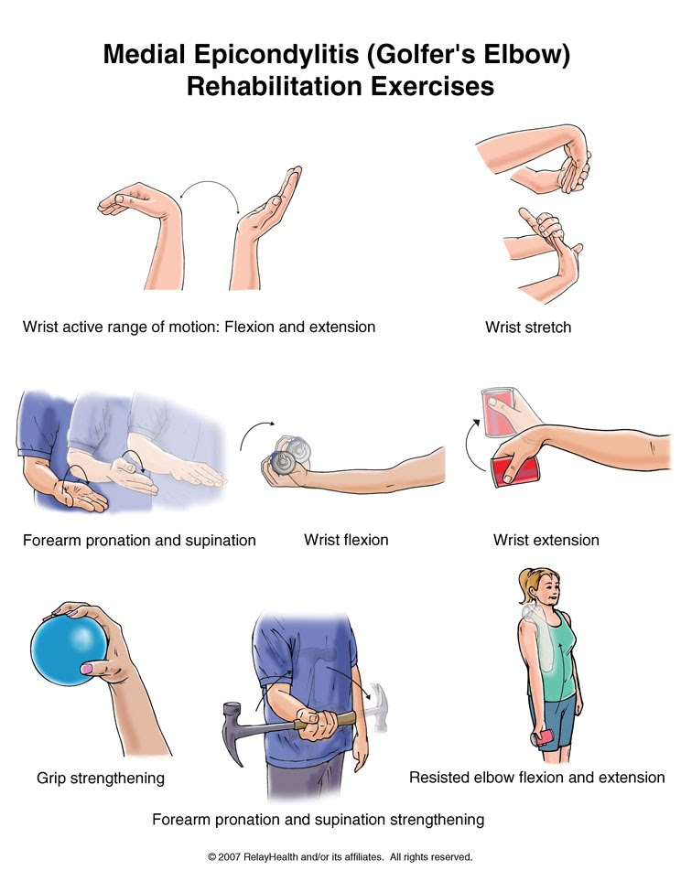

|  |
| --- |
|  |

|  |
| --- |
|  |
|  |

**Now choose some of your classmates to perform the exercises as you describe them**.

Source of pictures:

<http://www.summitmedicalgroup.com/media/db/relayhealth-images/xanklef1_3.jpg>

<http://www.summitmedicalgroup.com/media/db/relayhealth-images/xanklef2_3.jpg>

<https://sites.google.com/site/activecarephysiotherapyclinic/elbow-exercises>

[https://www.google.cz/search?q=patellofemoral+pain+syndrome+rehabilitation+exercises+pictures&espv=2&biw=1280&bih=923&tbm=isch&imgil=bcVQx4O6q4IUOM%253A%253B9Rzmez5yNM4Y2M%253Bhttp%25253A%25252F%25252Ftt.tennis-warehouse.com%25252Farchive%25252Findex.php%25252Ft-457677.html&source=iu&pf=m&fir=bcVQx4O6q4IUOM%253A%252C9Rzmez5yNM4Y2M%252C_&usg=__jzrSX2nx0xw468hAREVwQ5bFIBo%3D&ved=0CE0Qyjc&ei=P-BVVdroIYT-UqLSgKAJ#imgrc=bcVQx4O6q4IUOM%253A%3B9Rzmez5yNM4Y2M%3Bhttp%253A%252F%252Ftophealthfaq.com%252Fwp-content%252Fuploads%252F2013%252F02%252FPatellofemoral-Pain-Syndrome-Exercises.jpg%3Bhttp%253A%252F%252Ftt.tennis-warehouse.com%252Farchive%252Findex.php%252Ft-457677.html%3B744%3B963](https://www.google.cz/search?q=patellofemoral+pain+syndrome+rehabilitation+exercises+pictures&espv=2&biw=1280&bih=923&tbm=isch&imgil=bcVQx4O6q4IUOM%253A%253B9Rzmez5yNM4Y2M%253Bhttp%25253A%25252F%25252Ftt.tennis-warehouse.com%25252Farchive%25252Findex.php%25252Ft-457677.html&source=iu&pf=m&fir=bcVQx4O6q4IUOM%253A%252C9Rzmez5yNM4Y2M%252C_&usg=__jzrSX2nx0xw468hAREVwQ5bFIBo%3D&ved=0CE0Qyjc&ei=P-BVVdroIYT-UqLSgKAJ#imgrc=bcVQx4O6q4IUOM%253A%3B9Rzmez5yNM4Y2M%3Bhttp%253A%252F%252Ftophealthfaq.com%252Fwp-content%252Fuploads%252F2013%252F02%252FPatellofemoral-Pain-Syndrome-Exercises.jpg%3Bhttp%253A%252F%252Ftt.tennis-warehouse.com%252Farchive%252Findex.php%252Ft-457677.)

http://actilean.healthinformatics.net/docs/english/art_pages/xthighco.art.asp

**Task 6: Here is a list of exercises. Classify them into two groups:**

moderate (=using lower degree of energy) and vigorous (=full of energy)

* Swimming
* Hiking
* Digging holes
* Cross-country skiing
* Gardening
* Walking quickly on a level surface
* Mopping floor
* Cycling on a stationary bicycle
* Swimming laps
* Fast bicycling up hills
* Dancing
* Downhill skiing
* Volleyball
* Rowing
* Jogging
* Climbing stairs or hills
* Bicycling

Adapted from:

http://www.orthohyd.com/exercises-yoga

http://physicaltherapy.about.com

http://physicaltherapy.about.com/gi/o.htm?zi=1/XJ&zTi=1&sdn=physicaltherapy&cdn=health&tm=20&gps=255_334_1276_882&f=11&tt=14&bt=0&bts=0&zu=http%3A//weboflife.ksc.nasa.gov/exerciseandaging/chapter4_balance.html

**Task 7 Listening – Giving instructions**

**Pilates Exercises – One-leg stretch**

http://www.ehow.com/video_4940402_pilates-exercises-oneleg-stretch.html

Listen to a fitness trainer describing a Pilates exercise and write down as many verbs describing movement as possible.

**Follow-up: Complete the gaps with parts of the body.**

Rotate your____________clock-wise / anti-clock-wise

Shrug your_______________

Turn your______________from side to side

Stand with your ___________ apart/ shoulder width apart

Keep your ____________ straight

Bring/ stretch/ extend your ____________ to the side/ overhead/ straight forward

Swing ___ from side to side and around in a circle

Bend forward from your ______ and relax

Clasp your __________ behind your head

Cross ____________ over your chest

Lie on your ______, arms at the side, ___________ down/up, now bend your ___________

Hold your knee with both __________ and pull it towards your ___________

Squat on the floor with one ___________ bent up against the chest, the other leg stretched out behind

Lift up/ raise your ____________.

Adapted from: GOGELOVÁ, Helena. *Angličtina pro fyzioterapeuty*. 1. vyd. Praha: Grada, 2011. 314 s. ;. ISBN 9788024735313.

**Task 8**

1. Prepare a set of exercises that will ensure development of all large muscle groups in the body.
2. Consider a sport and develop exercises applying the overload principle that would develop all the large muscle groups used in the sport.