SEMINAR 4 SPORT AND THE DISABLED
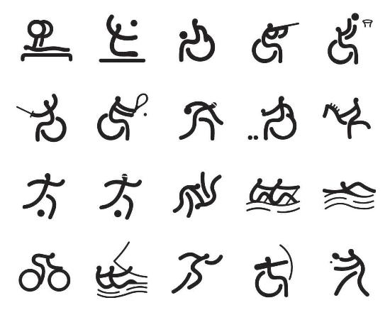
Before you read, discuss the following questions:
- Do you know any people with disabilities? Which problems may they encounter in the Czech Republic?
- Below are listed the top rated problems the disabled have to face according to a US survey. Discuss them – are they common in the CR?

1. Stereotyped Attitudes about PWDs
2. Discrimination
3. Being Patronized
4. Social Ostracization
5. Ignorance
6. Bigotry
7. Accessibility
8. Teasing and Bullying (Peer Abuse)
9. Unemployment (There is 60% to 70% unemployment in the PWD Community.)
10. Handicapped Parking Spaces being illegally taken by Non-PWDs (Outsiders).

READING
Education of Students with Physical Disabilities
I. In the field of special education, physical disabilities refer to a wide variety of conditions that may interfere with a child’s ability to perform everyday activities. Such conditions include problems with muscles, such as muscular dystrophy; problems involving the central nervous system, such as cerebral palsy; problems with the structure of the skeleton, such as spina bifida or missing limbs; and health problems, such as cystic fibrosis and heart disorders. For some children, physical disabilities are simply structural or health problems that do not require special educational facilities or services. For other children, however, the physical disabilities may interfere with their ability to walk, write, speak, or take care of their personal needs. Still others may be able to do all of these things but may not be able to accomplish one or more of them easily, or they may need more time or special assistance for certain school activities.

- Some special residential schools for students with physical disabilities were developed in Europe and the United States in the 19th century, but most of these schools had closed by the 1970s. At that time, many children with physical disabilities in the United States attended classes at special education centers in their community school system. These schools were specially designed to eliminate stairs, narrow doorways, and other barriers to students in wheelchairs, and to provide a concentration of specialists in one building. Today, however, a higher number of conventional school buildings are designed to be "barrier-free." Many students with physical disabilities attend their regular neighborhood schools where they receive the same social and academic benefits as students without disabilities. Specialists travel to those schools to provide whatever special services and equipment the students may need.

III. Most adaptive aids for students with physical disabilities are custom-designed to fit their physical size, abilities, and needs. The aids many children use are not very noticeable or unusual, such as pencils with specially designed handles for children with impaired motor skills. Other children, however, may need elaborate aids to perform any activity. These include aids to allow for greater mobility, such as electric or manually operated wheelchairs or crutches; seats specially designed to facilitate movement and posture; adaptive aids for turning pages, eating; and communication aids. Aids to assist in communication include materials and equipment ranging from simple books of pictures to sophisticated computer-based devices. The children use this equipment to interact with others in ways that take advantage of their individual abilities.

Task 1 Scan the text and think of a title for each paragraph.
Task 2 Guess the meanings of the words in bold from the context.

Task 3 Match the below words under the corresponding column.
muscular dystrophy learning disorders cerebral palsy obsessive-compulsive disorder autism spina bifida missing limbs cystic fibrosis anorexia nervosa heart disease
PHYSICAL DISORDERS | MENTAL DISORDERS

COLLOCATIONS
Task 4 Match the beginning of each sentence on the left with its ending on the right.

1.Health problems can seriously interfere a, successfully accomplished.
2.A rather difficult task has been b, of their individual abilities.
3.Schools facilities were designed to meet c, with a student´s work.
4.School programs for disabled students range d, for providing service and equipment.
5.Children use special aids to take full advantage e, special requirements of children
6.Specialists are responsible f, from a modified program in regular
classes to placement in a special school.
Academic Vocabulary

Task 5 Match the parts of collocations on the left (column A) with their endings on the right (column B):

A B
Go into several categories
Establish a connection
Carry out questions
Acknowledge the sources
Raise consideration
Divide into detail
Take into a study /research

Task 6 What is the noun which collocates with all the verbs below?
propose - put forward - formulate - develop - confirm - challenge - test - disprove

Task 7 Choose the correct collocation:

- She has made/done extensive research into renewable energy sources.
- He puts forward some hard/powerful arguments.
- The Prime Minister played a centralized/central role in the political crisis in 1811.
- The author goes into strong/great detail to support her argument.
- He draws/pulls attention to new research.
- The book raises/rises some key questions.

Task 8 Complete the sentences with the correct part of speech derived from the word in brackets.
  - There is clearly a _______________ between physical and mental health.(RELATE)
  - They discussed an interesting _____________ about the function of dreams. (HYPOTHESISE)
  - They presented some very __________ arguments. (CONVINCE)
  - It´s difficult to make a ___________ with her previous book – they are totally different. (COMPARE)
  - The students made a very positive ______________ to the success of the project. (CONTRIBUTE)
  - I find these statistics ____________ - what is their point? (MEANING)
  - Diet and exercise are ___________ important. (OBVIOUS)

PWD - Person With Disabilities
patronize - chovat se blahosklonně/povýšeně
ostracization - vyloučení ze společnosti
bigotry - úzkoprsost
accessibility - dostupnost
teasing - posmívání
bullying - šikana
peer abuse - šikana vrstevníky

