Unit 2 - Physical Therapy Exercises
Exercising daily plays a main role in the process of healing and recovering from injury or disease. This is the goal of physical therapy exercises. Stretching and strengthening activities are only a few types of physical therapy exercises. Balance, joint control, and muscle re-training are other types of important physical therapy exercises.

Task 1
Fill the gaps with the correct word chosen from below.
increase joints recovery health immune regular cardiovascular

Physical exercise is the performance of some activity in order to develop or maintain physical fitness and overall _____________. Frequent and _______________exercise is an important component in the prevention of the diseases such as heart disease, cardiovascular disease, Type 2 diabetes and obesity.

Exercises are generally grouped into three types depending on the overall effect they have on the human body:
1. Flexibility exercises such as stretching improve the range of motion of muscles and
________________.
2. Aerobic exercises such as walking and running focus on increasing ________________ endurance.
3. Anaerobic exercises such as weightlifting or sprinting ______________muscle strength.

Physical exercise is important for physical fitness including healthy weight, building and maintaining healthy bones, muscles and joints; and strengthening the ____________ system.
Proper nutrition is at least as important to health as exercise. When exercising it becomes even more important to have a good diet to ensure the body has the correct ratio of micro and macronutrients to help the body with the ________________ process after exercising.

Task 2 Speaking

Fitness - Exercise Myths
Although some old fitness fictions, such as “no pain, no gain” are fading fast, plenty of popular exercise misconceptions still exist. Here are some of the most common myths as well as the not-so-common facts based on current exercise research. Discuss them. Do you consider them myths? Support your arguments.

- If You’re Not Going to Work Out Hard and Often, Exercise Is a Waste of Time.

- Yoga Is a Completely Gentle and Safe Exercise.

- If You Exercise Long and Hard Enough, You Will Always Get the Results You Want.

- Exercise Is One Sure Way to Lose All the Weight You Desire.

- Overweight People Are Unlikely to Benefit Much From Exercise.

- Home Workouts Are Fine, But Going to a Gym Is the Best Way to Get Fit.
Task 3:
Here are some pictures of various physiotherapy exercises. First study the pictures properly, then choose some of them and describe how to perform the exercises:
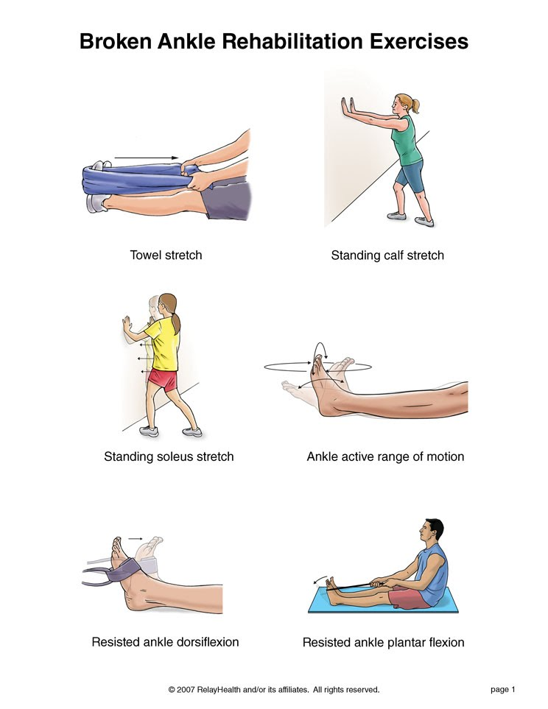

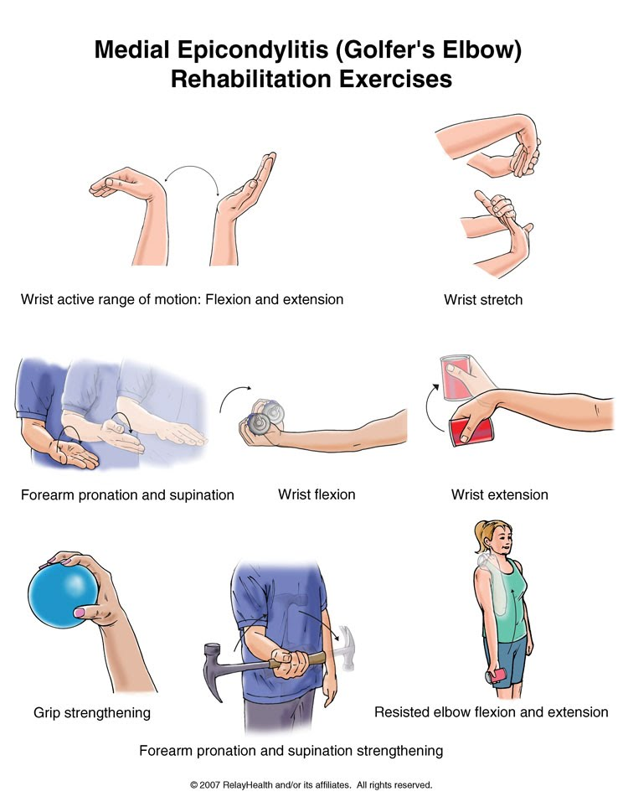

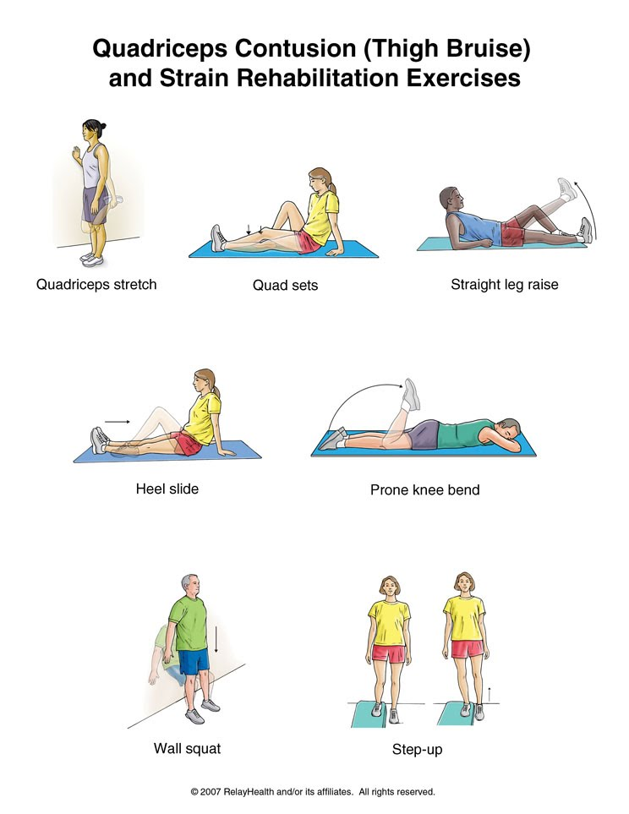

Now choose some of your classmates to perform the exercises as you describe them.

Adapted from:
http://www.orthohyd.com/exercises-yoga
http://physicaltherapy.about.com
http://physicaltherapy.about.com/gi/o.htm?zi=1/XJ&zTi=1&sdn=physicaltherapy&cdn=health&tm=20&gps=255_334_1276_882&f=11&tt=14&bt=0&bts=0&zu=http%3A//weboflife.ksc.nasa.gov/exerciseandaging/chapter4_balance.html

Task 4 Listening – Giving instructions
Pilates Exercises – One-leg stretch
(http://www.ehow.com/video_4940402_pilates-exercises-oneleg-stretch.html)

Listen to a fitness trainer describing a Pilates exercise and write down as many verbs describing movement as possible.

Follow-up: Complete the gaps with parts of the body.
Rotate your____________clock-wise / anti-clock-wise
Shrug your_______________
Turn your______________from side to side
Stand with your ___________ apart/ shoulder width apart
Keep your ____________ straight
Bring/ stretch/ extend your ____________ to the side/ overhead/ straight forward
Swing ___ from side to side and around in a circle
Bend forward from your ______ and relax
Clasp your __________ behind your head
Cross ____________ over your chest
Lie on your ______, arms at the side, ___________ down/up, now bend your ___________
Hold your knee with both __________ and pull it towards your ___________
Squat on the floor with one ___________ bent up against the chest, the other leg stretched out behind
Lift up/ raise your ____________.

Task 5
- Prepare a set of exercises that will ensure development of all large muscle groups in the body.
- Consider a sport and develop exercises applying the overload principle that would develop all the large muscle groups used in the sport.

Grammar
Infinitive, –ing forms

Task 1 Choose the correct answer:
- I hope going / to go to Brazil in July.
- I promise phoning / to phone you every day.
- Do you remember switching/to switch the lights off before you came out?
- We agreed working/to work together.
- The doctor says you must stop smoking/to smoke.
- I can´t keep driving/to drive – I´m too tired.
- The radio isn´t working. – Have you tried changing/to change the batteries?
- I advise buying/to buy your tickets well in advance.
- We can´t go on working/work like this.
- We cannot afford ignoring/ to ignore this warning.

Task 2 Speaking
Answer the following questions using the underlined words in your answer. You can change the tense of the verb if necessary.
Example: What do you like to do in your spare time?
Answer: I like to go to the movies in my spare time.

- Where do you expect to be ten years from now?
- Who did you pretend to be when you were a child?
- What did your parents advise you to do when you were a teenager?
- Is it easy to learn English? Why? Why not?
- Why are you studying English? (Use to in the answer.)

Task 3 Explain the difference between the sentences:
- She didn´t remember to write the report.
She didn´t remember writing the report.

- He hates jogging.
He hates to jog.

- Try to eat the blueberries.
Try eating blueberries.

- I regret to say that you are fired.
I regret saying it.

- This book helps me to understand English grammar.
This book helps me understand English grammar.

