**Unit 11 Living Longer, Living Better?**

**Task 1 Discuss with a partner:**

1. Do you know any centenarians? Describe their lifestyle.
2. Do you think you will live to be a centenarian?
3. Do you think that world life expectancy will continue to increase? Why or why not? What are the main factors affecting it?
4. According to researchers, people who live long lives stop eating when they are 80% full, often work hard and maintain a positive outlook on life. How do you think this helps them to live longer?
5. Rate the adjectives describing a personal quality on a scale from 10 (the most important) to 0 (the least important) for a long life:

*sociable independent religious healthy wealthy relaxed intelligent*

**Task 2 Read the following passage and fill in the blanks with suitable forms of verbs in brackets:**

Average life expectancy __________ (increase) rapidly in the past decades. In 1900, the average world life expectancy _______ (be) 30 years. Since then, life expectancy ___________ (increase) by about three years every 10 years, so that the world average is now 67 years. The maximum human life span – that is, the longest number of years a person _________ (live) – has also increased. In 1997, Jeanne Calment of France died at the age of 122. So far, she is the oldest known person ever to ________ (live).

During the twentieth century, increases in world life expectancy _________ (be) due to better sanitation, nutrition, medical practices, and healthcare. Today scientists _________ (try) to help people live longer by studying genes. As they learn how genes relate to health and aging, scientists may find ways to prevent cancer, heart disease, and other common diseases. They may even be able to slow the aging process. If genetic research ________ (be) successful, everyone may someday live to be 120 years old.

**Answer the following questions according to the information in the passage.**

1. What is the difference between life expectancy and life span?
2. According to the numbers given, what was the average life expectancy in 1950?
3. What are two ways that genetic research could help people be healthier and live longer?

**Task 3 Study the map and comment on the differences in average life expectancy across the globe (years)**

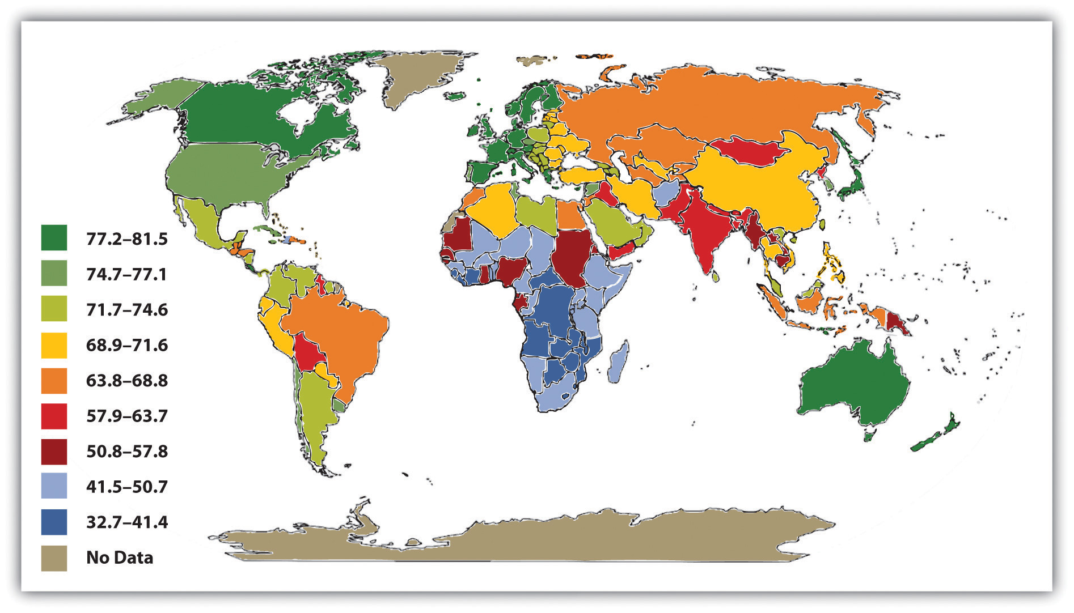

(http://catalog.flatworldknowledge.com/bookhub/2?e=barkbrief-ch09_s04)

**Task 4 Verbs + - ing or infinitive. Complete the sentences:**

To live a long life doctors recommend…

My doctor strongly advised me to stop…

In many countries of the world people can´t afford…

When I am old I hope…

Older people hate…

I told my grandmother to try…

My grandfather remembers…