Unit 2 **SPORTS PSYCHOLOGY**

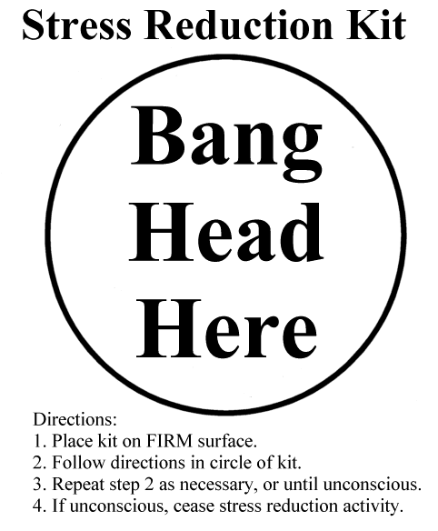

**Task 1 Stress Reduction Techniques**

*ERROR ALERT – ERROR ALERT - ERROR ALERT – ERROR ALERT - ERROR ALERT – ERROR*

**Correct the mistakes (in subject-verb agreement, word formation, word order, articles, etc.) in the text:**

*This paper show you effective methods of reduce stress to a level where you can perform most effective. The techniques that you select depend on cause of stress and situation in which occurs the stress.*

*In choosing methods to fight stress, it is worth ask yourself where comes the stress from: if outside factors such as relationship difficulties causing stress, then positive thinking or imagery-based technique may be effective. If the stress is based on feeling of adrenaline in the body, than it may be effective relax the body and slow the flow of adrenaline.*

**Task 2**

**Study the techniques for stress reduction. Which of them are physical, which are mental? How are they used? Match them with their descriptions below.**

### Imagery in Relaxation

### Progressive Muscular Relaxation

### Breathing Control

### Biofeedback

Thought Awareness, Rational Thinking and Positive Thinking

1. The idea behind this is that you tense up a group of muscles so that they are as tight and contracted as possible, and hold them in a state of extreme tension for a few seconds. Then relax the muscles to their previous state. Finally you consciously relax them again as much as you can.
2. To use the technique, observe your “stream of consciousness” as you think about the upcoming event. Do not suppress any thoughts. Instead, just let them run their course while you make note of them. As you notice negative thoughts, write them down and then let them go. The next step in dealing with negative thinking is to challenge the negative thoughts that you wrote down. Look at every thought you wrote down and rationally challenge it.
3. One common use of this method is to imagine a scene, place or event that you remember as peaceful, restful, beautiful and happy. You can bring all your senses into the image, with sounds of running water and birds, the smell of cut grass, the taste of cool white wine, the warmth of sun, etc. Use the imagined place as a retreat from places of stress and pressure.
4. These systems use electronic sensors to measure stress, and then feed the results of this measurement back to the athlete. They allow you to experiment with stress management techniques, and actually see or hear them taking effect on your body. Also, they allow you to practice different ways of using the techniques and compare the results. These methods convert vague feelings into hard, observable information, and help an athlete to fine-tune the use of stress management techniques.
5. This is a very effective method of relaxation, which is a core component of everything from the 'take ten deep breaths' approach to calming someone down, right through to yoga relaxation and zen meditation.

**Task 3 Would you agree with the following statements? Discuss in groups or pairs.**

1. The effectiveness of the stress reduction technique depends on practice.

2. Physical techniques are most effective where psychological factors are driving stress.

3. Positive thinking is a solution to everything.

4. Only very smart people can take full advantage of the mental techniques.

(adapted from: http://www.mindtools.com/stresstq.html)

**Task 4 Video**

**Inside the mind of champion athletes**

(http://www.youtube.com/watch?v=yG7v4y_xwzQ)

1. **Watch the video and complete the gaps in summarising sentences with one word:**
   * 1. Usain Bolt and Michael Phelps have contrasting ______________ , but both of them seem to be very ________________ .
     2. Sports psychology may play a part in their ___________________.
     3. Brazil were the ______________ favourites.
     4. The match between Brazil and Mexico was incredibly ________________ to watch.
     5. Sports psychology could explain why underdogs can win despite all the ______________ .
     6. Sports psychology may also help when ___________ a devastating defeat.

(0:00 - 3:30)

1. **Watch and answer the questions below:** (4:45 – the end)

What is sports psychology? What does it deal with?

_________________________________________________________________

What factors are linked to success in sport?

_________________________________________________________________

What are some of the successful athletes´ strategies?

_________________________________________________________________

**Task 5 Reading**

**Flow**

1 Flow as defined by Mihaly Csikszentmihalyi (1990) is the psychological state that accompanies highly engaging activities. Csikszentmihalyi became intrigued by flow when studying highly creative painters. When these artists were working on a painting and their work was going well, they were oblivious to hunger, fatigue, and discomfort. Csikszentmihalyi was struck by the **intrinsic motivation** that was behind the product. Painters did not paint with the external product in mind and certainly not with the thought of any extrinsic reward when they were done.

2 During flow, time passes quickly for the engaged individual. Attention is focused on the activity itself. The sense of the self as a social actor is lost. The aftermath of the flow experience is invigorating. Flow is not to be confused with sensual pleasure. Indeed, flow in the moment is non-emotional and nonconscious.

3 Here is a description by professional basketball player Ben Gordon of the Chicago Bulls of how it feels to be “in the zone” while playing:

*“You lose track of the time, what quarter it is. You don´t hear the crowd. You don´t know how many points you have. You don´t think. You´re just playing. Everything is instinctive. When the feeling starts going away, it´s terrible. I talk to myself and say, ´C´mon, you gotta be more aggressive. That´s when you know it´s gone. It´s not instinctive anymore.” (Peterson, 2006, s. 66).*

4 From numerous studies, psychologists have learned that flow is most likely to occur when there is an optimal balance between skill and challenge. In other words, flow represents the coming together of a person and an environment. The good news is that one doesn´t need to be an expert in a domain to experience flow. All that matters is that the presented challenge meets one´s skills, and vice versa. Too much challenge disrupts the process, as does too little skill. The bad news is that the challenge of the flow activity necessarily changes as one´s skills improve. All of us know how initially engaging activities eventually lose their magic unless the bar is raised to meet our changes in expertise.

5 Flow can be experienced in all sorts of activities, at work or play, but usually among those activities perceived as voluntary. For example, homework for most schoolchildren strikes a balance between challenge and skill, but because homework is perceived as coerced, it rarely produces the flow state.

6 Thus, we a have a paradox unanswered to date by research: Why do people so infrequently engage in the activities that they know will produce flow? One possible answer is provided by another experience that all of us know – so-called junk flow – with video games, TV shows or idle gossip as prime examples.

(adapted from Peterson, C. (2006). A Primer in Positive Psychology. OUP.)

**After you read**

How would you characterise “flow”?

When can we experience it?

How can we create environments in which athletes will experience it?

**Find synonyms in the text:**

1. very interested in sth., wanting to know more (1)
2. not aware of (1)
3. the situation that exists as a result of sth. (2)
4. making sb. feel full of energy (2)
5. an area of knowledge (4)
6. forced (5)
7. useless, with no particular purpose (6)