Unit 2 Physical Therapy Exercises + Injuries
Exercising daily plays a main role in the process of healing and recovering from injury or disease. This is the goal of physical therapy exercises. Stretching and strengthening activities are only a few types of physical therapy exercises. Balance, joint control, and muscle re-training are other types of important physical therapy exercises.

Task 1 Vocabulary
Fill the gaps with the correct word chosen from below.
increase joints recovery health immune regular cardiovascular

Physical exercise is the performance of some activity in order to develop or maintain physical fitness and overall _____________. Frequent and _______________exercise is an important component in the prevention of the diseases such as heart disease, cardiovascular disease, Type 2 diabetes and obesity.

Exercises are generally grouped into three types depending on the overall effect they have on the human body:
1. Flexibility exercises such as stretching improve the range of motion of muscles and
________________.
2. Aerobic exercises such as walking and running focus on increasing ________________ endurance.
3. Anaerobic exercises such as weightlifting or sprinting ______________muscle strength.

Physical exercise is important for physical fitness including healthy weight, building and maintaining healthy bones, muscles and joints; and strengthening the ____________ system.
Proper nutrition is at least as important to health as exercise. When exercising it becomes even more important to have a good diet to ensure the body has the correct ratio of micro and macronutrients to help the body with the ________________ process after exercising.

(Adapted from: http://www.sciencedaily.com/terms/physical_exercise.htm)

Task 2 Speaking

Do you consider the following statements to be true or not? Debunk the myths and defend the statements you agree with.

- If you exercise long and hard enough, you will get the results you want.
- No pain, no gain.
- Exercise is one sure way to lose all the weight you desire.
- Home workouts are fine, but going to a gym is the best way to get fit.
- Overweight people are unlikely to benefit much from exercise.

Task 3 Listening – Giving instructions
Pilates Exercises – One-leg stretch
(https://www.youtube.com/watch?v=R31EkWAU9dM)
Listen to a fitness trainer describing a Pilates exercise and write down as many verbs describing movement as possible.

Follow-up: Complete the gaps with parts of the body.
Rotate your____________clock-wise / anti-clock-wise
Shrug your_______________
Turn your______________from side to side
Stand with your ___________ apart/ shoulder width apart
Keep your ____________ straight
Bring/ stretch/ extend your ____________ to the side/ overhead/ straight forward
Swing ___ from side to side and around in a circle
Bend forward from your ______ and relax
Clasp your __________ behind your head
Cross ____________ over your chest
Lie on your ______, arms at the side, ___________ down/up, now bend your ___________
Hold your knee with both __________ and pull it towards your ___________
Squat on the floor with one ___________ bent up against the chest, the other leg stretched out behind
Lift up/ raise your ____________.

Task 4
Here are some pictures of various physiotherapy exercises. First study the pictures properly, then choose two pictures and describe how to perform the exercises:

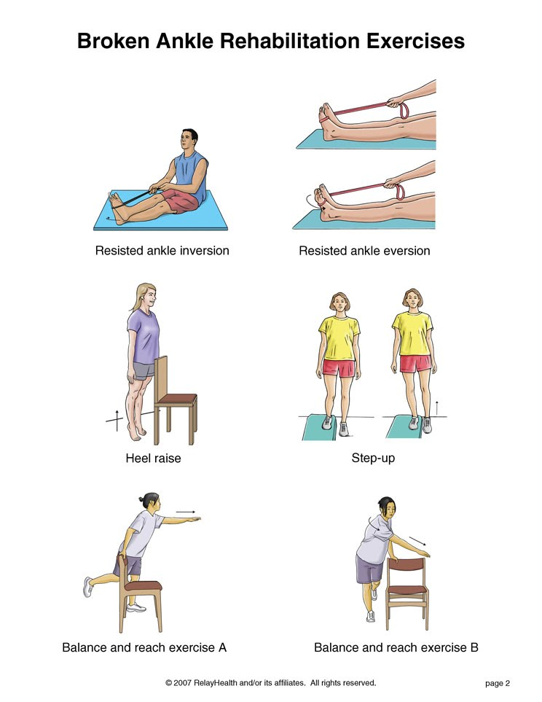

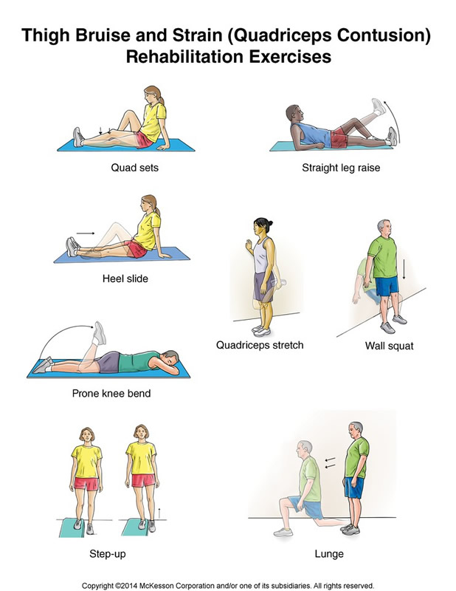

Source: http://www.orthohyd.com/exercises-yoga, http://physicaltherapy.about.com
Task 5
- Prepare a set of exercises that will ensure development of all large muscle groups in the body.
- Consider a sport and suggest exercises applying the overload principle that would develop all the large muscle groups used in the sport.

Task 6 Video: Watch and summarise the main points of the speech.
(http://www.ted.com/talks/cosmin_mihaiu_physical_therapy_is_boring_play_a_game_instead)

Task 7 INJURIES

- General vocabulary - Quiz

1. The floor is wet, you might___________
a) trip b) slip c) fall

2. She has a ___________ arm.
a) broke b) snapped c) broken

3. Your room is very messy, you might _____________ over all those cables.
a) kick b) fallen c) trip

4. I hit my arm hard against the table and now I´ve got a big ______________.
a) bruise b) break c) cut

5. He __________ the stairs, but he´s OK. Don´t worry.
a) fell off b) fell out c) fell down

6. While cycling he rode over a rock and __________ his bike.
a) fell off b) fell down c) fell out off

7. He wasn´t careful and _________ his hand on the stove.
a) cut b) bruised c) burned

- Sports injuries - Vocabulary

Check the pronunciation of these words:
inflammation - concussion – contusion – fracture – meniscus – cartilage – recovery – severe - chronic

- Study the list of injuries below. Do you know their Czech equivalents? Which of the injuries have you suffered? Which are most serious? Can you estimate the time needed for recovery after some of the injuries?

Achilles Tendinitis
The Achilles tendon attaches the muscles of the lower leg (gastrocnemius and soleus) to the heel. Achilles tendinitis is inflammation of this tendon generally caused by overuse or a direct blow.
Cruciate Ligament Injury
The anterior cruciate ligament (ACL) and the posterior cruciate ligament (PCL) attach the thighbone (femur) to the shinbones (fibula and tibia) acting to stabilize the knee joint. The ACL and PCL can be injured primarily by rotational forces on the knee. ACL and PCL sprains are categorized as first, second, and third-degree.
Concussion
A concussion is caused by a direct blow to the head. Depending upon the severity of the concussion, injury can cause varying levels of impairment of brain function. Concussions are categorized as mild (grade 1), moderate (grade 2), or severe (grade 3) depending upon symptoms.
Contusion
A contusion is basically a deep bruise that is caused by direct impact. In football we generally hear about quadriceps (thigh) contusions.
Dislocation
A dislocation occurs when the ball of a joint is forced out of its socket (i.e. arm forced out of the shoulder joint). A dislocation must be reset by proper medical professionals.
Fracture
A fracture is a break, crack, or shattering of a bone. In closed fractures, the broken bone does not pierce the skin, while in open fractures, the broken bone breaks the skin's surface.
Meniscus Injuries
The medial and lateral menisci are the cartilage shock absorbers located inside the knee joint. These can be damaged by excessive twisting, turning, or compression at the knee joint, which produces tears. Due to the poor blood supply, meniscal injuries generally require surgery for repair.
Sprain
This is an injury that involves the stretching, partial tearing, or complete rupture of a ligament. Sprains are categorized as first, second, or third degree. Sprains occur when a joint is forced beyond its normal range of motion, such as turning or rolling your ankle.
Stinger
A stinger, also called a burner or nerve pinch injury, is a very common injury in football. This injury involves a stretch or compression of the brachial plexus (a complex system of nerves that involve the back, neck, shoulders, and arms). Stingers generally cause shooting pain down the arm(s).
Strain
Strains are injuries that involve the stretching, partial tearing, or complete tearing of a tendon. Strains are categorized as first, second, or third degree. Chronic strains are injuries that gradually build up from overuse or repetitive stress.

(http://www.fftoolbox.com/football/football_injury_glossary.cfm)

- Complete the gaps with the expressions highlighted above, change the form if necessary:
The operation was only a ………………….. success.
Renal ……………….. needs to be treated urgently.
If your bone is broken, you need to see a professional to have it …………….. .
………………. exercise can lead to muscle strain.
The needle …………….. his skin.
Football is a low- ………….. sport – there is little stress on joints.

Injuries - Causes and symptoms

Which of the below are the causes and which are the symptoms of sports injuries? Can you think of some other causes and symptoms?
- athletic equipment that malfunctions or is used incorrectly
- weakness and pain
- falls
- limited range of motion
- swelling
- forceful high-speed collisions between players
- instability or obvious dislocation of a joint
- inability to move a limb
- wear and tear on areas of the body that are continually subjected to stress
- muscle spasm

- Listening
(http://www.youtube.com/watch?v=JwJHit6j5QU&feature=related)

How to prevent youth sports injuries
Discuss the questions below with your partner before you listen – how would you answer?
Then listen to an interview with a sports program director talking about prevention of injuries and note down his answers.
- What causes the increase in youth injuries?

- How many kids are hurt annually?

- What are the 6 tips given to parents to prevent an injury of a child?

…………………………………………….
…………………………………………….
…………………………………………….
…………………………………………….
…………………………………………….
…………………………………………….

4. What is the most dangerous sport for girls and why?

g) Treatment of injuries

Match the words below with pictures:

elastic bandage wrap – sling – knee sleeve – arm splint - sticking plaster - knee brace

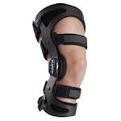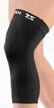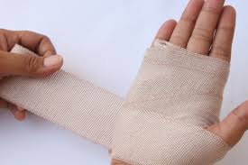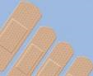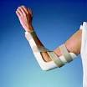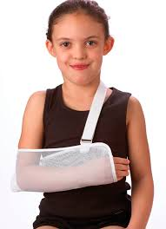

(Adapted from: http://medtalk.up.seesaa.net/image/Bones_.pdf)

