**JKII Session III Presenting visual information**

**Graphs and charts**

Charts and graphs measure various statistics and are helpful when presenting large amounts of information that need to be understood quickly. This includes: facts and figures, statistical information, profit and loss, polling information, etc.

**What are graphs used for in sports science? What information do we have to include when plotting a graph?**

# World population – describing trends

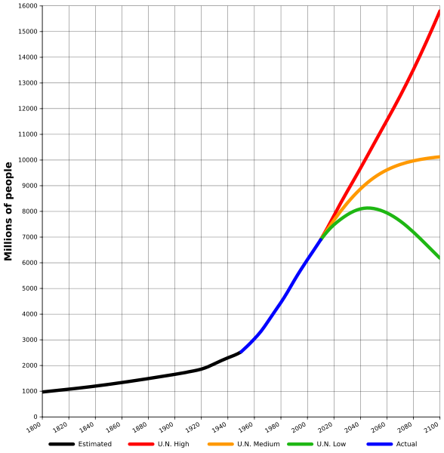

World population estimates from 1800 to 2100, based on "high", "medium" and "low" United Nations projections in 2010 (colored red, orange and green) and US Census Bureau historical estimates (in black). Actual recorded population figures are colored in blue.

* 1. **Complete the gaps with the words below:**

*seen range show remain experienced stood declined increase peaked*

The world population has (1) **___________** continuous growth since the end of the Great Famine and the Black Death in 1350, when it (2) **___________** at around 370 million. The highest rates of growth – global population increases above 1.8% per year – were (3) **___________**briefly during the 1950s, and for a longer period during the 1960s and 1970s. The growth rate (4) **____________** at 2.2% in 1963, then (5) **____________** to below 1.1% by 2012. Total annual births were highest in the late 1980s at about 138 million, and are now expected to (6) **_________** essentially constant at their 2011 level of 134 million, while deaths number 56 million per year, and are expected to (7) **___________** to 80 million per year by 2040.

Current UN projections (8) **____________** a continued increase in population in the near future (but a steady decline in the population growth rate), with the global population expected to reach between 8.3 and 10.9 billion by 2050. UN Population Division estimates for the year 2150 (9) __**_________** between 3.2 and 24.8 billion; mathematical modeling supports the lower estimate. Some analysts have questioned the sustainability of further world population growth, highlighting the growing pressures on the environment, global food supplies, and energy resources.

(<http://en.wikipedia.org/wiki/World_population>)

* 1. **Now fill in the missing prepositions:**

To peak _____ 17%

To increase ______ 2% / to increase ________ 2%

To decline _______ below 3 billion

To range _______ 4.5 and 5.3 billion / to range ____ A to Z

* 1. **Which of the verbs below can be used to refer to diagrams?**

illustrates shows believes suggests indicates represents states demonstrates argues reflects

1. **Types of graphs**

**Match the types of graphs on the left below with their respective charts. Then complete the sentences below.**

(<http://office.microsoft.com/en-us/excel-help/available-chart-types-HA010342187.aspx>)

1

A column chart

A line chart

A pie chart

A bar chart 2

An XY (scatter) chart

5

3

4

A stock chart

A doughnut chart

A bubble chart

8

7

6

1. **________________** are often a good choice to show **comparisons** among data.
2. **________________** are well suited to showing **change over time.**
3. ___________ are well suited for showing **parts of a whole**.
4. Like a pie chart, a __________ shows the relationship of parts to a whole, but it can contain **more than one data series**.
5. You could use a ___________chart to indicate the **fluctuation** of daily or annual temperatures.
6. **Complete the following tables supplying the appropriate vocabulary.**

|  |  |
| --- | --- |
| **VERB** | **NOUN** |
| to rise |  |
| to increase |  |
| to improve |  |
| to fall |  |
| to decrease |  |
| to recover  to decline  to grow |  |

|  |  |  |
| --- | --- | --- |
| **ADJECTIVE** | **ADVERB** | **HOW MUCH CHANGE?** |
| slight | slightly | very small |
| sharp |  |  |
| dramatic |  |  |
| steady |  |  |

1. **Examining graphic material**

Study the graphs below. What information does it show?

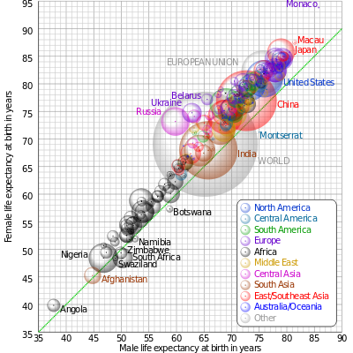

Comparison of male and female life expectancy at birth for countries and territories as defined in the 2011 CIA Factbook, with selected bubbles labelled. The dotted line corresponds to equal female and male life expectancy. The apparent 3D volumes of the bubbles are linearly proportional to their population. (wikipedia.org)

