**BODY COMPOSITION IN VOLLEYBALL PLAYERS.**



**PHYSIOLOGY OF SPORT EDUCATION**

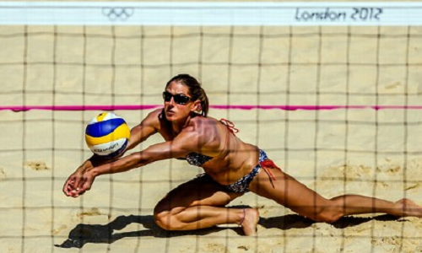

María Lozano Burón

464490

# INTRODUCTION: Body composition as a determinant of fitness and sport performance

The body composition is an important fundamental of individual’s motion, for sporting population, as much for general. To monitor values of basic somatic characteristics is the simplest way to assess health and nutrition state of an individual or a group of population.1

Current studies focus on changes in body composition associated with growth, maturation, ageing, changes associate with physical load and sport training, which means in early ages the body composition will not determinate the adult one, since this will be modify by the environment, nutrition, physical activity, etc.2, 3, 4. Anyway several studies support that children who are overweight at prepubescent age, usually have a high risk of being overweight or obese in their adulthood.1

Optimal and healthy body composition is determined by age, gender, somatotype, genetic factor, level of physical activity and other variables. It’s not only important the proportion of fat mass, but also the distribution of this in the body; for example, the intra-abdominal fat mass in adults, refers a major risk of having undesirable health problems, which can end in type 2 diabetes mellitus5.

In athletes, body composition is not only considered a health prerequisite, if not the key for developing a proper quality of human motion, getting the highest level of performance6. Monitoring body composition in athletes provides us with an athlete detailed physiological profile, which helps to estimate the optimal body weight7.

Athletes, generally, are slimmer than people with sedentary way of life, the same way than female athletes have more fat mass than male athletes, while proportion of inactive mass depends on the specific sport discipline. There is no an optimal body composition for each particular sport discipline, but the most of them control their caloric intake daily, getting a better control of their body weight. Sport performance is not only determined by percentage proportion of fat mass, but also by other components, such height, weight, circumferential measures, length of body segments, lean body mass, muscles mass, intracellular mass, and extracellular mass.6

Individuals with lower body weight tend to be more successful in middle-distance and long-distance runs; taller ones, with long segments, have an advantage in jumping and throwing; while the smaller ones are successful in diving8.

The degree of changes in body composition depends on the type of exercise as well as on frequency, intensity and duration of training, then, we can speak about the typical body composition in some specific disciplines.

# BODY COMPOSITION OF ELITE FEMALE VOLLEYBALL PLAYERS.

The issues connected with body composition and volleyball have been studied for several years9, 10, 11, 12, the most of them suggest that in volleyball, as in other sports, the most important factor in a success team, are technical and tactical skills, anthropometric characteristics and individual physical performances. The fat free mass (muscles and bones) is important for the quality of speed, strength and power, and to prevent injuries.13

To determine a general body composition is difficult because is not possible to compare results from various studies, because the use of different methods for body composition assessment: dual energy x-ray absorptiometry, air displacement plethys-mography, bioelectrical impedance analysis, skinfolds, hydro densitometry…

The results are different depending on the gender and ages, but using some studies results is possible to compare are perceive the differences.

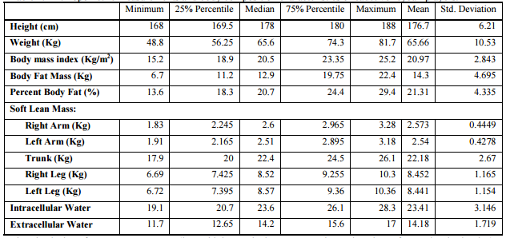

Table 1. Anthropometric measurements and body composition characteristics of a female cadet volleyball players, using the statistical program GraphPad Prism 6.14

For female senior players the results are:

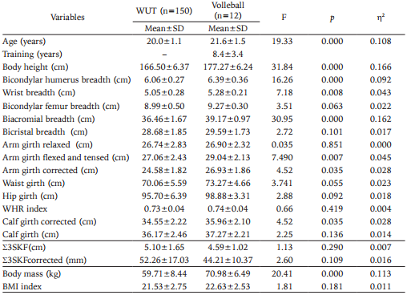

Table 2. Anthropometrical characteristics of volleyball players and students of Warsaw University of Technology.15

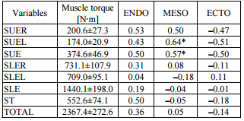

Table 3. Mean values (±SD) of the sums of the maximal muscle torque of the right (R) and left (L) upper extremity (SUE), lower extremity (SLE), trunk (ST) and all ten muscle groups (TOTAL), and Pearson’s linear correlation coefficients between muscle torque and endomorphy (ENDO), mesomorphy (MESO) and ectomorphy (ECTO).15

And for male volleyball players:

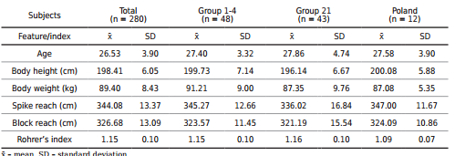

Table 4. Numeric characteristics of the examined features and Rohrer’s index of participants in the 2014 FIVB Volleyball Men’s World Championship16.

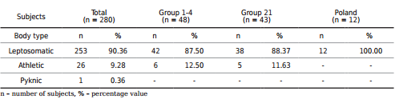

Table 5. Body types of the examined volleyball players participating in the 2014 FIVB Volleyball Men’s World Championship.16

For men I found the percent of players that have each kind of somatotype, instead of the median of all of them. But these results can help to make an idea about the best somatotype for a volleyball player.

# BIBLIOGRAPHY

1. Vignerová, J. & Bláha, P. (2001). Sledování růstu českých dětí a dospívajících (Norma, vyhublost a obezita). Praha, SZÚ, 173 p.
2. Baumgartner, R. N., Heymsfield, S. B., & Roche, A. F. (1995). Human body composition and the epidemiology of chronic disease. Obesity Research, 3, 73–95.
3. Heymsfield, S. B., Lohman, T. G., Wang, Z., & Going, S. B. (2005). Human body composition
4. Sporiš, G., Vuleta, D., Vuleta J. D., & Milanović, D. (2010). Fitness profiling in handball: physical and physiological characteristics of elite players. Collegium Antropologicum, 34(3), 1009–1014.
5. Maffeis, C., Pietrobelli, A., Grezzani, A., Provera, S., & Tató, L. (2001). Waist circumference and cardiovascular risk factors in prepubertal children. Obesity Research, 9, 179–187.
6. Malá, L., Zahálka, F., & Malý, T. (2014). Fitness Assessment : Body Composition. Prague: Charles University in Prague, Karolinum Press.
7. Malá, L., Bunc, V., Malý, T., & Zemanová, L. (2008b). Aktuálne telesné zloženie vrcholových seniorských judistov. Česká Kinantropologie,12(3), 85–93.
8. Dlouhá, R. (1999). Výživa a složení těla. In: Havlíčková, L. a kol. (1999). Fyziologie tělesné zátěže I. obecná část, Praha: Karolinum, 196 p.
9. Bandyopadhyay, A. (2007). Anthropometry and body composition in soccer and volleyball players in West Bengal, India. Journal of Physiological Anthropology and Applied Human Science, 26(4), 501–505.
10. Dostálová, I., Riegerová, J., & Přidalová, M. (2007). Body composition of young volleyball players. Acta Universitatis Palackianae Olomucensis. Gymnica,37(2) [abstract], p.42.
11. Malá, L., Malý, T., Zahálka, F., & Bunc, V. (2010c). The profile and comparison of body composition of elite female volleyball players. Kinesiology,42(1), 90–97.
12. Malousaris, G. G., Bergeles, N. K., Barzouka, K. G., Bayios, I. A., Nassis, G. P., & Koskolou, M. D. (2008). Somatotype, size and body composition of com-petitive female volleyball players. Journal of Science and Medicine in Sport. 11(3), 337–344.
13. Strava, C.C., Rusu, A.M., Avram, C. (2016). Anthropometric characteristics, body composition and physical performance of female cadet volleyball players.
14. Pastuszak, A., Busko, K., Kalka, E. (2016). Somatotype and body composition of volleyball players female students – reference group for comparison in sport.
15. Krzysztof, B., Lewandowska, J., Lipinska, M., Michalski, R., Pastuszak, A. Somatotype-variables related to muscle torque and power output in female volleyball players. *Acta of Bioengineering* [online]. (2013).
16. WNOROWSKI, Krzysztof a Karol CIEMIŃSKI. Volleyball players' somatic composition in the light of sports results at 2014 FIVB Volleyball Men's World Championship. *Baltic Journal of Health* [online]. 2016, **8**(4), 24-31 [cit. 2017-05-14]. ISSN 20801297.