**Unit 3 COACHING**

**Task 1 Speaking**

1. **What makes a great athlete? What makes a great coach?**
2. **Complete the gaps with the words below. There is one word you will not need.**

*cause / consider / determines / effort / emphasis / improved / revealed / set / understanding*

The journal **Sport England** (2007) ………….. (1) that there has been a rise in the number of children who are involved in sport. A number of scholars have suggested that participating in sport has numerous benefits for children such as development social skills, self-esteem, health benefits and ………. (2) motor abilities. It is therefore important to ………….. (3) motivation among children, because if more children are to participate in sport, it is essential that coaches have an …………….. (4) of motivation, so that they can maximise motivation among their athletes.

According to McArdle and Duda (2002) and Treasure (2001) the way in which the coach emphasises success versus failure …………….. (5) the motivational climate. There are two main types of motivational climate:

1. In this climate the coach focuses on encouraging the athletes to learn, make personal improvements and put in maximal…………. (6). The coach rewards athletes based on progress and improvement.
2. In this sport setting the coach emphasises and rewards winning. As such, coaches in this environment only praise the athletes that win in both training and competition. Within this environment there is also an ………….. (7) on players outperforming other players, so a coach would ……………. (8) tasks that encourage competition and allow players to be ranked.
3. **Now match each description of motivational climate (1,2) with one of the two types below. Which of the two do you prefer? What are their advantages?**

*Mastery motivational climate/ Performance motivational climate*

*(adapted from Nicholls, A.R., Jones, L. (2013) Psychology in Sports Coaching. Routledge. And Sheard, M.(2010) Mental Toughness. Routledge.)*

**Task 2 GRAMMAR - Conditionals**

1. **Define the rules for the three conditionals. When do we use them?**
2. If she wins the game, she will qualify for the World Cup.

……………………………………………………………………………

1. If she won the game, she would qualify for the World Cup.

…………………………………………………………………………….

1. If she had won the game, she would have qualified for the World Cup.

…………………………………………………………………………….

1. **What is the difference between these two sentences?**

Tom will throw a party **if** he passes the exam.

Tom will throw a party **when** he passes the exam.

**THIRD CONDITIONAL**

The Third Conditional is used to talk about imaginary situations in the past. You can describe what you would have done differently or how something could have happened differently if circumstances had been different.

Example:

* If the athlete **had had** a proper diet, he **would have performed** better. (But the diet was poor and the athlete did not perform well.)
* She **would have been** very frustrated if she **had failed** the test. (But she…?)

1. **Using the words in brackets, complete the text below with the appropriate conditional form:**

1. If I (train) ........................... with a different team, I (become) ........................... a champion. But, unfortunately, I didn´t.

2. He would have been here earlier if he (miss, not) ...........................the train.

3. She used old equipment and it malfunctioned. If she (use) ........................... new stuff, she (not lose) ………………….. the race.

1. **Complete the following conditional sentences:**
2. I´ll be very happy when…
3. I´ll be very happy if…
4. I´d be very happy if…
5. I would have been very happy if…
6. He´ll get over the injury if he…
7. If he hadn´t eaten so much…
8. You´ll improve your performance if you..
9. Training would be easy if…
10. They would have won a gold medal at the Olympics if they …

**Task 3 Describe the graph below.**

***Gym membership retention***

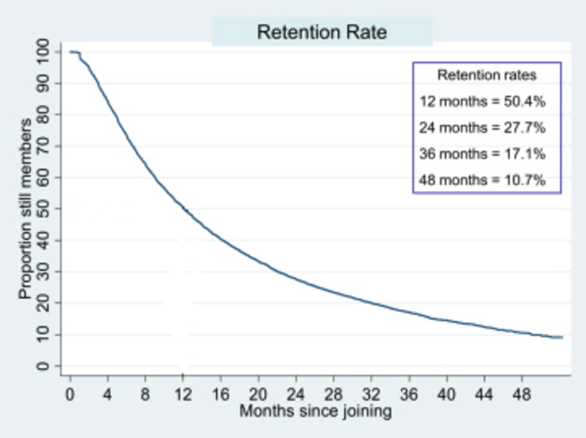

(<http://www.science20.com/the_conversation/why_we_give_up_on_new_years_resolutions_online_courses_and_diets-151892>)

**Task 4 Speaking**

Despite the medical and scientific evidence that physical activity promotes health, about 6 in 10 Americans are not regularly active, and another 1 in 4 are not active at all. So the questions are:

* Why is it so hard to adopt and maintain a physically active lifestyle?
* What are the barriers that keep so many people from being physically active?
* How can people change their behaviour to become more active?

**Task 5 Vocabulary**

Match the expression below with their definitions. Then use the expressions in sentences:

1. willpower
2. confidence
3. to adhere to (exercise programme)
4. resolution
5. to behave according to particular rules or instructions
6. the ability to control your thoughts and actions
7. a firm decision to do or not to do sth.
8. the feeling you can be sure about your abilities

**Task 6 Reading - Common barriers to physical activity**

**Classify the barriers described below as *personal, environmental, social or exertion barriers.***

1. Many people learn attitudes and habits from watching and listening to family and friends. Excessive distractions e.g. going to parties are unwanted.
2. Too much time spent watching TV or surfing the Internet creates huge barriers to starting an exercise programme that takes time and effort mainly because it may not feel as good as sedentary options to people. Physical activity after longer period of inactivity subjectively feels hard, people perceive pain, achy joints, sweating, etc.
3. Aging is associated with activity limitations due to deteriorating health. Also, older people may not know the benefits of being physically active. Furthermore, many older people may not view exercise as appropriate for their age.
4. People who dropped out of exercise programmes reported that they failed because the exercise schedule conflicted with other commitments such as work, or because of inaccessible facilities.
5. Many people lose motivation soon and give up exercising because their goals are too ambitious.

**Follow-up**

What tips or recommendations can you give to people to overcome the barriers described above?

**Task 7 Conjunctions**

**Choose the correct answer:**

1. *Although/ Despite / Due* to the vast majority of Americans believe that being active is healthy for them, most remain sedentary.
2. *Although / Despite / Due to* the medical and scientific evidence, many people do not maintain active lifestyle.
3. *Despite / In case / Unless* you stick with this programme, you will not lose the weight.
4. The injuries are largely *unless/ due to / although* ignorance.
5. Take a granola bar *in case / unless / despite* your blood sugar drops.

**Task 8 Phrasal verbs**

1. **Use the following phrasal verbs in sentences:**

*work out*

*get over sth.*

*make sth. up*

*get on with sb.*

*run out of*

*take off*

*deal with*

1. **Complete the sentences with suitable phrasal verbs. You may have to change the form of the verb.**

*burn off keep up cut down stick with*

*pay off give up put off drop out*

1. Rather than starting an exercise programme it is more difficult to ………………. it.
2. Her husband finally persuaded her to …………………. smoking.
3. Swimming can help you ……………. the unwanted calories.
4. She was injured after the first round and had to ………………. of the race.
5. I´m trying to ………………..on salt.
6. You should not ………………… going to the dentist.
7. The idea to exercise …………………. quickly – I look and feel much better after only a month!
8. Well done! ………………. the good work!

**Task 9 Listening**

(<http://www.bbc.co.uk/learningenglish/english/features/6-minute-english/ep-171123>)

**Listen to a BBC podcast on exercising. Answer the following questions:**

1. Why does Catherine prefer group exercise?
2. How many people in the UK are members of the gym?
3. Why has group exercise become more popular, according to Philip Mills?
4. What will exercise look like in the future?

**Note down new vocabulary from the programme.**