**INTERACTIVE TEACHING**

Name and surname: ______________________________________

ID number: __________________

Game: ________________ - ________________ Result: ___ - ___ (___ - ___)

**Task 1**

Draw on the field the positions of lost balls in the 1st and 2nd half of the home or away team, depending on which group you belong to.

**1st half 2nd half**

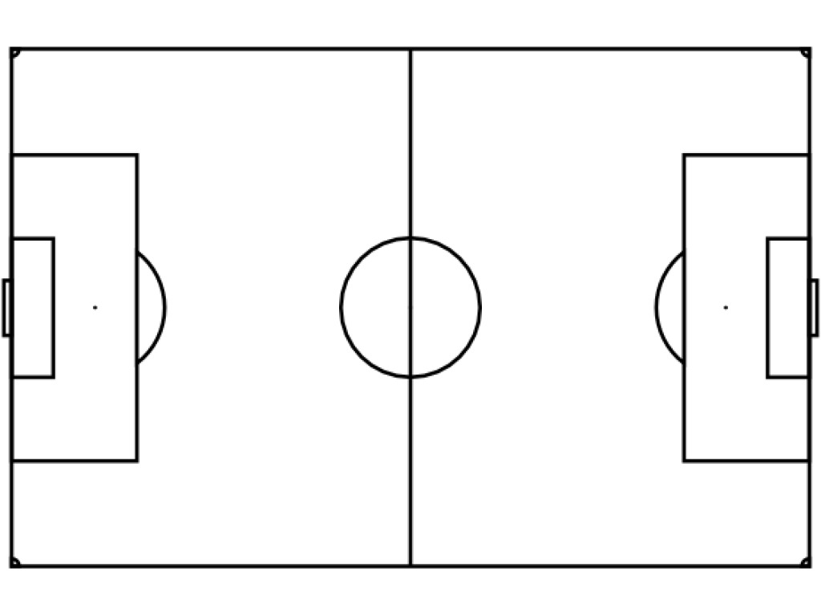Symbols:

**X** – lost ball

**X9** – lost ball by player No9

**Task 2**

Plot all passes (correct and incorrect) by one player (except the goalkeeper) in the team you are analyzing using the arrows.



Symbols:

– correct pass

– incorrect pass

**Task 3**

Perform statistical processing of Task 2 and graphically display the results in absolute and relative (percentage) values by zones of the field (defensive - red; central - green; offensive - yellow).

|  |  |  |  |  |  |  |  |  |
| --- | --- | --- | --- | --- | --- | --- | --- | --- |
|  | Defending | | Midfield | | Attacking | | Total | |
| Correct pass |  | % |  | % |  | % |  | % |
| Incorrect pass |  | % |  | % |  | % |  | % |

**Task 4**

Schematically show all the goals in the game from the moment of winning the ball to the moment of scoring the goal. Draw all the passes and indicate which player took part in the action.

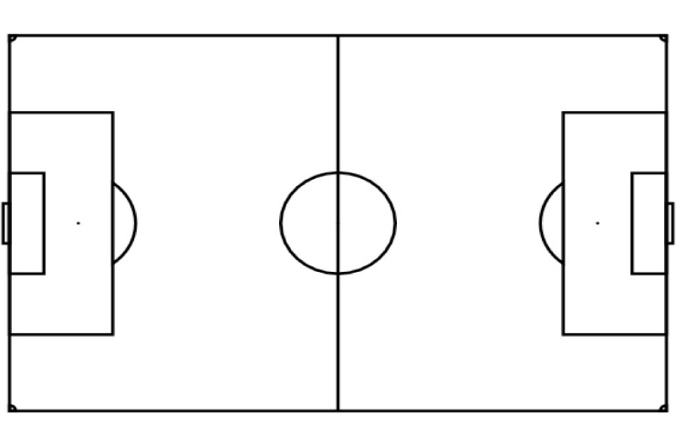

**Task 5**

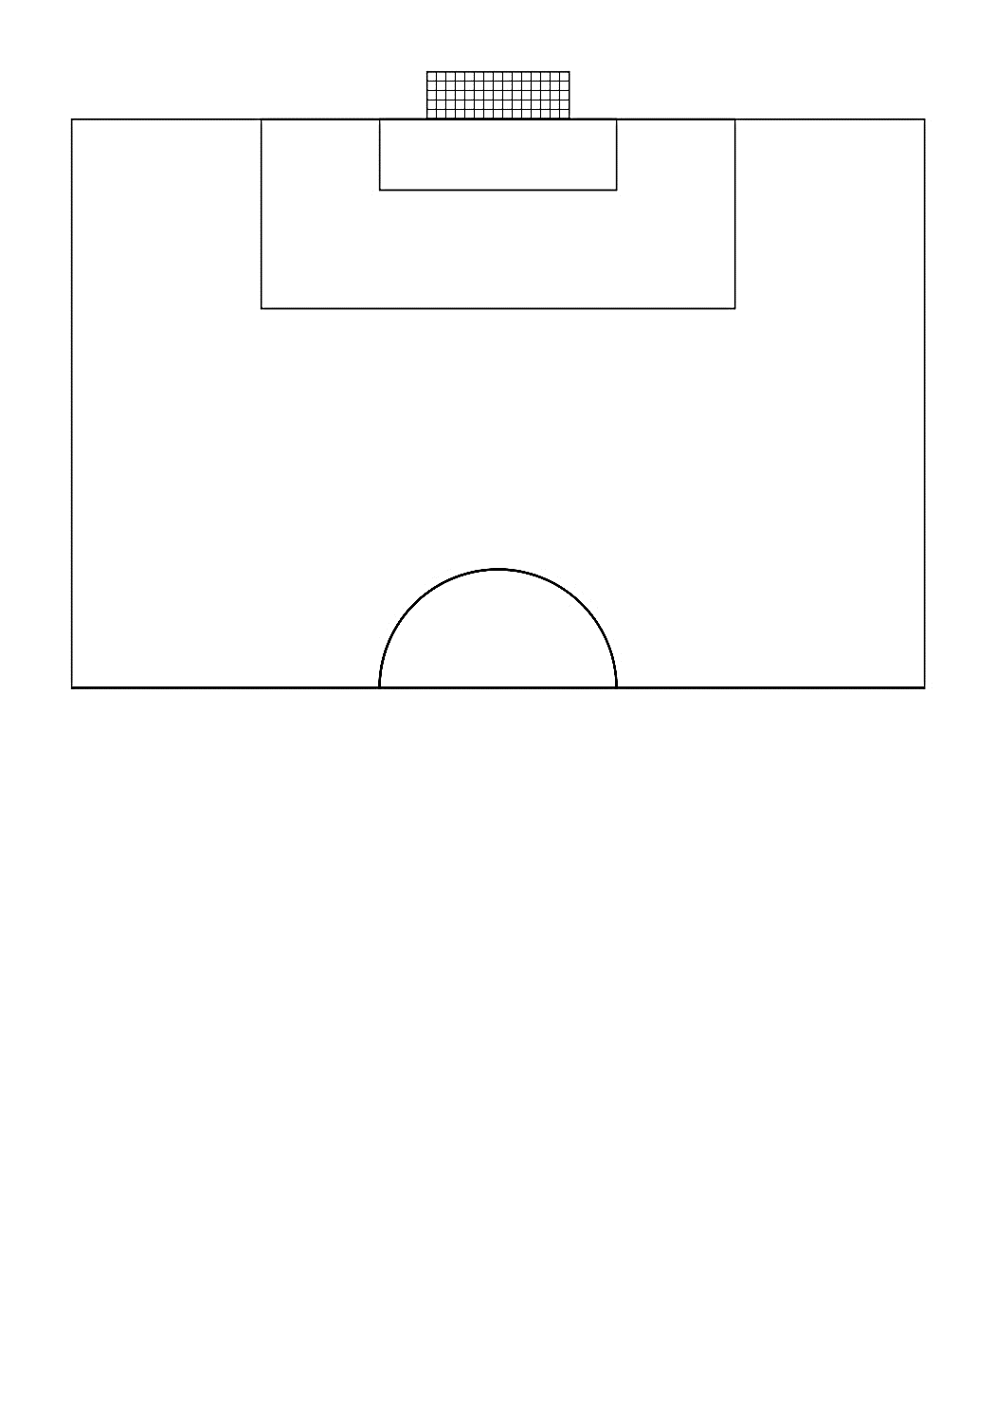Schematically show all shots on the opponent'sgoal.

Symbols:

– Shots on target

– Shot off target

**Task 6**

Make a graphic representation of the final pass for the specified (shaded) part of the field



Symbols:

– Short pass

– Long pass

**Task 7**

Present team formations

Team formation: _______________