The Physics of Martial Arts
Brian McGonagill

for: Classical Mechanics, Fall 2004
Dr. Charles W. Myles

Martial Arts as a Whole

Allow me to begin with a basic lesson in the differences between different styles of martial arts, the similarities of the different styles of martial arts, and my personal background with the martial arts.

Off the top of my head I can name ten different styles of martial arts, and that would only cover one tenth of the myriad of styles out there. The martial arts go back over 2000 years, and were developed originally by monks to defend their villages against invading armies. Through the years the martial arts have been refined and changed from the way they were originally taught. Many of these refinements are due to basic kinematics and energetic physical principles. The movements have been broken down to increase their efficiency in much the same manner as we would break down the inner workings of a semi-conductor, or car engine, or circuit in order to improve its efficiency.

The Martial arts can be separated into two extremely generalized styles. Hard style martial arts incorporates the use of punches, kicks, elbows, knees, and other hard strikes and blocks for the effect of crushing and destroying the body of the opponent. Soft style on the other hand uses joint locks, throws, take-downs, and joint manipulation to cause extreme pain to the end of gaining compliance from an opponent.

I have studied several of these styles since I was 7 years old. I hold a 2nd dan (degree) black belt in Tae Kwon Do (a Korean hard style art), a 1st dan in Hapkido ( a Korean soft style art), and, currently, a middle ranking belt in Aikido ( a Japanese soft style art). I have dedicated much of my life to perfecting these styles, and to refining them even further to increase their efficiency with minimal output on my part. Throughout this paper I will discuss how I have incorporated the use of mechanics into my refinement of these styles of martial arts.

The Basics

We can begin to analyze the martial arts with some of the basic physics knowledge that we attain during late high school and early college study. Then we can begin to incorporate more in stepped increments and see how the problem can become a bit more complex.

Starting with our basic equations for Energy we can write out an equation that will give us a fair understanding of what goes into the simplest punch or block. First, let’s analyze a basic straight (linear) punch. A martial artist punches in a way to maximize Pressure by using only a surface of the weapon one inch by one inch ( 1” x 1” ) max. Many martial arts use a rotating fist in order to help align the two punching knuckles (index and middle) appropriately. We will take our first punch to be more of a Gung-Fu (pronounced Kung Fu) style punch where the fist is held at all times with the knuckles vertical to the surface of the earth if the attacker is standing.

Using the concept that kinetic energy is based on mass and velocity, and potential energy is based on mass, gravity, and a change in position in the vertical (y) we can write the following:

E = ½ mv² + mgy

Where m is the mass of the fist and arm (approximately 7 – 10 kg), and v is the velocity in the horizontal (x) direction only. Now taking the velocity to be the velocity of the arm and fist at ¾ - 4/5 full extension we can ascertain the total mechanical energy of the punch just prior to contact with the target.

T = ½ (8.0 kg)(5.44 m/s)² = 118.3 J

V = -(8.0 kg)(9.8 m/s²)(.16 m) = - 12.5 J

E = T + V = 118.3 J – 12.5 J = 105.8 J

Once we have this total mechanical energy, we can use it to find the amount of pressure being put into the target due to the amount of area of the punch, and the force due to energy of the punch. First, we find the force of the punch.

F = ma = (8.0 kg)(109 m/s²) = 872 N

Now, this is obviously a large number, but we must understand that the entire arm did not travel the full 0.31 m used to arrive at the above acceleration. We can make a correction where we sum the distance traveled by each part of the arm, over slightly less distance as we get closer to the shoulder. We “chop” the arm into 10 pieces, each piece being one-tenth the mass of the whole arm, and then take each piece to have traveled one-tenth less than the piece just further from the shoulder.

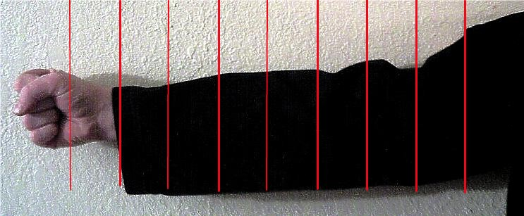

$\sum_{i=1}^{\text{10}}{m_{i}\left(\frac{\text{iv}}{\text{10}t}\right)}$ = 478.8 N

Now we can find the Pressure created on the target by the punching hand.

P_{ressure} = F/A

Even from this simple model we can use physics to determine the destructive power of the martial arts.

One might think it difficult to find the area of a fist, heel, or foot, because on each unique person these areas will differ, and quite significantly in many cases. In the martial arts, however, the use of the one inch rule is a well known, widely used rule for the weapons of the hand, feet, legs, arms, etc.

The one inch rule states that any weapon used to attack or block should be no wider than one inch at its widest point. We use the index and middle finger knuckle on the fist only. These are approximately one inch apart on any adult. There are seven primary weapons of the hand, each of which is approximately one inch in width at it’s widest part. Using this information we can easily suggest that the punch weapon is one inch square, and changing that to centimeters gives us 6.45 centimeters square.

So, P_{ressure} = 478.8 N / 6.45 x 10⁻⁴ m² = 7.42 x 10⁵ N/m²

Now we will add a few factors to the equations and look at how the problem can first become more involved, and second give us a much better idea of the true power behind the martial arts.

The Effects of Rotational Mechanics

In this section I will cover a range of issues dealing with the use of rotational mechanics, mostly with the idea of rigid body motion. The body, when performing the martial arts, is used in various ways to improve, balance, speed, and overall power as a system. To perfect this use of the entire body can take years of practical application, but only moments to understand.

First, let us discuss the different ways that the body moves when performing certain attacks and/or blocks in the martial arts. For our purposes now, we will only take into account the hard style art movements. Many of the hard style and soft style movements are similar, and rightly so, being based on a single system which has been diversified and refined throughout thousands of years. We will focus, however, specifically on the hard style movement first.

With the punch that we discussed previously, there comes much more motion from the body. First there is rotational motion at the hips thus causing the upper half of the body to turn, the shoulder to extend, and the arm to gain distance so that it can be accelerated through the target.

This motion will add a large amount of energy and momentum to the movement of the previously simple punch. We will estimate the shape of the human torso to be equivalent to figure 1 below.

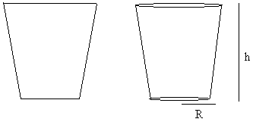
Figure 1

The first figure is a two dimensional approximation of the shape of the human torso from the front perspective, and the second part of the figure is how we will approximate the shape, as a three dimensional version of the first part of the figure.

For that shape we will approximate the moment of inertia I to be that of a thin, wide rectangle. Where

I = $\frac{1}{\text{12}}M(w^{2}+d^{2})$

Where M is the mass of the torso, w is the distance from the center of the torso to the edge of the shoulder, and d is the distance from the center of the torso to the outer edge of the back. Let’s use the following actual values for each of these variables:

M = 35 kg, w = 22 cm = 0.22 m, d = 7 cm = 0.07 m

so, I = 0.1554 kg * m²

Now we can use this information to get new values of energy, force, and pressure for the linear punch, adding the effects of the rotational mechanics of the body.

E = ½ Iω² + ½ mv² + mgy

In this case I was able to get a faster linear velocity off of my arm as I punched, so it has now increased to 7.3 m/s. We will use this for the new calculations.

E = 0.5(0.1554 kg m²)(1.9²/0.22²) + 0.5(8.0 kg)(7.3 m/s)² + (8.0 kg)(9.8 m/s²)(0.16 m)

E = 207.03 J

This value of total mechanical energy is almost twice the first value that we calculated without rotating the torso. This should prove to you conclusively that adding rotational mechanics into a linear movement can increase the energy output drastically, allowing for a much more destructive and powerful strike.

Now, let us look at the effects of this energy on the Force and pressure of our punch. We will use the same summation for the force, but this time will add in the effects of the rotation of the body.

F = $\sum_{i=1}^{\text{10}}{m_{i}\left(\frac{\text{iv}}{\text{10}t}\right)}$ + Iα = $\sum_{i=1}^{\text{10}}{m_{i}\left(\frac{\text{iv}}{\text{10}t}\right)}$ + Iα/w

F = 642.4 N + 128.4 N = 770.8 N

P = F/A = 770.8 N / 6.45 x 10⁻⁴ m² = 1.195 x 10⁶ N/m²

Again, we see a huge increase in Force and Pressure due to the rotational mechanics involved in rotating the torso during the punch.

Now that we have all of this great information, what does it tell us? We can answer this question in a fairly simple physical setup of board breaking. Martial artists throughout history have wanted to challenge their skills, and to test their limitations, and one of the best ways of doing this is board breaks. In the martial arts, the board is set to represent a bone in the body. The ability to swiftly and easily break the board, while causing only minimal damage to the body, is a test of the artist’s mastery of that particular move. We will look at this test from the physics standpoint.

Let’s take the punch through a board from the perspective of energy transfer and the resulting deformation damage due to the energy transfer. We take the board of mass m₁ at rest, and the mass of the hand and arm of the martial artist m₂ moving at velocity v upon impact, and ignoring the minimal amount of energy lost as thermal energy (heat energy). The amount of energy in the system lost due to the deformation damage can now be calculated as follows:

ΔE = $\frac{1−e^{2}}{2}⋅\frac{m_{1}⋅m_{2}}{(m_{1}+m_{2})}⋅v^{2}$

where e is the coefficient of restitution, which measures how elastic a collision is. It is a function of the hardness or softness of the colliding objects. In this case combining this with the masses and velocity determine the impulse of the collision. This tells us that when hard objects collide (e ~ 0) the transfer of energy and force is maximized as the objects accelerate one another very quickly. This allows for the breaking of the board which has a very small coefficient of restitution.

Here is a graph of the velocity needed by the hand and forearm to break through a board or concrete based on the maximum deflection of the board or concrete.

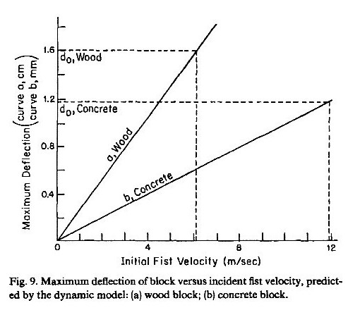

Physics in the “Soft Style” Arts

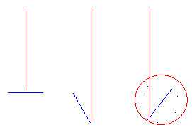

1. 2. 3.
Figure 2

Looking at figure 2 above we can get an idea of simple basis behind the majority of the soft style martial arts movements. The red line represents the attacker’s motion, and the blue line represents the defender’s standing position as if looking down from above. In step 1 you will see that the attacker begins in a straight line toward the defender as the defender is standing perpendicular to the attacker’s motion. As the attacker approaches with the attack, whether it is with an open hand, closed fist, knife, etc., the defender will receive the attacker by stepping back slightly as he grabs the attacker’s forward hand or arm, assisting the attacker in continuing in the direction of his motion momentarily.

The defender then does something interesting. He will step around behind the attacker, and pull the attacker in closer to him. This creates a system where two separately moving bodies have now merged into a single moving rigid body in circular motion. The steps taken by the defender have a very significant purpose in this process. The steps set the defender at the center of the circle and cause the attacker to be on the outside of the circle. To make this more easily understood there are two analogies that I use. The defender is a penny set near the center of an LP type record which is playing. The penny, if set near enough to the center or dead on top of the center will spin without slipping. The attacker is a penny placed at the outer edge of the same record, and will fly off the record as it spins.

The second analogy is to imagine yourself spinning in place as fast as you can and one of your friends trying to run around you at the same rate so that you are always facing them. Even worse is if your friend is trying to run backwards around with you so that you are always facing them.

Figure 3 below illustrates the discussion above. Simple rotational mechanics tell us that the further from the center something gets while moving in a circle, the faster the linear acceleration away from the center.

a = αr

where a is the linear acceleration outward, α is the angular acceleration of the object rotating about a fixed center, and r is the radial distance from the center to the object.

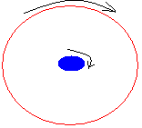
Figure 3

In the soft style arts, turning a two body problem into a one body problem is actually a very physically sound thing to do. Not only does it make the mathematics easier to work with, but it also eliminates human variables from the problem.

Let’s look at this as a two body problem first, where we will conserve momentum of the attacker (m₁) and the defender (m₂).

p₁= m₁v₁ and p₂ = m₂v₂

From my experience in law enforcement I have learned that an average human can cover about 6.2 m in approximately 1.5 seconds. Plugging these in for p₁ we find

p₁ = 90 kg (4.13 m/s) = 372 kg m/s

Now if we say that m₁ struck m₂ head on over a time interval of 0.2 seconds, we would find that the force of this interaction is as follows

F = $\frac{\text{dp}}{\text{dt}}=\frac{Δp}{Δt}$= 1860 N of force

This is a devastating amount of force, and the pressure that would be exerted on m₂ if m₁ were to strike head on with a fist is

P_{ressure} = F/A = 2.88 x 10⁶ N/m²

So by avoiding the head on attack with a small step back, rotating the body at an angle to the attack, and then blending with the attacker to create an inelastic collision, we not only conserve momentum and energy, but add to it by adding our own mass and velocity to the motion of the attacker, and use this against him.

L = r x p = pr sin θ

For our purposes we will let θ be 90º so that L = pr = mvr. Where m will be the combined mass of the attacker, v is the velocity of the two persons as a system, and r will be the average distance of the attacker’s body as it separates from the defender’s body during rotation.

For this portion, the attacker’s head and upper body will be pulled tightly into the defender’s chest. This allows the attacker’s lower body to drift outward from the defender as they rotate.

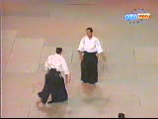 | 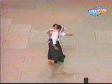
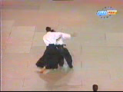 | 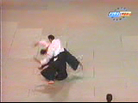

You can see in the pictures above that the attacker comes in, the defender steps at an angle, and pulls the attacker in for the rotation which causes the attacker to fall.

Using the above to approximate some numbers for this equation, we find that

p₁₂ = p₁ + p₂

You must understand that in soft styles, the initial velocity of the attacker dictates the velocity of the rotation. This is not so much for reasons of physics, but for a reason of maintaining the flow of movement. This is to minimize the energy output required on the part of the defender.

So if the attacker has a linear velocity of 4.13 m/s, the angular velocity of the outermost portion of the attacker’s body will be about 5.2 rad/s. This allows us to calculate the momentum which the two will have as a rotating system. The two as a system will have an approximate width of 0.12 m at their closest points, and 0.6 meters as the average value of their greatest separation.

L =$\sum_{i=1}^{\text{10}}{m_{i}\left(\frac{\text{irv}}{\text{10}}\right)}$ = 166.7 kg m²/s

Now that we have a value for their combined angular momentum in the spin, let’s convert that to linear momentum just prior to the separation of the two bodies.

L = pr p = L/r

p = 166.7 kg m²/s / 0.48 m = 347.2 N s

Again using the equation that momentum before must equal momentum after, we see that if the defender halts his momentum and allows the attacker to continue on alone, the attacker will gain almost all of the momentum of the combined system of bodies. This is the effect that can cause the attacker’s feet to come out from under him.

Now in Aikido, and most other soft style arts, things are not usually so nice, so we will look at the situation when the defender not only stops his own momentum, but changes the direction of his momentum quickly with a slight separation distance between himself and the attacker. The defender wants to move more quickly rotating in the opposite direction than he was in the initial direction while extending his arm, making it rigid, across the top portion of the attacker’s torso and neck area. Now we have a case where combined linear momenta are transformed into a rotational angular momentum with the body rotation in the x-axis rather than in the z-axis as before.

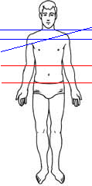
The picture to the left shows the various possibilities of the position of the axis of rotation created by the above action. In reality, the attacker would prefer not to fall at all, but if he had a choice would prefer one of the red lines be the axis of rotation, whereas maximal impact comes from creating the axis of rotation at one of the blue line positions. Striking at these points with enough momentum caused of course by the rotational motion of the defender’s body and rigidness of the arm, will cause the attacker’s feet to literally leave the ground, and thus the attacker has the full distance of his height to fall. While it may seem that the attacker would fall the same distance no matter where he is taken down from, it is also true that if hit near the red lines, the attacker is far more likely to bend forward, allowing him to cushion the fall with his hands and arms.

Conclusions

It becomes easy to see that with little to no knowledge of how to perform the martial arts, one can simply observe the motions involved in the martial arts and quickly come to the conclusions of how powerful and devastating these movements can be. It is also easily seen that regardless of the size of a person, if trained properly in the body mechanics, kinematics, and physics of the martial arts, a person can easily cause destructive damage to an attacker.

There are many other aspects to the martial arts that use similar physical principles as discussed here, but these are the principles that I could most widely generalize for the purpose of this paper. There is a multitude of blocks, punches, kicks, and throws that could be taken into account when breaking them down into the physics behind them, but that would take an entire book.

References

Bloomfield, Louis A., How things Work: the Physics of Everyday Life. New York: John Wiley & Sons, Inc. (1977)

Walker, Jearl D., “Karate Strikes.” American Journal of Physics 43, 845-849 (1975).

Wilk, S. R. et al, “The Physics of Karate” American Journal of Physics 51, 783-790 (1983).

Chabay, Ruth and Sherwood, Bruce, Matter and Interactions: Modern Mechanics. New York: John Wiley & Sons Inc. (2002).

Thornton, Stephen T. and Marion, Jerry B., Classical Dynamics of Particles and Systems, 5th Edition. Thomson, Brooks/Cole (2004).

