20.10.2011 Statistics

If p < 0,05 then we reject null hypothesis

If p > 0,05 then we not reject null hypothesis

If p = 0,05 then you can choose

t-test

*Null hypothesis: samples are equal (are the same)*

T-test for Dependent Samples (Desetiboj) Marked differences are significant at p < ,05000

|  |  |  |  |  |  |  |
| --- | --- | --- | --- | --- | --- | --- |
|  | **Mean** | **Std.Dv.** | **N** | **t** | **df** | **p** |
| **points 100 m** | 871,7179 | 53,0997 |  |  |  |  |
| **points long jump** | 803,3333 | 246,5539 | 39 | 1,880152 | 38 | ***0,067769*** |

***Because p (0,06)>0,05, we not reject null hypothesis, which is telling that samples are equal. It means that from “100m” has obtained*** *same* ***points. Difference is not statistically significant.***

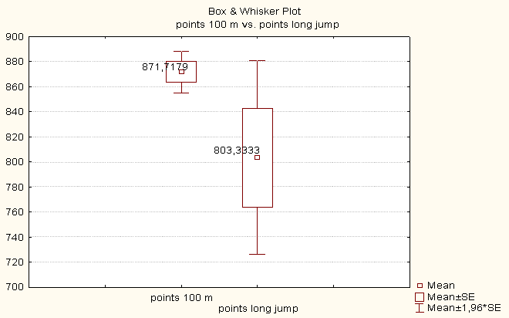

From statistical point of view, 871 points from “100 m” is equal 803 point from “long jump”. This difference is not statistically significant.At the 5% level of statistical significance

|  |  |  |  |  |  |  |
| --- | --- | --- | --- | --- | --- | --- |
|  | **Mean** | **Std.Dv.** | **N** | **t** | **df** | **p** |
| **points 100 m** | 871,7179 | 53,0997 |  |  |  |  |
| **points 400 m** | 725,7949 | 287,4990 | 39 | 3,323692 | 38 | 0,001974 |
|  |  |  |  |  |  |  |

***Because p (0,00)<0,05, we reject null hypothesis, which is telling that samples are equal. It means that from “100m” athletes have obtained*** *different* ***(more) points than from “400 m”. Difference is statistically significant.***

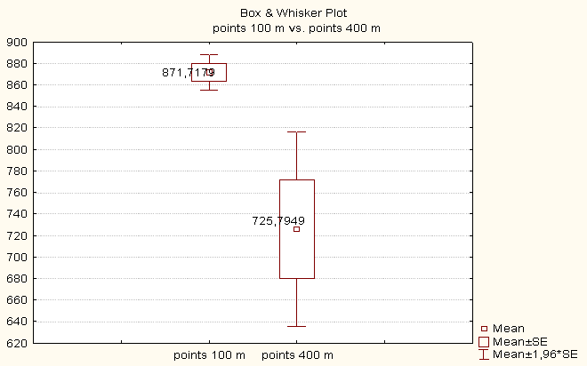

Graph is used to confuse the reader.

There are three lies. Terrible, ugly and statistics.

Do not believe the charts, believe numbers.

**Correlation**

|  |  |  |
| --- | --- | --- |
|  | **points 100 m** | **points long jump** |
| **points 100 m** | 1,0000 | ,4589 |
|  | p= --- | p=,003 |
| **points long jump** | ,4589 | 1,0000 |
|  | p=,003 | p= --- |

***Because p (0,003)<0,05, we reject null hypothesis, which is telling that correlation coefficient is ZERO. It means that correlation is not ZERO, and is 0,4589. Correlation is statistically significant. This relationship is direct.***

|  |  |  |
| --- | --- | --- |
|  | **points 100 m** | **points high jump** |
| **points 100 m** | 1,0000 | ,2792 |
|  | p= --- | p=,085 |
| **points high jump** | ,2792 | 1,0000 |
|  | p=,085 | p= --- |

***Because p (0,085)>0,05, we don´t reject null hypothesis, which is telling that correlation coefficient is ZERO. It means that correlation coefficient is ZERO. Correlation is statistically significant.***