SEMINAR 3 SPORTS PSYCHOLOGY, PERSONALITY, LANGUAGE WORK
STRESS AND PERFORMANCE
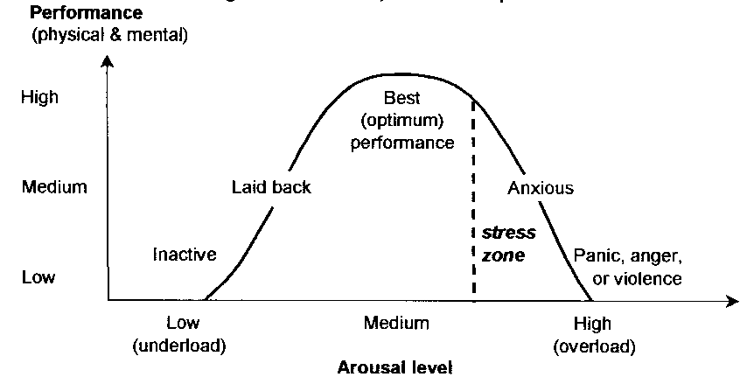
Discuss:
- Look at the graph above and interpret the bell curve.
- What types of stress do you know? Is stress always negative?
- What are the physical and mental symptoms of stress?
- What do you do to reduce performance anxiety?

Stress Reduction Techniques
This paper shows you effective methods of reducing stress to a level where you can perform most effectively. The techniques that you select depend on the cause of the stress and the situation in which the stress occurs.
In choosing methods to combat stress, it is worth asking yourself where the stress comes from: if outside factors such as relationship difficulties are causing stress, then a positive thinking or imagery based technique may be effective. If the stress is based on the feeling of adrenaline in the body, then it may be effective purely to relax the body and slow the flow of adrenaline.

Stress Reduction Techniques Explained
- Environmental Methods
  - Reduce the Importance of the Event
  - Reduce Uncertainties
  - Listen to Music or Relaxation Tapes
- Physical Techniques: these are most effective where stress is driven by excessive levels of adrenaline.
  - Progressive Muscular Relaxation
  - Breathing Control
  - Biofeedback

3. Mental Techniques: most effective where psychological factors are driving stress.
  - Imagery Relaxation
  - Thought Awareness, Rational Thinking and Positive Thinking
  - Remembering past good workouts, performances and achievements
  - Self-Hypnosis and Auto-Suggestion

Ad 3.2. Thought Awareness, Rational Thinking and Positive Thinking
You are thinking negatively when you fear the future, put yourself down, criticize yourself for errors, doubt your abilities or expect failure. Negative thinking can damage confidence, harm performance and paralyse mental skills.
Thought awareness is the process by which you observe your thoughts and become aware of what is going through your head.
To use the technique, observe your “stream of consciousness” as you think about the upcoming event. Do not suppress any thoughts. Instead, just let them run their course while you make note of them.
As you notice negative thoughts, write them down and then let them go.
Here are some examples of common negative thoughts:
- fear about the quality of your performance
- worry about how the audience or the press may react to you
- self-criticism over less than perfect practice
- a preoccupation with the negative consequences of a poor performance

Rational Thinking
The next step in dealing with negative thinking is to challenge the negative thoughts that you wrote down using the Thought Awareness technique.
Look at every thought you wrote down and rationally challenge it. Ask yourself whether the thought is reasonable. Would your friends or mentors agree with the thought or disagree with it?

Task 1 Look at the examples of common negative thoughts above and rationally challenge them:

Task 2 Would you agree with the following statements? Discuss in groups or pairs.

1. The effectiveness of the stress reduction technique depends on practice.
2. Physical techniques are most effective where psychological factors are driving stress.
3. Positive thinking is a solution to everything.
4. Hypnosis is an excellent mental technique.
5. Only very smart people can take full advantage of the mental techniques.
6. An experienced athlete is able to cope with any uncertainties concerning his/her performance.

(adapted from: http://www.mindtools.com/stresstq.html)

WORD STUDY
A
Which of these characteristics do you consider to be more attractive and less attractive? Which unattractive characteristics can you tolerate in your friends and relations?

Ambitious
Cautious
Easy-going
Enthusiastic
Eccentric
Disciplined
Frivolous

Introverted
Modest
Outgoing
Outspoken
Reliable
Reserved
Resourceful

Ruthless
Self-centred
Self-confident
Sensitive
Serious
Shy
Spontaneous

B
Can you think of opposites for these adjectives?

Generous
Kind
Narrow-minded
Prejudiced
Sensible
Sophisticated

C
Decide which of the adjectives on the left have a similar meaning to the ones on the right.

Smart
Forgetful
Glum
Frank
Reliable
Self-confident
Trustworthy
Bright
Self-assured
Absent-minded
Honest
Miserable

D
Use a suitable prefix or suffix to form the opposite of each of the adjectives below.

Un- Dis- In- Im- Il- -less

biased
careful
competent
credible
decisive
efficient
happy

harmful
honest
legal
logical
mature
organised
pleasant

patient
polite
possible
predictable
satisfied
tolerant

SPORT AND PERSONALITY
Your personality can affect the type of sports you like and excel in. These are just general rules however, you may be an exception to the rule.
Personalities are often described by how introverted or extroverted the individual is.
- Introverted people tend to be quiet and thoughtful
- Extroverted people are more loud and excitable
You can of course be somewhere inbetween these two extremes.
Whether you are more of an introvert or extrovert can affect the type of sport you like to play.
Introverts tend to like sports which require:
- Concentration
- Precision
- Self-motivation
- Intricate skills
- Low arousal levels
- Individual performances
Extroverts prefer sports which are:
- Exciting
- Team sports
- Fast paced
- High arousal levels
- Large, simple motor skills
- Low concentration

Discuss: According to the text what are the examples of sports typically chosen by introverts and extroverts?

LANGUAGE WORK

Task 3 Complete the second sentence so that it has a similar meaning to the first sentence. Use the word in bold and other words. use between two and five words.
1 Smoking in the library is forbidden.
allowed
You ____________________________________________________ in the library.
2 Magda saw Ela as she was going to work.
way
Magda saw Ela ___________________________________ work.
3 I regret not taking your advice.
followed
If only ___________________________________ your advice.
4 You might get thirsty, so I put a flask of tea in your bag.
case
I put a flask of tea in your bag _________________________________ thirsty.
5 Her voice was so quiet that we could hardly hear her.
such
She __________________________ that we could hardly hear her.
6 Going to parties was not something I did very often.
use
I ____________________________________________ to parties very often.

