Unit 11 Pediatric Physiotherapy

Task 1 Speaking - Milestones of childhood
- How would you characterize childhood, infancy and puberty?
- At what age do the following milestones usually occur?
Sitting
Crawling
First words
Walking
Talking (two-word sentences)

Task 2 Childhood diseases
Read the description of the celiac disease and find two pieces of information which are incorrect.

Coeliac disease
Coeliac disease is a disease of the large intestine caused by sensitivity to gluten. It can present at any age but in infancy it appears after weaning on to cereals containing gluten. The clinical features include diarrhoea, malabsorption and failure to thrive. There may be signs of malnutrition and there may be some thoracic distention. There is delayed growth and delayed puberty, leading to short stature in adulthood.

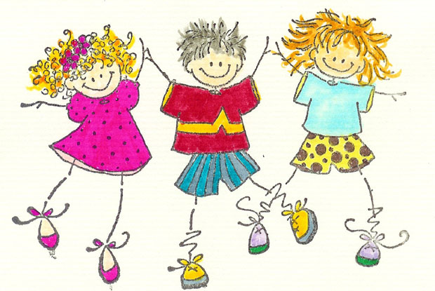
Pediatric Disorders and Physiotherapy to Help Them

Discussion point:

In your opinion, what are the difficulties a pediatric physiotherapist may have?
What is important to remember when working with children?

Vocabulary
Match the words with their synonyms:
occur renovate
severe defeat
curvature illness
revive happen
overcome bend (n)
disorder serious

Use these adjectives to make verbs: strong __________ straight ___________

Task 3 Reading
Most of us find illness and injuries to children very distressing. We instinctively seek to protect children from harm and suffering. But we have to accept the reality that many pediatric disorders do occur. Fortunately, physiotherapy can often help.

Among the many pediatric disorders, a few common examples are: scoliosis, torticollis, sports and traumatic injuries, developmental disorders, cerebral palsy, and genetic disorders.

Physiotherapy for scoliosis - a curvature of the spine - consists of exercises to strengthen the back. Electrical stimulation is used for this type of pediatric disorders. The stimulation goes directly to the skeletal muscles. Chiropractic is also used in an effort to straighten the spine.

Torticollis is a type of pediatric disorder of the neck. There is a problem with one of the muscles of the neck so that the child is not able to hold his/her head up straight. Physiotherapy can stretch this muscle so that the child can hold his/her head more normally.

Spinal cord injuries as pediatric disorders are difficult to treat. Children often do not want to do the work that is required for this condition. Physiotherapy personnel are challenged to keep the child's spirits up as they teach them how to exercise with and without special equipment.

Brain injuries, including cerebral palsy and strokes are pediatric disorders that must be managed delicately. The neurological system is often not as sturdy as the skeletal or muscular systems. However, brain injuries also involve these other systems as well.

A new treatment for these pediatric disorders like brain injuries is using hyperbaric oxygen therapy (HBOT). In an atmosphere of high pressure oxygen, certain dysfunctional areas of the brain may sometimes be revived.

Pediatric disorders such as sports injuries and traumatic injuries require different types of physiotherapy based upon the location and severity of the injury. If a child has repeatedly sprained the same ankle, therapy will necessarily focus on that ankle, as well as any body part that supports or counterbalances that ankle. Overall strength is important.
Traumatic injuries require a certain amount of psychological training, as the subject of the accident or other ordeal may bring on such distress that the child does not want to work. A good physiotherapist will be able to work with such a child. Traumatic injuries can also be severe enough that the physiotherapist plans a lengthy course of therapy to overcome them. Pediatric disorders like this require patience from everyone involved.
(http://thephysiosite.com/pediatric-disorders-and-physiotherapy-to-help-them.php)

After you read: Formulate five questions about the text, then take it in turns with your partner to ask and check each other´s understanding.

Video: http://www.youtube.com/watch?v=iRxewlARcYs&feature=related

Task 4 Phrasal verbs
(http://www.englishclub.com/vocabulary/phrasal-verbs-list.htm)
Study the sentences below and then match phrasal verbs with their synonyms:

A.
Jason called the wedding off because he wasn't in love with his fiancée.
My grandparents brought me up after my parents died.
You will lose weight if you stick to the diet.
Our car broke down at the side of the highway in the snowstorm.
You'll have to run faster than that if you want to catch up with Marty.

Call sth.off get to the same point as sb. else
Bring sb. up cancel
Stick to sth. raise a child
Break down continue doing sth.
Catch up with sb. stop functioning

B.
I need to figure out how to fit the piano and the bookshelf in this room.
I dropped out of Science because it was too difficult.
I turned the job down because I don't want to move.
My doctor wants me to cut back on sweets and fatty foods.
I am counting on you to make dinner while I am out.

Figure sth. consume less
Drop out rely on
Turn sth. down understand, find the answer
Cut back on sth. refuse
Count on sb., sth. quit a class, school

C.
If you keep those results up you will get into a great college.
We need to sort the bills out before the first of the month.
I just got over the flu and now my sister has it.
I work out at the gym three times a week. Our plan worked out fine. We have to work out the total cost before we buy the house.
My maths homework was too difficult so I gave up.

Keep sth. up recover from an illness, loss, difficulty
Sort sth. out exercise, be successfull, make a calculation
Get over sth. stop trying
Work out continue at the same rate
Give up sth. organize, resolve the problem

D.
Josie made up a story about why we were late.
My plane takes off in five minutes.
Do your coat up before you go outside. It's snowing!
I don't think I can put up with three small children in the car.
We ran out of shampoo so I had to wash my hair with soap.

Make sth. up have none left
Take off invent, lie about sth.
Do sth. up tolerate
Put up with sth. fasten, close
Run out of sth. start to fly

