Warm up: Run 3 circuit

side shuffle with arm crosses, carioca, inch worms, high knees, butt kickers, walking forward lunge, alternating side lunge, high kicks with a job back

exercise 1: Everyone have a ball. You will dribble a ball. You will be trying to save your ball and at the same time you will be trying to kick others balls away.

2 x 2 min. Rest: 2 min.

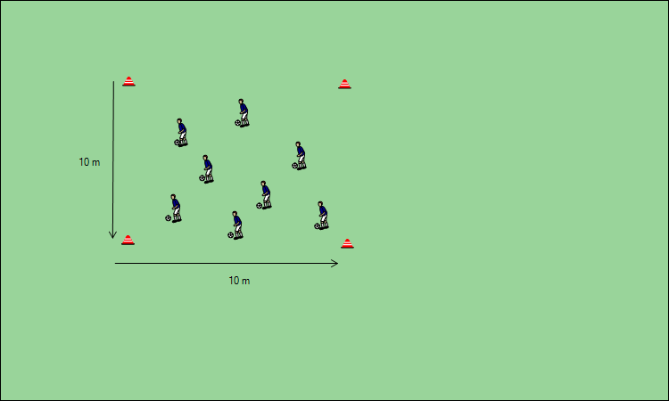

exercise 2: 5 players in one square. You have only two touch

Five players will be in one square. At the red con will stand two players (player no.1 and player no.5). Other players will stand by remaining cons. Player one pass the ball to player two. Player one run to the place of player two. Player two pass the ball to player three. Player two run to the place of player three and so on.

3 x 3 min. Rest: 2 min.

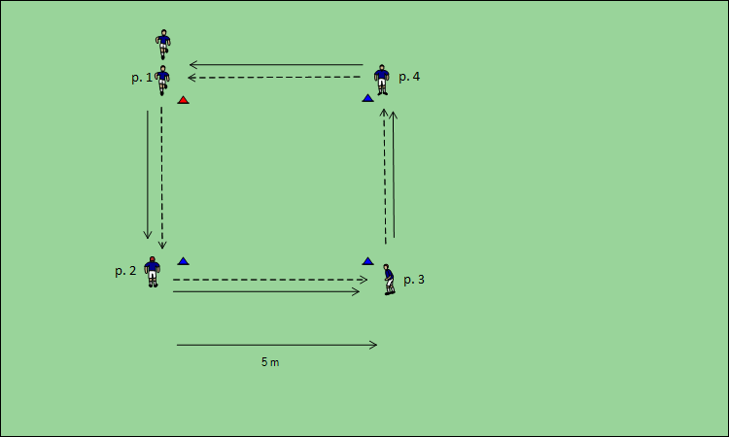

exercise 3: 4 players in one square. You have two – max. three touch

Four players will be in one square. One player will be in the middle and other players will stand by cons. Player one start exercise. He will pass the ball to the player in the middle. Middle player will turn around and pass the ball player three. When player one will pass the ball to player in the middle, player three will run to free con. Player two will pass the ball to the player in the middle. Player one will run to free con and so on. Middle player will still be turning around and pass the ball to free player.

Every player will be in the middle two times and for one minute. Rest: 2 min.

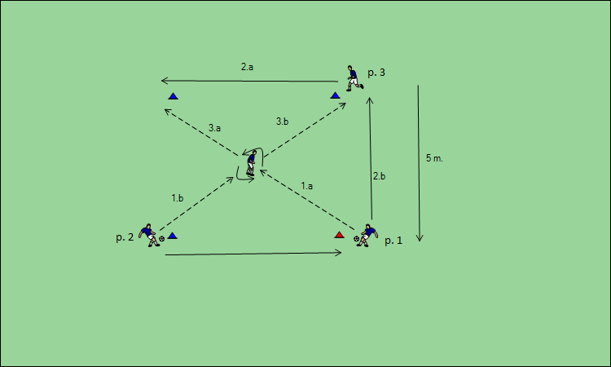

exercise 4: possession game Two teams. Every team has 4 players. Three touch

Two teams will play possession game. We will play two vs. two in the middle square and other players stand outside the square. First team will try possess the ball and second team will try catch the ball. When player one will pass the ball to the player outside the square, player one will run on his place and game continue.

4 x 4 min Rest: 3 min

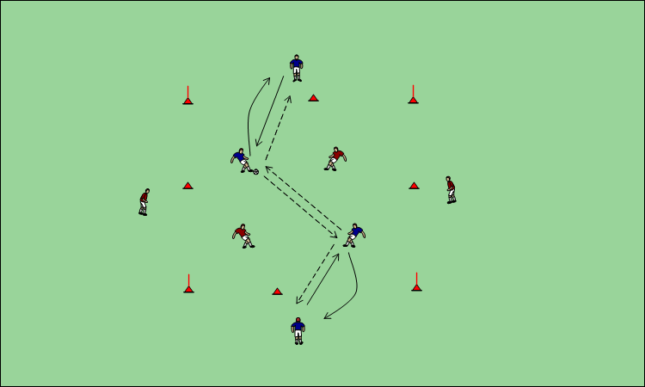

Viktor Kostovčik FsPs erasmus