IGNACIO AMAYA 440579

SAUL GARCIA-PORTILLO 440656

***FUTSAL TRAINNING***

WARM UP

1. - **Run:** around the football field (3 laps)

-  **Waist**: stop the race round the waist and on, about 5 times.

- **Career aside** : while running perpendicular to the path and put forward.

- **Carrera Back** : follow the direction of the run but going in reverse.

- **Touching the ground with both hands** : while it is running, bending over and touching the ground with both hands . For the past four movements it will take approx . About 10 minutes.

- **Kneeling above**: while it is running jumps with knees until they touch the chest, this will be about 5 or 6 times.

- **Heels ago:** after finishing his knees , touched his heels on the buttocks . This also will be about 5 or 6 times.

**- Jumping:** head is jump , while runs away , as if they finish off his head . As players make this the porters imitate the jump to catch a ball. About 5 times.

**- Skipping :** knees toward your chest without touching it were lifted. This will be done for one minute.

**- Short sprints:** will be great distress and about two meters sprint will . During a minute approx .

**- Long sprints:** about 20 meters sprints will be made.

**- Walking slowly :** Finally a length as the middle of the field players walk to catch air and get some rest .

**Stretch for 5 minutes:**

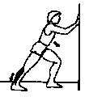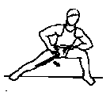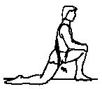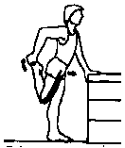

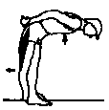

**EXERCICES**

1. **(RONDO).** A CIRCLE WITH TWO PEOPLE IN TRYING TO TAKE THE BALL TO REMOVE THE CIRCLE . CAN ONLY GIVE THESE TWO HITS.

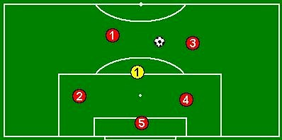

**2.** PASS THE BALL BETWEEN THREE PEOPLEs . FIRST CLOSER AND THEN MORE FAR.

**3.**  two lines and will make a zigzag movement of the ball .

at the end of the circulation will take a shot at goal without goalkeeper

**4. exercise ball to the area more shot .**

come in threes . one of them opens a band and go two a shot in the area.

**5. 4x3, 3x2, 2x1 and 1x1:** Coach assigns 3 defenders who wear an alternate jersey. The attackers begin with the ball. A keeper should be defending the goal

Instructions

Instruct the players to exploit their numerical advantage and finish with a shot on goal.

Attackers should move the ball looking for the open player and holes in the defense.

Defenders should attempt to break-down the attack and will gain experience in how to cover a one-down situation. Defensive players should complete a pass to the coach to end the attack.

The coach should then give the ball back to the attackers to build the attack again.

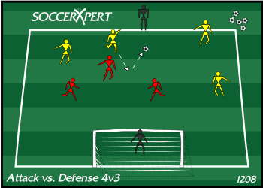

**6.** two teams, posesión of the ball.

- 10 passes

- 5 pasees + gol

- 7 pasees + comodín + gol.

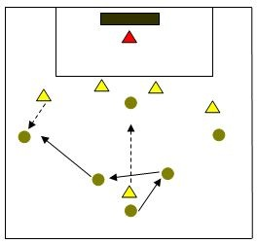

**7.**  To finish we will play a match with goalkeeper. and after a full stretch of the muscles involved in the exercise.