SPORT INJURIES

Broken Collar Bone
A broken Collar bone (broken Clavicle) is a very common shoulder injury. A broken collar bone frequently occurs when someone falls onto an out stretched hand. The Collar bone (Clavicle) is attached centrally to the sternum (breast bone) and at its outer side to the shoulder complex. This arrangement means that when a person falls onto an outstretched hand, the force is transmitted up the arm resulting in a collar bone fracture. Sometimes a direct blow to the clavicle can also result in a broken Collar bone.
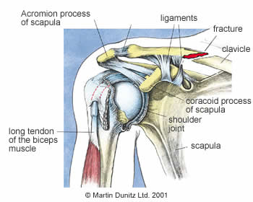
In older individuals, where more force is applied to produce a broken Collar bone, the two fragments often become displaced and are prominent through the skin.
Occasionally there are complications with this type of fracture, including a fragment of bone causing damage to blood vessels in the chest, or imperfect union of the two fracture fragments which leads to a prominent notch once healing has taken place.

Broken Collar Bone Signs & Symptoms
Because the Collar bone is so close to the surface of the skin, the fracture is usually characterised by the protruding fracture fragments. As with any fracture there is considerable pain, and bruising may be visible. The patient will hold the arm immobile in an attempt to relieve the pain. Other symptoms are instability and weakness.

Broken Collar Bone Treatment
Treatment of a broken Collar bone is dependent upon the degree of displacement of the fracture fragments. If the two pieces of bone are reasonably well aligned, it will usually be sufficient to immobilise the affected arm in a sling or a figure-of-eight harness.
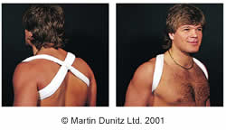

What you can do
Throughout the healing process the patient should follow a series of exercises to maintain the range of movement in the elbow, wrist and hand of the affected limb.

Tennis Elbow Injury
Tennis Elbow (Lateral Epicondylitis) is a common causes of elbow pain. Tennis Elbow is characterised by pain over the outer side of the elbow, which may radiate down the forearm. Despite the name, Tennis Elbow does not just afflict tennis professionals. In fact, this common elbow problem (it affects about 3% of the population) is most often associated with work-related activities.
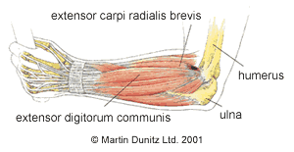
Tennis Elbow usually begins as inflammation of the extensor tendons of the forearm as they attach to the Humerus (upper arm) bone, just above the elbow joint. Typically this inflammation is caused by prolonged gripping activities such as weight lifting, canoeing, and, of course, racquet sports.
If these activities are continued, then the inflammatory nature of Tennis Elbow can give rise to a chronic tendon problem that is characterised by pain, weakness and degeneration of the
tendon.

Tennis Elbow Signs & Symptoms
Tennis Elbow is very easy to diagnose. There is pain when the Lateral Epicondyle (outermost part of the elbow) is touched, and also if the elbow is straight and the hand is moved forward and back at the wrist. Oher symptoms are: weakness and stiffness.

Tennis Elbow Treatment

What you can do
Since severe Tennis Elbow is an inflammatory condition, the obvious treatment would be a short course of non-steroidal anti-inflammatory drugs ( NSAIDs), prescribed by a doctor. Anti-Inflammatory Gel can also be helpful to relieve Tennis Elbow pain.
Ice Packs are a cheap and effective treatment for Tennis Elbow, applied for ten minutes every couple of hours (never apply ice directly to the skin). and inflammation.
In addition to anti inflammatory treatments, it is important that the patient reduces the strain on the painful area, otherwise the treatments can simply mask the pain while the condition gets worse.

Runner's Knee
Runner's Knee is the common term for Ilio Tibial Band Friction Syndrome (ITBFS). Runner's Knee is a painful overuse knee injury that affects the outer part of the knee. It is fairly common in runners and cyclists.
To fully understand Runner's Knee it is necessary to be familiar with the anatomy of the outer side of the thigh and knee. The Ilio Tibial Band (ITB) is a tough length of fascia that attaches to the outer side of the pelvis (which is known as the Ilium), goes down the outer side of the thigh and inserts into the outer side of the shin bone (Tibia). As such, the Ilio Tibial Band forms a length of taught fibrous tissue that connects the hip and knee.
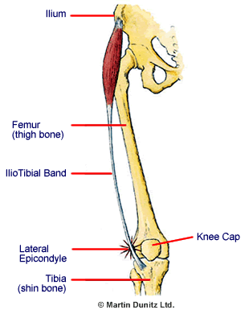
The Lateral Epicondyle is a bony prominence that is the widest point of the thigh bone. When the knee is straight the ITB is in front of the Lateral Epicondyle of the thigh bone and when the knee is fully bent the ITB is behind the Lateral Epicondyle of the thigh bone. During movements of the knee, the ITB moves over the Lateral Epicondyle of the thigh, with maximum friction at 30 degrees of knee bend.
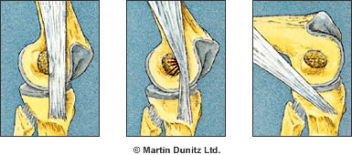
During activities such as running and cycling, where there is repeated bending and straightening of the knee joint, the ITB can 'impinge' upon the Lateral Epicondyle and the resultant friction can lead to inflammation of the tissues.
Between the ITB and the thigh there is a sac of fluid, called a bursa, which is meant to prevent friction. However, where there are repeated knee bending movements with a tight ITB, the bursa can become impinged between the ITB and the Lateral Epicondyle of the thigh. The bursa itself, as well as the ITB, can become inflamed and painful.

Runner's Knee Signs & Symptoms
Typically there is pain located on the outer side of the knee joint. This pain may radiate up the thigh or down the outer side of the shin. Usually, the pain from Runner's Knee is only present during activity and settles when the person rests.

Runner's Knee Treatment
Virtually all cases of Runner's Knee respond well to physiotherapy treatment.
Local treatment is concerned with reducing inflammation in the tissues. Rest and ice therapy are very important and Non Steroidal Anti Inflammatory Drugs (NSAIDs) can be very helpful where there is acute pain.

Snowboarder's Ankle
Snowboarder's Ankle is the common term for a fracture of the lateral process of the Talus bone, which is located on the outerside of the ankle, above the heel bone. A fracture of the lateral process of the Talus bone is rare in the general population. Because the fracture of the lateral process of the Talus is 15 times more common in snowboarders than in the general population, this injury is commonly called a Snowboarder's Ankle.
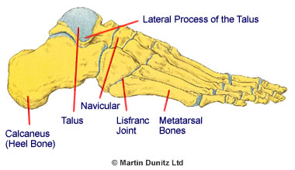
The Talus is located above the heel bone, deep in the ankle, and joins with the shin bone above it to form the ankle joint.
When the ankle is 'dorsiflexed' (toes are brought toward the shin) the Talus gets locked in place by the surrounding bones. If a person brings their foot into a dorsiflexed position and they then roll the ankle otwards, then the lateral process of the Talus gets compressed in between the heel and the lateral malleolus of the Fibula. If there is sufficient force then the lateral process of the Talus will fracture.

Snowboarder's Ankle Signs & Symptoms
A history of an ankle sprain when snowboarding is common. Typically, there is ankle pain at the back of the lateral malleolus of the Fibula (bony prominence on the outerside of the ankle). This can be extremely tender to touch. It is usually accompanied by swelling and bruising. Other symptoms are: instability, stiffness and weaknessand

Snowboarder's Ankle Treatment
Ice Packs may help with the pain but pain-relieving medication may also be necessary.
All fractures of the lateral process of the Talus should be reviewed by an orthopaedic surgeon. If the CT scan shows that the fracture fragments are not displaced, then 6 weeks of non weight bearing on crutches and a Removable Plastic Cast is the usual treatment. However, if the fracture fragments are displaced, or the fracture has shattered pieces of bone in the ankle joint, then surgery is usually required.

Tick the common signs and symptoms of :

Broken Collar Bone

Tennis Elbow Injury

Runner's Knee

Snowboarder's Ankle

 | Common Signs & Symptoms
 | Pain | Swelling | Stiffness | Weakness | Instability | Locking
Broken Collar Bone

Tennis Elbow Injury

Runner's Knee

Snowboarder's Ankle

Tick the treatment used in:

A/ Broken Collar Bone

B/ Tennis Elbow Injury

C/ Runner's Knee

D/ Snowboarder's Ankle
 | sling | harness | cast | Exercise/physiotherapy | Ani-inflammatory treatment | Ice therapy | rest | analgesics | surgery
A
B
C
D

Supply Latin-based synonyms to the following expressions:
shin bone tibia
widest point of the thigh bone lateral epicondyle
snowboarder´s ankle fracture of the lateral process of the talus bone
collar bone clavicle
heel bone calcaneus
breast bone sternum
tenis elbow lateral epicondylitis
runner´s knee ilio-tibial band friction syndrome
upper arm humerus
outermost part of the elbow lateral epicondyle
outer side of the pelvis ilium
adapted from: http://www.physioroom.com/injuries

