Unit 5 Physical Therapy Exercises
Exercising daily plays a main role in the process of healing and recovering from injury or disease. This is the goal of physical therapy exercises. Stretching and strengthening activities are only a few types of physical therapy exercises. Balance, joint control, and muscle re-training are other types of important physical therapy exercises.

Task 1
Fill the gaps with the correct word chosen from below.
increase joints recovery health immune regular cardiovascular

Physical exercise is the performance of some activity in order to develop or maintain physical fitness and overall _____________. Frequent and _______________exercise is an important component in the prevention of the diseases such as heart disease, cardiovascular disease, Type 2 diabetes and obesity.

Exercises are generally grouped into three types depending on the overall effect they have on the human body:
1. Flexibility exercises such as stretching improve the range of motion of muscles and
________________.
2. Aerobic exercises such as walking and running focus on increasing ________________ endurance.
3. Anaerobic exercises such as weightlifting or sprinting ______________muscle strength.

Physical exercise is important for physical fitness including healthy weight, building and maintaining healthy bones, muscles and joints; and strengthening the ____________ system.
Proper nutrition is at least as important to health as exercise. When exercising it becomes even more important to have good diet to ensure the body has the correct ratio of micro and macronutrients to help the body with the ________________ process after exercising.

(Adapted from: http://www.sciencedaily.com/terms/physical_exercise.htm)

Task 2 Speaking

Choose at least one of the following types of exercises and describe its methods and goals:
Endurance training
Resistance training (strengthening exercises) – isotonic, isometric, isokinetic ex.
Flexibility training
Bed-ridden and convalescing patients: AAROM ex., PROM ex., circulatory ex.
Balance and stability training
Functional mobility training
Gait training
Back school
Aquatic exercises
Relaxation technique
ADL training
HEP training

Task 3: Look at the pictures and explain the described movements:
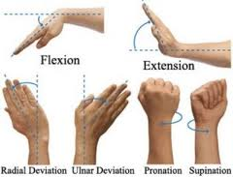

(Source of picture: http://thesandtrap.com/t/65441/photo-radial-deviation-i-cant-do-this-maybe-a-couple-of-degrees)

Task 4 Listening – Giving instructions
Pilates Exercises – One-leg stretch
http://www.ehow.com/video_4940402_pilates-exercises-oneleg-stretch.html
Listen to a fitness trainer describing a Pilates exercise and write down as many verbs describing movement as possible.

Follow-up: Complete the gaps with parts of the body.
Rotate your____________clock-wise / anti-clock-wise
Shrug your_______________
Turn your______________from side to side
Stand with your ___________ apart/ shoulder width apart
Keep your ____________ straight
Bring/ stretch/ extend your ____________ to the side/ overhead/ straight forward
Swing ___ from side to side and around in a circle
Bend forward from your ______ and relax
Clasp your __________ behind your head
Cross ____________ over your chest
Lie on your ______, arms at the side, ___________ down/up, now bend your ___________
Hold your knee with both __________ and pull it towards your ___________
Squat on the floor with one ___________ bent up against the chest, the other leg stretched out behind
Kneel on the ground, __________ apart
Lift up/ raise your ____________.

Task 5:
Here are some pictures of various physiotherapy exercises. First study the pictures properly, then choose 4 pictures and describe how to perform the exercises:

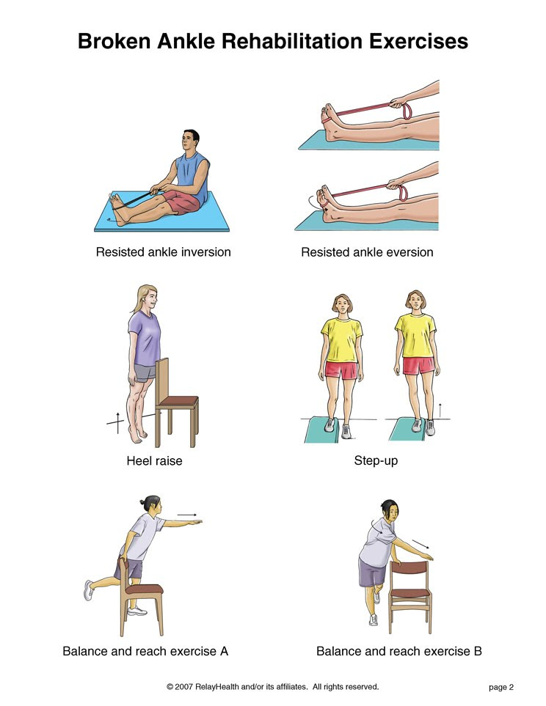
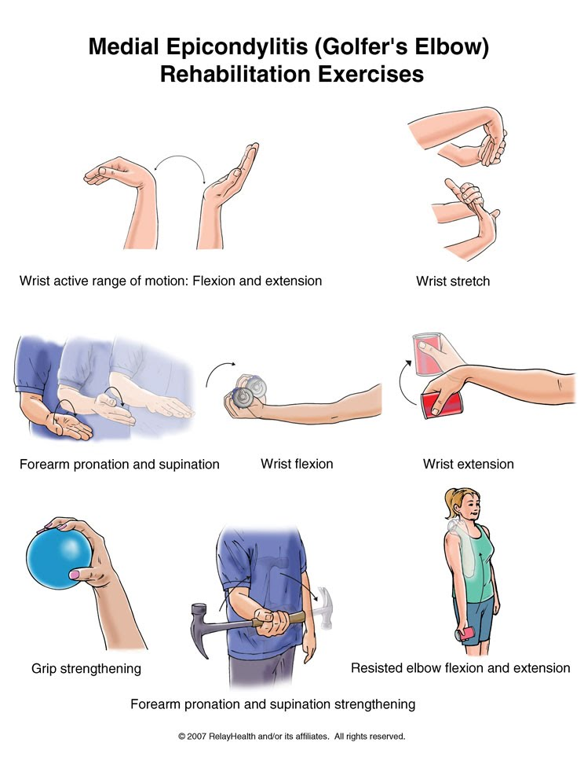

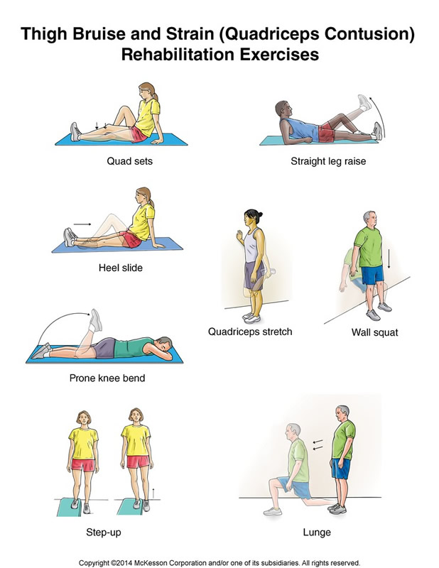

Now choose some of your classmates to perform the exercises as you describe them.
Adapted from:
http://www.orthohyd.com/exercises-yoga, http://physicaltherapy.about.com
Task 6
- Prepare a set of exercises that will ensure development of all large muscle groups in the body.
- Consider a sport and suggest exercises applying the overload principle that would develop all the large muscle groups used in the sport.

GRAMMAR

Infinitive or –ing overview

Verb + ing:
delay, fancy, consider, admit, miss, involve, finish, postpone, imagine, avoid, deny, risk, practise, enjoy, suggest, mind, give up, put off, carry on, go on, keep on, can´t help /laughing/,dislike, can´t stand.

Verb + to:
offer, decide, hope, deserve, attempt, promise, agree, plan, aim, afford, manage, threaten, refuse, arrange, learn, forget, fail, seem, appear, tend, pretend, claim, decide, dare, want, ask, help, expect, beg, tell, remind, force, enable, teach, order, warn, invite, persuade, make, let.

both -ing + infinitive:
begin, start, intend, continue, bother, love, like, hate, can´t bear /no difference in meaning/

difference in meaning:

stop + ing = give up the activity /he stopped smoking/
stop + inf. = intent /he stopped to smoke = with the aim to smoke/

advise, recommend, encourage, allow, permit, forbid:
verb + -ing /without an object/ verb + object + to:
I recommend waiting I recommend you to wait

remember + -ing = I did it and now I remember /I remember posting the letter/
remember – to…= not to forget or to realise /please remember to post the letter/

regret + -ing = I am sorry about what I did /I regret saying it/
regret + to…= I´m sorry that I have to…/We regret to inform you…/

go on + -ing = continue /He went on talking/
go on + to.. = do or say something new /After discussing it he went on to talk about economy/

try + -ing = testing /try pressing the button/
try + to.. = attempt, effort /I tried to move the table/

need + -ing = something needs to be done /the floor needs cleaning/
need + to.. = it is necessary /I need to take more exercise/

