**2D and 3D Motion Analysis**

**Masaryk University**

**Table Tennis hit**

**Angle:**

To calculate the angle of the arm with the body I took the coordinates of 3 points: hand, shoulder line and hip. After this, I put these coordinates in the “angle” section of excel sheets to calculate the angles of triangle formed by ankle, knee and hip.

Angle 1: 69.31ᵒ

Angle 2: 90ᵒ

Angle 3: 20.69ᵒ

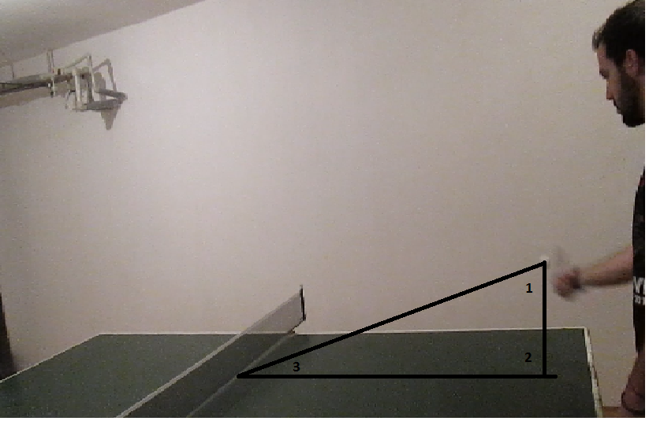

**Time:**

To calculate the time that the ball takes from the contact with the raquet and the contact with the table, I subtracted the time in the video.

5.30s – 5.39s = 0.9s

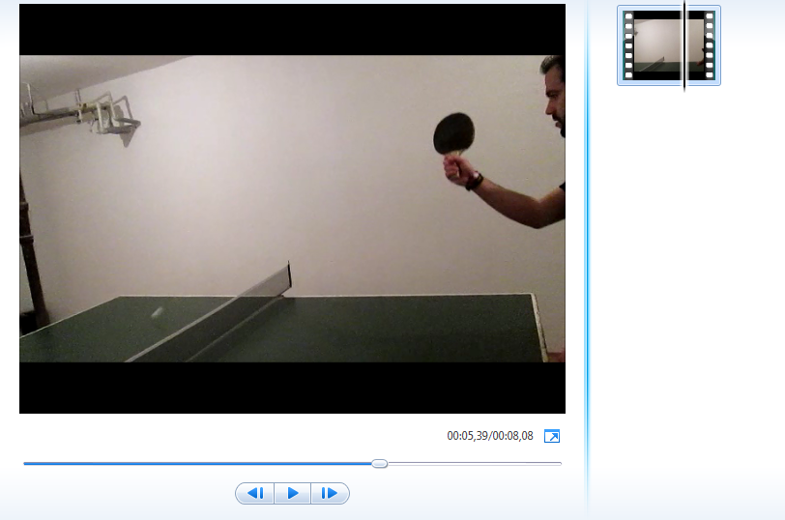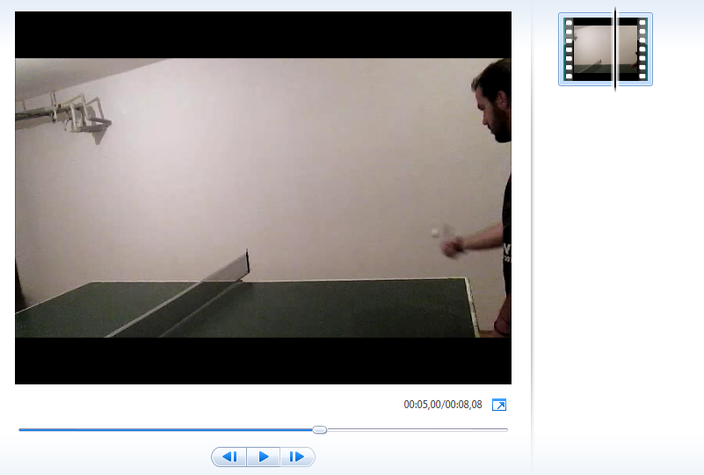

**Height:**

To calculate the height that the ball reach, first I measured the height of the net and afterwards, using the paint I saw the coordinates to use them in Excel Calculation Sheet. I just put the coordinates of the net in Calibration section and the ball in the distance Section of excels sheets.

Net: **15.25cm**

Ball height: **26,78 cm**

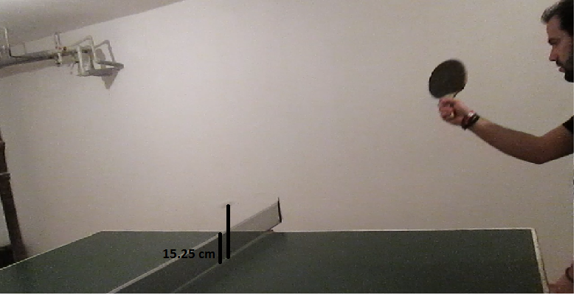

**Distance:**

To calculate the distance traveled by the ball between the contact with the raquet and the contact with the field, It's known that the distance of the table is 2,74m, so I calibrated the system of pixel putting the coordinates of the two points in the calibration section of excel sheet and then the coordenates of the ball contacts.

Distance: **224.91 cm**

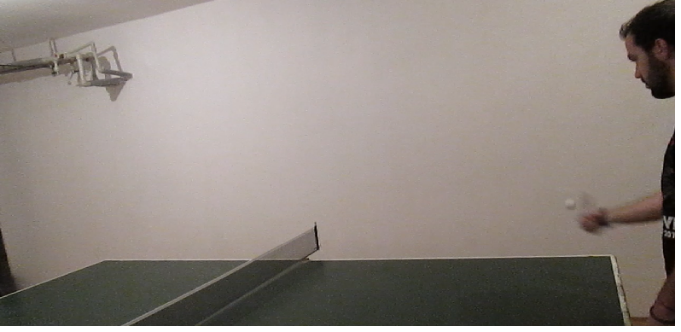

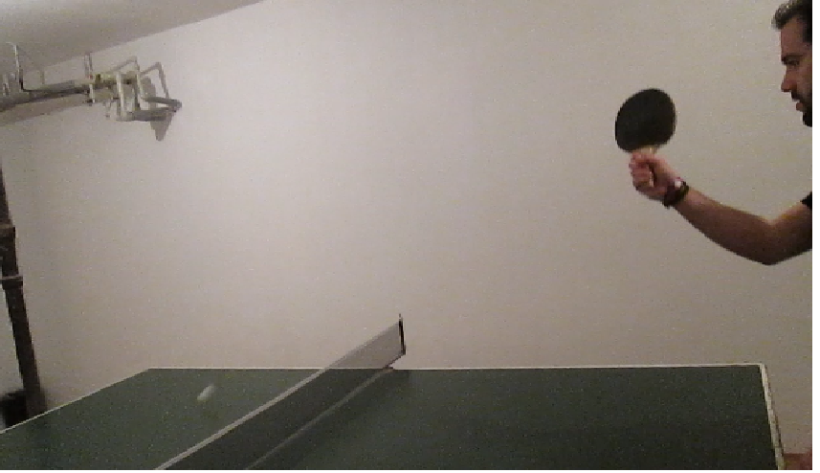

**Speed:**

To calculate the speed of the ball I calculated the distance covered by the ball and the time that the ball spent to do it. Then I calculated to the speed of the ball.

2,24m / 0,9s = 2,48 m/s



