**2d and 3d Motion : Jessica Hendle**

Length=3 frames

Time= 2 seconds (movement)

1. Distance= from the foot of one player to the other (3 metres/300cm)

Distance from-hand to hand of movement

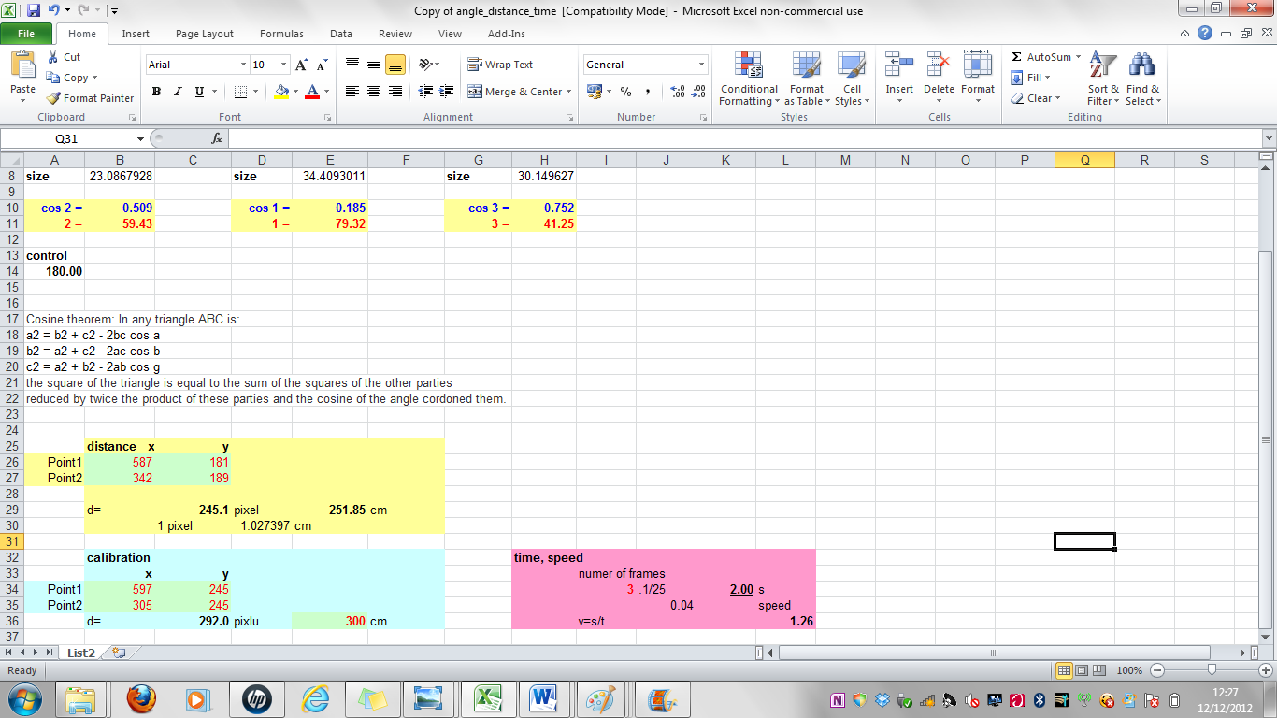

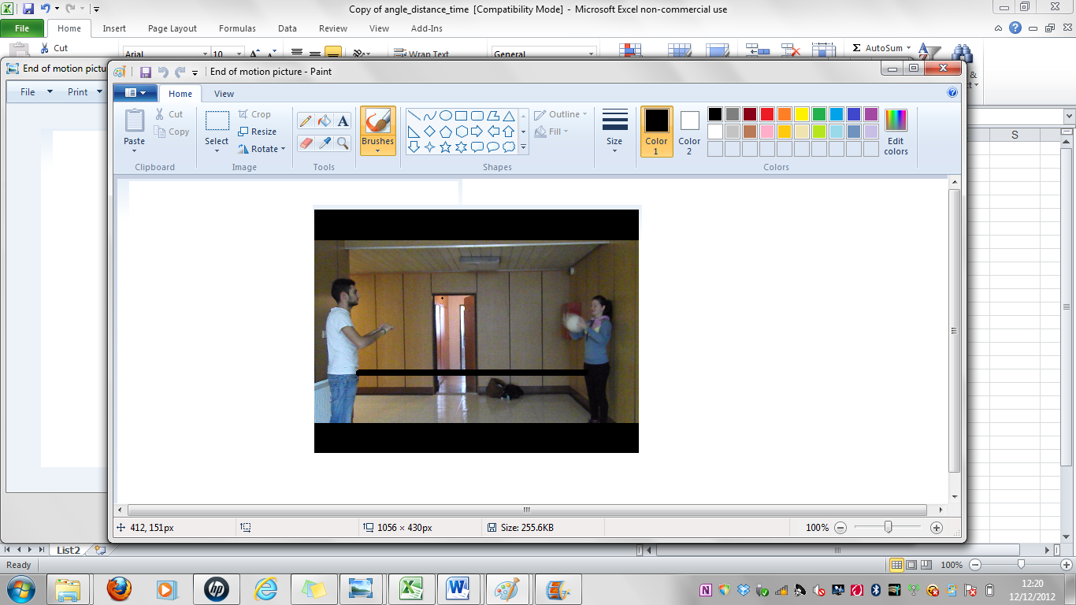

1. To calculation the speed = distance x seconds of movement =

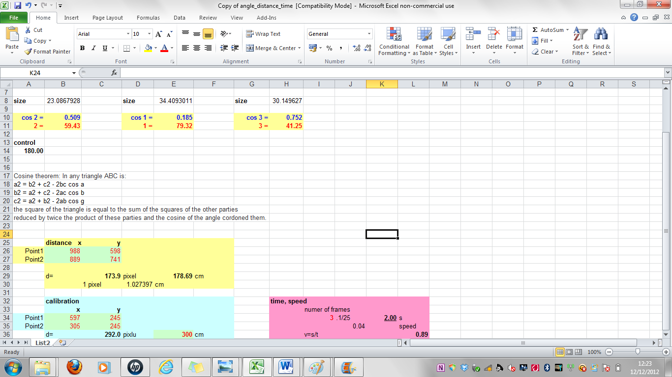

1. Angles

* 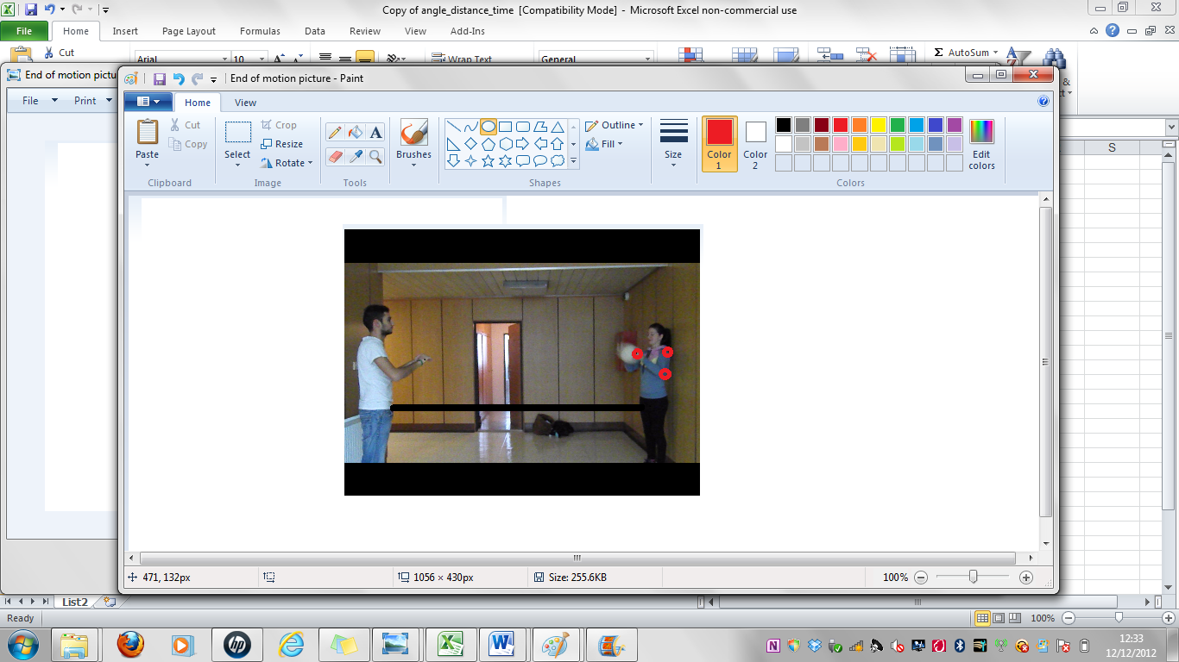Starting Stance (3 points-hand, shoulder and elbow)

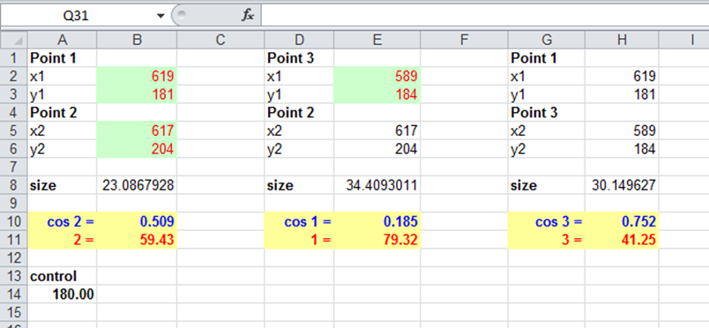

* Leaving Phase of movement (hand on ball, elbow & shoulder)

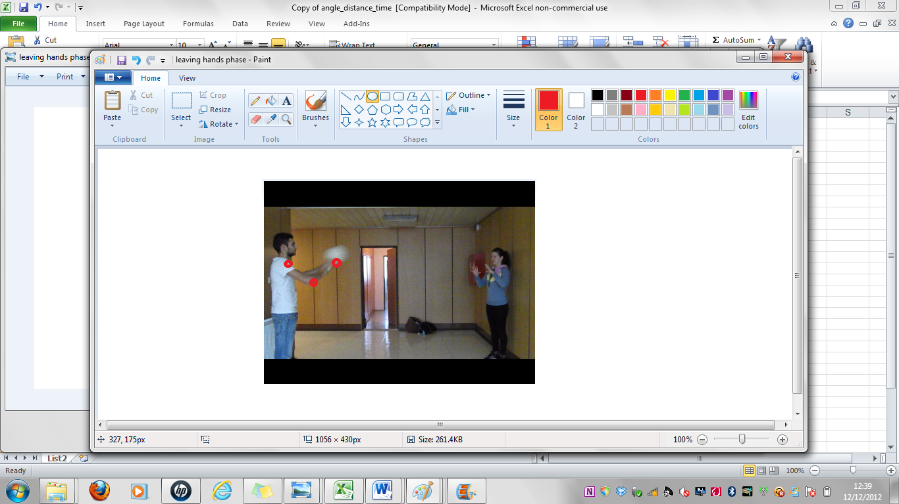

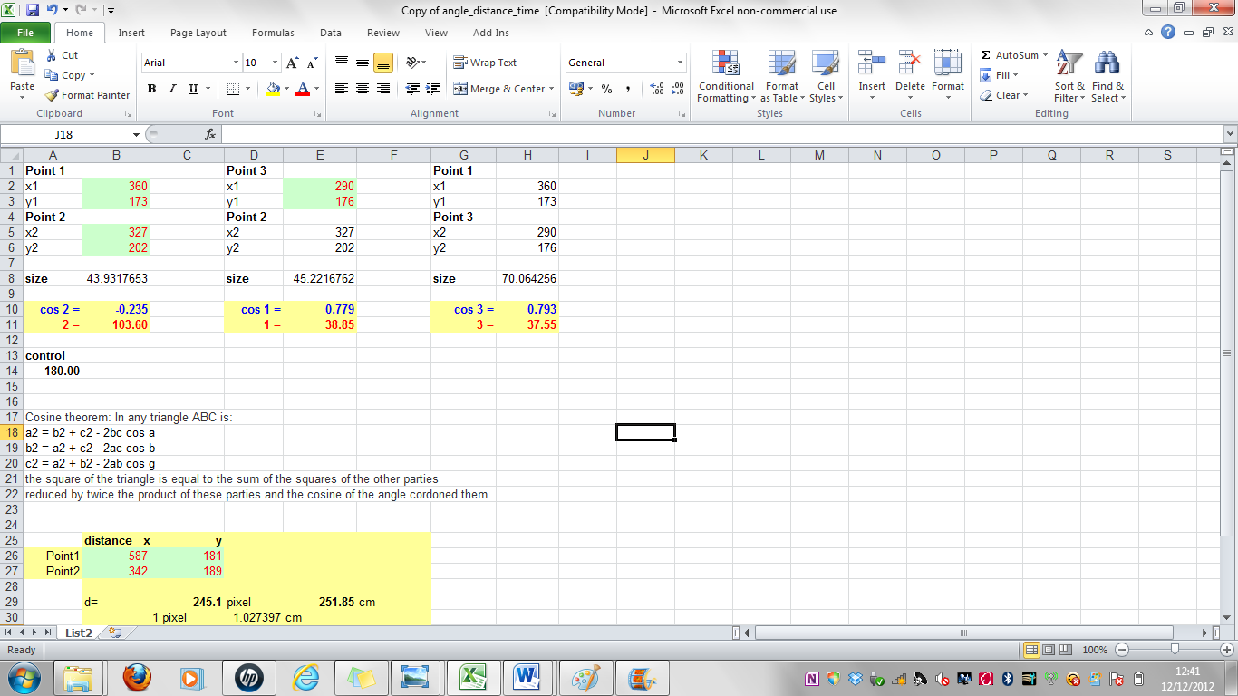

* 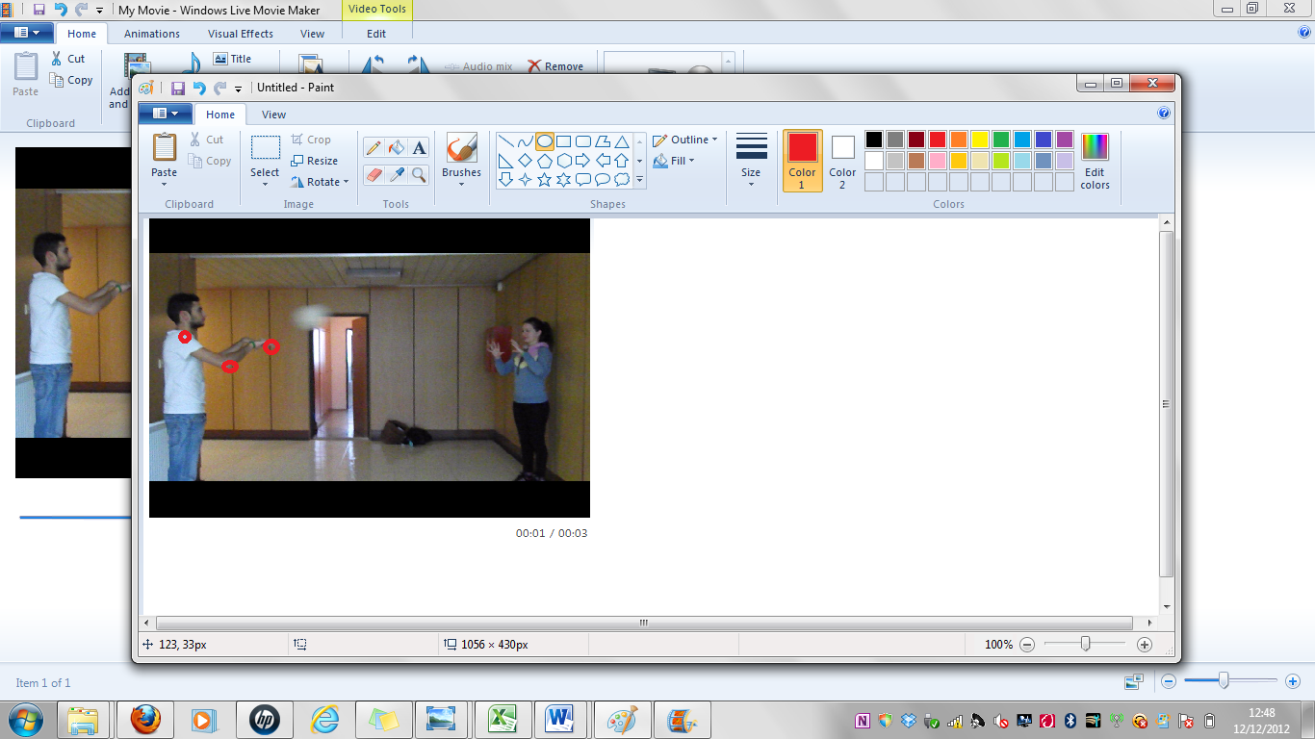Release of ball phase

