**Unit 10 Postural Assessment**

**Task 1 Are the following causes of effects of poor posture?**

* headaches
* stress
* sedentary lifestyle
* back pain
* misalignment in the body
* strain on the body
* hunching to get closer to a screen
* vertebrae deteriorate
* earlier exhaustion
* being overweight

**Task 2 Describe the types of posture in the picture using the following phrases:**

*tilted (forward) round excessively (lordotic) (mis)aligned pelvis shifted forward retracted shoulders curved lower lumbar flattened*

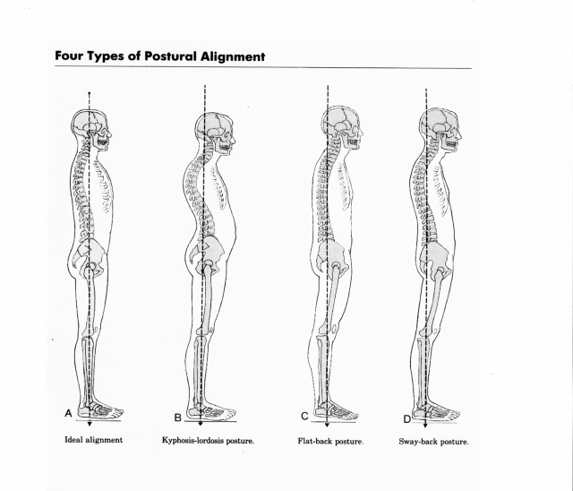

(<https://www.linkedin.com/pulse/posture-matters-dr-caroline-keddie>)

**Task 3 Vicious cycle of poor posture**

**Describe the “vicious cycle” between posture and pain.**

**Task 4 Close test**

**Fill in the missing word.**

The postures we assume provide clues to not only the condition of our bodies – traumas and (1) …………… old and new, and mild or more (2) …………. pathologies – but (3)………… how we feel about ourselves, our confidence (or lack of it), how much energy we (4) ……….. (or are lacking), how enthusiastic (or unenthusiastic) we feel, or whether we feel certain and relaxed (or anxious and (5) ………….). Intriguingly, we all almost always adopt the same postures in response to the same (6) ………….. .

Observe 10 people feeling confident, motivated, and optimistic, and you will notice that most are standing (7) …………., with their chests out and heads (8) ……………, and that most have adopted a wide stance, giving themselves a wide (9) …………… of support. By contrast, observe 10 people feeling anxious, demotivated or pessimistic, and you may notice that they have shifted their (11) ……………. to one leg, and that they stoop or flex at the waist, looking at the (12)………….. rather than up and ahead. They may also cross one or both (13) ………….. against the chest in a protective manner.

**Task 5 Factors affecting posture**

|  |  |
| --- | --- |
| **FACTOR** | **EXAMPLES** |
| Structural or anatomical | scoliosis, discrepancy in the length of the long bones in the upper or lower limbs, extra ribs, extra vertebrae |
| Age | changes in posture due to ageing |
| Physiological | effects of discomfort, tiredness, pregnancy, etc. |
| Pathological | Illness, stroke, pain, mal-alignment in the healing of fractures, osteoporotic changes |
| Occupational | sedentary jobs, manual jobs |
| Recreational | playing tennis, being a committed cyclist |
| Environmental | responding to temperature |
| Social and cultural | sitting cross-legged, squatting or on chairs |
| Emotional | grieving, being angry or fearing pain |

**Task 6 Why should I do a postural assessment?**

**Consider the following examples:**

1. You are treating clients who regularly engage in sport or physical activity. A 30-year-old man comes to you complaining of recurring knee pain. He is a keen runner. Could this pain be aggravated by the posture of his lower limbs?
2. Your client is a woman with pain in her left ankle. Observing her posture from the posterior and anterior views, you get the impression that she does not bear weight equally through her lower limbs but seems to favour her left leg despite this being the problem ankle. There is slightly more bulk in the left calf muscle, too. Upon questioning, the client recalls fracturing her right ankle as a child and admits to feeling fearful about bearing weight through this ankle. Even though the client knows the fracture is fully healed, she reports always having relied more on her left leg for support. Could this information explain the pain in the client´s left ankle?

**Task 7 Conditionals**

**Define the rules for the first and second conditionals:**

**Conditional 1:** If I go to London, I´ll visit Jenny. / If the weather is good, we can go out.

…………………………………………………………………………………………….

**Conditional 2:** If I went to London, I would visit Jenny. / If the weather was good, we could go out.

……………………………………………………………………………………………..

**Complete the sentences:**

1. He´ll live to be 90 if he …
2. You´ll get a bad back if …
3. She´ll lose weight if …
4. The patients would comply to the treatment plan if …
5. If everyone exercised regularly, …
6. You´d feel less tired if …