**Unit 10 Psychology in PT**

**Task 1 Speaking**

**Use the expressions from the cloud to talk about psychology in physical therapy.**

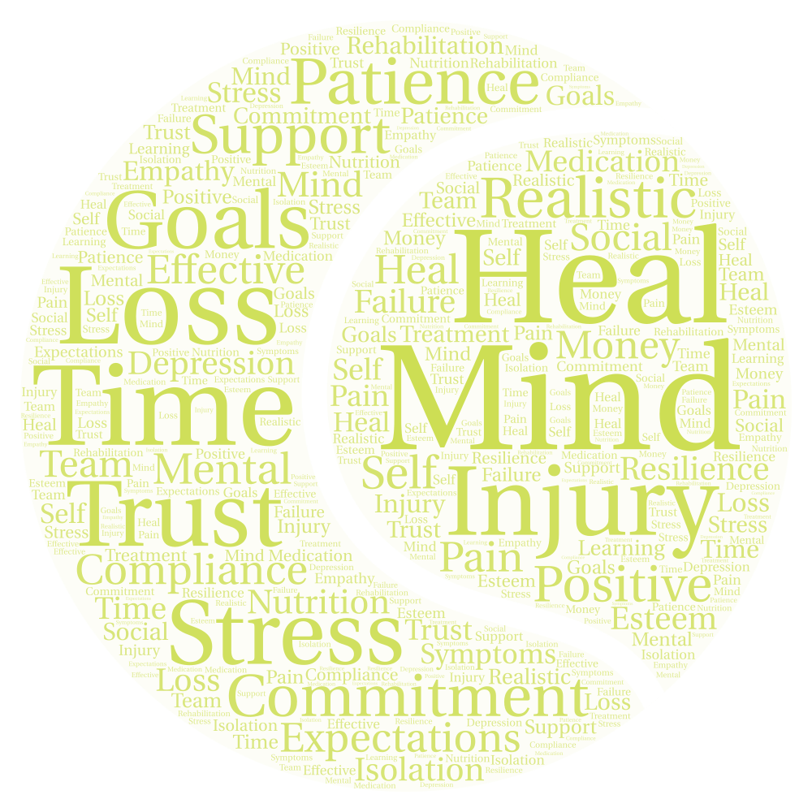

**Task 2 Why psychology for sports rehabilitation?**

**Complete the gaps with some of the words (or their forms) from the cloud above.**

Your role as a sports rehabilitator is to prepare the athlete for return to sport or performance as physically fit. However, the reality of the rehabilitative process is that it can be painful, …………. consuming and uncomfortable. Your patient/ client may require techniques for managing …………… and relieving …………… . Therefore, you will need to address the psychological and emotional issues of your injured athlete. If your athlete is to ………….. psychologically as well as physically then you need to understand how issues such as stress and adherence affect the rehabilitation process. You may also want to help athletes use techniques such as ………… setting and self-talk.

**Task 3 Emotional responses to sports injury and rehabilitation: A stage model**

Being injured is obviously an emotional experience for your athlete. In examining athletic injury, a classic ´stage model´ has been applied to sport, which outlines a normal progression of emotions. Originally, this model was designed as a framework for understanding the psychological response during the grieving process.

**Label the stages:**

*Acceptance Anger Bargaining Denial Depression*

1. ………………….

Firstly, the shock state immediately following the injury when the player is in a state of disbelief and may even respond with shortness of breath and physical freezing. It may progress in a period where the athlete still finds it hard to accept their limitations due to injury.

1. …………….

Secondly, the athlete may enter a blame culture in feeling that others have put them there, thinking or saying things such as “The opponent shouldn´t have tripped me…” or they may suggest it is your fault for not doing a good enough job.

1. …………….

The third stage involves negotiations. The athlete may promise to attend all sessions in exchange for your hard work as a rehabilitator in helping them to return to full recovery. This can include religion where an athlete will promise to be a better person in return for better health.

1. ……………..

This is a sense of helplessness and despair, and athletes may express sadness and apathy through statements such as “my sports career is over”. Your athlete may not feel like coming to rehabilitative sessions or working hard at the home exercises you have given them.

1. ………………

This is acknowledging that an injury has occurred and that the way forward is by working through the rehabilitative process. Your athlete may demonstrate this by saying “I am going to the gym regularly and working on these exercises at home.”

**Task 4 Speaking – Techniques in sports psychology**

**Work in pairs. Use the prompts to talk about imagery and self-talk in sports psychology.**

1. **Imagery**

* mind and body programmed to respond
* a desirable mental image
* brain transmitting impulses to the muscles
* an optimal performance
* confidence and focus to perform successfully
* mentally correct mistakes
* upcoming competition

(https://believeperform.com/performance/the-mechanisms-underlying-imagery-in-sport/)

1. **Self-talk**

* internal dialogue.
* positive or negative
* facilitates enhanced performance
* proper focus
* building confidence
* positive mood
* trigger desired actions more effectively
* aid in the rehabilitation process

(<https://www.researchgate.net/publication/251600096_The_effect_of_self-talk_on_injury_rehabilitation>)

**Task 5 Grammar – Gerund or infinitive**

**Choose the correct option:**

1. After my injury I had to give up *to ski/ skiing*.
2. My PT said I should try *to exercise/ exercising* with dumbbells.
3. She couldn´t afford *to pay/ paying* for the new treatment.
4. He promised *to practise/ practising* every day.
5. We decided *to try/ trying* the latest approach in physiotherapy.
6. They are considering *to use/ using* electrotherapy.
7. This method is definitely worth *to try/ trying*.
8. The doctor agreed *to do/ doing* the surgery.

**Task 6 Video - The fascinating science of phantom limbs**

(<https://www.ted.com/talks/joshua_w_pate_the_fascinating_science_of_phantom_limbs#t-242777>)

**Watch and answer the questions:**

1. What causes phantom limb sensations?
2. Describe the neural pathway from limb to brain.
3. What happens at the site of an amputation?
4. What is the cortical homunculus? What happens there when a body part in injured?
5. What happens to phantom pain over time? How is it treated?
6. How does mirror box therapy work?