**Unit 10 Psychology in Physiotherapy**

**Homework Task:**

***Watch the video on cardiac rehab from the link below and answer the questions:*** <https://www.physio-pedia.com/Cardiac_Rehabilitation>

Where did Fred attend his cardiac rehab sessions?

Individuals who have had what type of cardiac conditions attend for rehabilitation?

What information and guidelines do the patients receive during their rehabilitation?

When do patients usually start their cardiac rehab? What is the duration and frequency of the program?

What sorts of physical exercise did you observe during the video?

**Revision from seminar 9**

***\* Identify the condition described below:***

**A)** ……is an inflammatory disease of the airways to the lungs. It makes breathing difficult and can make some physical activities difficult or even impossible. To understand ………., you need to understand a little about what happens when you breathe. Normally, with every breath you take, air goes through your nose and down into your throat, into your airways, eventually making it to your lungs. There are lots of small air passages in your lungs that help deliver oxygen from the air into your bloodstream.

Symptoms occur when the lining of the airways swell and the muscles around them tighten (bronchospasm). Mucus then may collect in the airways, further reducing the amount of air that can pass through. These conditions then bring on an …….. “attack,” the coughing and tightness in your chest that is typical of ……. . Symptoms include: coughing – especially during exercise, wheezing (a whistling sound made when breathing, tightness in the chest, shortness of breath and fatigue.

No single cause has been identified for …… . Instead, researchers believe that the breathing condition is caused by a variety of factors. These factors include genetics, history of infections or early allergen exposure. Certain conditions and environments may also trigger the symptoms. These triggers include: illness, exercise, allergens eg grass and pollens, extreme weather conditions or intensive emotions.

(<https://www.healthline.com/health/what-does-shortness-of-breath-feel-like>)

***\* Choose from the two options to complete the sentence below:***

a) Our lecturer *told that / told us* that the exchange of gases during breathing takes place in the alveoli – the air filled sacs - of the lungs.

b) My friend *said to me / said me* that air enters the body via the nostrils before passing through the upper airways into the trachea, bronchi and broncheoli.

c) *I’m going to / I will* review with the respiratory specialist for my pneumonia next week, after I’m discharged from hospital.

d) *I’ll just listen / I’m going to* listen to your chest (auscultate) one more time. I think my stethoscope isn’t working properly so *I’ll / I’m going* *to* use another one.

e) My friend with cystic fibrosis *told me / told* that her physiotherapist comes to her house daily to perform postural drainage, percussion, vibrations and airway clearance techniques.

f) By the time you review in a months time, you *will do / will have been doing* your controlled breathing and relaxation exercises for four weeks.

g) My grandfather has emphysema. He is going to the respiratory consultant in a few weeks time to review his progress, as *he is doing / has been doing* rehabilitation and a breathing exercise program for around six months now.

h) The cardiologist *said that / told that* his heart attack *had been caused / is caused* by too much smoking, not enough exercise and a poor diet.

i) My physiotherapist *showed / showed me* that I need to lay prone over 3 pillows, in order to properly drain the lower lobes of the lungs.

j) Jim needs to do six weeks of intensive cardiac rehab following his myocardial infarction. He has done 3 weeks already so in 4 weeks time he *will be completing* / *will have completed* the program.

k) I saw on the *internet / on internet* that pleural effusion is sometimes known as ‘water on the lungs’, due to the fluid that builds up between the pleural membranes.

l) My specialist sent me for a chest X-ray. He then diagnosed my breathing problems as chronic bronchitis. He *said me that / told me that* I need to exercise regularly and quit smoking, in order to stop the excessive mucous production in my lungs.

m) After I was diagnosed with bronchiectasis, I was told that it’s important to have on going physiotherapy. I have planned it now, I *will be going / will go* to the hospital every week for treatment.

**Unit 10 Psychology in Physiotherapy**

**1. Speaking**

**Use the words in the picture below to discuss why psychology is important in physiotherapy:**

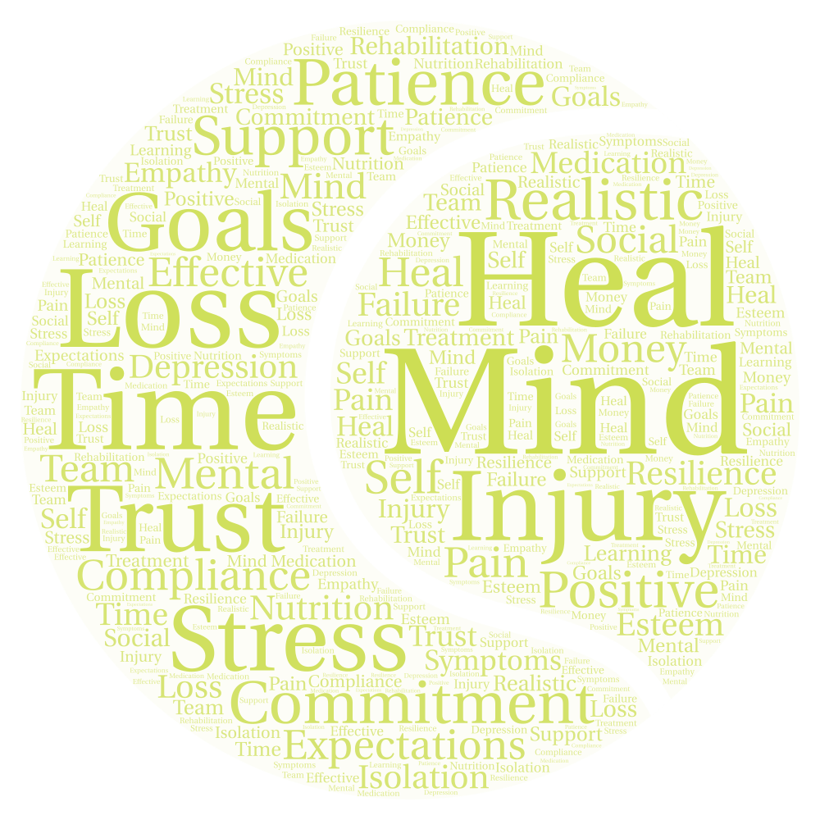

**2. Psychology in sports rehabilitation?**

***\* Complete the gaps with some of the words (or their forms) from the cloud above:***

Your role as a sports rehabilitator is to prepare the athlete for return to sport or performance in optimal physical condition. However, the reality of the rehabilitative process is that it can be painful, …………. consuming and uncomfortable. Your patient/ client may require techniques for managing …………… and relieving …………… . Therefore, you will at times need to address the psychological and emotional issues of your injured athlete. If your athlete is to ………….. psychologically as well as physically then you need to understand how issues such as stress and adherence affect the rehabilitation process. You may also want to help athletes use techniques such as ………… setting and self-talk.

**3. Psychological Terminology Commonly Used in Physiotherapy**

***\* Match the terms to their meanings / definitions below***

***\* Discuss their relevance in the physiotherapy setting***

*yellow flags self efficacy disability pacing*

*activity cycling compliance coping strategies*

*catastrophic thinking pain behaviour* *fear avoidance*

a) A psychiatric model that describes how individuals develop and maintain chronic musculoskeletal pain as a result of thinking too much about their pain and avoiding behaviour based on their pain-related fear.

b) Functional level of an individual related to their ability to carry out and achieve tasks and functions related to normal activities of daily living and other normal functional areas of their life, eg sport.

c) The situation where an individual may range between doing too much activity which creates painful exacerbation of their symptoms, followed by avoiding activity in order to allow their symptoms to settle down once again. Often this is cycled repetitively in a chronic fashion.

d) These are psychological indicators which suggest an increased risk of progression to long term sickness, distress, pain or disability. They include a patients thoughts, beliefs, emotions, behaviours, social and work situations which all may have profound effects upon a patient.

e) The manner in which a patient follows what they should be doing, eg taking medications as prescribed, attending appointments, completing home exercise programs, etc.

f) Refers to spacing out activities across a longer period of time, in order to allow an individual to stay within the limits of what their body can handle, without overly flaring up their symptoms.

g) One's belief in the ability to succeed in specific situations or accomplish a task. It can play a major role in how someone approaches goals, tasks, and challenges and is a positive trait for physiotherapy patients to possess in order to increase their independence and chances of successful rehabilitation.

h) When someone assumes that the worst will always happen, or may exaggerate the situation they are in negatively. It often may lead to rumination, where someone repetitively thinks about this worst case scenario…and in doing so may amplify the symptoms or situation.

i) The specific efforts in terms of behaviour and thinking which people may adopt to address or overcome a problem or challenge. Sometimes these may be classified into active or passive / avoidant strategies.

j) These may include verbal descriptions of the pain (sometimes exaggerated), using medication (eg overuse), verbalisations of distress (eg moaning, gasping, crying) and non-verbal cues such as avoiding tasks or adopting pain related postures or facial expressions.

**4. Speaking: Discuss how the following terms are related?**

a) catastrophic thinking / fear avoidance / pain behaviour:

b) activity cycling / flare ups / pacing:

c) yellow flags / psychological screening tests / active treatment:

d) passive treatment / coping strategies / compliance:

**5. Emotional responses to sports injury and rehabilitation: A stage model**

Being injured is obviously an emotional experience for your athlete. In examining athletic injury, a classic ´stage model´ has been applied to sport, which outlines a normal progression of emotions. Originally, this model was designed as a framework for understanding the psychological response during the grieving process.

**Label the stages:**

*Acceptance Anger Bargaining Denial Depression*

1. ………………….

Firstly, the shock state immediately following the injury when the player is in a state of disbelief and may even respond with shortness of breath and physical freezing. It may progress in a period where the athlete still finds it hard to accept their limitations due to injury.

1. …………….

Secondly, the athlete may enter a blame culture in feeling that others have put them there, thinking or saying things such as “The opponent shouldn´t have tripped me…” or they may suggest it is your fault for not doing a good enough job.

1. …………….

The third stage involves negotiations. The athlete may promise to attend all sessions in exchange for your hard work as a rehabilitator in helping them to return to full recovery. This can include religion where an athlete will promise to be a better person in return for better health.

1. ……………..

This is a sense of helplessness and despair, and athletes may express sadness and apathy through statements such as “my sports career is over”. Your athlete may not feel like coming to rehabilitative sessions or working hard at the home exercises you have given them.

1. ………………

This is acknowledging that an injury has occurred and that the way forward is by working through the rehabilitative process. Your athlete may demonstrate this by saying “I am going to the gym regularly and working on these exercises at home.”

**6. Speaking: Techniques in sports psychology**

***\* Use the prompts to talk about imagery and self-talk in sports psychology:***

1. **Imagery**

* mind and body programmed to respond
* a desirable mental image
* brain transmitting impulses to the muscles
* an optimal performance
* confidence and focus to perform successfully
* mentally correct mistakes
* upcoming competition

(<https://believeperform.com/performance/the-mechanisms-underlying-imagery-in-sport/>)

1. **Self-talk**

* internal dialogue.
* positive or negative
* facilitates enhanced performance
* proper focus
* building confidence
* positive mood
* trigger desired actions more effectively
* aid in the rehabilitation process

(<https://www.researchgate.net/publication/251600096_The_effect_of_self-talk_on_injury_rehabilitation>)

**7. Grammar: Gerund or infinitive**

**\* Choose the correct option in *Italics*:**

1. After my injury I had to give up *to ski / skiing*. I felt very depressed because of this for a while, but then I decided to *taking up / take up* cycling instead. It helped me recover mentally and physically.
2. My PT said I should try *to exercise / exercising* with dumbbells. Since I injured my back I had been avoiding *lifting / to lift* anything heavy, so training with light weights was good for *helping / to help* me gain more confidence with lifting and physical tasks.
3. She couldn´t afford *to pay / paying* for the new treatment as her health insurance had finished when she went on sick leave from work. This *put / was putting* her under financial stress which made it difficult for her to afford to do the proper injury rehabilitation.
4. He promised to *practise / practising* every day. However when he returned for the follow up consultation, it was clear his compliance had been very poor.
5. We decided on *trying* / *to try* a new approach with his physiotherapy rehabilitation. It involved *focussing / to focus* on achieving small increases in activity level and function every week.
6. The pain team are considering *to use / using* a CBT program for treatment of Mr Jones. He is not *respond / responding* to traditional physiotherapy treatment as he has some strong psychological issues affecting his presentation also.
7. This method is definitely worth *to try / trying*. In fact pacing and graded exposure can really help patients *increasing / to increase* their confidence and self-efficacy as they progress.
8. The doctor agreed *to operate / operating* on the patient as he had completely torn his ACL. I warned him that he must *prepare / preparing* for an extensive rehab program and at least six months off to *play / playing* contact sports.

**8. Treatment Case Study: CBT and the Pain Team**

***\* More articles practice: complete the gaps with a, an, the or zero article.***

Cognitive Behavioural Therapy (CBT) is *____* most common psychological intervention for individuals who are suffering from ____ chronic pain. CBT strategies are often incorporated into chronic pain management programs in ____ hospital or clinical setting, and used by ____ pain team to help manage some of their most difficult and challenging patients.

CBT is a way to help patients stay well or cope with ____ health problem by changing how they think. And how someone thinks affects how they feel and behave. CBT is ____ therapy that is often used to help people think in a healthy way and to make positive behavioural changes. It focuses on thoughts (cognitive) and actions (behavioural). Using CBT, people can learn to stop negative or harmful thoughts and replace them with ____helpful thoughts.

CBT is often used in conjunction with other physical exercise and strategies, including goal setting, education about pacing, relaxation techniques and physical exercises. CBT and pain programs often involve several different professions as part of ____ pain team, including clinical psychologists who run ____ CBT and psychological therapies, a physiotherapist who looks after the active exercise and relaxation components, and ____ pain specialist who may be involved to prescribe or change medications and to monitor the patients overall progress in ____ program.

CBT programs may help individuals with largely psychological issues such as ____ depression, anxiety or mood disorders, individuals with ____chronic pain (eg back pain, long term work injuries etc) and more.

**Homework task**

- Prepare Revision Assignment and Presentation (see below)

**Revision Assignment and Presentation**

The final two seminars this semester will be used to revise the course content before the final test / exam. This assignment and presentation will hopefully help you with this revision and give you some speaking / presentation practice in English.

***\* Prepare a 4-5 minute presentation (no longer) on one of the seminars*.** Try and choose a range of important points and information from the seminar to present to the group, and try and rephrase the language (use your own words to describe the information when appropriate, don’t just read what has been presented).

You can also add some information, eg more detail on a topic if you would like, or if it’s of interest to you / the group, eg more information on a pathology, a different sports injury etc.

**\* *We will listen to the presentations in the final two weeks of the seminars in January*.**

**\* *Once you have chosen a seminar / topic to review,* *please add your name to the list of topics that I will place on MS Teams*.** Ideally we will have someone presenting information from each seminar to help everyone revise all of the seminar content.

Any questions – please contact me.