**Unit 5 Postural Assessment**

**Homework tasks:**

### 5. Subjective questions for the injured patient. Complete the phrases:

### 

### Do you know what ___________ or triggered the problem?

### _____________ this problem before, so far in your life?

### Are you in p ______?

### Where does it h______ ?

### Is it _________, moderate or severe pain?

### Is the pain s________ or dull, _________ or intermittent?

### Do you have any tingling s __________or _______ and needles in your hands or feet?

### Does the pain feel deep or ____________ (on the surface of the skin)?

### Did the symptoms start ____________ or come on more gradually?

### Do you have any ___________ pain going down into your lower limb?

### Have you noticed any dizziness or ___________ disturbance (problem with the eyes)?

### Have the symptoms got _________ or _________ since it started?

### Have you noticed any __________ or other noise in your knee since the injury?

### What movements _________ your pain? What positions ease your symptoms?

**6. Injuries - Quiz**

1. The floor is wet, you might___________

a) trip b) slip c) flip

2. Your room is very messy, you might _____________ over all those cables.

a) kick b) bump c) trip

3. I hit my arm hard against the table and now I´ve got a big ______________.

a) bruise b) blister c) scar

4. He __________ the stairs, but he´s OK. Don´t worry.

a) fell off b) fell out c) fell down

5. Put your foot into cold water to help the __________ go down.

a) graze b) wound c) swelling

6. He wasn´t careful and _________ his hand on the stove.

a) cut b) bruised c) burned

**Listening: How to prevent youth sports injuries** (<http://www.youtube.com/watch?v=JwJHit6j5QU&feature=related>)

***\* Discuss the questions below with your partner before you listen – how would you answer?***

***\* Listen to an interview with a sports program director talking about prevention of injuries and note down his answers.***

1. What has caused an increase in youth injuries?

2. How many kids are hurt annually?

3. What are the 6 tips given to parents to help injury prevention in children?

4. What is the most dangerous sport for girls and why?

**Revision from seminar 4**

***\* Grammar: Choose the correct modal verb to complete the sentence below***

If the physiotherapist does not understand the mechanism of injury, he *may / should* not be able to diagnose the injury correctly.

Someone with a severely sprained ankle *might / won’t* have to elevate their ankle regularly in order to reduce the swelling and pain.

After they have strained or torn a calf muscle, many runners often state that they *may have / should have* stretched more before they exercised.

When someone has torn their anterior cruciate ligament they *must have / might have* to consider having a cruciate ligament reconstruction (surgery).

When a player suffers a mild contusion of the quad muscles, they *should / might* be able to play on in their football match.

A medial meniscus injury of the knee *should / may* present with pain, clicking, swelling and locking of the knee joint.

When a player suffers a shoulder dislocation, they *shouldn’t / could* try and relocate it themselves.

After suffering a moderate / grade 2 muscle strain, an individual *mighn’t / shouldn’t* rub or massage the injury in the first few days while it is acute.

Someone with a lumbar disc injury and referred pain into the posterior thigh (sciatica) *might have to / should have to* have some time off sport to help them recover.

Following a concussion, a rugby player *will / mightn’t* need to rest for a week before playing contact sport again.

**Unit 5 Postural Assessment**

**1. Speaking:**

1. **Discuss in pairs or with the group:**

* What is posture? What does this mean?
* Is there an ideal posture that everyone should aim for?
* Is good posture important? What might occur if someone adopts poor postural positions for extended periods of time?
* What lifestyle factors might contribute to poor postural positions and the build up of injuries related to these postures?

1. **Are the following causes or possible effects of poor posture?**

* headaches related to muscle tension
* stress
* sedentary lifestyle
* lumbar or thoracic back pain
* muscular fatigue as they overwork
* strain on the soft tissues of the body
* leaning forward towards a screen
* using a laptop without raising the screen
* fatigue and tiredness due to inefficient muscle use
* being overweight

**2. Common *habitual* postures**

***\* Explain these images, then match them to the vocabulary below:***

***1. 2. 3.***

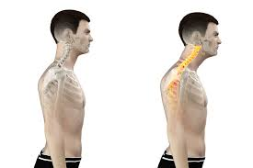 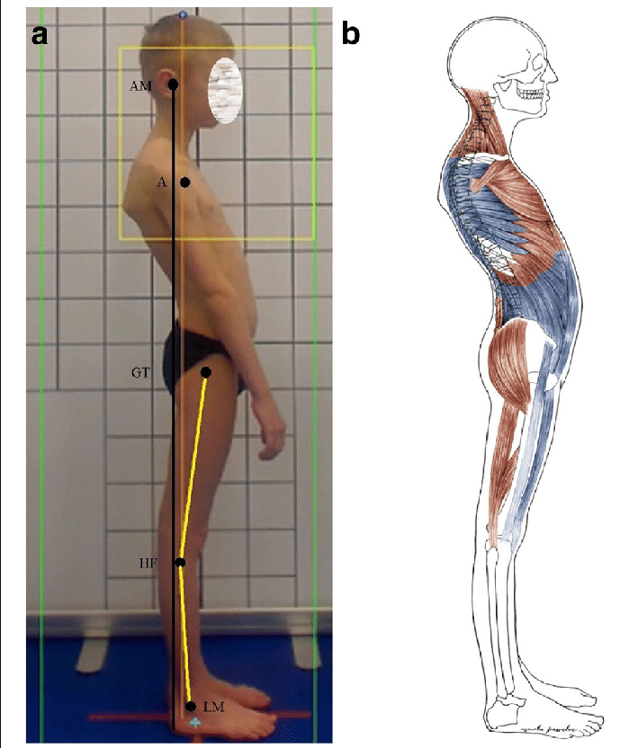 

**4. 5. 6.**

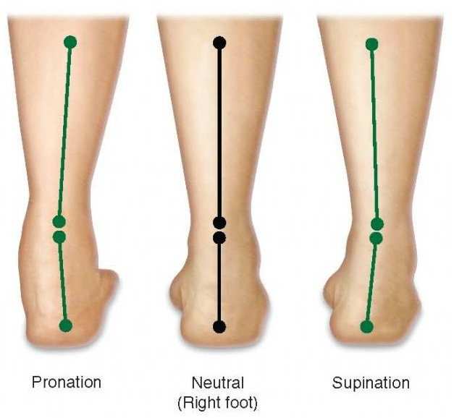 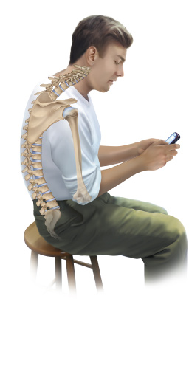 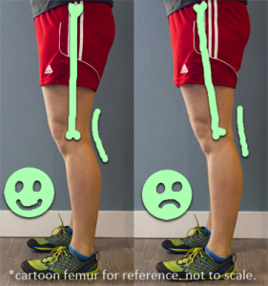

**7. 8.**

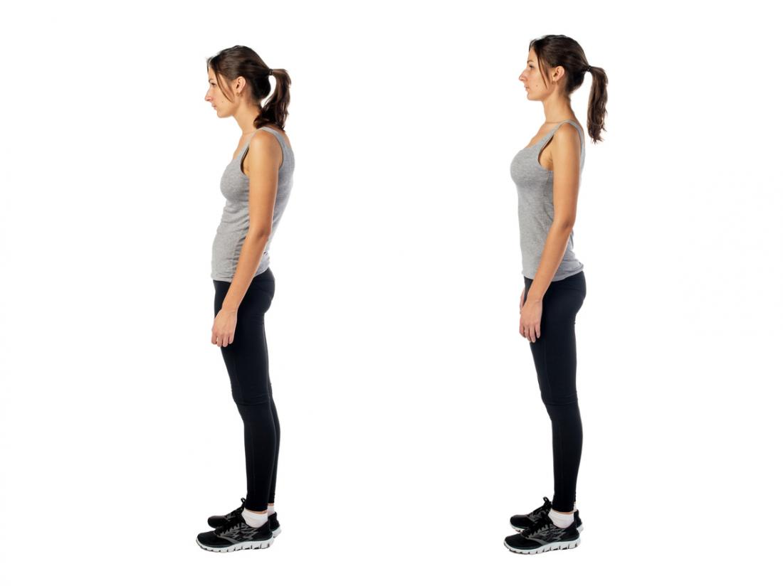 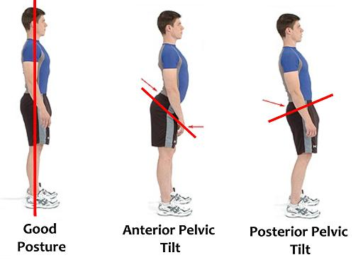

***\* Explain the meaning of the following expressions:***

***a.*** *To slouch or slump –*

***b.*** *To lock your knees –*

***c.*** *To have high arches or flat feet -*

***d.*** *To elevate or hunch your shoulders -*

***e.*** *To stand in a sway posture –*

***f.*** *To sit in a protracted position of the shoulders -*

***g.*** *Anterior / posterior pelvic tilt -*

***h.*** *To use an active / passive posture -*

***i.*** *A forward head posture -*

**3. Describing normal and abnormal posture.**

**a) How would you describe normal spinal posture (use diagram A below):**

**b) Describe the types of posture in the picture using the following phrases:**

*pelvis tilted forwards / anteriorly excessive lumbar lordosis sway standing position lower lumbar spine flattened excessive thoracic kyphosis neutral standing posture pelvis tilted backwards / posteriorly protracted cervical spine hyperextended knees*

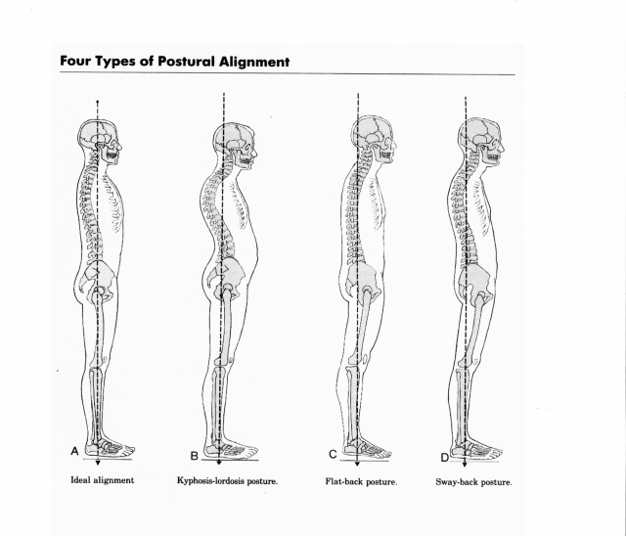

(<https://www.linkedin.com/pulse/posture-matters-dr-caroline-keddie>)

**4. Posture Assessment – practical:**

**When performing a postural assessment in a clinical scenario, what would you observe from each angle / direction:**

***\* Place in the correct column of the box where the following terms should be:***

a. The knee joint line

b. The height of the pelvis by observing the anterior superior iliac spines

c. Muscle bulk of the calf muscles (gastrocnemius and soleus muscles)

d. The position of the head and neck (or a forward head position)

e. Position of the scapulae (winged scapulae)

f. The lumbar, thoracic and cervical spinal curves or contours

g. Height of the shoulders, using the clavicles and upper trapezius muscles.

h. Pelvic position, using the posterior superior iliac spines

i. The size and bulk of the pectoralis major muscles

j. The position of the patellae

k. A sway back position with associated pelvic tilt

l. If there is a lumbar or thoracic scoliosis present

m. Posture of the lumbar spine, and any variation from the normal lumbar lordosis

|  |  |  |
| --- | --- | --- |
| **From the front** | **From the side** | **From the back** |
|  |  |  |
|  |  |  |
|  |  |  |
|  |  |  |
|  |  |  |

**5. Speaking: Factors affecting posture**

***\* Study the list of factors below and give specific examples of their impact on posture.***

|  |  |
| --- | --- |
| **FACTOR** | **EXAMPLES** |
| Structural or anatomical | a leg length discrepancy, an extra rib or vertebrae, scoliosis |
| Age | changes in posture due to ageing |
| Physiological | effects of discomfort, tiredness, pregnancy, etc. |
| Pathological | Illness, stroke, pain, mal-alignment in the healing of fractures, osteoporotic changes |
| Occupational | sedentary jobs, manual jobs |
| Recreational | playing tennis, being a committed cyclist |
| Environmental | responding to temperature |
| Social and cultural | sitting cross-legged, squatting or on chairs |
| Emotional | grieving, being angry or fearing pain |

**6. Clinical examples of using postural assessment**

**Reading – case examples:**

1. A 50 year old female presents to your physiotherapy outpatient clinic complaining of a 8 month history of pain in the lower cervical spine and bilateral upper trapezius region. Her symptoms correspond with a period of intense project work involving long working hours, regular use of a laptop during travel and offsite visits, and significant stress due to important deadlines.

- What might you see when you assess the posture of this patient?

- What would you be looking for?

1. A 25 year old pregnant female (30th week of pregnancy) presents to the women’s health department of her local hospital. She is suffering from a strong ache in her central lower back when she stands or walks for anything longer than 20 minutes. The problem has got progressively worse during her pregnancy, particularly when she had to stop exercising some weeks ago.

- What might you see when you assess the posture of this patient?

- What would you be looking for?

1. A 23 year old male patient presents to the orthopaedic physiotherapy department of a major teaching hospital. He is complaining of widespread lower and upper back pain along the left side of the spine, which is worse when standing and walking compared to sitting, but better when he swims or exercises. He reports that the pain started only after a MVA where he fractured his femur and had it repaired and fixated with a metal rod. He also reports then he feels like his normal gait pattern has changed.

- What might you see when you assess the posture of this patient?

- What would you be looking for?

1. You are treating a client who is a keen recreational runner. He has presented again with a recurring, bilateral anterior knee problem. His knee pain appears to come on after running between 5-6 km, and is worse when running up or down hills or steps.

- What might you see when you assess the posture of this patient?

- What would you be looking for?

1. Your client is a woman with pain in her left ankle. Observing her posture from the posterior and anterior views, you get the impression that she does not bear weight equally through her lower limbs but seems to favour her left leg despite this being the problem ankle. There is slightly more bulk in the left calf muscle, too. Upon questioning, the client recalls fracturing her right ankle as a child and admits to feeling fearful about bearing weight through this ankle. Even though the client knows the fracture is fully healed, she reports always having relied more on her left leg for support.

- What might you see when you assess the posture of this patient?

- What would you be looking for?

**Homework tasks:**

**Listening - The benefits of good posture**

<https://www.youtube.com/watch?v=OyK0oE5rwFY>

***\* Watch the video and answer the questions below:***

* Why is good posture important?
* What does bad posture cause?
* What does good posture look like?
* What can we do to improve our posture?

**Grammar: The conditionals**

**\**revise the structure and examples of the 1st, 2nd and 3rd conditionals below***

***\* We will practice these next seminar***

**Conditional 1:** *If + present simple, modal verb (would/will etc.) + infinitive verb*

- If she *has* another injury, she *will* retire from professional sport. - If the weather *is* bad, they *may* cancel the tournament. - If I d*on’t train* harder, I *might* not make the team….

* **Real possibility** of something that might happen – in the **future**.

**Conditional 2:** I*f + S + past simple, S + would + infinitive (s = subject)*

- If I wasn’t injured, I would play much better. - If the weather was better, they would continue with the tournament. - If I was a better player, I would win more matches

* A **possible,** but not likely **(improbable) present or future** scenario**.**
* Or, an **impossible or imaginary** situation – **present or future.**

**Conditional 3:** *If + S + past perfect, S + would + perfect infinitive (have + past participle)*

- If I had studied more, I would have passed the exam. - If I had trained harder, I would have been in better physical condition. - If I had listened to my coach, I wouldn’t have lost the match

* Refers to an **imaginary past** and how things would have been different (**in the past**). Is **imaginary / impossible**, as we can’t change the past.
* Useful to **express regret**…If I had of done something differently…