Unit 6 Orthopaedic Physiotherapy

Homework tasks:

- Reading task – case examples of posture and posture assessment from last seminar

- Listening - The benefits of good posture
https://www.youtube.com/watch?v=OyK0oE5rwFY

* Watch the video and answer the questions below:
- Why is good posture important?

- What does bad posture cause?

- What does good posture look like?

- What can we do to improve our posture?

Revision from seminar 5

Vocabulary: what clues do habitual postures give us about an individual?

- Fill in the gaps using the words listed, you may need to change the form of the word:

possess stimulus weigh severe stress align
injury arms upright base ground addition
The postures we assume provide clues to not only the condition of our bodies – traumas and (1) …………… old and new, and mild or more (2) …………. pathologies – but (3)………… how we feel about ourselves, our confidence (or lack of it), how much energy we (4) ……….. (or are lacking), how enthusiastic or lethargic we feel, or whether we feel confident and relaxed (or anxious and (5) ………….). Intriguingly, we all almost always adopt the same postures in response to the same (6) ………….. .
Observe 10 people feeling confident, motivated, and optimistic, and you will notice that most are standing (7) …………., with their chests out and heads (8) ……………, and that most have adopted a wide stance, giving themselves a wide (9) …………… of support. In contrast, observe 10 people feeling anxious, demotivated or pessimistic, and you may notice that they have shifted their (11) ……………. to one leg, and that they stoop or flex at the waist, looking at the (12)………….. rather than up and ahead. They may also cross one or both (13) ………….. against the chest in a protective manner.

Grammar: The conditionals

Conditional 1: If + present simple, modal verb (would/will etc.) + infinitive verb
- If she has another injury, she will retire from professional sport.
- Real possibility of something that might happen – in the future.

Conditional 2: If + S + past simple, S + would + infinitive (s = subject)
- If I wasn’t injured, I would play much better.
- A possible, but not likely (improbable) present or future scenario.
- Or, an impossible or imaginary situation – present or future.

Conditional 3: If + S + past perfect, S + would + perfect infinitive (have + past participle)
- If I had studied more, I would have passed the exam.
- Refers to an imaginary past and how things would have been different (in the past). Is imaginary / impossible, as we can’t change the past.
- Useful to express regret…If I had of done something differently…

*Complete the sentence for the conditional stated and using the verbs supplied:
* Also think about the meaning of the sentence.

eg: 1st: If she has another injury, she will retire from professional sport (sustain, retire)

a) 2nd: If I __________ a more ergonomic chair for my workplace, I _________________ less muscle tension in my shoulders. (buy, develop)

b) 1st: If you __________ too much fast food, you _____________ weight. (consume, put on)

c) 3rd: If ______________ a less sedentary lifestyle, I ______________________ a lower back injury. (have, not sustain)

d) 2nd: If I ________ my knees in standing, I _____________ in a sway posture. (relax, not stand)

e) 1st: If I __________ all day when I’m at work, I _______________ my neck muscles. (slouch, overstrain)

f) 3rd: If _________________ the patient’s winged scapulae, I ____________________ he has a shoulder injury. (notice, suspect)

g) 2nd: If I __________ an anterior tilting pelvis, It’s likely I __________________ an increased lumbar lordosis. (have, have)

h) 1st: If a patient ____________ high foot arches, it’s likely he ________________ lower leg problems when he runs excessively. (have, suffer)

i) 3rd: If _______________ a leg length discrepancy, I _______________________ a scoliosis. (have, not develop)

Unit 6 Orthopaedic Physiotherapy
1. Reading: Orthopaedic physical therapy

Orthopaedic physical therapy focuses on the problems of the musculo-skeletal system (muscles, bones, ligaments, tendons, cartilage). It deals with diagnosing and treating such injuries, and rehabilitation following orthopedic operations as well. Orthopaedic physiotherapists play an important role particularly in treating patients who have undergone joint replacement surgery, who have been injured due to sporting activities, and in treating conditions such as arthritis, fractures and spinal pain.

Orthopaedic physical therapy is very important for restoring the patients’ mobility, strength and range of motion following injuries or surgery. There are a variety of treatment and management tools that physiotherapists use with their orthopaedic patients. These include manual treatment techniques such as massage and joint mobilization, exercise therapy, using ice, heat and electrical stimulation. Most importantly after orthopaedic surgery is assisting patients to mobilise after resting in bed including gait re-education and teaching them to use appropriate walking aids while in hospital.

Stretching and range of motion exercises are necessary if a patient has a stiff joint which can affect normal activities severely. Proper stretching exercises can assist to preserve such functions. To help a patient in improving the function of his/her muscles, increasing endurance and maintaining or improving the range of motions strengthening exercises are used and often given as a home exercise program.

Ice and heat therapy cool down and warm up muscles respectively, and may contribute to the stimulation of blood circulation. Ice may assist in reducing swelling and inflammation also. By using ultrasound, both superficial or deep tissues may be stimulated and warmed while helping local blood flow to improve.

(adapted from http://physical-therapy-treatment.com/orthopedic-physical-therapy.html)

- Speaking: Discuss these questions:
What type of problems does orthopaedic physiotherapy focus on?
What are some common conditions seen in an orthopaedic clinic?
What type of treatments do orthopaedic physios use?
Give some examples of when ROM exercises might be beneficial?
When might strengthening exercises be useful?

2. Common orthopaedic Conditions

* Match the description of the condition with the headings listed below:

osteoarthritis fibromyalgia sub-acromial bursitis osteoporosis

carpal tunnel syndrome skiers thumb scoliosis

ruptured Achilles tendon plantar fasciitis dislocated patella

a) A condition that causes pain and tenderness in the soft tissues and muscles all over the body. It is most common in middle-aged women and is often a chronic condition.

b) A very common cause of heel pain, this occurs when the thick band of tissue on the plantar aspect of the foot becomes painful close to its attachment to the calcaneum (heel bone).

c) A degenerative joint disease, common in middle aged to older adults, where there is a breakdown of articular cartilage in a joint, and a loss of joint space. It commonly affects the large weight bearing joints (hip, knee) as well as the spine and fingers.

d) Often caused by a blow or rapid change of direction during sport, the kneecap displaces out of its normal position at the front of the knee. It is usually very painful and can become a chronic condition if not managed correctly.

e) A condition caused by inflammation of the bursa underlying the acromion process of the shoulder. The bursa may become thickened and painful, leading to limitation of shoulder range of motion and function due to pain.

f) This is an acute partial tear or rupture of the ulna collateral ligament of the thumb, often caused by a hyper-abduction trauma to the thumb. It leads to pain, swelling and loss of range of motion of the thumb, and can lead to chronic instability of the thumb.

g) Compression of the median nerve at the wrist as it passes through a small tunnel to enter the hand. Symptoms may include numbness or paraesthesia in the hand, weakness, pain and loss of normal function of the hand.

h) Usually as the result of rapid acceleration with running or jumping, the tendon of the Achilles tears completely, resulting in weakness of ankle plantar-flexion, pain, localised swelling and often bruising acutely. Normal walking is very difficult in addition.

i) A bone disease which occurs where the body loses too much, or doesn’t make enough bone. This results in thinner, brittle bones which are more susceptible to injury such as fractures.

j) A sideways curvature of the spine which may occur in children or adults, and commonly may appear during the adolescent growth spurt around puberty. The cause of scoliosis is very often unknown, but it may occur due to structural asymmetry such as a leg length discrepancy.

* Now discuss with the group some treatments which may be used with each of the above conditions:

OA: Skier’s thumb:

OP: fibromyalgia:

Scoliosis: carpal tunnel:

SAC bursitis: patella dislocation:

Ruptured TA: Plantar Fasciitis:

3. Walking aids and other orthopaedic equipment

One of the prime roles of the physiotherapist on an orthopaedic hospital ward is to assist patients to walk again following their surgery or injury. Patients often need specialised equipment to help them walk, and need to be taught safely to use the walking aid, both when walking on level ground and up / down steps.

Often a patient is unable to be discharged from hospital until the physiotherapist can state that they are safe to ambulate independently (with or without a walking aid).

* Name the type of walking aid or equipment from the description below:

Two of these are used together in order to reduce weight bearing off the affected limb. There are two types - axillary and elbow. Younger and more physically able patients are usually able to use this type of walking aid, even on day 1 post-operatively. (crutches)

This walking aid is primarily used to assist with balance, rather than to achieve any reduction of weight off the legs. Often they are used as a long-term walking aid for the elderly suffering from chronic balance issues due to aging and injury. (walking stick)

This is a more stable walking aid which has four legs and is very supportive and steady for patients to use. They may have wheels or simply four legs, and they are often used to assist patients to walk initially following a total knee or total hip replacement. (walking frame).

This equipment is applied to a fractured limb in order to immobilise the area and allow the injured bone to heal. They are kept on for a number of weeks, depending on the location and severity of the break. Following their removal ROM exercises usually need to be prescribed. (cast / plaster cast).

These are usually made from thermoplastic which allows them to be heated, and moulded around a patients limb or body part. They are often used instead of plaster in order to allow the patient to remove it, so the area can be washed or exercised while free. (splint).

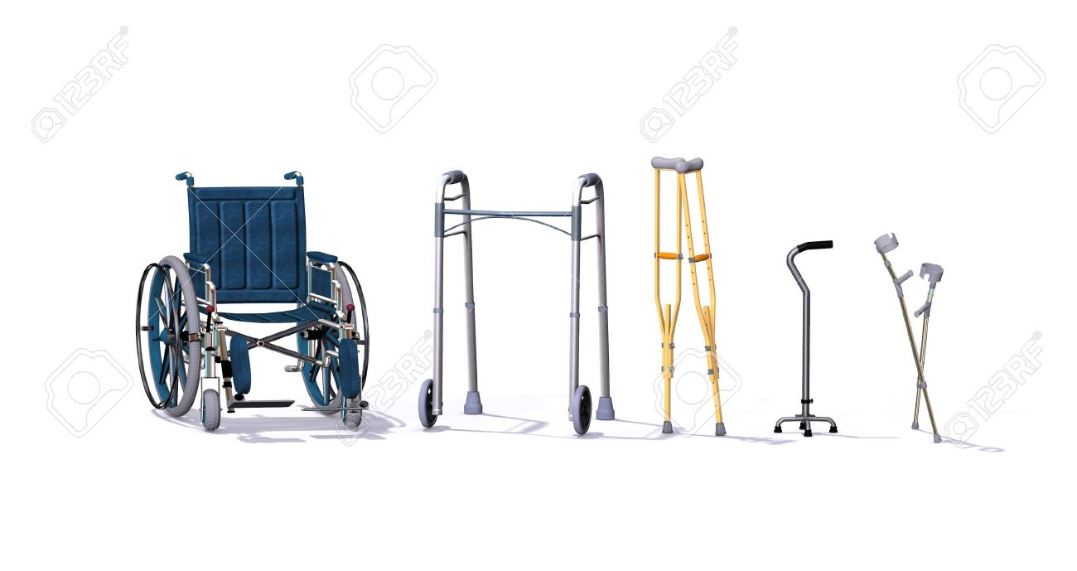

* Name the orthopaedic equipment in the picture above:

* When are these items commonly used?

4. Speaking: What is the difference between:

a) open surgery vs arthroscopic surgery

b) an X-ray vs an MRI scan

c) a guided injection vs a blind injection

d) an outpatient appointment vs a day surgery case

e) an orthopaedic surgeon vs an orthopaedic physician

f) a fractured NOF vs a THR

g) therapeutic ultrasound vs an diagnostic ultrasound

Homework tasks:
1. Word formation
- The orthopaedic specialist wrote him a …………. for a course of antibiotics. (PRESCRIBE)
- He has made a full …………. . (RECOVER)
- The lab is doing an ………… of the blood sample. (ANALYZE)
- The patient was given a hip ……….. . (REPLACE)
- The patient was given a …………. to a specialist. (REFER)
- His arm was ………… after the stroke. (PARALYSIS)
- The blood clot formed an …………… in the artery. (OBSTRUCT)
- The surgeons operated to repair the patient's …………… heart valve. (DEFECT)
- His diet is calcium-………….. . (DEFICIENCY)
- The doctor noted an …………… amount of bile in the patient's blood. (EXCESS)
- She complained of generalised ……………of her joints. (STIFFNESS)
- He was diagnosed with cancer but thankfully his tumour is …………… . (OPERATE)
- Fruit juices can be …………… to your teeth. (HARM)

2. Idioms

* Write down the meaning of the idioms below:

To go under the knife
To be under the weather
To be a picture of health
To get a taste of your own medicine
To twist a knife in the wound

