**Unit 9 Cardio-pulmonary PT**

**Homework Task**

Think about the language you would use when you are giving advice or educating a patient. In particular think about how you might advise / tell / encourage someone to:

**\* Think about choice of language and use of modal verbs:**

- ***stronger language / obligation*** eg laws, rules, strong recommendations: must / have to

- ***moderate language eg recommendation***, stronger suggestions: should, need to

- ***softer advice eg suggestions, ideas*** etc: could, may, might, try and…., you might want to try….

- ***factual / matter of fact, prescription:*** Do these exercises 3 x day, complete this program every second day

* exercise more regularly:
* stop smoking:
* try and sit better / improve their posture when they’re working:
* do their home exercise program regularly to maximise their recovery:
* warm up and stretch before or after exercise:
* to complete their exercises with good form / technique and a focus on quality:
* not to over-exercise:

**Revision from seminar 8**

***\* Correct the sentence below if needed. Think about both the meaning and the grammar:***

a) Flaccid muscles are muscles which have low muscle tone and can occur by both the trunk and peripheral muscles.

b) Motor neuron disease is progressive disease which is also known as Amytrophic Lateral Sclerosis (ALS) or Lou Gehrig’s disease.

c) Ataxia refers to a lack in muscular control and difficulty coordinating normal voluntary movements such as walking or picking up objects.

d) In a CVA the severity of the symptoms depend the region of the brain affected and the severity of the stroke.

e) In Multiple Sclerosis the myelin sheath surrounding the nerve fibres is attacked by the immune system, resulting a loss of normal conduction along the course of the nerve.

f) Physiotherapists try to maintain normal ROM on joints and to stretch muscles with increased tone and contractures, in individuals who have suffered a spinal cord injury.

g) Strengthening exercises order to reduce progressive muscular atrophy are very important for patients with Motor Neuron Disease.

h) After a stroke, most of the recovery occurs in the first half a year following the acute onset. However neurological recovery can continue to occur at months and years after initial injury.

i) In Spinal cord injury, quadriplegia means the upper limbs are affected while paraplegia means that the trunk and all four extremities are affected on the lesion.

j) Individuals with MS may experience periods of exacerbation and remission throughout the disease course, and symptoms may vary widely from different people.

**Reading: Study the conditions below. Can you guess their names?**

1. ……….. refers to a group of disorders that affect muscle movement and coordination. In many cases, vision, hearing, and sensation are also affected. It is the most common cause of motor disabilities in childhood. The symptoms vary from person-to-person and range from mild to severe. Some people with …… may have difficulty walking and sitting. Other people can have trouble grasping objects. The symptoms can become more severe or milder over time. They also vary depending on the part of the brain that was affected.

Some of the more common signs include:

* delays in reaching motor skill milestones, such as rolling over, sitting up or crawling
* variations in muscle tone, including rigid or flaccid muscles.
* delays in speech development
* stiff muscles and exaggerated reflexes
* tremors or involuntary movement
* problems with swallowing
* difficulty walking
* favouring one side of the body, such as reaching with one hand

Most children are born with ……….., but they may not show signs of a disorder until months or years later. Symptoms usually appear before a child reaches age 3 or 4. The brain damage usually occurs before birth, but it can also happen during birth or the first years of life. In most cases, the exact cause of ……….. isn’t known.

1. ….... is a progressive neurological disorder. It first presents with problems of movement. Smooth and coordinated muscle movements of the body are made possible by a substance in the brain called dopamine. Dopamine is produced in a part of the brain called the “substantia nigra.” In ………, the cells of the substantia nigra start to die. When this happens, dopamine levels are reduced. When they have dropped 60 to 80 percent, symptoms start to appear. There’s no cure for …..…. This disorder is chronic and worsens over time.

The exact cause of ……. is unknown. It may have both genetic and environmental components. Some scientists think that viruses can trigger it as well. Some of the earliest symptoms of …….. are decreased ability to smell (anosmia) and constipation. These symptoms can precede motor problems by several years.

The four major motor problems seen in ………. are:

* tremor—shaking that occurs at rest
* slow movements
* stiffness and rigidity of the arms, legs, and trunk
* problems with balance and tendency to fall

Secondary symptoms may include:

* lack of facial expression
* a tendency to ‘freeze’ when walking
* decreased blinking and swallowing
* a tendency to fall backwards
* reduced arm swinging when walking (adapted from https://www.healthline.com/health/)

**Unit 9 Cardiopulmonary PT**

**1. Speaking: *\* What is cardiopulmonary Physiotherapy?***

***\* What types of health conditions do CP physios deal with?***

***\* What types of techniques, treatments, interventions do CP physios use?***

***\* Where do CP physiotherapists work?***

**2. The Respiratory System *\* Label the diagram using the terms below:***

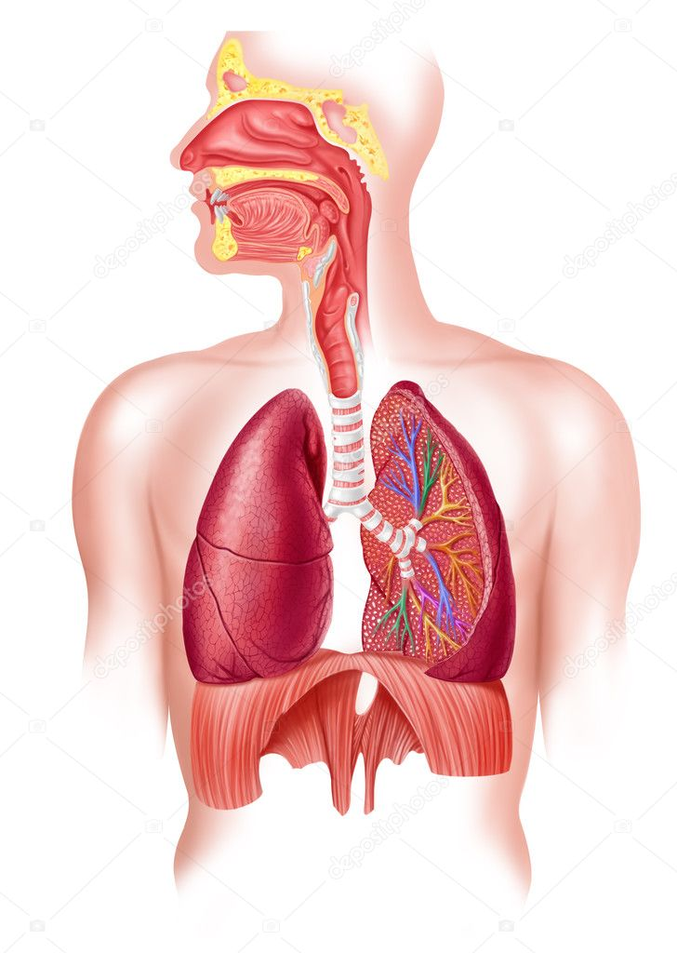 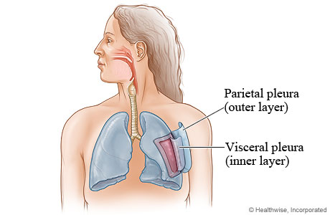

**a)** bronchiole  **b)** upper airways / throat **c)** nose / nostrils

**d)** lung **e)** alveoli **f)** bronchi  **g)** broncheoli

**2. Look at the pictures and describe what you see in them?**

**a) b)**

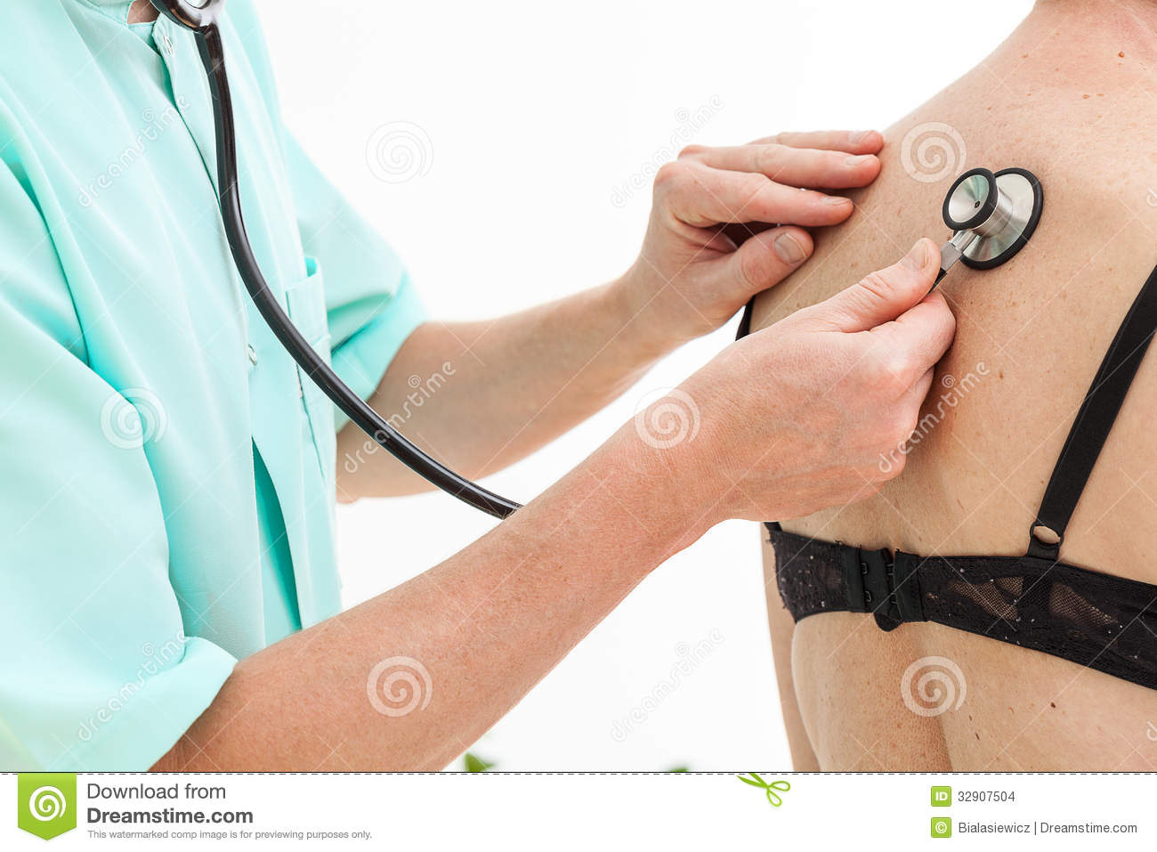 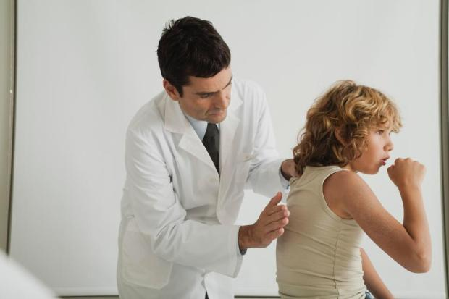

**c) d)**

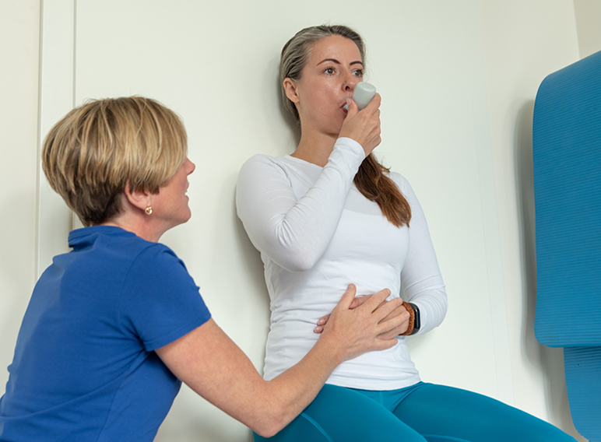 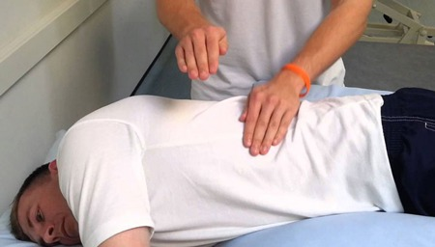

**e) f)**

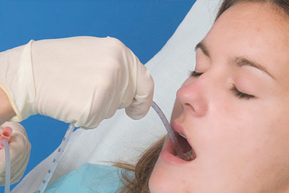 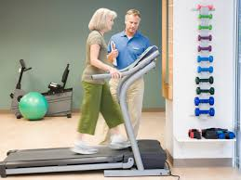

**3. Cardiopulmonary Conditions**

**\* Match the disease to its description below:**

*asthma*  *bronchiectasis* *chronic bronchitis myocardial infarction*

*cystic fibrosis*  *emphysema* *pneumonia*

*pleural effusion* *pulmonary embolism* *lung cancer*

a) An infection that inflames the air sacs (alveoli) in 1 or both lungs, and may range from being very mild to life threatening. Symptoms may include a cough, fever, chest pain and difficulty breathing.

b) A disease where there is permanent enlargement of parts of the airways of the lung. Symptoms usually include a chronic cough with mucous production, and also chest pain and shortness of breath.

c) The build up of excess fluid between the layers of the pleura, the thin membranes that line the lungs. Sometimes this condition is known as ‘water on the lungs’.

d) A condition where the airways narrow, swell and may produce extra mucous. Breathing is often difficult and attacks may include shortness of breath, coughing and wheezing. It may be minor or even life threatening.

e) The leading cause of oncological deaths worldwide, this disease begins in the cells of the lungs. Smoking is a significant risk factor and its risk rises with the length of time and amount of cigarettes smoked.

f) A chronic lung condition where the alveoli become weakened and rupture, creating larger air spaces within the lungs rather than the usual small ones. This reduces the surface area and efficiency of the lungs resulting in less oxygen reaching the bloodstream.

g) A hereditary disease that affects the lungs and the digestive system. The body produces thick, sticky mucous which can obstruct the lungs. It may be life threatening and the life expectancy of those with the disease tends to be shorter.

h) Blockage of an artery in the lungs caused by an obstruction that has moved through the bloodstream from elsewhere in the body. Symptoms include shortness of breath, chest pain and coughing up blood (haemoptysis).

i) Inflammation and irritation of the bronchial tubes. Irritation of the bronchi causes mucus build up and symptoms include a productive cough with a lot of mucus, wheezing, shortness of breath and chest tightness.

j) Otherwise known as a heart attack, this occurs when blood flow decreases or stops to part of the heart causing damage to the heart muscle. Acute symptoms include shortness of breath and chest pain which may radiate to the shoulder, neck, jaw or arm.

**4. Treatment – Case Examples**

***\* Read the case examples and complete the gaps in the text:***

**Cystic Fibrosis:** Manual chest physiotherapy is the typical airway clearance treatment for CF. The removal of thick, sticky s___________ is important to prevent o___________ of the airways and to help improve breathing. Physiotherapists use p_________ d___________, where they position the patient so that the mucus may d________ from the smaller airways into the larger airways by using g___________. They then use percussion and vibration – m___________ techniques on the chest and t_________ – to help loosen the secretions. Finally deep breathing and c___________ is promoted to help clear the airways. Patients may be seen at home for daily treatment or in a hospital or clinic setting.

***\* Describe the postural drainage positions below:***

**a) b) c)**

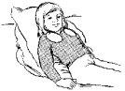 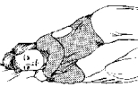 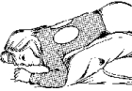

(https://www.uwhealthkids.org/cf-center/cystic-fibrosis-cf-treatment-manual-chest-physiotherapy)

**Pneumonia:** Physiotherapists help to s______ u___ recovery from pneumonia by helping patients improve their breathing, removing secretions and encouraging m_________ . Special breathing and coughing exercises are carried out, along with manual techniques to help loosen the mucus in the chest where necessary. Walking and general mobility help to encourage the lungs to function normally once again. Assistive devices such as an i___________ spirometer, designed to improve lung e___________ and help clear the airways also can be beneficial. Patients will usually be seen on the respiratory w_______ or sometimes even the i_________ c______ u_____ (ICU) of a hospital.

***\* Describe how an incentive spirometer is used to help improve breathing?***

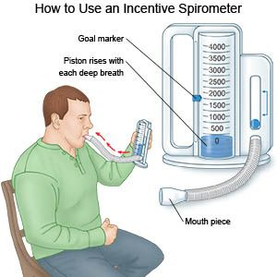

**Cardiac Rehabilitation:** Physiotherapy led cardiac rehab p__________ can be very helpful in reducing the length of h__________ stay and improving the health and quality of life for those who have suffered a heart attack. A cardiac rehab program aims to improve cardiac f__________ and capacity and increase the patient’s self ___________ through a conditioning program. Physiotherapists will often coordinate the patient a___________ and conditioning exercise programs and advise on general activities as part of a m______ -d__________ team, all aiming to maximise the patients cardiac and general health.

***\* Who else (other professions / people) may be involved as part of the MDT in a cardiac rehab program?***

(https://www.physio-pedia.com/Cardiac_Rehabilitation)

**Homework Task:**

***\* Watch the video on cardiac rehab from the link below and answer the questions:***

<https://www.physio-pedia.com/Cardiac_Rehabilitation>

Where did Fred attend his cardiac rehab sessions?

Individuals who have had what type of cardiac conditions attend for rehabilitation?

What information and guidelines to the patients receive during their rehabilitation?

When do patients usually start their cardiac rehab? What is the duration and frequency of the program?

What sorts of physical exercise did you observe during the video?