Unit 7 Diet and nutrition

Discuss in pairs: What do you think about the diet of most Czech people? What about your diet – is there anything that you should change or improve?

Task 1: Study the words in the columns. Write the correct name of the food group for each column.
1. | 2. | 3. | 4. | 5. | 6.
pasta, rice, noodles, cracker,  couscous  bread, pit(t)a, cereals, wheat, corn, oatmeal | cauliflower,  onion, lettuce, potato, cucumber, tomato, pepper, beetroot, carrot, garlic, cabbage | plum, pear, pineapple, cherries, currants, apricot, peach, raspberries, strawberries,  apple, watermelon | cheese, yogurt, cottage cheese, ice cream, soft cheese, sliced cheese, pudding, cream, whipped cream | eggs, lentils, pulses/legumes, nuts, beans, pork, bacon, beef, ham, veal, mutton, lamb, duck, goose, salmon, cod | butter, lard, margarine, cooking oil, cream

Task 2: Work in pairs. Describe at least two words from each food group. The other will try to guess which words you meant. Then switch roles.

Task 3: Read the introductory paragraph about food groups. Complete the correct prepositions.

The food groups are part of a method ........¹ classification for the various foods that humans consume in their everyday lives, based ........² the nutritional properties of these types of foods and their location ........³ a hierarchy of nutrition. Eating certain amounts and proportions of foods ........⁴ the different categories is recommended ........⁵ most guides to healthy eating as one of the most important ways to achieve a healthy lifestyle ........⁶ diet.

Task 4: Study the two food pyramids below. What do they illustrate? Which do you prefer? Compare them using the phrases for comparison and contrast (page 4).
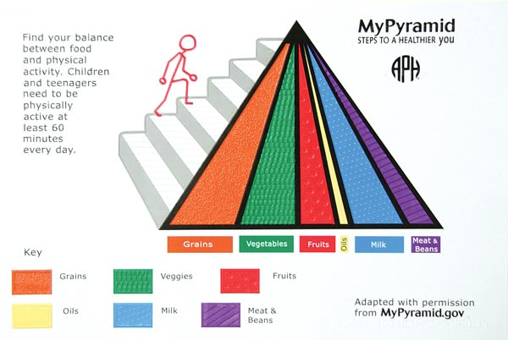

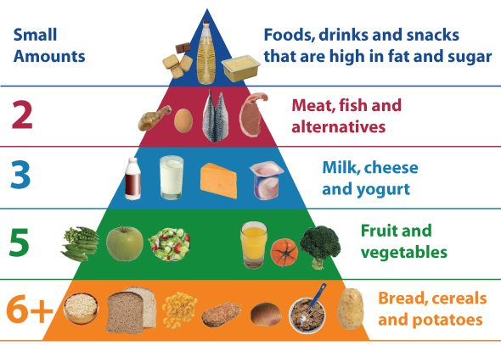

Task 5: Reading
Read the text about the food pyramid for endurance athletes, then summarise the differences between the standard diet and the diet of an endurance athlete.
Food pyramids are used to represent the portions of each food group you need to be healthy. Because athletes have different nutritional needs than non-athletes, food pyramid guides have been modified to show athletes what they should consume. In order to perform well, endurance athletes need to fulfil their energy, carbohydrate, protein and fat requirements.

Fruits and Vegetables
Endurance athletes do not need to eat more fruits and vegetable than non-athletes. Food guides recommend that everyone eats at least three servings of vegetables and two servings of fruit a day. According to the Swiss Society for Nutrition, it is okay to eat more than this recommended number of servings, but it may cause some athletes to experience gastro-intestinal problems.

Grains
Grains are an important part of an athlete's diet because they are the primary source of carbohydrates used for energy. Because whole grains are more nutritious than refined grains, they should be eaten more often. The recommended amount of carbohydrates for endurance athletes is about 6 to12 g per kg of body weight. This is based on the assumption that endurance athletes exercise at an intensity that is at least 70 percent of their aerobic capacity for more than 1 hour a day. Athletes can also eat refined sources of carbohydrates such as sports drinks and energy bars, to fill more immediate energy demands.

Dairy, Meat and Eggs
Dairy, meat and eggs are sources of protein, calcium and fat. Although athletes have higher protein requirements than non-athletes, they do not need to increase their intake of these food groups. According to a Swiss study published in the 2008 issue of the "International Journal of Sports Nutrition and Exercise Metabolism," athletes can fulfil their protein requirements by eating the recommended servings of meat, dairy and eggs, along with grains that contain protein. Many sports drinks and bars also contain protein to fill the demand.

Oils
Oils are a liquid form of fat that comes from plants. They are important dietary sources of essential fatty acids that you need for proper cell function and health. Athletes need more healthy fats than non-athletes because they have higher energy requirements. They should eat an additional half serving of oil for each hour of exercise by adding cooking oil to their food and eating nut products.
(http://www.livestrong.com/article/392079-food-guide-pyramid-for-endurance-athletes/)

Task 6: Food - vocabulary
Match the words from the box with the groups of words below to create meaningful phrases. Then use some of these collocations in sentences.
diet fruit eating meal salad food meat weight

lose / reduce/ put on / gain _________________
a balanced / a healthy / an adequate/ a special / a poor/ a slimming/ a weight-loss _________________
healthy / nutritious / organic / fresh / junk / fast/ convenience / GM _________________
a light / a heavy / a big / a nourishing / a lovely / our main _________________
ripe / tropical / rotten / tinned _________________
white / red/ lean / fatty / raw / bad / frozen _________________
a potato / a green / a fruit / a side _________________
comfort / binge / ________________ / disorder

COMPARING AND CONTRASTING – PHRASES
(https://www.dlsweb.rmit.edu.au/lsu../content/4_WritingSkills/writing_tuts/linking_LL/linking3.html)
Comparison
- Similarly
- Likewise
- Also
- Like
- Just as
- Just like
- Similar to
- Same as
- compare(d) to / with

Contrast
- However
- Nevertheless
- Although / even though
- In contrast (to) / in comparison
- While
- Whereas
- On the other hand
- On the contrary

Homework: GRAMMAR - Tenses
Study the examples below and then write your own sentences on the same topic:
EATING HABITS
- Present Simple
I eat out a few times a week.
- Present Continuous
I am trying to lose weight these days.
I´m cooking dinner for a few friends tonight.
- Past Simple
I had a tuna salad for lunch yesterday.
- Past Continuous
I cut my finger when I was preparing this fish dish.
- Present Perfect Simple
I´ve already had three cups of coffee today.
- Present Perfect Continuous
I have been following the diet of wild meat, nuts, fruit and vegetables for two weeks.
- Past Perfect
I had been a few kilos overweight before I changed my lifestyle in adulthood.
- Future
I think you will feel better if you give up eating junk food.
- Future Perfect
I will have lost 5 pounds by the end of this year.
- Going to
I´m going to eat regularly, healthily and stick to a balanced diet – starting tomorrow!

