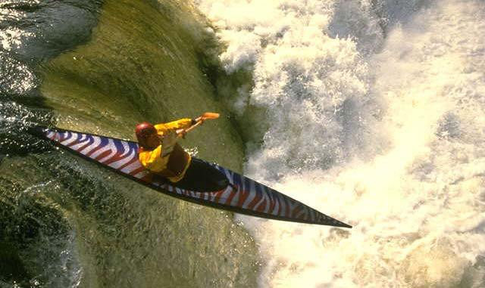

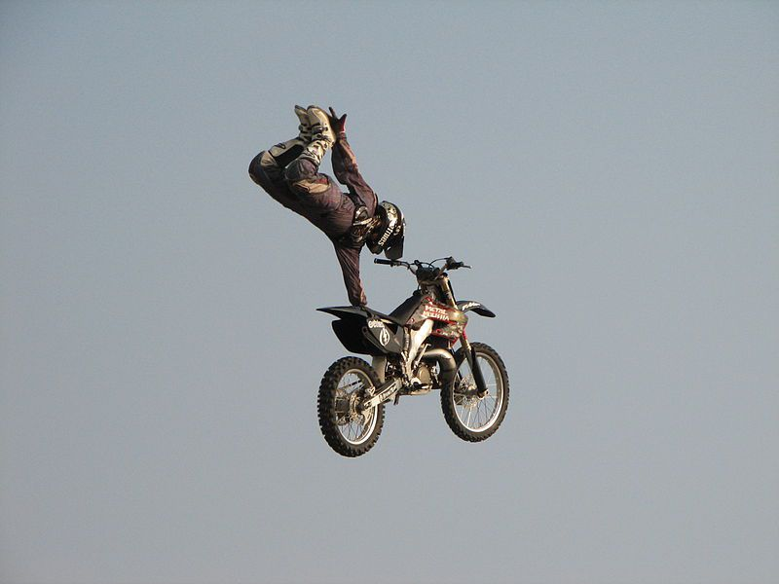

[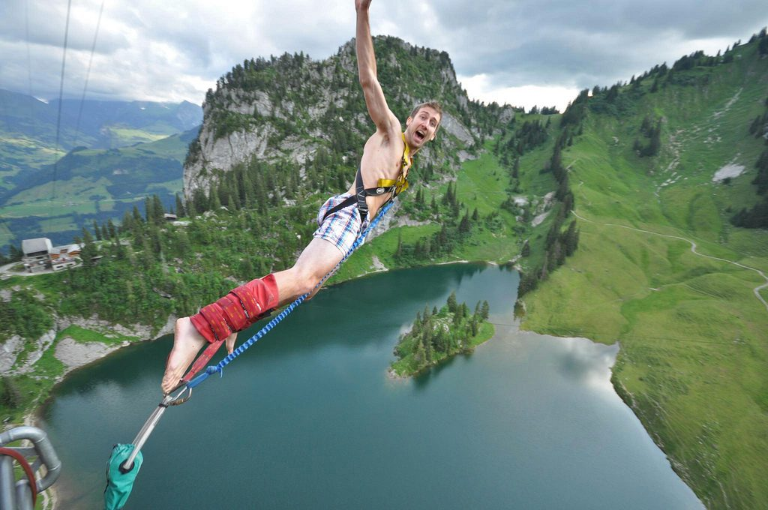](https://awe365.com/content/uploads/2017/09/10-best-bungee-jumps-in-Europe-Bungy-European-style-flickr-CC-image-by-Alan-Light.jpg)

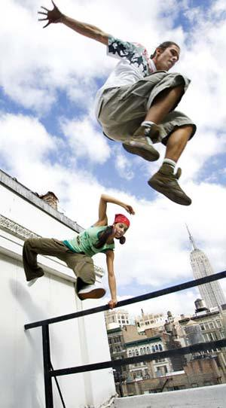

[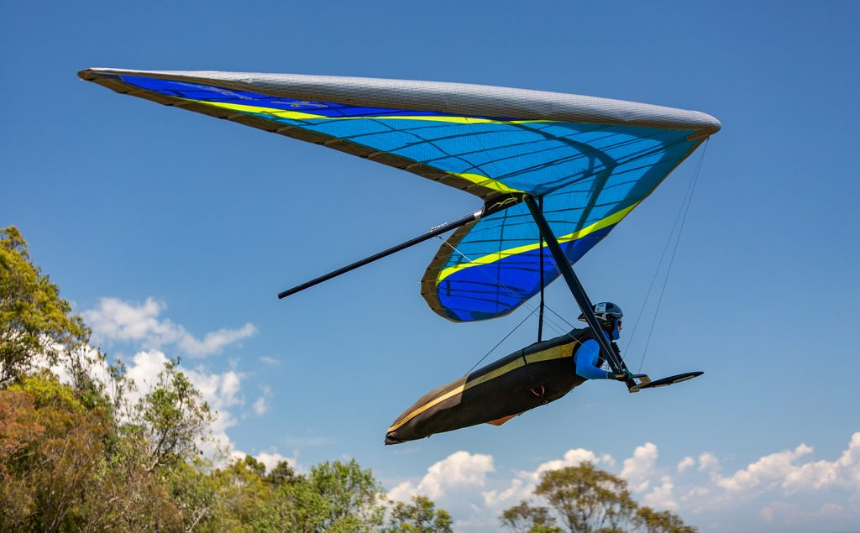](https://awe365.com/content/uploads/2013/07/Hang-gliding-one-of-the-many-types-of-extreme-sport-Ultimate-list-of-adventure-sports-Flickr-CC-image-by-texaus1.jpg)

[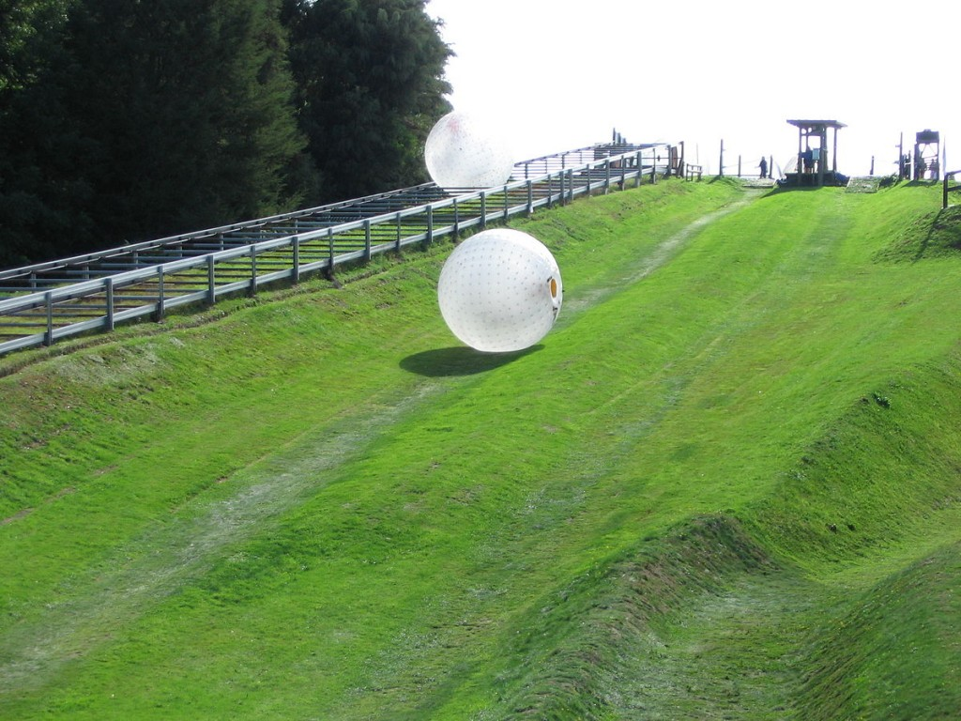](http://www.365hops.com/blog/wp-content/uploads/2015/06/1200px-Zorbing.jpg) 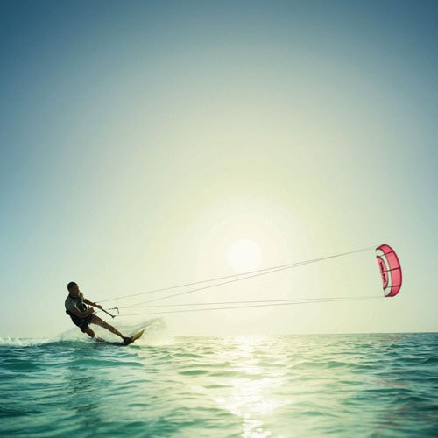

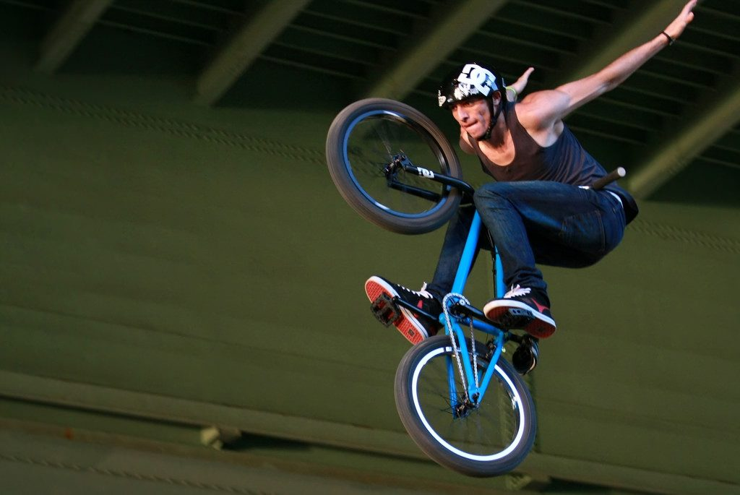

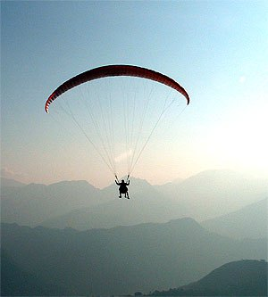

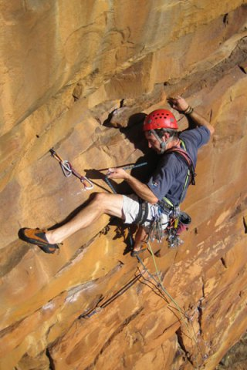

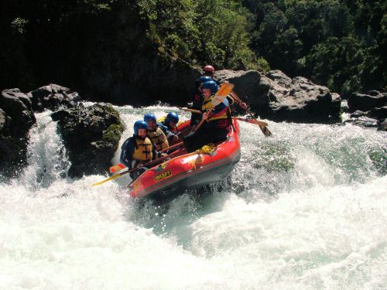

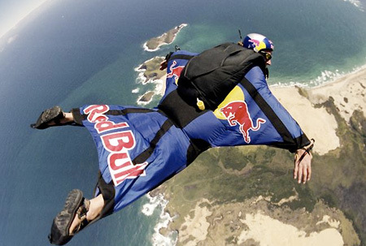

Advertisements

[](https://awe365.com/content/uploads/2016/03/How-to-maintain-your-skydiving-gear-Flickr-image-by-Philip-Leara.jpg)