**p947/15, p947/16 Tělesná výchova – Turistika – pěší**

**Základní informace k předmětu**

Both seminar groups p947/15 and p947/16 will have a common program. The lesson will take place between January 4-8, 2023. The subject program is a winter crossing of the highest Czech mountain range, the Krkonoše.

**Necessary equipment:**

Gore jacket, gore pants (softshell), second layer, underwear (merino/ice breaker), etc. , hat 2 pcs, warm gloves 1x, gloves 1x, high boots, boots or snowshoes (to be specified according to the conditions), sleeves, backpack approx. 40 l., sleeping bag, mat, headlamp, thermos for tea, sunglasses, socks, spare socks, slippers for huts, other clothes for staying in huts, towel, basic hygiene, small snack for the trip, cash, mobile phone (telescopic poles). Without this equipment, the course cannot be completed!!!!

It could also be useful: payment card, additional insurance, sunscreen, lip balm, camera.

**Program:**

1 day:

4/1/2023

Arrival in Harrachov individually - pension Varšavjanka. Meeting until 17:00. Introductory meeting, introduction and introduction, lecture on safety and movement in mountain terrain, how to use crampons (snowshoes).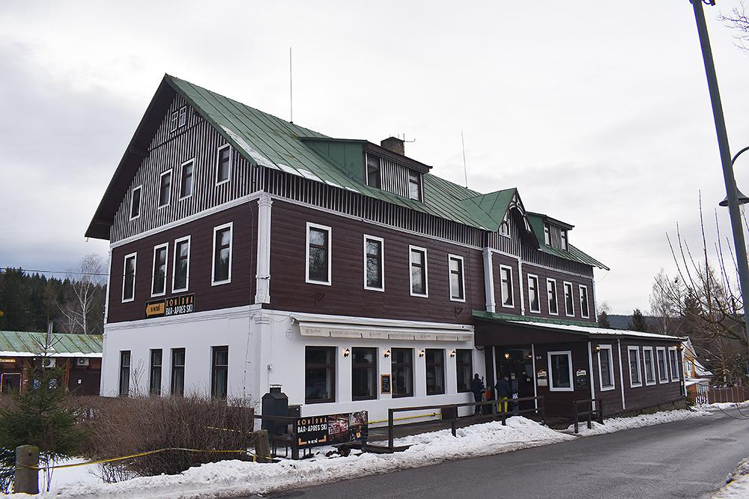

2. Den:

5/1/2023

Breakfast at the Varšavjanka guesthouse, approx. 9:00 a.m. departure towards Labská bouda, approx. 3:00 p.m. Labská bouda. Free program.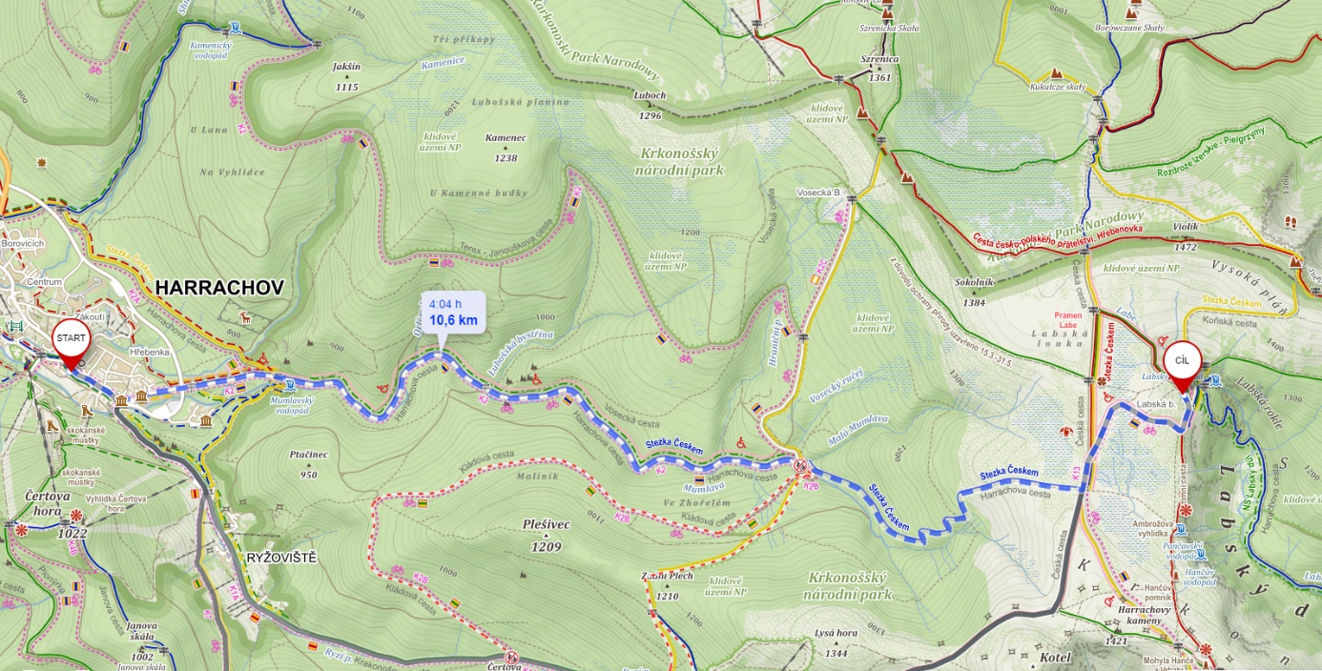

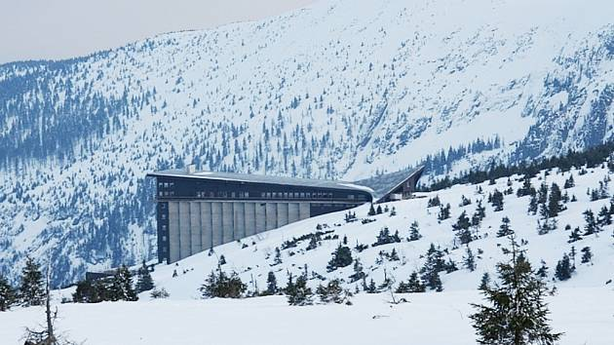

3. Day:

6/1/2023

Breakfast at Labská bouda, approx. 8:00 a.m. departure towards Luční bouda, approx. 4:00 p.m. Luční bouda. Wellness + free program.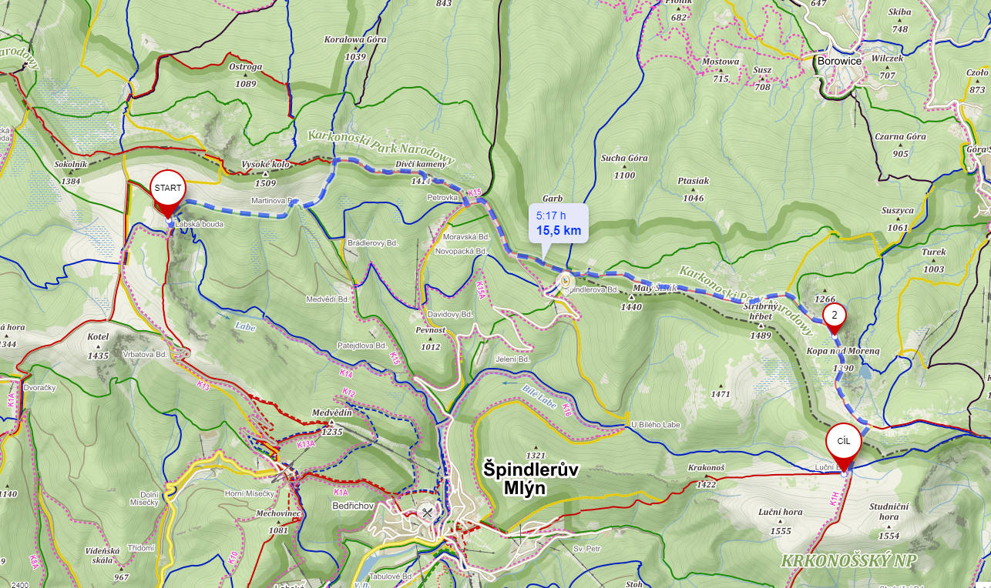

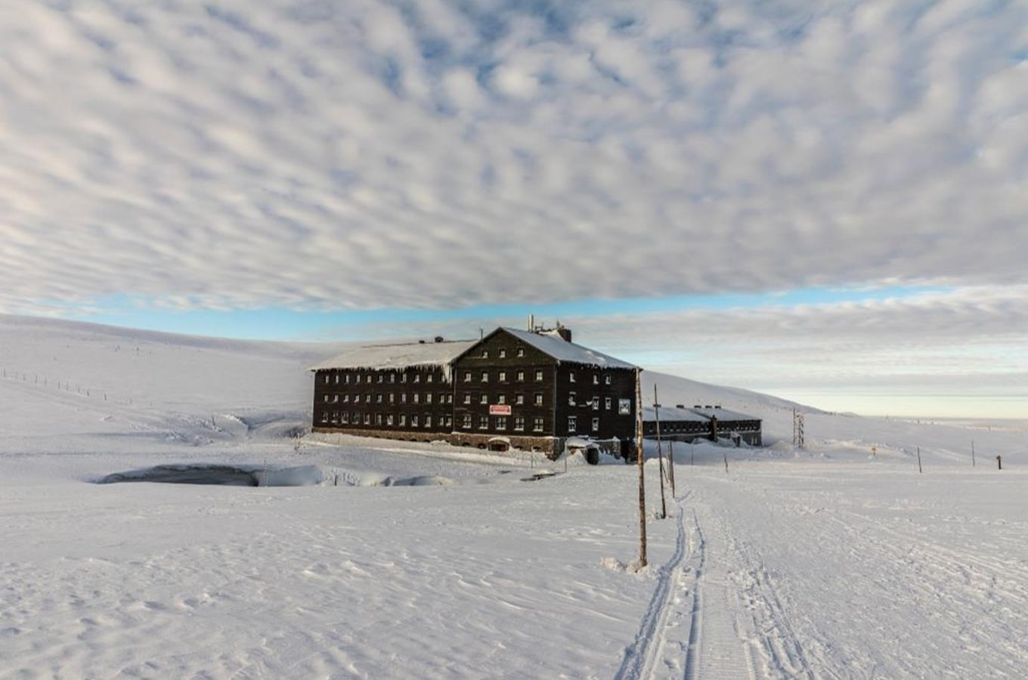

4. Day:

7/1/2023

Breakfast at Luční bouda, approx. 8:00 a.m. departure towards Pivovar Trautenberk (Horní Malá Úpa), approx. 4:00 p.m. Pivovar Trautenberk. Free program.

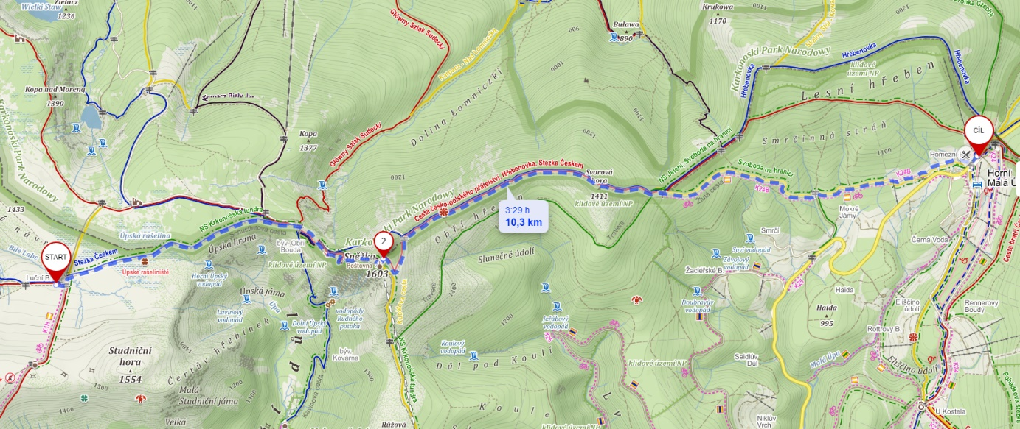

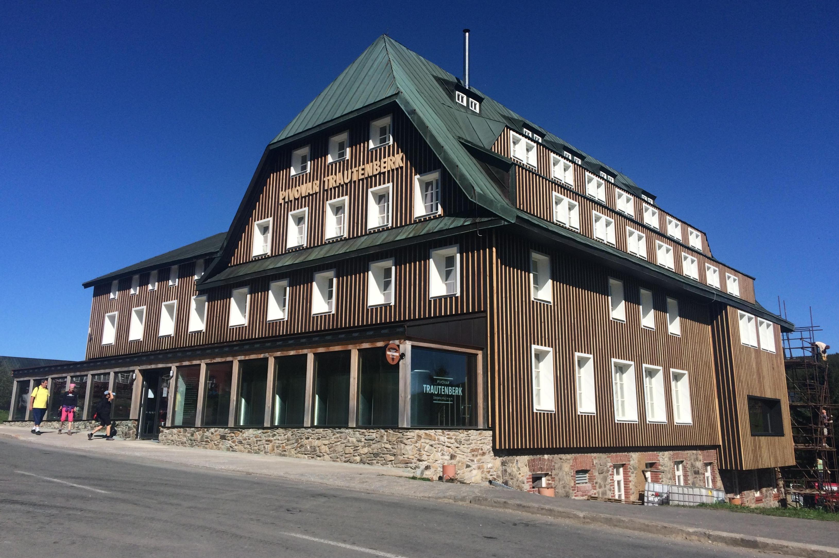

5. Day:

8/1/2023

Breakfast at the Trautenberk brewery, after breakfast the end of the event and individual departure.

The whole event is physically demanding. In total, we will cover at least 37 km in three days with an elevation gain of at least 1,600 meters. Consider carefully whether you have the necessary fitness for such an event. As it is a transition, there is not much room to send someone home during the event. All the time, you will carry all the necessary equipment on your back, approx. 6-10 kg. The first day we sleep in the boarding house (bed), the next days we sleep in sleeping bags on mats in common areas (sleeping rooms).

Price: 3,000 CZK - accommodation and breakfast included.

Lunches and dinners are provided by everyone separately.

Link to the business center:

The event is traded between September 20 and October 15, 2022

https://is.muni.cz/obchod/baleni/276430

Link to last year's video:

https://youtu.be/n6gy0Pcr-wQ