4 Sports Injuries

1. Name the exercises in pictures 1-10 and match the exercises with the descriptions a) – j)
What type of exercise is each one? E.g. flexibility, strengthening etc.
straight leg raise quads stretch shoulder elevation push ups standing balance bridge position calf stretch heel slides (knee flexion) standing forward bend sit ups
- Laying supine with the knees bent, lift your bottom up off the ground:
- In standing, link your hands then lift both arms forwards and up towards the sky:
- Standing on one leg, pull your foot up behind you towards your bottom:
- In supine with one knee bent up and keeping the other leg completely straight, tighten your quad muscles and lift the leg straight up and down 10 x:
- Laying on your back, hands behind your head and knees bent up, lift your trunk up and down to work your abdominal muscles:
- Standing on one leg, lift the other leg up and try and maintain your balance, while closing your eyes:
- Laying on your back with the legs out straight, slowly slide one heel up towards your bottom, then return back down:
- Leaning into the wall with one leg behind you, one leg in front – lean forwards until you feel a stretch in the back leg:
- Starting in prone, lift your body up and down off the floor using your arms with your knees straight and feet contacting the floor:
- In standing with your knees straight, slowly stretch your arms down towards your toes, until you feel a stretch in your hamstrings or lumbar spine:

1 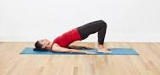 2 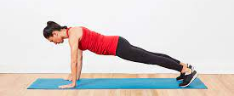

3  4 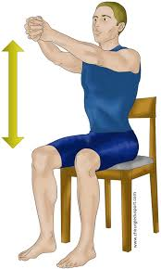 5 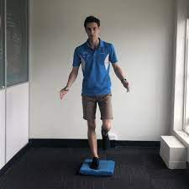

6 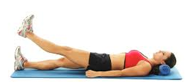 7 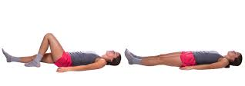

8 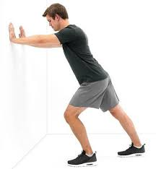 9 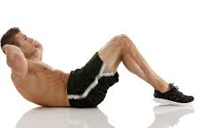 10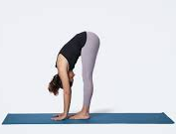

2. Discuss the questions:
Why do people get injured playing sport or exercising?

If sport causes injuries, should people avoid playing sport?

What specific things should people know about to avoid injuries or the development of diseases?

What are some common sports injuries?

3. Complete the gaps using the correct form of the verb in brackets:
(most are past simple, past continuous, present perfect continuous and present perfect)

- Ouch! I just stepped in a hole and I think I _________________ my ankle (sprain).
- Yesterday I ______________ too quickly and I hit my shin on the corner of the bed (walk).
- The doctor ______________ the patients neck rotation, when suddenly the patient fainted (examine).
- Last year I _____________ my lower back when I was lifting something very heavy (injure).
- I ______________ here for 1 hour for the doctor….and my chest pain is getting worse! (wait).
- Did you hear that Tim fell off his bike yesterday? He _______________ to the orthopaedic clinic today as he thinks he ______________ his arm (go, break).
- Last year playing football I _____________ my ACL. Now my knee always hurts, so I wonder if I am ______________ arthritis in it (develop).
- Mary has just ______________ with type 2 diabetes. The specialist said she has to eat a more balanced diet with less sugar and exercise more (diagnose).
- The man was unlucky when he had a car accident, as he ___________ 3 ribs and also ___________ his scapula. He has a lot of pain around his chest and upper back (break, fracture).
- During the hockey season last year I ____________ my thigh muscle when I _____________ for the ball. It ___________ several months to full recover (injure, run, take).
- I ________________ a splitting headache all day, I need to take some pain killers (have).
- Yesterday I _____________ severe back pain all day but today it feels much better (have).
- Unfortunately Tom ____________ a cold right before his tennis match and couldn’t compete. He was unlucky as he _______________ extremely hard in the lead up to the tournament (catch, train).
- I __________________ a lot recently so I’m feeling really fit and healthy! (work out).
- James _____________ in hospital last year after suffering from a serious heart attack (treat).

4. Which of the below are the causes and which are the symptoms of sports injuries? Can you think of some other causes and symptoms?

- athletic equipment that malfunctions or is used incorrectly
- weakness and pain
- falls
- limited range of motion
- swelling
- forceful high-speed collisions between players
- instability or obvious dislocation of a joint
- inability to move a limb
- wear and tear on areas of the body that are continually subjected to stress
- muscle spasm

5. Sports injuries http://www.fftoolbox.com/football/football_injury_glossary.cfm
a) Check the pronunciation of these words:
inflammation - concussion – contusion – fracture – meniscus – cartilage – recovery – severe – chronic

b) Watch the video and answer the questions. What happens when you have a concussion? https://ed.ted.com/lessons/what-happens-when-you-have-a-concussion-clifford-robbins/review_open#question-8
- What happens to neurons when the brain is suddenly jolted?

- How can the damage manifest?

- What makes post concussive syndrome likely to develop?

- What is a sub-concussive blow? What is the cumulative effect of such blows?

c) Study the list of injuries below. Do you know their Czech equivalents? Which of the injuries have you suffered? Which are most serious? Can you estimate the time needed for recovery after some of the injuries?
Achilles Tendinitis
The Achilles tendon attaches the muscles of the lower leg (gastrocnemius and soleus) to the heel. Achilles tendinitis is inflammation of this tendon generally caused by overuse or a direct blow.
Cruciate Ligament Injury
The anterior cruciate ligament (ACL) and the posterior cruciate ligament (PCL) attach the thighbone (femur) to the shinbones (fibula and tibia) acting to stabilize the knee joint. The ACL and PCL can be injured primarily by rotational forces on the knee. ACL and PCL sprains are categorized as first, second, and third-degree.
Concussion
A concussion is caused by a direct blow to the head. Depending upon the severity of the concussion, injury can cause varying levels of impairment of brain function. Concussions are categorized as mild (grade 1), moderate (grade 2), or severe (grade 3) depending upon symptoms.
Contusion
A contusion is basically a deep bruise that is caused by direct impact. In football we generally hear about quadriceps (thigh) contusions.
Dislocation
A dislocation occurs when the ball of a joint is forced out of its socket (i.e. arm forced out of the shoulder joint). A dislocation must be reset by proper medical professionals.
Fracture
A fracture is a break, crack, or shattering of a bone. In closed fractures, the broken bone does not pierce the skin, while in open fractures, the broken bone breaks the skin's surface.
Meniscus Injuries
The medial and lateral menisci are the cartilage shock absorbers located inside the knee joint. These can be damaged by excessive twisting, turning, or compression at the knee joint, which produces tears. Due to the poor blood supply, meniscal injuries generally require surgery for repair.
Sprain
This is an injury that involves the stretching, partial tearing, or complete rupture of a ligament. Sprains are categorized as first, second, or third degree. Sprains occur when a joint is forced beyond its normal range of motion, such as turning or rolling your ankle.
Stinger
A stinger, also called a burner or nerve pinch injury, is a very common injury in football. This injury involves a stretch or compression of the brachial plexus (a complex system of nerves that involve the back, neck, shoulders, and arms). Stingers generally cause shooting pain down the arm(s).
Strain
Strains are injuries that involve the stretching, partial tearing, or complete tearing of a tendon. Strains are categorized as first, second, or third degree. Chronic strains are injuries that gradually build up from overuse or repetitive stress.

6. Treatment of injuries

Explain what the acronym RICE means. Why is it relevant in sports physiotherapy?

R

I

C

E

Now explain what HARM means. Why is this important for a patient with a sports injury to know?

H

A

R

M

Match the words below with pictures:

elastic bandage wrap – sling – knee sleeve – arm splint - sticking plaster - knee brace

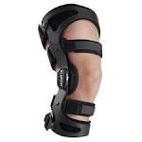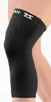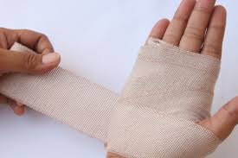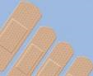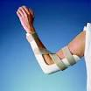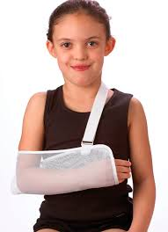

7. Subjective questions for the injured patient. Complete the phrases:

Do you know what ___________ or triggered the problem?

_____________ this problem before, so far in your life?

Are you in p ______?

Where does it h______ ?

Is it _________, moderate or severe pain?

Is the pain s________ or dull, __________ or intermittent?

Do you have any tingling s __________or _______ and needles in your hands or feet?

Does the pain feel deep or ____________ (on the surface of the skin)?

Did the symptoms start ____________ or come on more gradually?

Do you have any ___________ pain going down into your lower limb?

HOMEWORK
Complete the gaps with the expressions highlighted in the text 5c), change the form if necessary:
The operation was only a ………………….. success.
Renal ……………….. needs to be treated urgently.
If your bone is broken, you need to see a professional to have it …………….. .
………………. exercise can lead to muscle strain.
The needle …………….. his skin.
Football is a low- ………….. sport – there is little stress on joints.

