Systematic review: a summary of the literature using reproducible methods to systematically search, appraise, synthesize results, and report bias of included studies. It is usually performed by three and more co-authors.
STEPS

Topic definition | Benefits of Esport  Červinka, A. (2024). Pozitiva esportu [Master's thesis, Masaryk University]. Institutional repository MU. https://is.muni.cz/th/rrz4j/
Define study problem (PICO criteria) | - P (Population): The population or patients that the study focuses on. It defines who the study participants are.  - I (Intervention): The intervention being investigated. This can be a medical procedure, drug, diagnostic test or other medical intervention.  - C (Comparison): A comparison or control group that is used to compare the effects of an intervention.  - O (Outcome): The outcome or consequence that is measured and investigated in the study.
PRISMA Guideline | - PRISMA (Preferred Reporting Items for Systematic Reviews and Meta-Analyses) is a methodological framework and set of guidelines designed to ensure transparency and quality in the processing of systematic reviews and meta-analyses.  - The purpose of PRISMA is to increase transparency and facilitate the critical evaluation and reproduction of systematic reviews and meta-analyses.
Database search | Databases MEDLINE, SportDiscus, IEEE Xplore Digital Library and Web of Science, …  (esport* OR e-sport* OR "digital sport*" OR "electronic sport*" OR "online sport*" OR "virtual sport*") AND (advancements OR assets OR advantage OR benefit OR bonus OR favors OR gain OR merits OR perks OR plus OR positive OR profit OR provision OR privilege OR profits OR reward)
Selection process (using software Rayyan) | 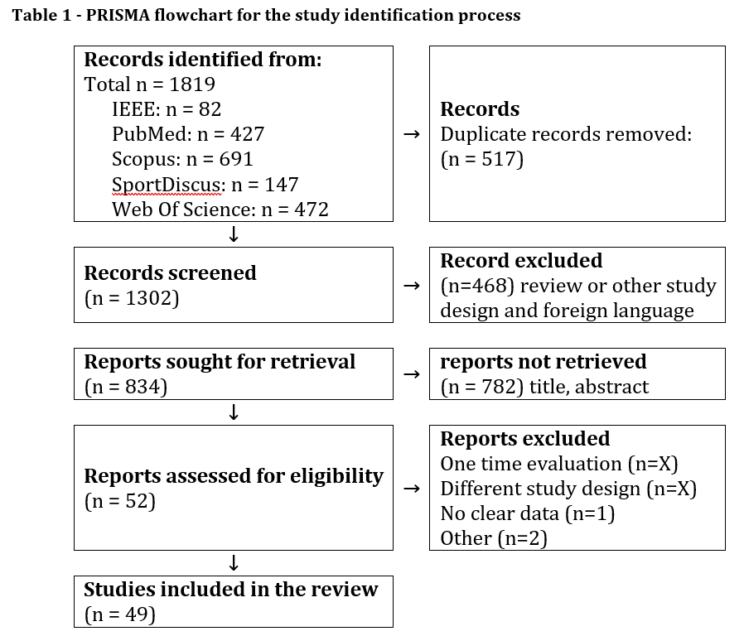
Study Quality | Evaluation of the quality of studies according to criteria  Downs, S. H., & Black, N. (1998). The feasibility of creating a checklist for the assessment of the methodological quality both of randomised and non-randomised studies of health care interventions. Journal of Epidemiology & Community Health, 52(6), 377–384. https://doi.org/10.1136/jech.52.6.377  Final scores were converted to percentages and methodological quality was classified as follows: <45.4% “poor” methodological quality; 45.4–61.0%, “fair” methodological quality; >61.0%, “good” methodological quality
Describe the Results  (Data analysis) | - General interpretation of results in the context of other evidence  - Implications for practice, the field, and future research  - Limits of the studies included in the research  - Limits of the systematic review procedure  - Cognitive & psychological benefits. Esport’s cognitive and psychological benefits were the primary focus of most studies analyzed, with 23 (see Tables 13-17) addressing these benefits. The overall findings suggest a positive influence on various cognitive functions including attention, speed of information processing, and decision -making abilities. Additionally, other frequently reported benefits include visual spatial memory (Benoit et al., 2020; Campbell et al., 2018; Grushko et al., 2021; Wechsler et al., 2021), Pleasure or enjoyment (Abbasi etl., 2023; Baltezarević & Baltezarević, 2019; Carboine et al., 2018; Guo et al., 2020; Leung & Chu, 2023; Onishi et al., 2022). Furthermore, Campbell (2018) reported that esports also offer numerous benefits to children with dyslexia such as enhancing word recognition and reading efficiency.  - Social Benefits Out of 49 research projects, 25 (see Tables 18-22) evaluated the positive effects on society. The results revealed three main advantages: enhancement of social relationships and community cohesion, stronger interpersonal connections, and better communication abilities. Communication was identified as the most cited benefit (40% of studies). Notably, Tabacof (2021) conducted a study that concentrated on individuals with spinal cord injuries and examined the influence of esport activities on their social well-being. The findings indicated that following participation in these activities, patients experienced an increased sense of belonging within their social circles and reduced feelings of isolation.  - Educational and career benefits Among the 10 (see Tables 23, 24) research studies that investigated the educational and career advantages of esports, one highlighted the potential for improvement in academic performance (Delello et al., 2021). Another pair of studies demonstrated how esports could serve as an effective learning tool (Bisht et al., 2022; Wong et al., 2011), while four other studies focused on career prospects and financial autonomy achievable through participation in esports (Harris et al., 2022; Lu et al., 2010; Keskin & Aral, 2021; Shynkaruk et al., 2021; Willis & Manik, 2022). These opportunities included skills development such as coding (Keskin & Aral, 2021) or media production expertise (Harris et al., 2022). Lastly Türkay et al. (2021) suggested that VR sports have future potential for use in medical team training. RESULTS 40  - Physical Benefits The physical benefits were examined in 9 studies (see Tables 25, 26) and on the results showed that playing esport reduces the risk of obesity in children and adolescents due to the increased motivation in physical sports and real-world exercising (Fletcher et al., 2020; Ketelhut et al., 2021; Ningning & Wenguang, 2023; Ruth et al., 2022). Two studies (Ersin et al., 2022; Onishi et al., 2022) found, that by playing esport your heart rate and energy expenditure is higher than during the sitting. Ersin et al. (2022) highlighted the improvement of hand-eye coordination as in his study, the professional athletes had comparable reaction times as professional esport athletes. One study found, that VR sports are considered as a physical activity and have health benefits (Türkay et al. 2021). Lastly, Rossoni et al. (2022) mentions the possible injury prevention strategies and programs.
Summarize the findings, discussion, conclusion)

