seminární skupina

 |  | Frequency | Percent | Valid Percent | Cumulative Percent
Valid | A | 24 | 29,3 | 29,3 | 29,3
Valid | B | 25 | 30,5 | 30,5 | 59,8
Valid | CD | 12 | 14,6 | 14,6 | 74,4
Valid | kombinovaní | 21 | 25,6 | 25,6 | 100,0
Valid | Total | 82 | 100,0 | 100,0

Četnosti - lateralita

ruka1

 |  | Frequency | Percent | Valid Percent | Cumulative Percent
Valid | levou | 5 | 6,1 | 6,1 | 6,1
Valid | pravou | 77 | 93,9 | 93,9 | 100,0
Valid | Total | 82 | 100,0 | 100,0

ruka2

 |  | Frequency | Percent | Valid Percent | Cumulative Percent
Valid | levou | 6 | 7,3 | 7,3 | 7,3
Valid | pravou | 76 | 92,7 | 92,7 | 100,0
Valid | Total | 82 | 100,0 | 100,0

noha1

 |  | Frequency | Percent | Valid Percent | Cumulative Percent
Valid | levou | 10 | 12,2 | 12,2 | 12,2
Valid | pravou | 72 | 87,8 | 87,8 | 100,0
Valid | Total | 82 | 100,0 | 100,0

noha2

 |  | Frequency | Percent | Valid Percent | Cumulative Percent
Valid | levou | 31 | 37,8 | 39,2 | 39,2
Valid | pravou | 48 | 58,5 | 60,8 | 100,0
Valid | Total | 79 | 96,3 | 100,0
Missing | neodpověděl | 3 | 3,7
Total |  | 82 | 100,0

ruka3

 |  | Frequency | Percent | Valid Percent | Cumulative Percent
Valid | levou | 7 | 8,5 | 8,6 | 8,6
Valid | pravou | 74 | 90,2 | 91,4 | 100,0
Valid | Total | 81 | 98,8 | 100,0
Missing | neodpověděl | 1 | 1,2
Total |  | 82 | 100,0

oko1

 |  | Frequency | Percent | Valid Percent | Cumulative Percent
Valid | levou | 17 | 20,7 | 21,0 | 21,0
Valid | pravou | 64 | 78,0 | 79,0 | 100,0
Valid | Total | 81 | 98,8 | 100,0
Missing | neodpověděl | 1 | 1,2
Total |  | 82 | 100,0

Lateralita - součtová škála

 |  | Frequency | Percent | Valid Percent | Cumulative Percent
Valid | -6 | 2 | 2,4 | 2,6 | 2,6
Valid | -4 | 2 | 2,4 | 2,6 | 5,1
Valid | 0 | 3 | 3,7 | 3,8 | 9,0
Valid | 2 | 7 | 8,5 | 9,0 | 17,9
Valid | 4 | 30 | 36,6 | 38,5 | 56,4
Valid | 6 | 34 | 41,5 | 43,6 | 100,0
Valid | Total | 78 | 95,1 | 100,0
Missing | System | 4 | 4,9
Total |  | 82 | 100,0

Bar Chart
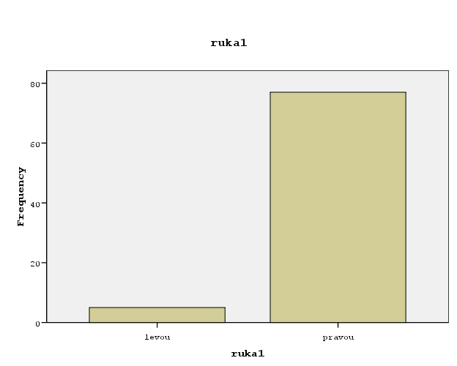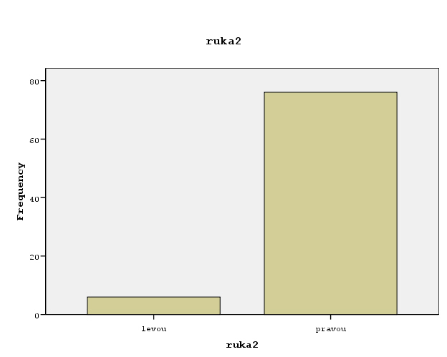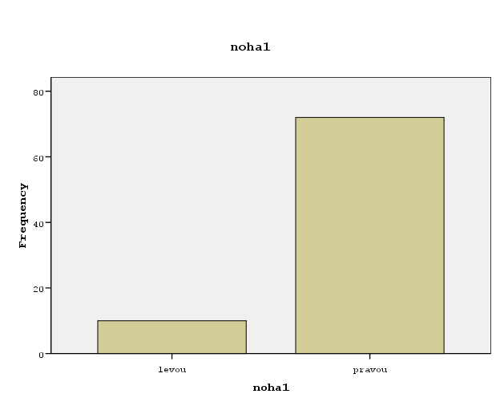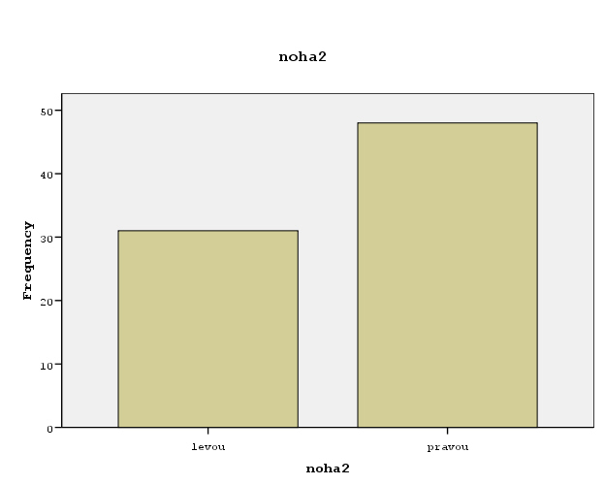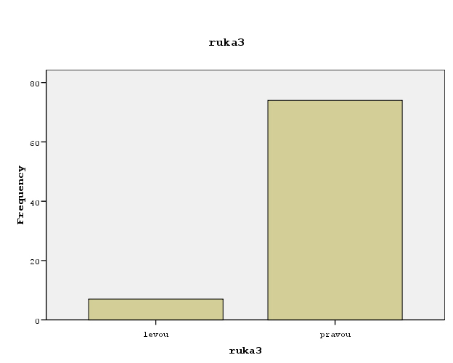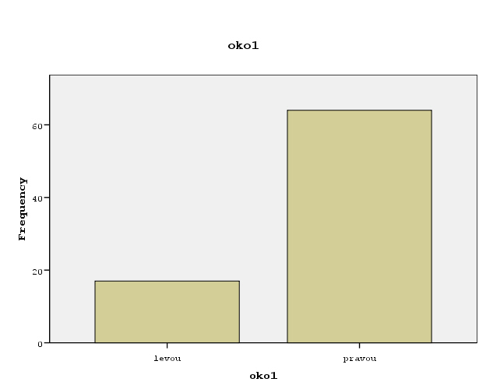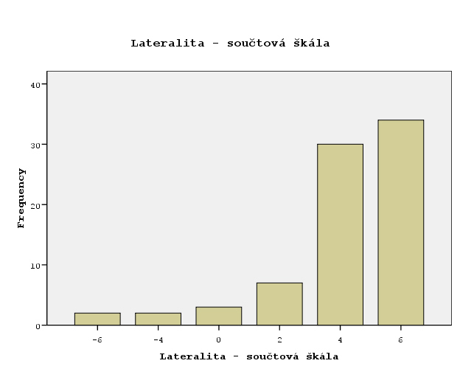

Histogram
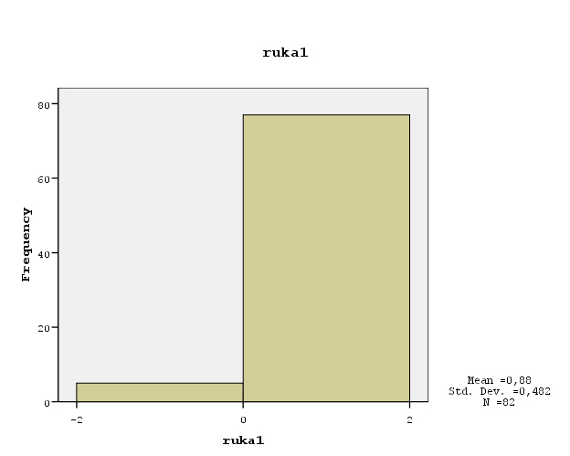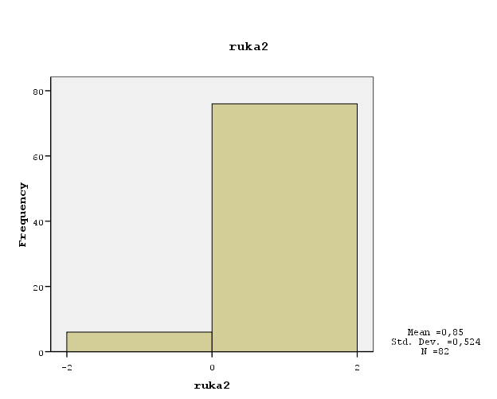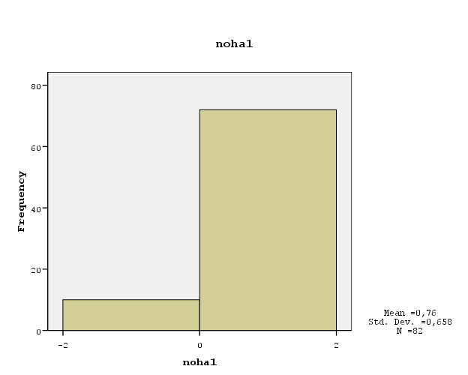

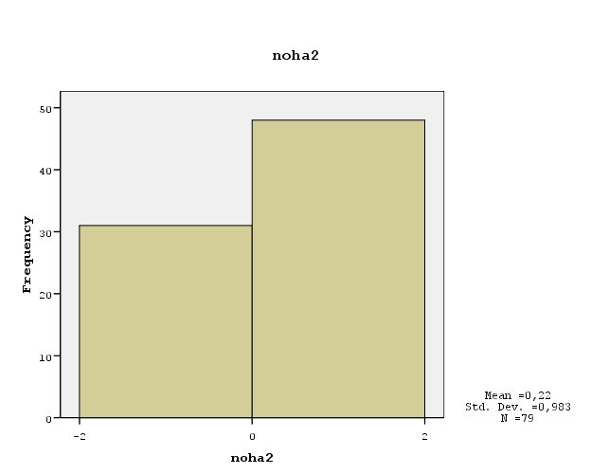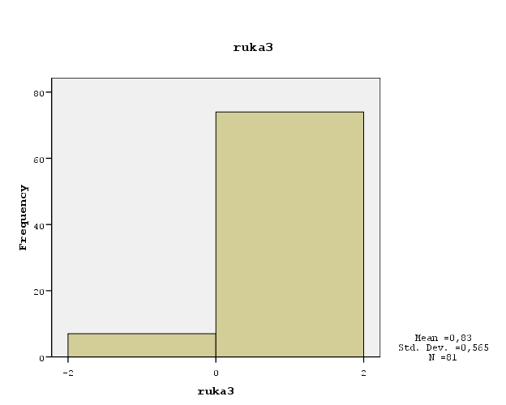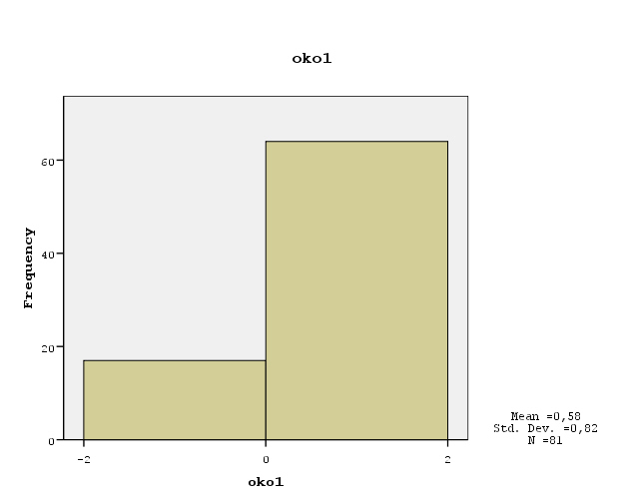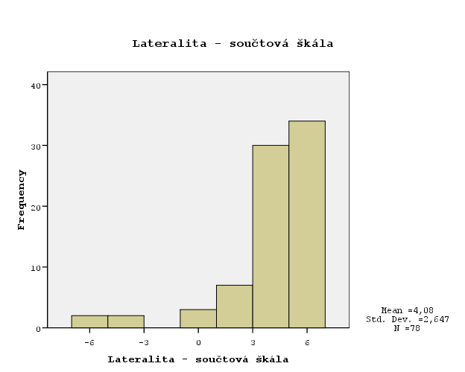

Deskriptivy - lateralita

 |  | ruka1 | ruka2 | noha1 | noha2 | ruka3 | oko1 | Lateralita - součtová škála
N | Valid | 82 | 82 | 82 | 79 | 81 | 81 | 78
 | Missing | 0 | 0 | 0 | 3 | 1 | 1 | 4
Mean |  | ,88 | ,85 | ,76 | ,22 | ,83 | ,58 | 4,08
Std. Error of Mean |  | ,053 | ,058 | ,073 | ,111 | ,063 | ,091 | ,300
Median |  | ,88(a) | ,85(a) | ,76(a) | ,22(a) | ,83(a) | ,58(a) | 4,63(a)
Mode |  | 1 | 1 | 1 | 1 | 1 | 1 | 6
Std. Deviation |  | ,482 | ,524 | ,658 | ,983 | ,565 | ,820 | 2,647
Variance |  | ,232 | ,275 | ,434 | ,966 | ,320 | ,672 | 7,007
Skewness |  | -3,738 | -3,339 | -2,354 | -,449 | -3,000 | -1,452 | -2,245
Std. Error of Skewness |  | ,266 | ,266 | ,266 | ,271 | ,267 | ,267 | ,272
Kurtosis |  | 12,273 | 9,380 | 3,629 | -1,846 | 7,174 | ,110 | 5,618
Std. Error of Kurtosis |  | ,526 | ,526 | ,526 | ,535 | ,529 | ,529 | ,538
Range |  | 2 | 2 | 2 | 2 | 2 | 2 | 12
Minimum |  | -1 | -1 | -1 | -1 | -1 | -1 | -6
Maximum |  | 1 | 1 | 1 | 1 | 1 | 1 | 6
Sum |  | 72 | 70 | 62 | 17 | 67 | 47 | 318
Percentiles | 25 | -,12(b) | -,15(b) | -,24(b) | -,78(b) | -,17(b) | -,42(b) | 2,97(b)
 | 50 | ,88 | ,85 | ,76 | ,22 | ,83 | ,58 | 4,63
 | 75 | . | . | . | . | . | . | 5,84
a Calculated from grouped data.
b Percentiles are calculated from grouped data.

Četnosti – další proměnné

kino

 |  | Frequency | Percent | Valid Percent | Cumulative Percent
Valid | 0 | 44 | 53,7 | 53,7 | 53,7
Valid | 1 | 19 | 23,2 | 23,2 | 76,8
Valid | 2 | 16 | 19,5 | 19,5 | 96,3
Valid | 3 | 2 | 2,4 | 2,4 | 98,8
Valid | 8 | 1 | 1,2 | 1,2 | 100,0
Valid | Total | 82 | 100,0 | 100,0

hudba

 |  | Frequency | Percent | Valid Percent | Cumulative Percent
Valid | 0 | 6 | 7,3 | 7,4 | 7,4
Valid | 1 | 14 | 17,1 | 17,3 | 24,7
Valid | 2 | 34 | 41,5 | 42,0 | 66,7
Valid | 3 | 5 | 6,1 | 6,2 | 72,8
Valid | 4 | 13 | 15,9 | 16,0 | 88,9
Valid | 5 | 1 | 1,2 | 1,2 | 90,1
Valid | 6 | 7 | 8,5 | 8,6 | 98,8
Valid | 8 | 1 | 1,2 | 1,2 | 100,0
Valid | Total | 81 | 98,8 | 100,0
Missing | neplatná odpověď | 1 | 1,2
Total |  | 82 | 100,0

knimol

 |  | Frequency | Percent | Valid Percent | Cumulative Percent
Valid | a) 3 knihy | 38 | 46,3 | 46,3 | 46,3
Valid | b) 5 knih | 34 | 41,5 | 41,5 | 87,8
Valid | c) 7 knih | 10 | 12,2 | 12,2 | 100,0
Valid | Total | 82 | 100,0 | 100,0

skolne

 |  | Frequency | Percent | Valid Percent | Cumulative Percent
Valid | pro | 28 | 34,1 | 34,1 | 34,1
Valid | proti | 54 | 65,9 | 65,9 | 100,0
Valid | Total | 82 | 100,0 | 100,0

pid

 |  | Frequency | Percent | Valid Percent | Cumulative Percent
Valid | 10,00 | 1 | 1,2 | 1,3 | 1,3
Valid | 12,00 | 1 | 1,2 | 1,3 | 2,5
Valid | 15,00 | 3 | 3,7 | 3,8 | 6,3
Valid | 16,00 | 1 | 1,2 | 1,3 | 7,5
Valid | 17,00 | 4 | 4,9 | 5,0 | 12,5
Valid | 17,50 | 1 | 1,2 | 1,3 | 13,8
Valid | 18,00 | 9 | 11,0 | 11,3 | 25,0
Valid | 19,00 | 11 | 13,4 | 13,8 | 38,8
Valid | 20,00 | 25 | 30,5 | 31,3 | 70,0
Valid | 20,50 | 1 | 1,2 | 1,3 | 71,3
Valid | 21,00 | 12 | 14,6 | 15,0 | 86,3
Valid | 21,50 | 1 | 1,2 | 1,3 | 87,5
Valid | 22,00 | 6 | 7,3 | 7,5 | 95,0
Valid | 23,00 | 2 | 2,4 | 2,5 | 97,5
Valid | 24,00 | 1 | 1,2 | 1,3 | 98,8
Valid | 24,50 | 1 | 1,2 | 1,3 | 100,0
Valid | Total | 80 | 97,6 | 100,0
Missing | neplatná odpověď | 2 | 2,4
Total |  | 82 | 100,0

vyska

 |  | Frequency | Percent | Valid Percent | Cumulative Percent
Valid | 158,0 | 3 | 3,7 | 3,8 | 3,8
Valid | 159,0 | 1 | 1,2 | 1,3 | 5,0
Valid | 160,0 | 1 | 1,2 | 1,3 | 6,3
Valid | 161,0 | 2 | 2,4 | 2,5 | 8,8
Valid | 163,0 | 1 | 1,2 | 1,3 | 10,0
Valid | 164,0 | 3 | 3,7 | 3,8 | 13,8
Valid | 165,0 | 1 | 1,2 | 1,3 | 15,0
Valid | 166,0 | 1 | 1,2 | 1,3 | 16,3
Valid | 167,0 | 5 | 6,1 | 6,3 | 22,5
Valid | 168,0 | 11 | 13,4 | 13,8 | 36,3
Valid | 169,0 | 3 | 3,7 | 3,8 | 40,0
Valid | 170,0 | 7 | 8,5 | 8,8 | 48,8
Valid | 171,0 | 1 | 1,2 | 1,3 | 50,0
Valid | 172,0 | 4 | 4,9 | 5,0 | 55,0
Valid | 173,0 | 2 | 2,4 | 2,5 | 57,5
Valid | 175,0 | 6 | 7,3 | 7,5 | 65,0
Valid | 176,0 | 5 | 6,1 | 6,3 | 71,3
Valid | 177,0 | 2 | 2,4 | 2,5 | 73,8
Valid | 179,0 | 2 | 2,4 | 2,5 | 76,3
Valid | 180,0 | 6 | 7,3 | 7,5 | 83,8
Valid | 181,0 | 1 | 1,2 | 1,3 | 85,0
Valid | 182,0 | 1 | 1,2 | 1,3 | 86,3
Valid | 183,0 | 3 | 3,7 | 3,8 | 90,0
Valid | 184,0 | 2 | 2,4 | 2,5 | 92,5
Valid | 185,0 | 1 | 1,2 | 1,3 | 93,8
Valid | 186,0 | 1 | 1,2 | 1,3 | 95,0
Valid | 187,0 | 1 | 1,2 | 1,3 | 96,3
Valid | 189,0 | 1 | 1,2 | 1,3 | 97,5
Valid | 190,0 | 1 | 1,2 | 1,3 | 98,8
Valid | 196,0 | 1 | 1,2 | 1,3 | 100,0
Valid | Total | 80 | 97,6 | 100,0
Missing | 999,0 | 2 | 2,4
Total |  | 82 | 100,0

Bar Chart

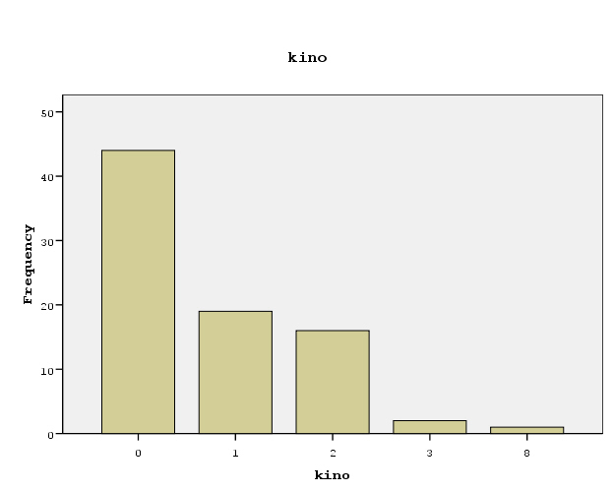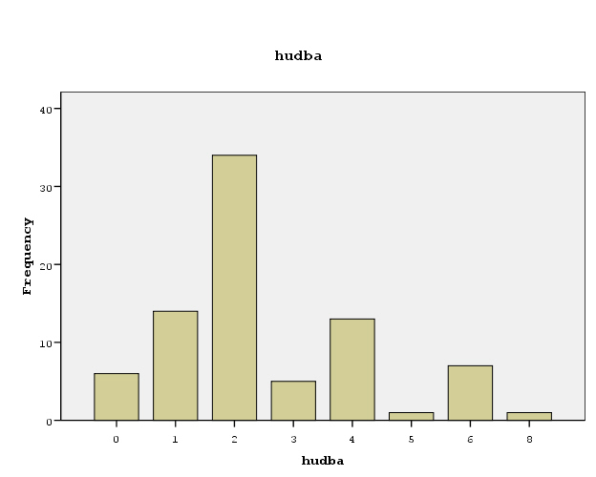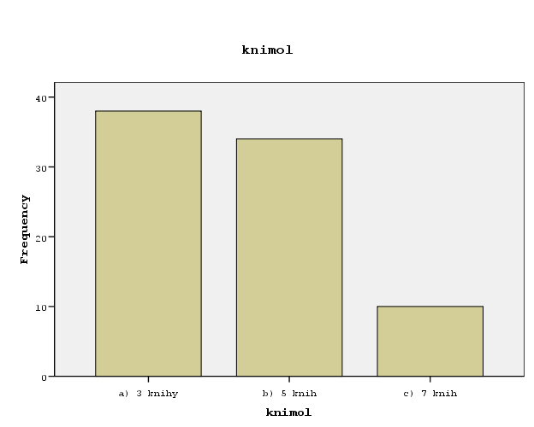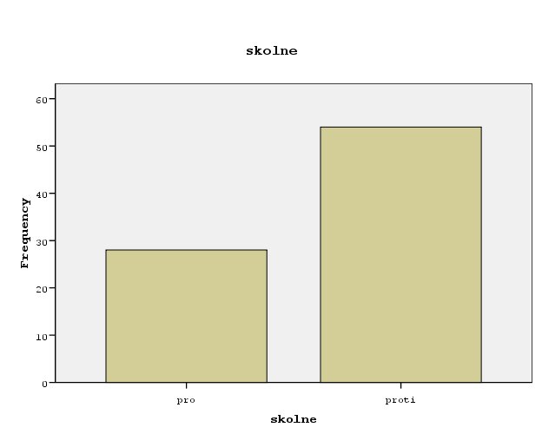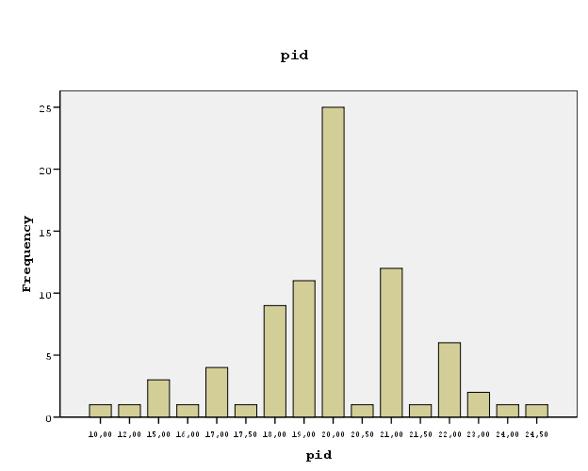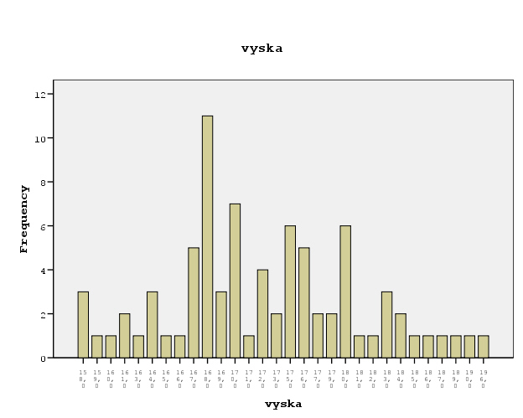
Histogram

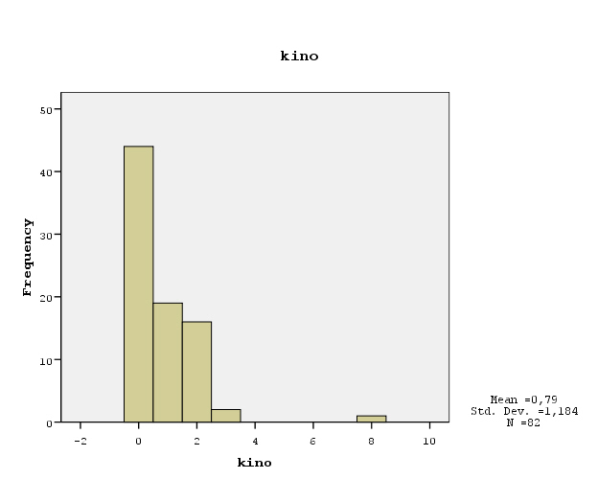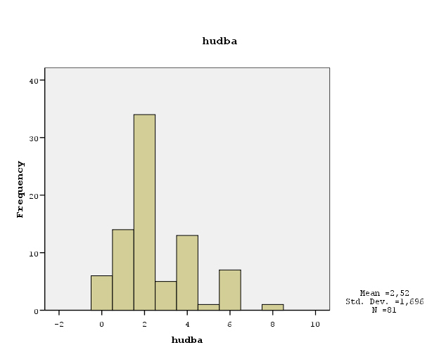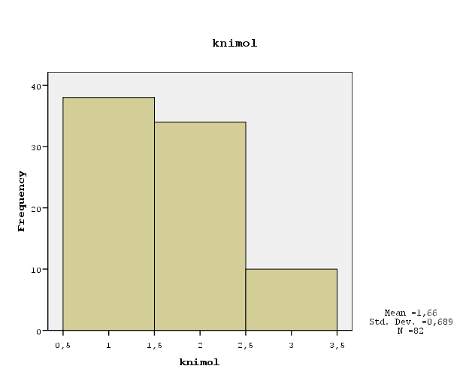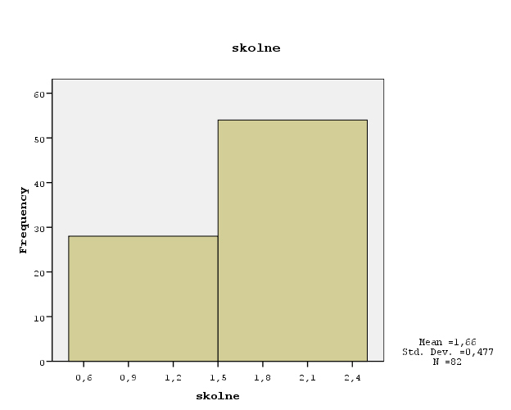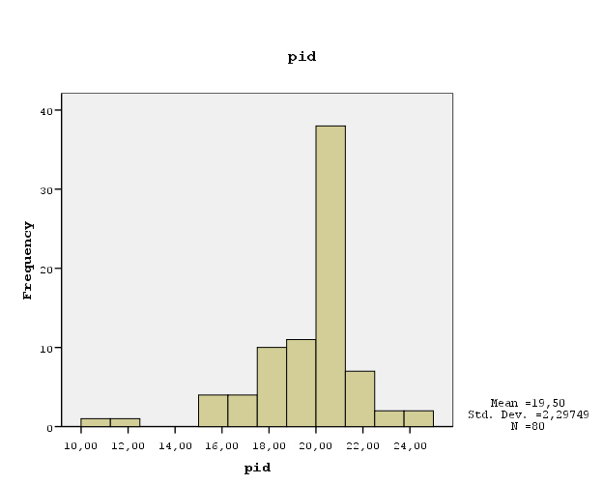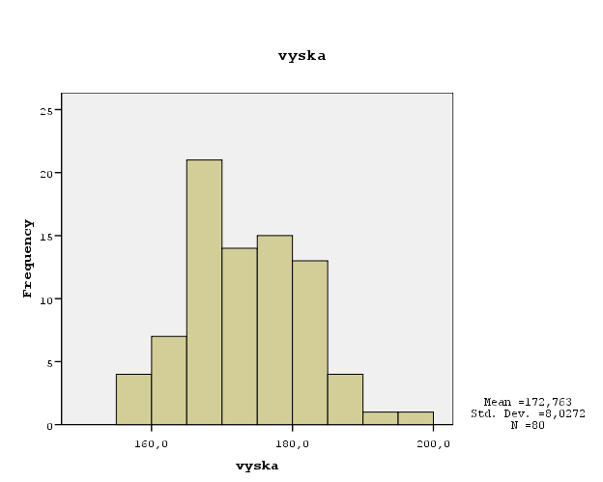

Deskriptivy – další proměnné

 |  | kino | hudba | knimol | skolne | pid | vyska
N | Valid | 82 | 81 | 82 | 82 | 80 | 80
N | Missing | 0 | 1 | 0 | 0 | 2 | 2
Mean |  | ,79 | 2,52 | 1,66 | 1,66 | 19,5000 | 172,763
Std. Error of Mean |  | ,131 | ,188 | ,076 | ,053 | ,25687 | ,8975
Median |  | ,60(a) | 2,18(a) | 1,61(a) | 1,66(a) | 19,8056(a) | 171,200(a)
Mode |  | 0 | 2 | 1 | 2 | 20,00 | 168,0
Std. Deviation |  | 1,184 | 1,696 | ,689 | ,477 | 2,29749 | 8,0272
Variance |  | 1,401 | 2,878 | ,475 | ,228 | 5,278 | 64,437
Skewness |  | 3,070 | ,968 | ,567 | -,681 | -1,338 | ,396
Std. Error of Skewness |  | ,266 | ,267 | ,266 | ,266 | ,269 | ,269
Kurtosis |  | 15,834 | ,708 | -,753 | -1,575 | 4,018 | -,062
Std. Error of Kurtosis |  | ,526 | ,529 | ,526 | ,526 | ,532 | ,532
Range |  | 8 | 8 | 2 | 1 | 14,50 | 38,0
Minimum |  | 0 | 0 | 1 | 1 | 10,00 | 158,0
Maximum |  | 8 | 8 | 3 | 2 | 24,50 | 196,0
Sum |  | 65 | 204 | 136 | 136 | 1560,00 | 13821,0
Percentiles | 25 | .(b,c) | 1,30(c) | 1,04(c) | 1,16(c) | 18,4500(c) | 167,563(c)
Percentiles | 50 | ,60 | 2,18 | 1,61 | 1,66 | 19,8056 | 171,200
Percentiles | 75 | 1,46 | 3,47 | 2,30 | . | 20,7692 | 179,000
a Calculated from grouped data.
b The lower bound of the first interval or the upper bound of the last interval is not known. Some percentiles are undefined.
c Percentiles are calculated from grouped data.

Četnosti - odhady

vek1

 |  | Frequency | Percent | Valid Percent | Cumulative Percent
Valid | 19 | 1 | 1,2 | 1,2 | 1,2
Valid | 21 | 2 | 2,4 | 2,4 | 3,7
Valid | 22 | 6 | 7,3 | 7,3 | 11,0
Valid | 23 | 6 | 7,3 | 7,3 | 18,3
Valid | 24 | 7 | 8,5 | 8,5 | 26,8
Valid | 25 | 19 | 23,2 | 23,2 | 50,0
Valid | 26 | 7 | 8,5 | 8,5 | 58,5
Valid | 27 | 18 | 22,0 | 22,0 | 80,5
Valid | 28 | 6 | 7,3 | 7,3 | 87,8
Valid | 29 | 3 | 3,7 | 3,7 | 91,5
Valid | 30 | 5 | 6,1 | 6,1 | 97,6
Valid | 32 | 1 | 1,2 | 1,2 | 98,8
Valid | 35 | 1 | 1,2 | 1,2 | 100,0
Valid | Total | 82 | 100,0 | 100,0

vek2

 |  | Frequency | Percent | Valid Percent | Cumulative Percent
Valid | 20 | 1 | 1,2 | 1,2 | 1,2
Valid | 23 | 2 | 2,4 | 2,5 | 3,7
Valid | 24 | 4 | 4,9 | 4,9 | 8,6
Valid | 25 | 8 | 9,8 | 9,9 | 18,5
Valid | 26 | 5 | 6,1 | 6,2 | 24,7
Valid | 27 | 6 | 7,3 | 7,4 | 32,1
Valid | 28 | 11 | 13,4 | 13,6 | 45,7
Valid | 29 | 1 | 1,2 | 1,2 | 46,9
Valid | 30 | 16 | 19,5 | 19,8 | 66,7
Valid | 31 | 7 | 8,5 | 8,6 | 75,3
Valid | 32 | 5 | 6,1 | 6,2 | 81,5
Valid | 33 | 2 | 2,4 | 2,5 | 84,0
Valid | 34 | 2 | 2,4 | 2,5 | 86,4
Valid | 35 | 5 | 6,1 | 6,2 | 92,6
Valid | 36 | 2 | 2,4 | 2,5 | 95,1
Valid | 38 | 1 | 1,2 | 1,2 | 96,3
Valid | 40 | 3 | 3,7 | 3,7 | 100,0
Valid | Total | 81 | 98,8 | 100,0
Missing | neplatná odpověď | 1 | 1,2
Total |  | 82 | 100,0

Bar Chart

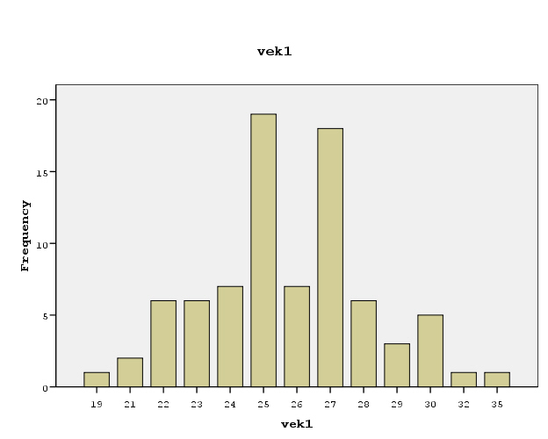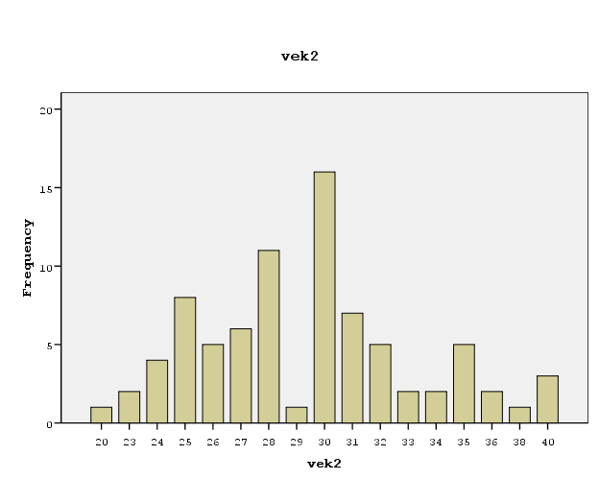
Histogram

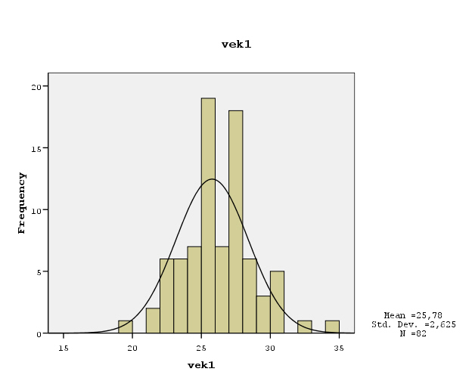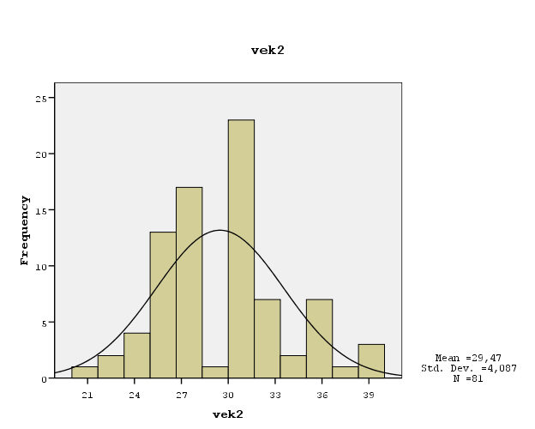

Deskriptivy - odhady

Statistics

 |  | vek1 | vek2
N | Valid | 82 | 81
N | Missing | 0 | 1
Mean |  | 25,78 | 29,47
Std. Error of Mean |  | ,290 | ,454
Median |  | 25,73(a) | 29,35(a)
Mode |  | 25 | 30
Std. Deviation |  | 2,625 | 4,087
Variance |  | 6,889 | 16,702
Skewness |  | ,396 | ,529
Std. Error of Skewness |  | ,266 | ,267
Kurtosis |  | 1,265 | ,324
Std. Error of Kurtosis |  | ,526 | ,529
Range |  | 16 | 20
Minimum |  | 19 | 20
Maximum |  | 35 | 40
Sum |  | 2114 | 2387
Percentiles | 25 | 24,15(b) | 26,50(b)
Percentiles | 50 | 25,73 | 29,35
Percentiles | 75 | 27,38 | 31,54
a Calculated from grouped data.
b Percentiles are calculated from grouped data.

