Cafe Bistro Coffeehouse Business Plan

The Watertower Cafe

Source: <http://www.entrepreneur.com/landing/216013>

1. Executive Summary 1

1.1 Objectives 1

1.2 Mission 2

1.3 Keys to Success 2

2. Company Summary 2

2.1 Company Ownership 3

2.2 Start-up Summary 3

2.3 Company Locations and Facilities 5

3. Products 5

3.1 Product Description 5

3.2 Competitive Comparison 6

3.3 Sourcing 6

3.4 Technology 6

3.5 Future Products 6

4. Market Analysis Summary 6

4.1 Market Segmentation 7

4.2 Target Market Segment Strategy 8

4.2.1 Market Needs 8

4.2.2 Market Trends 8

4.2.3 Market Growth 8

4.3 Industry Analysis 9

4.3.1 Competition and Buying Patterns 9

4.3.2 Main Competitors 9

5. Strategy and Implementation Summary 10

5.1 Competitive Edge 10

5.2 Value Proposition 11

5.3 Sales Strategy 11

5.3.1 Sales Forecast 11

5.4 Milestones 12

5.5 Marketing Strategy 13

5.5.1 Sales Programs 13

5.5.2 Positioning Statement 13

5.5.3 Pricing Strategy 13

5.5.4 Promotion Strategy 13

5.5.5 Marketing Programs 14

5.6 Strategic Alliances 14

6. Internal Structure 14

6.1 Organizational Structure 14

6.2 Personnel Plan 14

6.3 Management Team 15

6.4 Management Team Gaps 16

7. Financial Plan 16

7.1 Important Assumptions 16

7.2 Projected Cash Flow 16

7.3 Key Financial Indicators 18

7.4 Break-even Analysis 18

7.5 Projected Profit and Loss 19

7.6 Projected Balance Sheet 20

# 1. Executive Summary

The Watertower is a full-service restaurant/cafe located in the Sweet Auburn District of Atlanta. The restaurant features a full menu of moderately priced "comfort" food influenced by African and French cooking traditions, but based upon time honored recipes from around the world. The cafe section of The Watertower features a coffeehouse with a dessert bar, magazines, and space for live performers.

The Watertower will be owned and operated by The Watertower LLC, a Georgia limited liability corporation managed by David N. Patton IV, a resident of the Empowerment Zone. The members of the LLC are David N. Patton IV (80%) and the Historic District Development Corporation (20%).

This business plan offers financial institutions an opportunity to review our vision and strategic focus. It also provides a step-by-step plan for the business start-up, establishing favorable sales numbers, gross margin, and profitability.

This plan includes chapters on the company, products and services, market focus, action plans and forecasts, management team, and financial plan.

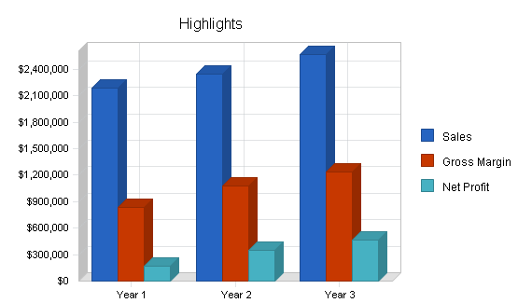

## 1.1 Objectives

1. Sales approaching and surpassing $1.9 million by the end of the first year.
2. Targeting and maintaining a net profit of at least 14% by the second year.
3. To cultivate monthly sales to reach $167,000 by the end of the fourth month of operation, and $220,000 monthly by the end of the first year of operation.

## 1.2 Mission

The Watertower concept is built upon the success stories of Atlanta's many casual dining and coffeehouse venues. Located in the Sweet Auburn District of Atlanta adjacent to the Studioplex on Auburn residential loft development, The Watertower will provide accessible and affordable high quality food, coffee-based products, and entertainment to the thousands of residents and hotel visitors located within a five-mile radius. In time, The Watertower will establish itself as a "destination" of choice to the many residents of the greater Atlanta metropolitan area, as well as numerous out-of-town visitors.

The establishment will provide a "complete, high-quality" evening experience for those searching for something that is rapidly becoming popular among Atlanta diners. Not only will patrons be able to dine on "comfort" food based upon time honored recipes from the world over, they will do so in a facility containing ample patio space for a favorite pastime of Atlanta's residents: alfresco dining. Patrons will also have the option of enjoying coffee, desserts, and live entertainment in The Watertower's coffeehouse or, a relaxed game of bocci in the gardens located adjacent to the patio space.

The cafe's aim is simple. It will provide a completely sophisticated, sensual, yet casual dining and/or coffeehouse experience for the many Atlantans and visitors who frequent the city's casual dining spots and entertainment venues. It will be an affordable venture for patrons, one that will encourage them to return on many occasions. The menu will feature hearty fare of the type that is frequently out of the reach of the typical young professional...out of reach because time frequently prevents her/him from cooking hearty meals like those featured on our menu.

Finally, and quite significantly, The Watertower will provide a much needed neighborhood-based retail food operation that is currently unavailable to the southern end of Atlanta's Old Fourth Ward neighborhood. Not only is it projected that the business will generate 21 new jobs, the partnership responsible for creating The Watertower will generate additional revenue specifically dedicated to assisting the Historic District Development Corporation in its efforts to bring affordable housing, new jobs, and commercial activity to the Old Fourth Ward.

## 1.3 Keys to Success

The keys to success in this business are:

1. Product quality: Food, coffee-based beverages, and entertainment are our products. They must be of the high quality and value.
2. Service: Our patrons are paying to have a good time. Their experience will suffer if service is not of the highest caliber. Each member of the staff will be courteous, efficient, and attentive.
3. Marketing: We will need to target our audience early and often. While the business is located in a central and accessible location, many people will have to be re-introduced to the neighborhood surrounding the Martin Luther King National Historic Site and Auburn Avenue.
4. Management: We will need to have a firm grasp on food, beverage, and labor costs. The dining/entertainment/coffeehouse experience must be delivered in a fashion that will not only inspire repeat business, but encourage word-of-mouth recommendations to others. Proper inventory, employee management, and quality control is key.

# 2. Company Summary

The Watertower is a bistro and coffeehouse facility located in a renovated house immediately adjacent to the Studioplex on Auburn residential loft development. The Watertower derives its name from an historic 200+ foot tall watertower located on the grounds of the restaurant, and immediately across the street from the main entrance of the Studioplex facility. Architecturally, this watertower will serve as a beacon/locator for our facility as it towers over the southern end of the Old Fourth Ward neighborhood and the eastern end of the Sweet Auburn residential and business district.

The facility is bordered by Auburn Avenue to the south and Irwin Street to the north. Residential live/work townhouses are planned for construction across the street from, and adjacent to, The Watertower on Irwin Street.

## 2.1 Company Ownership

The Watertower is a privately held limited liability corporation wholly owned by David N. Patton IV(80%) and the Historic District Development Corporation (20%).

## 2.2 Start-up Summary

The start-up costs for The Watertower cafe can be found in the chart and table below.

Since the business property is located in an enterprise zone, property taxes on the property are abated for the initial years covered by the business plan. The owner/general manager will be responsible for maintaining insurance that will cover the loss of the building and all of its contents, as well as insurance covering business interruption and death or injury to himself.

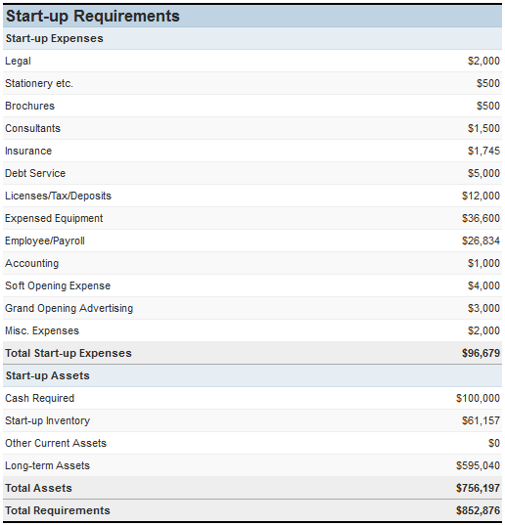

**Start-up Funding**

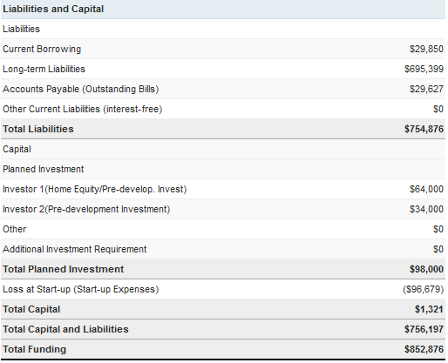

## 2.3 Company Locations and Facilities

The Watertower will be located in a newly renovated facility designed by the architectural firm of Richard Rauh & Associates, Atlanta, GA.

The facility will be divided equally between the cafe/restaurant function and the coffeehouse/entertainment function. The restaurant will feature dining room seating for approximately 100 patrons and flexible indoor/outdoor patio seating for an additional 40 patrons. The cafe/coffeehouse will provide a full-service dine-in and carry-out coffee-based beverages, as well as a dessert bar. The coffeehouse/cafe portion of the business will also contain a full-service bar, a small entertainment stage, and niche magazines and newspapers available for purchase. The coffeehouse will maintain ample indoor/outdoor seating under a covered patio space shared with the restaurant.

The facility's perimeter will feature a simple garden and bocci courts which will provide comfortable waiting areas during the warm weather months.

Finally, an historic 200+ foot watertower forms the centerpiece of the grounds immediately adjacent to the proposed business. This watertower, constructed in 1906, features extraordinary cathedral-like interior space. It is our hope that our construction plans will support dramatic lighting of the tower after sundown, creating a rather visible nighttime landmark for northeast Atlanta.

# 3. Products

The Watertower is a cafe/restaurant/coffeehouse venue that sells moderately-priced food to an upscale casual dining market. The venue features brewed coffee and espresso-based beverages, granita ices, fruit smoothies and juices, and other beverages typically associated with a coffee shop. A dessert bar will serve a range of freshly prepared desserts, as well as baked goods associated with breakfast.

Luncheon offerings contain both carry-out and dine-in menu selections, while evening hours will accommodate full-service dining and Spanish tapas (appetizer) service, a full-service bar and light, weekend, live entertainment.

Reflecting a target niche market, a limited selection of out-of-town newspapers, as well as art, architecture, cinema, design and lifestyle magazines will be sold. Additionally, the venue will feature art and products made by Studioplex artists, providing a cross-selling opportunity.

## 3.1 Product Description

The Watertower's menu will feature a selection of pan-ethnic dishes influenced by African and French cooking traditions. Whether South American, Caribbean, Mediterranean or African-American, the menu items will have an identifiable African origin and/or influence.

Generally, the dishes will offer variations on "country" cooking themes. Braised and smoked meats and poultry, seafood, and vegetarian offerings will change seasonally.

Dinner items will only be available in the dining room section of the establishment. Standard appetizer/tapas offerings will be available in the coffee shop and patio area through the late evening.

Specialty coffees, espresso-based drinks, desserts and pastries, and light sandwiches will be available in the coffee shop.

Niche-magazines and newspapers will be readily available for purchase by the venue's patrons.

Musical offerings will span jazz, Latin, and urban musical traditions. The performance space will also offer ample opportunities for space for an artist, poet, reader, etc. When not in use as a stage, the space will double as a customer seating area with tables and chairs.

## 3.2 Competitive Comparison

The Watertower's closest competitors (relative to location) are Virginia's (Inman Park), Sotto Sotto (Inman Park), The Roman Lily, and Thumb's Up Diner (Old Fourth Ward), Cabbagetown Grill (Cabbagetown), Eureka (Cabbagetown).

Virginia's, The Roman Lily, Cabbagetown Grill, and Eureka feature fairly similarly priced menus and menu offerings with a notable traditional American southern influence. The Roman Lily is notably more "downscale" from Eureka and Cabbagetown Grill. Virginia's decor and menu offerings strikes squarely in between downscale casual and upscale casual. Sotto Sotto is an upscale casual dining establishment featuring finer northern Italian cuisine (the restaurant is currently undergoing a significant expansion).

None of these establishments features a traditional coffeehouse atmosphere or live or recorded evening entertainment.

Relative to the location of these establishments, The Watertower is centrally geographically located. It's location will easily allow for patrons from these other establishments to finish an evening with dessert, coffee, drinks, and/or dancing.

## 3.3 Sourcing

The Watertower will buy from a select group of Atlanta restaurant suppliers and liquor distributors. Direct sales relationships will also be established with fresh produce, meat, and seafood distributors based at the Sweet Auburn Curb Market. Negotiations are also underway to establish direct relationships with seafood suppliers on the Florida Gulf coast.

The cafe will receive substantial discounts from artists and artisans participating in the manufacture of signature pieces of dinnerware, furniture, lighting, and sculpture to be featured at The Watertower. As part of a marketing agreement with Studioplex merchants, the business will prominently feature their products in exchange for these discounted fixtures and equipment.

## 3.4 Technology

The Watertower logo is protected by federal trademark laws. All of our menu creations will not necessarily have the same protections, however, when possible, popular "trade-names" will be protected. The business of The Watertower is not dependent upon process technology or patentable inventions.

## 3.5 Future Products

While The Watertower will initially focus upon the dining, coffeehouse, and entertainment functions located on the immediate grounds of the establishment, future expansion efforts will focus upon providing full-scale catering for Studioplex events as well as other off-site venues. The Watertower's owner has established relationships with Atlanta law firms and Emory University, these institutions offer many opportunities for catering/special event service.

# 4. Market Analysis Summary

The casual dining/full service restaurant market is a $100+ billion industry in the United States, with annual increases in revenue outpacing 5% yearly. More and more people are choosing to eat out. One of the most common reasons cited by restauranteurs and industry associations is that women have joined the workforce in record numbers. In fact, from 1955 to 1995, the dollars spent for food away from home rose by almost 20%, coinciding with the number of women entering the work force. With two income earners per household, neither person may have time to fix meals. Since the 1950s, commercial food service sales have continued to rise as more and more people find that eating away from home suits their lifestyles.

Specialty coffee is a $5+ billion per year industry in the United States, and has grown at a rate in excess of 20% per year in the last decade. That sustained growth is expected into this decade according the the Specialty Coffee Association of America.

Atlanta in the mid-1990s had only a handful of specialty coffee retailers: San Francisco Roasters, Cafe Diem, Cafe Intermezzo, Aurora Coffee, J. Martinez, and others. Now, coffee roasters, shops, and suppliers take more than two full pages in the Yellow Pages. Starbucks announced last year that it expects to open 600 additional stores in 2000.

## 4.1 Market Segmentation

The "Market Opportunity Analysis for Residential and Commercial Uses along the Auburn Avenue Corridor," written by Robert Charles Lesser & Co., makes the following points about food retail for The Watertower at the Studioplex on Auburn site:

Studioplex is in proximity to new and existing residences, including the affluent, and immediately adjacent Inman Park neighborhood; a restaurant would be a destination space within the neighborhood.

A restaurant/coffeehouse would provide one of the best food and beverage opportunities for the more than 500,000 annual visitors to the Martin Luther King Historic District.

Location is close to employment centers or within retail corridor.

Studioplex patrons and residents will provide primary support; secondary support will come from area residents and hotel visitors/conventioneers.

Cross selling opportunities exist with coffee beverages and magazines.

The coffee shop and the magazines sold there will be positioned to fill a niche demand for people interested in art, architecture, design photography, and home and garden pursuits.

Target market audience is a mix of Studioplex residents, artists, patrons, intown residents, downtown hotel visitors/conventioneers, and workers.

The immediate market area is within a four-mile radius of The Watertower and Studioplex and includes the neighborhoods of Sweet Auburn, Fairlie Poplar, Downtown, Grant Park, Inman Park, Poncey Highlands, Virginia Highland, Little Five Points, Lake Claire, Midtown, East Atlanta, Candler Park, Morningside, Cabbagetown, Druid Hills, and adjacent neighborhoods.

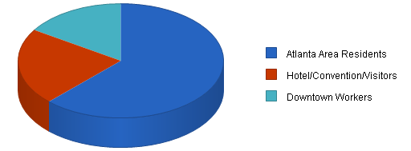

## 4.2 Target Market Segment Strategy

The Watertower will appeal to urban professionals residing in the targeted intown neighborhoods, the many downtown hotel visitors/conventioneers, and workers who desire a sophisticated yet casual eating, coffeehouse entertainment experience. The business will also meet an under-served need for a pedestrian-friendly dining/coffeehouse establishment for the numerous residents in the area, particularly newcomers to the immediate area.

Members of this market segment dine out frequently, approximately three times or more per week. The market segment is largely made up of singles between the ages of 25 and 40, married couples in the same age bracket without children, graduate and professional students attending area universities, tourists, and conventioneers.

### 4.2.1 Market Needs

Our customer's dining and entertainment needs are critical to the success of The Watertower. As a supplier of a full-service dining experience, The Watertower must appeal to people who are interested in integrating our type of cuisine regularly into their dining/food purchase experiences. Moreover, we must also appeal to those customers who regularly take advantage of Atlanta's coffeehouse and/or evening entertainment scene.

Our customers are well educated and interested in partaking of new experiences. Keeping the menu and the entertainment offerings "fresh" will remain a constant challenge to the business. Segments of the target market tend to dine out, visit coffee shops, and seek evening entertainment frequently. They tend to choose comfortable, affordable venues, and repeat appearances at places that offer familiar scenery with new twists.

### 4.2.2 Market Trends

Atlanta is experiencing a trend toward the creation of evening dining/entertainment venues. They are popular and gaining more recognition. Evidence of this is found in local news and magazine coverage. These venues are finding new homes in the areas close to and/or adjacent to downtown.

The city's burgeoning music scene is growing and in need of more venues to accommodate the mainstream jazz, acid jazz, Latin, and live dance music artists that are choosing Atlanta as home for their production efforts.

The market opportunity for coffee shop establishments has never been better in this area of Atlanta. The immediate area surrounding the business venue is undergoing a building renaissance as many residents chose to move into or return to the inner city.

### 4.2.3 Market Growth

Intown Atlanta is currently in the middle of a building and population explosion. Young singles and couples are choosing to reject long commutes in favor of living closer to their work and recreational venues. With the extra time that comes from being in a vibrant growing city with an active nightlife, intown neighborhoods that were formerly dotted with a limited number of night spots have seen their neighborhoods burgeon with new venues.

The section of Midtown Atlanta along 10th Street near Peachtree Street and Piedmont Avenue has experienced remarkable growth in it's nightlife scene. After a devastating demolition in the mid 1980s of buildings located in and around this area to make way for a mall that was never built, the area is featuring a resurgence. The development is rapidly moving south along Juniper Street and Peachtree Street.

As the area's population increases and the frustration with Buckhead congestion grows, people are opting for dining, coffeehouse, and entertainment venues closer to and in Downtown Atlanta.

## 4.3 Industry Analysis

The restaurants and coffeehouses that make up the community of establishments in the area surrounding The Watertower are quite diverse. Their concepts range from typical fast food/chain venues to expensive fine dining establishments. However, the predominating nature of the immediately surrounding restaurants and coffee shops is casual/upscale.

### 4.3.1 Competition and Buying Patterns

The general nature of the competition is typically a 70 to 150 seat restaurant with outdoor seating. The menu prices for entree's range from $7.00 to over $25.00. All of the surrounding establishments serve, at a minimum, beer and wine. Most serve liquor-spirits as well.

Some of these venues have added live entertainment to their offerings, however, most are prevented by their facilities from expanding into this area of service. Most of the live entertainment/dancing venues are located in Midtown and Buckhead to the north with a few more venues located west in Downtown Atlanta, and to the east in Little Five Points.

While historically Buckhead has remained a center for restaurants and entertainment venues, Virginia Highland, Little Five Points, and Midtown have grown tremendously in their appeal to diners and partygoers. With the tremendous rise in intown property values, a residential building boom, and a decrease in crime statistics, venues closer to downtown have seen a remarkable rise in business.

A busy population of urban professionals, intent upon working hard and playing hard, has fewer and fewer opportunities to cook at home. These people eat out often and do so with friends.

Because this population tends to eat out far more than the typical population, they look for value. While they might not regularly frequent a restaurant featuring entree prices of $17.00 and higher, they will repeat appearances at restaurants featuring entrees ranging between $7.00 and $16.00.

Many of these patrons also seek entertainment venues on the weekends that are close to their dining venues and homes. Historically, live jazz and Latin music venues in northeast Atlanta have been unavailable to patrons. The market currently suggests that such a venue on Auburn Avenue is not only desired by the populations frequenting restaurants and clubs in northeast Atlanta, it is suggested that it is needed. As Buckhead traffic and appeal has grown beyond the capacity of the neighborhood, patrons are now looking for "easier" places to go out, eat, and have fun.The parking and traffic woes of Buckhead have grown to notorious proportions. Midtowners and residents in adjacent neighborhoods would much rather patronize venues closer to downtown. The Watertower offers them an attractive dining/entertainment/coffeehouse option.

### 4.3.2 Main Competitors

**Loca Luna**: Located in the heart of Midtown, this establishment features a Latin house band which is often a group of four Brazilian musicians. The menu is primarily a Spanish tapas style menu with other entree offerings. The venue also features a small dance floor.

While its location near two longstanding Atlanta nightclubs, Backstreet and The Armory, would seem to offer considerable overflow, the restaurant is not easily seen from the street and parking is at a premium. Its concept has received very favorable press in Atlanta.

**Yin Yang Cafe**: Located on Spring Street, just north of Atlanta's landmark Varsity restaurant, the club features a limited menu and a regular offering of acid jazz, hip-hop, and R&B acts.

The location is very "out-of-the-way" and can be perceived as a marginally safe area. Nevertheless, the club remains wildly popular given the parking difficulties, its small size, and it's rather hidden location. It has become identified nationally as a residence of Atlanta's growing African-American music scene.

**Kaya**: A bistro and large scale nightclub located on Peachtree Street in Midtown, Kaya boasts an impressive array of entertainment, from Latin music, to hip-hop, disco, and live bands. The restaurant is located on the Peachtree Street side of the club. In the evening, the restaurant generally features a dj or a live band, while the large club portion in the rear of the establishment features a large dance floor and a dj.

It is very popular and regularly features large crowds. Kaya maintains limited parking immediately adjacent to the club.

**Cosmopolitan**: Cosmopolitan is located in a converted house in Midtown. It is a very small venue featuring a casual-upscale dining menu. The club is converted to a cocktail bar/nightclub in the evening with a small dance floor. It has no designated parking.

Newly arrived to the Atlanta scene, the club features long lines in the evenings. Quite often the club is not able to accommodate the numbers of people interested in visiting the establishment.

**The Somber Reptile**: Located in downtown Atlanta on Marietta Street, the club features live rock bands and a cajun oriented menu. The clientele is growing steadily as the club's reputation grows. It offers an alternative to the traditional Atlanta nightlife scene.

The Somber Reptile is part of the growing renovation trend taking place in the warehouse district along Marietta Street just west of Downtown Atlanta. While it naturally draws from the nearby residents, it competes directly with the rock music venues located in Little Five Points on the east side of the Atlanta.

**Cafe/Apres Diem**: Cafe Diem, the first coffeehouse/restaurant to be located south of Ponce De Leon Avenue on the northeast side of Atlanta, has enjoyed extraordinary success. Formerly located on Highland Avenue, the business recently (and reluctantly) located to a strip mall in midtown after a lengthy dispute with its former landlord. It's departure from the immediate area provides an extraordinary opportunity for The Watertower to capitalize on an even greater unmet need for a casual restaurant/coffeehouse experience.

**Highland Bagel/Caribou Coffee**: Located on North Highland Avenue, this is a traditional corporate coffeehouse which provides morning coffee and sandwich service. The owners are currently expanding to provide evening service.

# 5. Strategy and Implementation Summary

The Watertower's strategy is based upon targeting and serving:

* The atypical Atlanta intown resident. This urban professional works long hours and has relatively little time to cook at home. She/he has an active social life and spends a substantial amount of disposable income maintaining it.
* The many downtown businesses which regularly use restaurant dining as an function of conducting business.
* The tourist and convention populations centered in downtown venues.

## 5.1 Competitive Edge

The Watertower maintains a competitive edge in several significant areas:

* The facility's location puts it into close proximity to substantial populations of affluent Atlantans.
* The owner, a 16-year-resident of Atlanta, was educated in and works professionally in northeast Atlanta. His early work experience included a substantial period working within a casual/upscale restaurant in the mid-to-late 1980s in Virginia Highland. As the Dean of Students at Emory University School of Law, he has conferred over 1,300 law degrees during his tenure, most of them have remained in the Atlanta area. His position at Emory also required him to manage significant catering budgets. The owner, through his business, academic, and community activities, maintains a substantial Atlanta-based network of professionals.
* The facility's construction will easily allow for flexible dining/coffeehouse/entertainment options making it attractive to numerous populations.
* The facility's location in an Empowerment Zone and local Enterprise Zone provides significant tax advantages.

## 5.2 Value Proposition

We think our value proposition is quite clear and quite easily distinguished from most others in the market. We offer affordable and accessible menu items and entertainment as measured by their inherently natural value, at an affordable price that will encourage regular visits.

## 5.3 Sales Strategy

The first category of our sales strategy is to establish and maintain a position with our primary constituents: intown Atlanta residents within a 4 mile radius of The Watertower's location. We will depend upon keeping these people happy with our food and beverage products and entertainment options.

Our second strategy is to utilize the downtown hotel/convention business through developing and maintaining close relationships with the planners of upcoming conventions and their respective attendees in order to create a "private function/party" option for corporations visiting Atlanta during the early part of the week, as well as encouraging individual visits by conventioneers later in the week. This strategy will also target the many hotel concierges who are available to promote dining options located within two miles of downtown hotel venues.

Our third strategy targets the more than 500,000 visitors to the Martin Luther King National Historic Site. This segment provides mainly lunch business.

Fourth, the restaurant will target sales to downtown and midtown businesses (particularly law firms) for regular business lunch and dinner entertaining.

### 5.3.1 Sales Forecast

Our sales forecast assumes no change in cost of prices, which is a reasonable assumption for the last few years.

We are expecting to increase sales from $2.0 million at the end of the first year, to $2.5 million by the end of the third year. The growth forecast is in line with the restaurants in the area and is tied to the projected increase in population of the immediate area.

The combined sales figures (across all sale items for the restaurant and coffee shop) presume an average of 2.5 "turns" per day for a 155 seat dining room with an average tab of $12.54. The business will be open an average of 26 days per month.

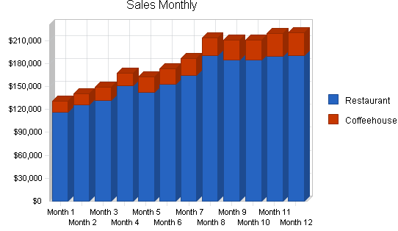

The projections show increases in:

* November, resulting from Halloween party planning for Emory University graduate and professional students.
* January, based upon corporate Christmas party and New Year's Eve programming.
* May, as a result of catering programming scheduled for Emory University Commencement functions.

## 5.4 Milestones

The accompanying table lists important program milestones, with dates and managers in charge, and budgets for each. The milestone schedule indicates our emphasis on planning for implementation.

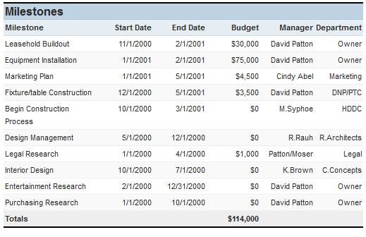

What the table doesn't show is the commitment behind it. Our business plan software includes complete provisions for plan-vs.-actual analysis, and we will be holding monthly follow-up meetings to discuss the variance and course corrections.

## 5.5 Marketing Strategy

The most important element of our marketing strategy is the delivery of a quality product. Our food, beverage, newspaper/magazine, and entertainment products must first sell themselves through word of mouth.

Next, the packaging of The Watertower's concept and external messages have to fit our positioning. We offer an upscale feel without a required "pinch" in your wallet. We then communicate this through the free weekly media (Creative Loafing, Southern Voice, and others), radio advertising on particular jazz, acid-jazz, Latin, and dance-oriented music shows, and traditional public radio sponsorships.

Through establishing relationships with the concierges of the local hotels and with the Atlanta Convention and Visitors Bureau, we will then attempt to create opportunities for visitors to the city to look forward to experiencing The Watertower.

### 5.5.1 Sales Programs

Specific Sales Programs:

* Special Event Sales: Develop opportunities to sell to companies for private parties and special events. The specific responsibility is with the owner with assistance from the manager on staff and Real World Communications.
* Music Related Special Events: Develop relationships with artists and promoters in the area to feature artists rising in popularity, either through CD release parties or live performances.
* Artist/Studioplex Special Events: Develop opportunities to host or cater artist openings.

### 5.5.2 Positioning Statement

For our most important target market, local residents who crave new and sophisticated dining/entertainment/coffeehouse options, The Watertower satisfies the need for a casual, all-in-one dining and entertainment experience. Unlike our key competition, The Watertower is designed to handle this need from its inception, starting with the general construction of the facility. The general food programming, coupled with the entertainment programming, will offer the customer an experience unlike anything he or she has currently available.

### 5.5.3 Pricing Strategy

Our food, drinks, and entertainment options are priced to give us an attractive margin while at the same time offering value to the consumer. We want repeat business. We also want the experience to remain fresh. Therein lies why the food, beverages, and musical/entertainment programming will be relatively flexible.

A sample menu is included in an appendix.

## 5.5.4 Promotion Strategy

We will promote our company name and label almost more than the product itself, because to be successful we have to stand for brand-name integrity, excellent menu offerings, and first class entertainment and fun. Therefore, our promotion strategy includes focusing on events and messages that match:

* Our participation in the Chocolate Soul and Funk Jazz Kafe' special promotions and the Sweet Auburn and Inman Park festivals is important because these are events that bring our target market together.
* Our participation in local radio and specifically targeted PBS shows on the local stations.
* Public relations programs focusing on related opportunities, guest appearances on local radio, etc.
* Advertising placed carefully, in mostly-alternative channels like Creative Loafing, Southern Voice, university newspapers, etc.

### 5.5.5 Marketing Programs

Our marketing program will be handled by Cindy Abel of Real World Communications. With an annual budget of $16,000, and with a milestone beginning in August, Ms. Abel will assist with the initial marketing programs and ongoing efforts to increase the visibility of The Watertower and its offerings.

## 5.6 Strategic Alliances

We depend on our alliances with personnel at Emory University, the Historic District Development Corporation, the Atlanta Executive Network, The Atlanta Convention and Visitors Bureau, and local music promoters to generate continuous leads for new sales and promotional opportunities. We need to make sure that the personnel of these allies are especially aware of our support and reciprocation.

# 6. Internal Structure

The Watertower is owned by a limited liability corporation including David N. Patton IV and the Historic District Development Corporation. Mr. Patton will also operate as general manager/managing partner. Crucial employees include an additional manager who will assist in maintaining and reviewing operations of the restaurant and the entertainment venue/bar, and a chef who will manage kitchen operations.

Additionally, an assistant manager/senior server and a sous-chef/line cook will perform secondary management functions.

Part-time personnel will be hired to handle bartending, serving, and dishwashing functions.

## 6.1 Organizational Structure

The Watertower is owned by David N. Patton IV (80%) and the Historic District Development Corporation (20%). Mr. Patton who will also operate as general manager/managing partner.

An additional manager (to be hired) will assist in maintaining and reviewing operations of the restaurant and the entertainment venue/bar.

A chef (to be hired) will manage kitchen operations and be crucial to maintaining food inventory stability and assistance in menu development.

An assistant manager/senior server (to be hired) who will be a salaried employee, will provide regular table service as well as assistance to the manager and the general manager.

A sous-chef/line cook (to be hired) will perform secondary management functions in the kitchen as well as provide assistance to the chef in main kitchen/cooking functions.

Part-time personnel will be hired to handle bartending, serving, and dishwashing functions.

The marketing, and accounting function will be handled by independent contractors/consultants.

## 6.2 Personnel Plan

The personnel plan calls for hiring 5 full-time salaried employees at start-up. Part time barristas/bartenders will have to be hired to manage approximately 135 hours of operation per week, servers/waiters will have to be hired for approximately 203 hours of operation per week, and dishwashers will have to be hired to handle approximately 62 hours of operation per week.

Any additional hires will be part time and devoted to the expansion of any catering function, as well as increased capacity/operation of a private party function.

Employee salaries are as follows:

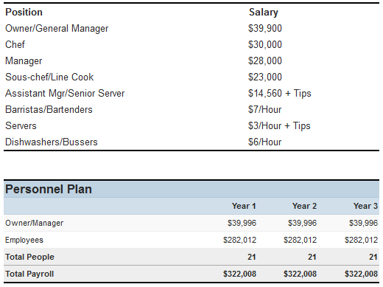

## 6.3 Management Team

**David N. Patton IV - Owner and General Manager:** Mr. Patton worked for 6 years as the Dean of Students for Emory University School of Law. While working at Emory, he was responsible for special event planning and catering, particularly related to student centered events. Mr. Patton is the Chairman of the Board of Directors of the Historic District Development Corporation, an organization devoted to the redevelopment of the properties and neighborhood surrounding Atlanta's Martin Luther King National Historic Site and Preservation District. He is also a member of the Advisory Board for the Atlanta Executive Network, a 1,000+ member business organization in Atlanta, and the past Chairman of the Board of Directors for Fulton County Court Appointed Special Advocates. Prior to his position at Emory, Mr. Patton worked as an attorney for a Cincinnati, Ohio-based law where he specialized in litigation and small business development. Mr. Patton received his law degree from the University of Georgia in 1991 and his undergraduate degree from Emory University in 1988. Mr. Patton put himself through college working in a casual dining establishment in the Virginia Highland neighborhood in the late 1980s.

The following potential managers are under consideration for employment

**Nicolas Godebert - Chef:** Mr. Godebert is currently the Executive Chef of the Chanteclair Restaurant, St. Martin, F.W.I. He has been in this position since 1997. Prior to this appointment, he was the sous-chef at Dessirier Restaurant, Paris, France and the sous-chef for the Raphael Hotel Restaurant, Paris, France. He received his apprenticeship and cooking school certificate from the Sous l'Olivier Restaurant and the Ecole de Paris des Metiers de la Table in 1993, respectively.

**Cristina Brito - Manager**: Ms. Brito, currently a food and beverage supervisor for the Westin Atlanta North hotel, received her start in the hotel and restaurant business in Recife-PE/ Brazil. At the Mar Hotel, she was responsible for the sales and marketing of a five-star establishment. She maintained extensive contact with corporate clients, thus requiring her to speak English, French, Italian, and Portuguese fluently. Ms. Brito has extensive experience in Atlanta's catering industry dating from 1988, as well as experience as a chef.

## 6.4 Management Team Gaps

The management team will have to partially rely upon outside contractors/consultants for both the marketing and accounting functions.

The management team is still in the early stages of formation. Nicolas Godebert and Cristina Brito are under heavy consideration. Cristina Brito is currently working as a consultant on many issues facing the establishment of The Watertower's start-up.

# 7. Financial Plan

We want to finance growth mainly through cash flow. We recognize that this means we will have to grow more slowly than we might like.

The most important indicator in our case is inventory turnover. We have to make sure that food inventory turnover stays at approximately four turns per month, or we risk loss through spoilage.

We do not want to let our average collection days get above 45 under any circumstances. This could cause a serious problem with cash flow, because our working capital situation is tight. Most credit sales will be via credit and debit cards. We do have plans to initiate direct billing for law firms and other businesses conducting regular visits.

We must target a net profit of 14% at the least, and hold marketing costs to no more than one to three percent of gross sales.

## 7.1 Important Assumptions

The financial plan depends on important assumptions, most of which are shown in the following table. The key underlying assumptions are:

* We assume a slow-growth economy, without major recession.
* We assume of course that there are no unforeseen changes in technology to make equipment immediately obsolete.
* We assume access to equity capital and financing sufficient to maintain our financial plan as shown in the tables.

## 7.2 Projected Cash Flow

We expect to manage cash flow over the next three years with minimal new investment required over the first two years. It is our expectation that revenue beyond projected sales will be invested in retiring long-term debt early.

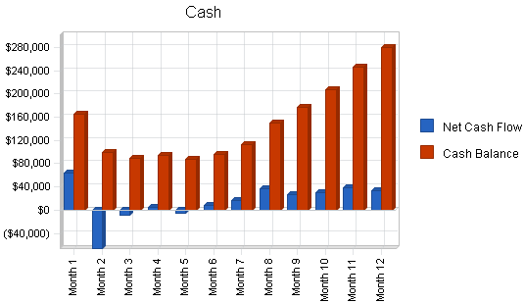

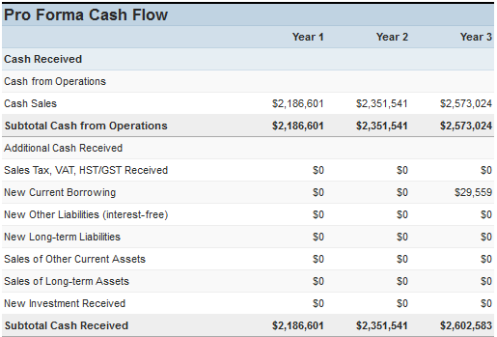

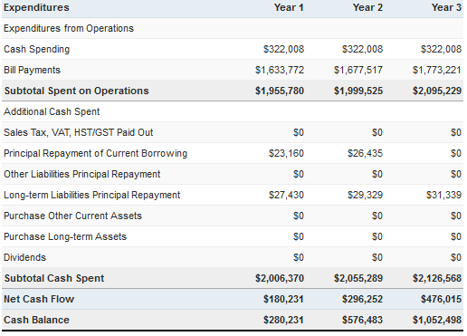

## 7.3 Key Financial Indicators

The most important indicators in our case are are daily seating "counts" and weekly sales numbers. We must also make sure that we are turning our inventory rapidly so as to avoid food spoilage.

We must target net profit/sales figures toward the 14% level with gross margins never dipping below 38%. Marketing costs should never exceed three percent of sales.

## 7.4 Break-even Analysis

The Break-even Analysis shows that The Watertower has a good balance of fixed costs and sufficient sales strength to remain healthy. Our break-even point is $106,101 on sales averaging $12.54 per patron. This break-even position is achieved on a monthly fixed cost of $57,873 and and per unit/patron variable cost of $5.70.

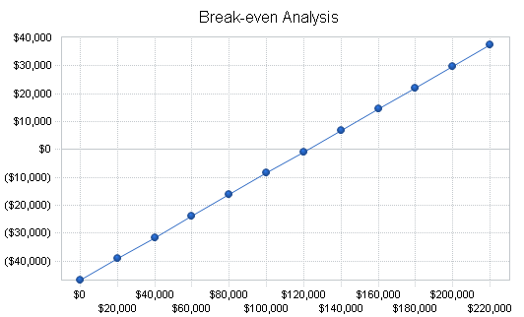

## 7.5 Projected Profit and Loss

We expect income to approach $2.1 million for calendar year 2002. It should increase to $2.57 million by the end of the years covered in this plan.

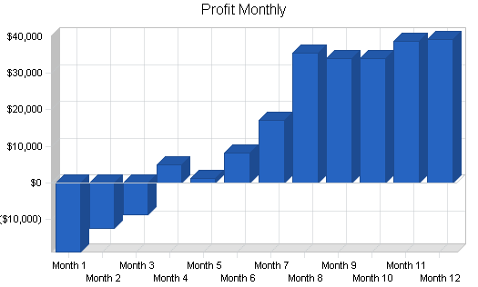

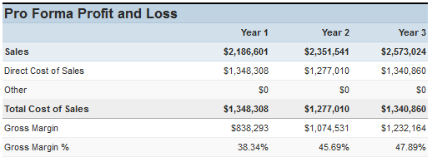

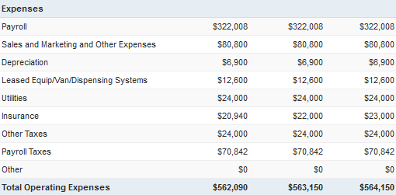

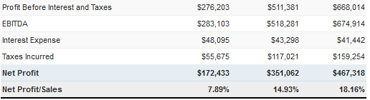

## 7.6 Projected Balance Sheet

As shown in the Balance Sheet, we expect a healthy growth in net worth from approximately $172,000 at the end of 2002 to almost $1 million by the end of the plan period.

