**Greetings from Italy (and its schools in the 1950s)**

by Francesca Gobbo, University of Turin (Italy)

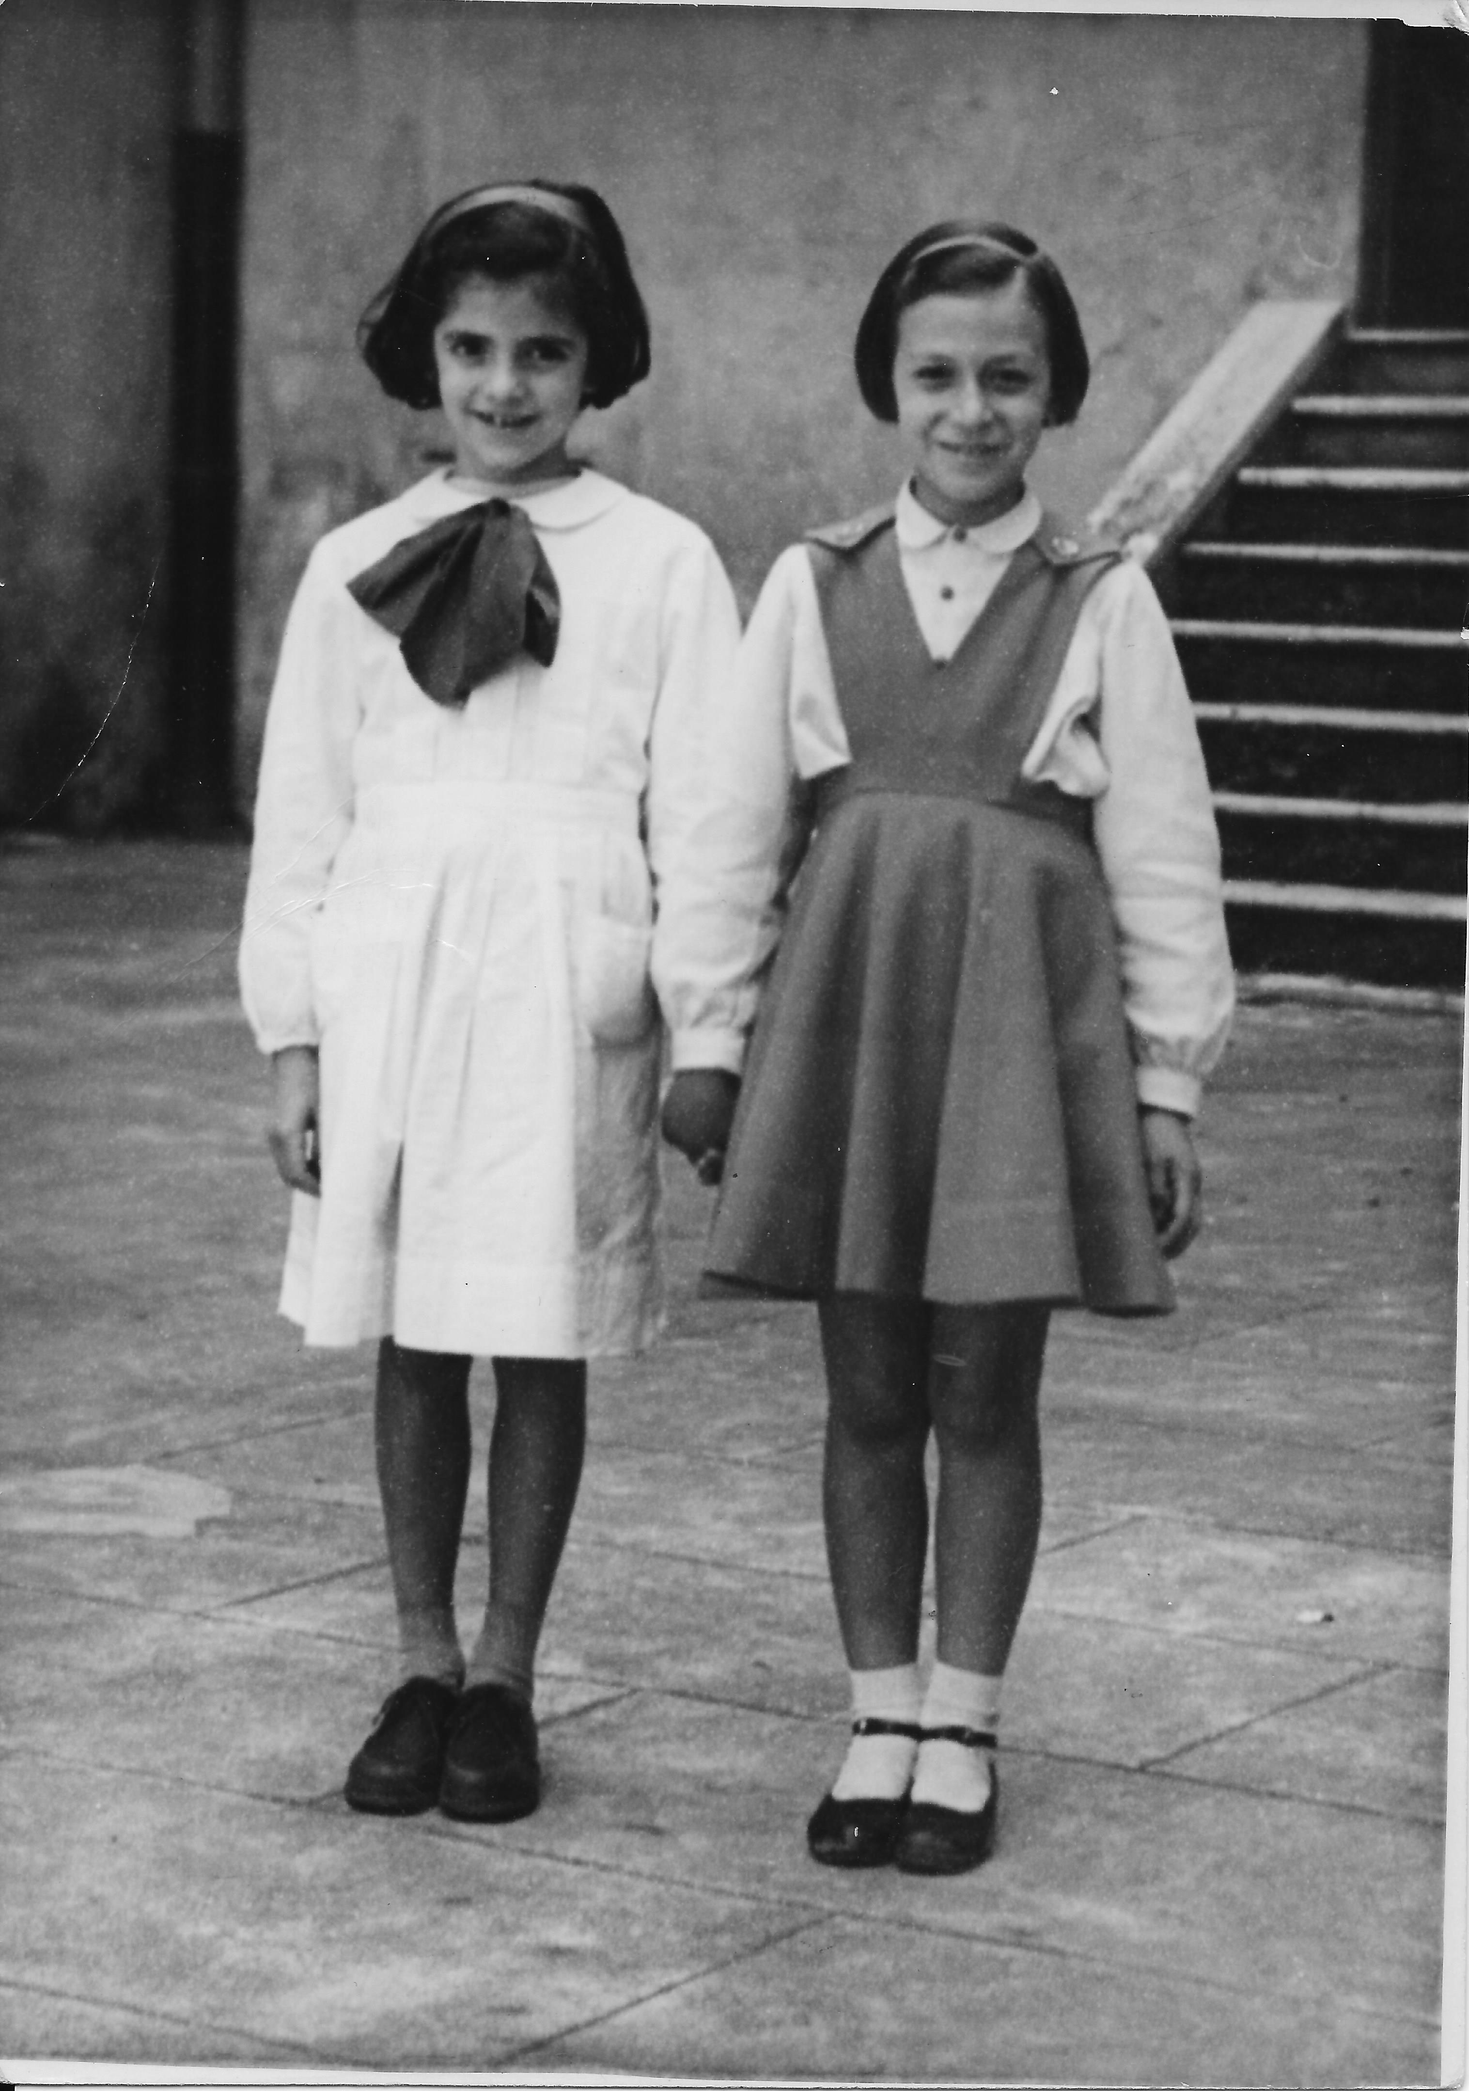

***ALESSANDRA AND FRANCESCA 1953***

Some months ago, a friend from primary school, whom I had last met in 1970, surprised me by emailing a photo of the two of us when we were eight. It is not the usual school picture, though it was taken at school, because there are only the two of us, holding hands and smiling shyly into the camera. Furthermore, while she is in the white school uniform and blue cravat, I unexpectedly wear a skirt and a blouse. Looking at the photo almost sixty years later, I wonder at the show I had staged that day: I must now assume that I discarded my white uniform so as to boldly show off the new red skirt my mother had sewn, but while I can remember the color with great precision I have trouble seeing myself as someone other than the non-descriptive, withdrawn child I had always thought I was. Yet, on that occasion, and for a reason I cannot today fathom, I had obviously come forward and asked the photographer to portray me as an eight year old girl proudly sporting her new red skirt. Maybe I entertained unspoken ambitions, if not dreams, and having an additional photo taken (surely with the teacher’s permission) gave me the chance to play with a different image of myself. However, it is today that I make this interpretation, as I am quite certain that originally that 1953 photo was looked at as that of two good school friends - third grade pupils at the “*Vittorino da Feltre”*, the *scuola elementare* in Rome, facing the Colosseum. Today I would also describe that school as “multicultural”, since children attending it came from widely different socio-economic backgrounds, spoke Italian with a local accent and often according to a grammar and a syntax that did not promote their school success and social mobility, and were at the same time surrounded (among other things) by the ruins of classical times, the lingering signs of the Fascist era, the graffitis either celebrating the brighter future promised by Communism or reclaiming the towns and areas still under military control after WWII, as well as by the colorful posters advertising the most recent Hollywood movies. By looking back at such memories without nostalgia but rather through the lens of the contemporary debate on multi/intercultural identities, I would point out how the construction of one’s own identity and cultural membership proceeded through multiple, diverse, contradictory images and visual suggestions. They would continue to diversify, become more complex and challenging to the eyes of the red skirted pupil, not unlike the worlds and the people today assiduously portrayed by photographers. From this point of view, photography seems intrinsically intercultural to me, in the sense of being an effective way to gauge differences in meanings and understanding across generations and events, and to promote a clarifying conversation, if not a dialogue, around conflicting interpretations, misunderstandings, silences. From this point of view, it can be agreed that photos not only illustrate or exhibit familiar and exotic places and people, but also pro-voke – i.e., call forth – thinking and questioning from the viewers, as well as communicate, namely they invite the latter to that sort of participation and mutual exchange that can engender new, unforeseen meanings, besides suggesting that what is taken for granted can be highly problematic.

The usual class pictures are the other ones attached to my mail: the first was taken at the same time that the one above but for the official picture of the school year we stood in three lines with the teacher in the middle.

Instead, on our last year of elementary school we sat at the desks with the school books in front of us; our teacher was now seated at our side as if indicating that she accompanied us that far and now we were ready to leave.

The next, and last picture, shows all the girl students (29!) of the 1st year of *scuola media*: students were separated by gender, they all had to take an entrance exam and those who passed it were to study Latin for the following three years. Before the 1962 school reform, after which all graduates from *scuola elementare* were recognized the right to access *scuola media* (no more entrance exam!), there were only two alternatives that children of age 10 could take: *scuola media* or *avviamento* (vocational school). Obviously, *scuola media* – with all its Latin – paved the way to social mobility (if one succeeded) and because it was originally thought for those whose family could claim some degree of cultural and social capital, it was a rather hard experience for those who lacked such capital. The empahsis was on Latin, but during the second and third year we also studied the Italian versions of *Iliad* and *Odissey*. Italian was presented and used as *the* language of the Italians, but in the 1950s television had not yet disseminate it all over the country, and we future teachers had to wait until 1967 and the *Lettera a una professoressa* written by the pupils of the *Scuola di Barbiana* to see recognized what some of us had known all along, namely that there were different versions of Italian and they usually matched and expressed the social status of families and children.