[**COMMENT**](https://www.foreignaffairs.com/browse/comment)[**September/October 2015 Issue**](https://www.foreignaffairs.com/issues/2015/94/5)[**Americas**](https://www.foreignaffairs.com/regions/americas)[**U.S. Foreign Policy**](https://www.foreignaffairs.com/topics/us-policy)

**Obama and Latin America**

A Promising Day in the Neighborhood

*By*[*Michael Reid*](https://www.foreignaffairs.com/authors/michael-reid)

In April 2009, just three months after he took office, U.S. President Barack Obama traveled to Trinidad and Tobago for the Summit of the Americas. There, he told Latin America’s leaders that he wanted to begin “a new chapter of engagement” and an “equal partnership . . . based on mutual respect and common interests and shared values.” Most dramatically, he pledged to seek “a new beginning with Cuba,” which had not enjoyed diplomatic relations with the United States for five decades.

Six years later, at the April 2015 summit in Panama, Obama declared that he had met those commitments. Indeed, the previous December, Obama had announced his intention to normalize relations with Havana. The turnaround delighted Latin American leaders of all ideological stripes, who have long seen the U.S. embargo against Cuba and its exclusion from hemispheric institutions as counterproductive. In Panama, Obama sealed the new policy by sitting down for an hour with Cuban President Raúl Castro, the first face-to-face meeting between leaders from the two countries since U.S. Vice President Richard Nixon met with Raúl’s older brother Fidel in 1959.

Cuba aside, over the past year or so, the Obama administration has also unveiled new initiatives to help Central American governments battle drug-related crime and help Caribbean island states overcome their chronic energy shortages. It has begun playing a more direct role in talks between Colombia’s government and the FARC guerrillas, naming a special envoy for the peace process. And it has shifted its focus from interdicting drug supplies to reducing demand and has at least tried to reform immigration policy, efforts that have been warmly received in the region.

According to the Obama administration, these initiatives, coupled with an inclusive, multilateral approach, are in tune with the new Latin America: largely democratic, increasingly prosperous, and more self-confident than ever. The administration’s opponents, mainly on the right, accuse Obama  of abandoning American values in the region. In their view, he gave Cuba a free pass by offering diplomatic relations without demanding anything in return—a concession, they say, that is  of a piece with his wider failure to stand up to autocratic left-wing governments in Latin America, notably in Venezuela. And they claim that the United States has slept while China has become the dominant foreign influence in much  of the region.

Those criticisms are overblown. True, for years, the Obama administration took a largely reactive approach to Latin America that resulted in multiple fumbles. And the recent attention it has paid to the region, although welcome, came late in the day and is still incomplete. But Obama’s record must be viewed in the context of dramatic changes in Latin America, which have inevitably reduced the United States’ influence. The region still suffers from unresolved challenges—notably, a persistent drug trade, widespread violent crime, and the erosion of democracy in Venezuela. Yet Obama has bequeathed to his successor a solid platform from which to take advantage of new developments in Latin America’s economics and politics.

THE NEIGHBORHOOD IS CHANGING

For U.S. presidents, Latin America usually offers more frustrations than foreign policy triumphs. The region’s leaders gripe about both U.S. interference and U.S. neglect. Because it is not a source of strategic threats, Latin America languishes at the bottom of the United States’ long list of foreign policy priorities. It is rarely the object of a coordinated approach from the White House. Rather, individual agencies, such as the Drug Enforcement Administration and the Treasury Department, exert unusual influence over policy. So do lobbies within Congress, such as Cuban Americans or sugar and cotton farmers.

At the same time, strong ties of trade, tourism, family, immigration, and remittances link the United States to Latin America. In 2014, 26 percent of U.S. merchandise exports were destined for Latin America—about the same percentage destined for Asia. Many of the 57 million Latinos in the United States retain family connections south of the border. Because of their proximity, Mexico and the countries of Central America and the Caribbean see little distinction between the United States’ domestic policy and its foreign policy. Its failed war on drugs, its permissive gun laws, and its deportation of undocumented immigrants and former prisoners—all these U.S. policies are felt directly.

Yet the United States arguably has less influence now in Latin America than at any point in the past century, on account of the rapid changes sweeping the region over the past 30 years or so. In the 1980s and 1990s, it shook off the Cold War, military dictatorships, and statist economic policies, turning to democracy and the free-market teachings of the so-called Washington consensus. Proclaiming shared values with the United States, Latin American governments agreed to discuss a 34-country Free Trade Area of the Americas in 1994, and in 2001, they signed the Inter-American Democratic Charter, which asserted the right of Latin Americans to live in democracy and bestowed on the region the duty to uphold that right.

Both projects quickly fell victim to the changing political seasons. The initial fruits of free-market reform were modest, and Latin American economies were hit by the financial instability that was affecting emerging markets worldwide. That, combined with the alternation of power inherent in democracy, led to the “pink tide” that rolled over much of South America after the turn of the millennium, with a number of left-wing governments winning elections. Some of the new leaders, such as Brazil’s Luiz Inácio Lula da Silva, proved fairly moderate and fully democratic. But half a dozen countries, led by Venezuelan President Hugo Chávez, formed a hard-left anti-American bloc with authoritarian tendencies. Owing to past U.S. intervention, Latin American politicians and diplomats, especially the current generation, are reflexively opposed to outside interference, be it in the name of anticommunism or democracy. That attitude has turned the Inter-American Democratic Charter into a dead letter—or at least one applied only when elected presidents are threatened, and not when they themselves threaten democracy.

*The United States arguably has less influence now in Latin America than at any point in the past century.*Latin America has been much less inclined to blindly follow the United States for another reason: China. As China industrialized in the first decade of the century, its demand for raw materials rose, pushing up the prices of South American minerals, fuels, and oilseeds. From 2000 to 2013, Chinese trade with Latin America rocketed from $12 billion to over $275 billion. In Brazil, Chile, and Peru, China has displaced the United States to become the biggest commercial partner. Across the region, China is increasingly acting as a foreign investor and lender to governments—often with no strings attached. Its loans have helped sustain leftist governments pursuing otherwise unsustainable policies in Argentina, Ecuador, and Venezuela, whose leaders welcomed Chinese aid as an alternative to the strict conditions imposed by the International Monetary Fund or the financial markets. In the wake of the 2008 financial crisis, Western finance capitalism seemed discredited, whereas Chinese state capitalism seemed invincible.

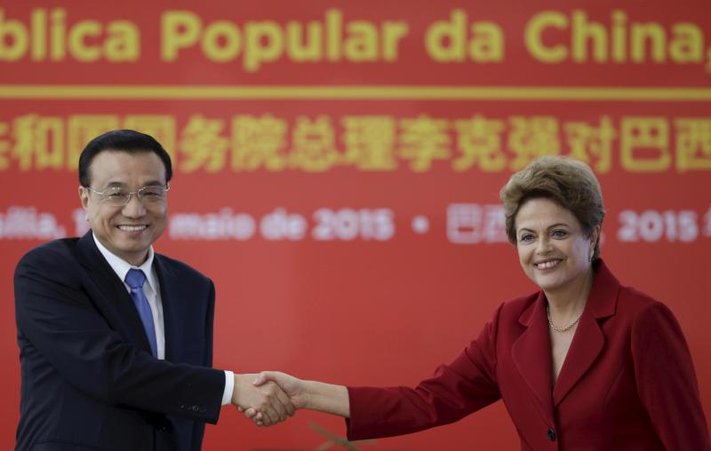

UESLEI MARCELINO / COURTESY REUTERS

Chinese Premier Li Keqiang greets Brazil's President Dilma Rousseff during a meeting at the Planalto Palace in Brasilia, May 2015.

The Chinese-fueled commodity boom, which ended only recently, lifted Latin America to new heights. The region—and especially South America—enjoyed faster economic growth, a steep fall in poverty, a decline in extreme income inequality, and a swelling of the middle class. In his second term, U.S. President George W. Bush responded to these changes by adopting a broadly multilateral approach to Latin America, in which Washington tried to coordinate more closely with Brazil, Chile, and Mexico. But most of the new crop of left-of-center leaders have been uninterested in the United States’ economic diplomacy. For many of them, regional integration has meant not deeper commercial ties but political coordination. In 2008, 12 leaders signed a treaty creating the Union of South American Nations, and in 2011, a larger group formed the Community of Latin American and Caribbean States, which linked 33 countries in the Americas, yet not the United States and Canada. Both bodies were an explicit challenge to the traditional machinery of hemispheric diplomacy embodied in the Organization of American States, which is headquartered in Washington, D.C.

A ROCKY START

When Obama took office, he thus faced a very different Latin America from that of the 1990s: politically more diverse and less biddable. Regardless, his priorities lay elsewhere, in dealing with the Great Recession and winding down the wars in Afghanistan and Iraq, and throughout his first term, Latin America received only fitful attention. He failed, for example, to fulfill his campaign promise to appoint a special envoy for the region, a role that would be filled in a de facto manner in the second term by Vice President Joe Biden, with some success.

*China is increasingly acting as a foreign investor and lender to Latin American governments—often with no strings attached.*From the beginning, events showed how hard it could be to practice multilateralism in Latin America. In June 2009, the Honduran army ousted President Manuel Zelaya, who had fallen under the sway of Chávez and fallen out with the Honduran Congress and judiciary. Many Latin American governments, led by Brazil, were incensed by what they saw as an old-fashioned coup and demanded Zelaya’s unconditional reinstatement.

The Obama administration made the same demand. But its position was undermined by nine Republicans in the Senate, who backed the interim government of Roberto Micheletti, the ultraconservative speaker of the Honduran Congress. They blocked the approval of Obama’s nominees for senior State Department posts dealing with the region. Brazil, for its part, had overreached: it lacked the means to restore Zelaya, whose support in Honduras was limited. It was left to the U.S. State Department to attempt to broker a deal in which Zelaya would return to office and new elections would take place. Eventually, U.S. officials gave up on insisting on his restoration, and after elections were held in November 2009, it took Brazil and other Latin American governments up to a year to recognize their results. The administration could claim to have achieved a pragmatic  outcome, but its handling of the affair was marked by inconsistency and indecisiveness.

The Honduran imbroglio was a harbinger of further frictions with Brazil. By 2010, it had become the world’s seventh-largest economy and a proud member of the BRIC countries (Brazil, Russia, India, and China), and it was determined to assert itself. After the Obama administration signed a military basing agreement with Colombia in October 2009, Brazilian leaders expressed annoyance that they were not consulted. In May 2010, Lula da Silva flew to Tehran, where he helped broker an agreement that he claimed defused Iran’s nuclear threat while supporting its right to a peaceful nuclear program. But the Obama administration saw the substance of the deal as inadequate, and within hours, Iran announced that it would continue to enrich uranium. Washington also considered the timing unhelpful, since the deal came just as the State Department was persuading China and Russia to back tougher sanctions against Iran—sanctions that Brazil, which held a rotating seat on the UN Security Council, would vote against in June. The incident left a deep scar of mistrust between Washington and Brasília.

Brazil had its own grievances. The Obama administration had backed India’s quest for a permanent seat on the UN Security Council, but for Brazil’s, Obama merely expressed “appreciation.” The United States levied a stiff tariff on imports of ethanol from Brazil and elsewhere, which lapsed only in 2011. When Dilma Rousseff succeeded Lula da Silva as Brazil’s president that year, she distanced herself from Iran and sought to repair relations with Washington. But rapprochement was derailed in October 2013, when the former National Security Agency contractor Edward Snowden revealed that the U.S. government had tapped her phone, prompting her to cancel a state visit. Rousseff would wait until June 2015 to make the trip to Washington, where she and Obama signaled a fresh start to relations between the two most important countries in the Americas. Now, however, Rousseff finds herself in a much weaker position, with the Brazilian economy in recession and her popularity at home at rock bottom.

The U.S.-Brazilian relationship has long lacked any warmth. Although Brazil would like the United States to consult it on global issues, Washington does not see Brazil as a top-tier power and has been frustrated by what it sees as Brasília’s failure to act more decisively to protect democracy and human rights in South America. Each country blames the other for a lack of closer economic cooperation. And there is an ambivalence at the heart of Brazil’s foreign policy: even though it is a Western capitalist democracy, its political establishment has long sought autonomy from the United States on foreign affairs. Nonetheless, although Brazil has been a difficult partner for the United States, Obama could have done more to woo it.

TROUBLE AT THE BORDER

Since Mexico has been both the source of illegal immigrants to the United States and the site of a violent war among drug Mafias, the Obama administration’s relations with the country were at first dominated by security. Under pressure from Congress, the administration continued to pour billions of dollars into defending the United States’ southern border. The Mexican government was disappointed when Obama failed to achieve the comprehensive immigration reform he had promised. It was pleased, however, that the administration continued the Mérida Initiative, a program begun under Bush that is aimed at beefing up Mexico’s police and judiciary in their efforts against the drug gangs.

Mexican officials also welcomed Washington’s change in tone about the drug violence. Obama was more explicit than his predecessors in accepting that the responsibility for it was shared, admitting during an April 2009 press conference with Mexican President Felipe Calderón in Mexico City that  “a demand for these drugs in the United States is what is helping to keep these cartels in business.” Indeed, cross-border cooperation among law enforcement agencies has grown on Obama’s watch. But Mexican officials remain frustrated by the ease with which drug gangs can arm themselves in American gun stores. U.S. officials, meanwhile, complain that Mexico’s reforms have only diminished, rather than eliminated, police corruption.

Compared with Calderón, Mexican President Enrique Peña Nieto, who took office in 2012, has put greater stress on deepening economic ties with the United States. In 2014, he opened up the oil, gas, and electricity sectors, which had been closed to private investment since the 1930s. That ambitious reform has created the enticing possibility  of finally integrating the U.S. and  Mexican energy markets. After a slow start, the Obama administration showed some interest in trying to upgrade transportation links between the two countries. In 2015, it at last allowed Mexican truckers to make cross-border deliveries, after two decades of union resistance to implementing a market-opening provision contained in the North American Free Trade Agreement. But both the United States and Mexico could make much more of their relationship if their outdated road and rail links and customs services were brought into the twenty-first century.

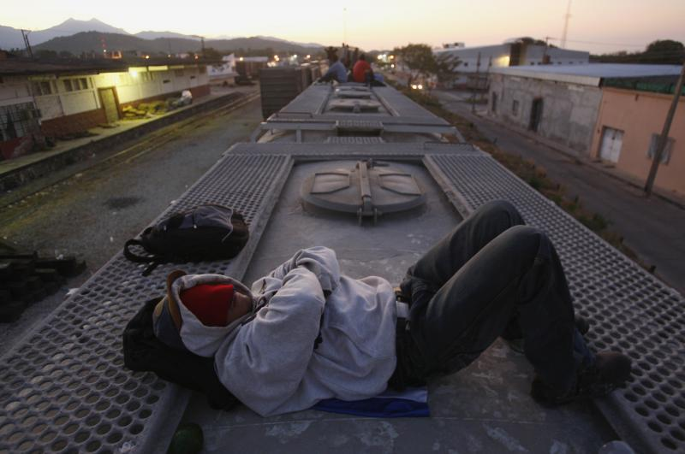

JORGE LUIS PLATA / COURTESY REUTERS

A Central American migrant sleeps atop a wagon while waiting for a freight train in Arriaga, Chiapas, January 2012.

As drug violence in Mexico declined and net immigration from the country to the United States fell to zero, Washington’s attention shifted elsewhere in the region. Many immigrants attempting to cross the U.S. border now come from Central America’s “Northern Triangle”: El Salvador, Guatemala, and Honduras. These countries suffer weak governance, corrupt law enforcement, and appalling levels of criminal violence. After tens of thousands of Central American children turned up at the U.S. border in 2013, the administration reacted. Biden cajoled the Central American presidents to come up with a plan to boost economic development and security, which the White House promised to back with $1 billion in aid over two years, focusing on reforming the police, cracking down on human trafficking, and reducing youth unemployment. Although promising in principle, this effort will prove effective only with local political leadership—something that can be hard to find in Central America.

A REGION DIVIDED

Despite initial reservations, Obama continued Bush’s policy of pursuing bilateral free-trade agreements with those Latin American countries that wanted them, approving deals with Colombia and Panama in 2011. The result is that Latin America has crystallized into two economic groups. On one side, mostly in the Caribbean basin and on the Pacific coast of South America, are the 11 countries in the region that now have free-trade agreements with the United States. Four of them—Chile, Colombia, Mexico, and Peru—formed the Pacific Alliance in 2011, based on free-market economic policies and openness to Asia. On the other side, on the Atlantic seaboard, are the more protectionist countries of the Mercosur trade bloc: Argentina, Brazil, Paraguay, Uruguay, and Venezuela. By harmonizing and strengthening trade and investment rules, the proposed Trans-Pacific Partnership, if it happens, is likely to solidify this division.

*As with Venezuela, the administration’s policy on Cuba involves a recognition that change can come only from within.*Until Chávez’s death in 2013, one aim of Washington’s trade strategy was to contain Chávez and his dreams of continental domination. At least since the Bush administration, U.S. policy toward Venezuela was based on the accurate assessment that Chávez was a threat to his own people but not to the United States. Chávez deployed Venezuela’s oil wealth to secure diplomatic allies. Under an aid scheme called PetroCaribe, he offered subsidized oil to a dozen countries, mainly island states in the Caribbean, which began to vote with Venezuela in regional bodies. But Chávez’s regional influence peaked around 2007. His regime lost appeal because of its mounting authoritarianism and economic difficulties.

Officials in the Obama administration argued that it was counterproductive to publicly criticize Chávez, since doing so failed to change his behavior and merely allowed him to pose as a popular campaigner against American imperialism. Instead, the administration sought to persuade Brazil, Chile, and other South American countries to take the lead in defending democratic norms in Venezuela. But they proved reluctant to do so in public. At a 2014 meeting of the Organization of American States, only Canada and Panama joined the United States in voting to allow an opposition leader to speak on human rights abuses in Venezuela.

Obama earned criticism at home  for his quiet response to Venezuela’s harassment and jailing of opponents. Congress imposed targeted sanctions on Venezuelan officials, a move that gave Nicolás Maduro, Chávez’s deeply unpopular successor, a short-lived propaganda boost without doing anything to weaken his regime. The test of the administration’s multilateral approach to Venezuela will come when the country holds the parliamentary elections scheduled for December 2015. If the vote is to be even remotely free and fair, it will be thanks to pressure from other Latin American countries.

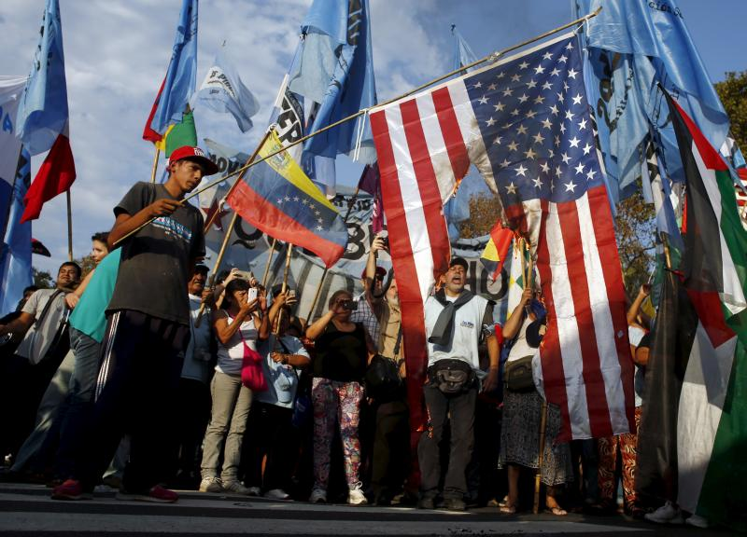

MARCOS BRINDICCI / COURTESY REUTERS

Supporters of Venezuela's President Nicolas Maduro shout slogans as they burn a U.S. national flag during a demonstration outside the U.S. Embassy in Buenos Aires, April 2015.

As with Venezuela, the administration’s policy on Cuba involves a recognition that change can come only from within. In addition to restoring diplomatic relations, Obama announced initiatives to intensify people-to-people contacts and help Cuba’s incipient private sector. He also loosened the ban on travel to the island, raised the limit on remittances to Cubans, and relaxed export restrictions on U.S. firms.

This policy represents a medium-term bet: that private investment in the Cuban economy will replace aid from Venezuela, which, at its peak under Chávez, accounted for some  15 percent of the island’s GDP. In 2018, Castro plans to step down. His successors, too young to boast any revolutionary credentials, will be judged by Cubans strictly on economic performance. The hope is that their need to rely more on the private sector will lead, eventually, to political reform. Obama’s approach is a bold yet commonsense policy. As Obama said in April, “If you keep on doing something for 50 years and it doesn’t work, you should try something new.”

OPPORTUNITY KNOCKS

When it comes to broader regional diplomacy, the payoff from the Cuba initiative may come sooner. Obama is fairly popular in Latin America, albeit less so than he was at the outset of his presidency. According to Latinobarómetro, a polling organization, an average of 69 percent of respondents in the region held a favorable view of the United States in 2013, up from 58 percent in 2008. Nevertheless, making the most of his legacy in Latin America will depend in part on Congress and whether it is prepared, for example, to fully lift the embargo against Cuba and enact immigration reform.

Multilateralism is inevitably a patient, collaborative exercise in which it takes more than two to tango. If partnership has sometimes been lacking in the Americas, that is far from the fault solely of the Obama administration. In today’s Latin America, it is hard to imagine that more confrontational policies would have achieved better results, as some of Obama’s critics imply: since the United States is no longer the only game in town in much of Latin America, bullying is often ineffective.

**Related Tweets**

Yet circumstances in the region are becoming increasingly favorable for the United States. The end of the commodity boom has brought a sharp slowdown in economic growth. Latin America’s exports to China have plunged, and there are signs that Beijing is no longer willing to hand a blank check to its allies. Many of the left-wing governments have lost their popularity at home. If Latin American countries want to restore faster growth, they will have to raise productivity, improve infrastructure, and join global value chains. Trade with and investment from the United States can play a large role in that agenda. The U.S. government cannot and should not try to match the Chinese checkbook, but it can take such steps as promoting technology transfers, arranging educational exchanges, and offering technical advice.

What should Washington do next? Although Cuba may get the headlines, U.S. priorities should lie elsewhere in Latin America. Helping Mexico establish the rule of law and intensify its economic integration with the United States is a prime U.S. interest. So is deepening ties with the Pacific Alliance, whose governments share many values and policies with the United States. It makes sense to persevere with Brazil, given its size; its present troubles do not vitiate its strengths, such as its strong agribusinesses, ample energy reserves, and increasingly robust democracy.

The coming years offer an opportunity for the United States to strike mutually beneficial partnerships, ones that could cement the emergence of a group of increasingly prosperous democracies. This outcome is not inevitable: populism is not dead in Latin America,  the authoritarian regimes in Cuba  and Venezuela are weakened but not defeated, and the region’s economic outlook is gloomier than it has been for more than a dozen years. Nevertheless, the underlying trend is one of progress. Policymakers in Washington should be thinking of ways to build on Obama’s promising legacy by collaborating with partners as Latin America enters yet another new era.