# Why do women get lower pay

Tomas Dosedel, 365877

Because the education is coded into eleven categories, I recoded it into five. First contains incomplete and complete primary education. Second category named “vocational” contains all types of secondary education which do not allow to study in the tertiary education. The third category called “secondary” contains the complete secondary education with availability to continue in tertiary study programme. Last two categories contain university degrees – bachelor and master. Doctoral degree is quite rare so I assign it into master degree category.

Table 1 show the differences in average hourly income (mean) by sex and educational level. I assumed in hypothesis one, that with the rising higher of education the income will rise. According to the table 1 I can assert, firstly that women really get lower pay than men at all levels of education and secondly that the higher an attained educational level is, the higher the income becomes. I cannot refuse hypothesis 1.

Table 1: Average hourly income by sex and education in 2015 in the Czech Republic

|  |  |  |
| --- | --- | --- |
|  | male | female |
| primary | 84.38 | 82.31 |
| vocational | 131.62 | 103.15 |
| secondary | 199.10 | 141.47 |
| bachelor | 165.37 | 151.60 |
| master | 242.89 | 176.32 |

Source: CHPS

In second step of my analysis I calculated the length of work experiences as a difference between actual year (2015, when the data were collected) and the year when respondent get his or her higher level of education. Because I got 62 different values I recoded it into 6 groups by 10 years. First group consist of people with work experiences 0-10 years, second groups contains people with work experiences 11-20 years etc. The last group is 50-62 years.

Graph 1 shows the average hourly income for both genders by the above described group of work experiences. We can clearly see that the income rises when one gets more work experiences with two exceptions. When one has work experiences of 21-30 and 31-40 years, his or her income is slightly lower. To explain this, we should look at the years when people in these groups got their education. Because in 2015 they had 21-40 years since graduation, it means that they graduated in 1975-1994. This is before the educational expansion which took place after 2000 in the Czech Republic, so their education will probably be lower. As shown in table 1, the income depends on education, therefore I assume that the income differences is caused by lower education of people in these two groups. The right answer will give us the multivariate analysis. I can refuse hypotheses 2 only partially.

Another possible problem is that work experience calculated as mentioned above doesn’t consider the career breaks caused by unemployment or maternity leave. But more precise data about the work experiences are not available.

Graph 1: Income by the length of work experiences in 2015 in the Czech Republic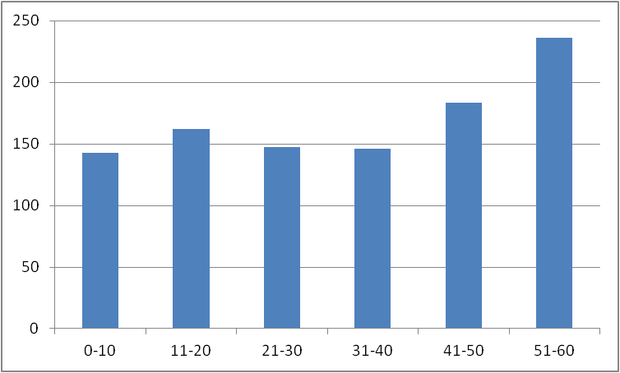

Source: CHPS

My third hypothesis deals with the marital status, which is coded in five categories. I recoded it into three categories: first contains people in marriage or registered partnership, second consist of people who were married but either widowed or divorced, third contains only people who were never married. Table 2 shows the income differences by gender and recoded marital status.

Married people have higher income only when primarily, vocationally or tertiary educated (master degree). All the other educational levels lead to refusing the hypothesis 3. For secondary and bachelor education, highest income have people who are divorced or widowed. The differences can be caused by the different length of work experiences. This will show the multivariate analysis.

Table 2: Average hourly income by marital status and education in 2015 in the Czech Republic

|  |  |  |  |
| --- | --- | --- | --- |
|  | married | not married | never married |
| primary | 95.12 | 91.05 | 64.77 |
| vocational | 121.40 | 119.22 | 110.16 |
| secondary | 169.23 | 198.52 | 137.35 |
| bachelor | 154.07 | 161.37 | 159.16 |
| master | 220.67 | 197.60 | 178.85 |

Source: CHPS

By descriptive analysis I show the differences in incomes by sex, education, work experiences and marital status. I proved that women get lower pay than men, no matter which level of education they obtain. With some exceptions, income is positively linked also with the length of work experiences and with the marital status.