**Faculty of Social Studies, Masaryk University**

**BSS 186/486 – NATO & European Security**

**Dr. Schuyler Foerster – Spring 2019**

**NATO Crisis Simulation**

**Morning Situation Report**

**EXERCISE EXERCISE EXERCISE**

***Reuters.***

Blaming “outside agitators” for riots in Crimea, the Kremlin has airlifted additional security forces into Crimea to put down protests and has threatened to declare martial law in the region. In addition, a battalion of Russian infantry—with armored personnel carriers—has begun to move through Mariupol in eastern Ukraine. NATO sources indicate that the forces appear to be poised to move down the coast in an effort to secure a land bridge to Crimea.

Kiev has protested the Russian movements as a violation of the OSCE Minsk Accords and has warned that further Russian incursion into Ukrainian territory would be met with “all appropriate force.” The Ukrainian Ambassador to NATO has formally notified the Secretary General that Ukraine, as a NATO Partner, is seeking consultation within NATO under the NATO-Ukraine Charter.

***Baltic Times.***

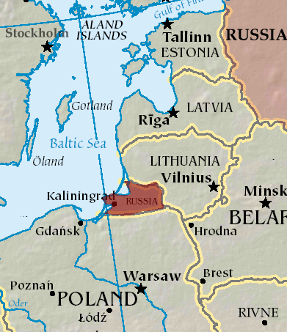The Lithuanian government has issued a stern protest to Moscow, warning that continued “nationalist” rhetoric out of Kaliningrad calling for a “land-bridge” with Russia “does not contribute in any way to the stability of an already-fragile security situation and threatens to enflame public opinion against Russia” within his own country.

In both Tallinn and Riga over the weekend, more protests erupted by Russian communities who continue to be denied citizenship because of their inability to pass language tests. The protests were peaceful, but organizers warned that they would come back if the government did not respond to their demands. Russian language media warned residents that “fascist activists” might hijack the protests and turn them violent. Local security forces said they would continue to respect non-violent protest but would take “necessary measures” to protect the population from violent outbreaks.

***Estonia Post Times***

This morning, in Tartu, Estonia, a group called the "Estonian Russian Alliance" claims that they have occupied Tartu City Hall and called upon Russia to support their cause in restoring the Baltic borders of the Soviet Union. There are no known records of the existence of this group. Crowds of ethnic Russians surrounded the building and kept Estonian Homeland security forces at bay.

This follows anti-Russian protests last night in Tartu, after which some of Tartu’s 15% ethnic Russian population launched a counter-demonstration, claiming persecution.

A Kremlin press spokesman repeated Russia’s determination to protect the rights of Russian minorities living in neighboring countries.

***Kiev Times***

The Ukrainian Interior Ministry announced today that they had captured four Russian *Spetsnaz* soldiers 100 km southwest of Mariupol.

Unless Russia admitted to its aggression eastern Ukraine, the Ministry said they would be tried as criminals instead of being treated as prisoners of war.

The Kremlin responded that this would be viewed as a “severe provocation” in what was already a volatile relationship.

***The Warsaw Voice***

Poland’s Defense Ministry announced that Polish Air Force F-16’s intercepted a Russian fighter in Polish airspace and escorted it back to Russian airspace in Kaliningrad without incident. The Russian Ministry of Defense had no comment.

***Associated Press.***

A spokesman for the Russian Ministry of Defense confirmed that the Russian military has redeployed a battery of its new 9M729 ground-launched cruise missiles (GLCM) to a position approximately 500 miles east of the Estonian/Latvian border. The Ministry claims this was part of pre-planned deployment in conjunction with ongoing exercises, but the spokesman also cautioned that the system could be used in response to any NATO “provocations.” The spokesman would neither confirm nor deny whether the missile had conventional or nuclear warheads available with the deployment.

***Moscow Times.***

The Kremlin confirmed this morning that Russian President Vladimir Putin had tweeted over the weekend, complaining that the West was once again “interfering in the internal affairs” of sovereign states on Russia’s border, where Russia has “vital” national security interests. Putin called upon President Trump to meet with him and find ways for Russia and the United States to “manage” growing crises in Europe.

***CNN.***

President Trump tweeted this morning that he did not understand why the United States would want to defend small countries so far away, especially since they were not paying their “fair share” of what he claimed NATO owes the U.S.

The U.S. State Department and Defense Department both issued statements affirming continued U.S. support for NATO and America’s commitments under the NATO Treaty.

In the U.S. Senate, Senator Lindsay Graham was reported to be preparing a draft Senate resolution reaffirming U.S. support for NATO and its Article 5 commitments.

**EXERCISE EXERCISE EXERCISE**