**Corporation Profile: Mafra a.s.**

**Introduction**

In this paperwork I am going to deal with the biggest Czech Media Company which is Mafra a.s. Firstly, I will sum up brief history of the company and will present basic information about the company as financing and structure of organization. Then, I will show an infographic with all ordering in Media industry which have the same owner – Andrej Babiš. Lastly, I will try to find an answer on the question *what* *the primary business of this media company is*.

I assume that everyone knows the name Andrej Babiš (at least in the Czech Republic and Slovakia), the current prime minister of the Czech Republic, and maybe just this is enough why we should dedicate to him. Here is really evident a Political Economy of Media.

**History**

The company was founded in Prague twenty-six years ago and her majority owner was German publishing house Rheinisch-Bergische Druckerei- und Verlagsgesellschaft (RBDV). It means that multimedia´s group was owned by a big corporation whose main product German daily Rheinische Post is. After twenty-one years, in 2013, Mafra was bought by Czech holding group Agrofert. This Czech group is a property of Babiš.[1] The problem is that he is current Prime Minister of the Czech Republic together with chairman of the political party ANO2011 which nowadays it is the most popular political party in Czech. On top of that he is the second richest man in the Czech Republic.[2]

**General Information**

First of all, Mafra is one of the biggest media groups in Czech when publishes printed and online media. While its printed media addresses on regular basis 2.5 million readers internet-based projects on 2.8 million users.

The most important projects of this group are dailies called Mladá fronta DNES, Lidové noviny and Metro. Further weeklies TÉMA, 5plus2 and online media iDNES.cz, Lidovky.cz, MOBIL.CZ, Playtvak.cz, the television channel Óčko and the radio Impuls. All these types of media are the component of the media division of the Agrofert group. Besides that, there is the division Mafra Slovakia which serves content on the Slovak market. The Mafra group has more than 1.000 employees who create content on a daily basis, process its graphic designs and distribute her products. They also have to keep communication with their partners. The chairman of the board at the company is Štepán Kosík.[3]

**Financing**

The crucial and most successful product of the Mafra group is Mladá fronta DNES which is the daily. It also plays the key role on the market. It is the second most read daily over a long period. The first position belongs to the tabloid Blesk. Again, it is in the long term. According to the newest data every edition of Mladá fronta DNES is read by 557 thousand people. This daily occupies the second position from eight paid dailies in Czech. Another product of the Mafra group is on the seventh position (Lidové noviny).4 You can find these data below.

|  |  |
| --- | --- |
| **Dailies** | **Readers of the dailies** |
| Blesk | 947.000 |
| Mladá fronta DNES | 557.000 |
| Deník | 546.000 |
| Sport | 250.000 |
| Právo | 240.000 |
| Aha | 211.000 |
| Lidové noviny | 195.000 |
| Hospodářské noviny | 157.000 |

Source: <http://www.unievydavatelu.cz/gallery/files/MP_1704_Prezentace_14.pdf>

The internet division was launched early in 2011 and became the third most visited Czech website on the internet. They have 3.7 million unique visitors every month. This number includes web portals iDNES.cz and Lidovky.cz, other websites are available on a link at iDNES.cz.[4] Furthermore, and one part of this media group is a printing plant named MAFRAPRINT. It produces leaflets, magazines, newspapers and other periodicals. The productions take place in two printing plants located in Prague and Olomouc. Thanks to these locations it is possible to offer day-to-day supply of newsprint products in all regions of Czech. It also provides optimal conditions for their operating safety and a high-quality printing. Almost two-thirds of their printing capacity is available for external clients.[5]

**Infographic**

In this infographic you are able to see all media companies which are owned by Babiš. It is also possible to identify all media which belong to the media group Mafra. Here is necessary to write explanatory notes, so a blue colour has print media, red one is for online media, green one for TV channels and finally yellow one is for radio.

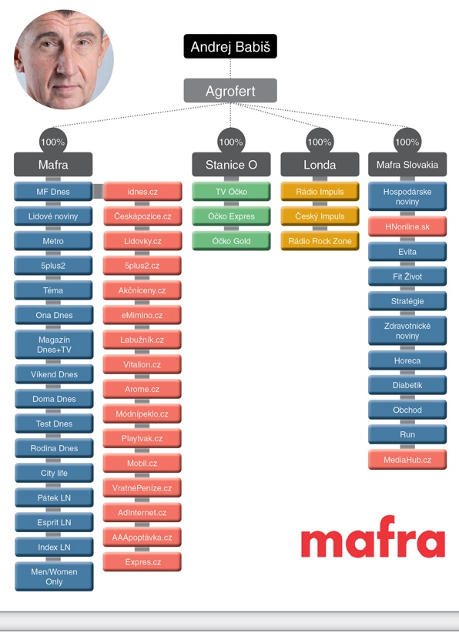

Source of the picture: <http://www.hpcg.cz/novinka/en/342/konsolidace-ceskeho-medialniho-trhu-jeste-neni-u-konce/>

**Conclusion**

My task was to find an answer on the question what the primary business of Mafra is. It is a quite special case. Obviously, there is need to seek relations and not just the numbers. As it was mentioned the Prime Minister of the Czech Republic and leader of the political party ANO2011 Andrej Babiš is the owner of Mafra. He is the second richest man in Czech and that´s why we can consider that his profit is not the most important thing. Especially in this time when print has many problems with maintain itself. But he can use media house for a struggle in policy. This is the topic discussed as many times as even possible. This is a real threat. The politician has an impact within the topic is or not mentioned in media which is very popular. Even the evidence exists here, his interview with a journalist from the daily Mladá fronta DNES about the articles against his political enemies was recorded.[6]

The most successful project of Mafra is the daily Mladá fronta DNES which the second most read daily in Czech is. There are also the printing plants and both of them are economically strong. But there is an option to communicate their primary business as political aims of the owner of the media group. It is not very optimistic way, but it can be based on a true.

**Sources**

Aktuálně.cz. “Volby vy vyhrálo ANO, ČSSD se propadla na čtvrté místo.” [online] [Accessed 27. 4. 2018] Available from: <https://zpravy.aktualne.cz/domaci/volby-by-vyhralo-ano-cssd-se-propadla-na-ctvrte-misto-zemano/r~c52179be493111e7b0440025900fea04/>

Forum24. NAHRÁVKA č. 2: Babiš domlouvá s redaktorem MF Dnes články proti Chovancovi. [online] [Accessed 27. 4. 2018] Available from: <http://forum24.cz/nahravka-c-2-babis-domlouva-s-redaktorem-mf-dnes-clanky-proti-chovancovi/>

HPCG. “Konsolidace českého mediálního trhu ještě není u konce. ” [online] [Accessed 27. 4. 2018] Available from: <http://www.hpcg.cz/novinka/en/342/konsolidace-ceskeho-medialniho-trhu-jeste-neni-u-konce/>

Mafra. “About the company” [online] [Accessed 27. 4. 2018] Available from: <http://www.mafra.cz/english.aspx>

Mafraprint. “Company profile.” [online] [Accessed 27. 4. 2018] Available from: <http://www.mafraprint.cz/firemni-profil.aspx?lng=en>

Mediaguru. “Mapa vlastníků médií.” [online] [Accessed 27. 4. 2018] Available from: <https://www.mediaguru.cz/2016/03/infografika-aktualizovana-mapa-vlastniku-medii/>

Unie vydavatelů. “Media projekt 3. a 4. čtvrtletí 2017.[online] [Accessed 27. 4. 2018] Available from: <http://www.unievydavatelu.cz/gallery/files/MP_1704_Prezentace_14.pdf>

Wikipedia. “Mafra.” [online] [Accessed 27. 4. 2018] Available from: <https://en.wikipedia.org/wiki/Mafra_(company)>

1. Wikipedia. “Mafra.” [Accessed 27. 4. 2018] Available from: <https://en.wikipedia.org/wiki/Mafra_(company)>
2. Aktuálně.cz. “Volby vy vyhrálo ANO, ČSSD se propadla na čtvrté místo.” [Accessed 27. 4. 2018] Available from: <https://zpravy.aktualne.cz/domaci/volby-by-vyhralo-ano-cssd-se-propadla-na-ctvrte-misto-zemano/r~c52179be493111e7b0440025900fea04/>
3. Mafra. “About the company” [Accessed 27. 4. 2018] Available from: <http://www.mafra.cz/english.aspx>
4. Wikipedia. “Mafra.” [Accessed 27. 4. 2018] Available from: <https://en.wikipedia.org/wiki/Mafra_(company)>
5. Mafraprint. “Company profile.” [Accessed 27. 4. 2018] Available from: <http://www.mafraprint.cz/firemni-profil.aspx?lng=en>
6. Forum24. NAHRÁVKA č. 2: Babiš domlouvá s redaktorem MF Dnes články proti Chovancovi. [Accessed 27. 4. 2018] Available from: <http://forum24.cz/nahravka-c-2-babis-domlouva-s-redaktorem-mf-dnes-clanky-proti-chovancovi/>