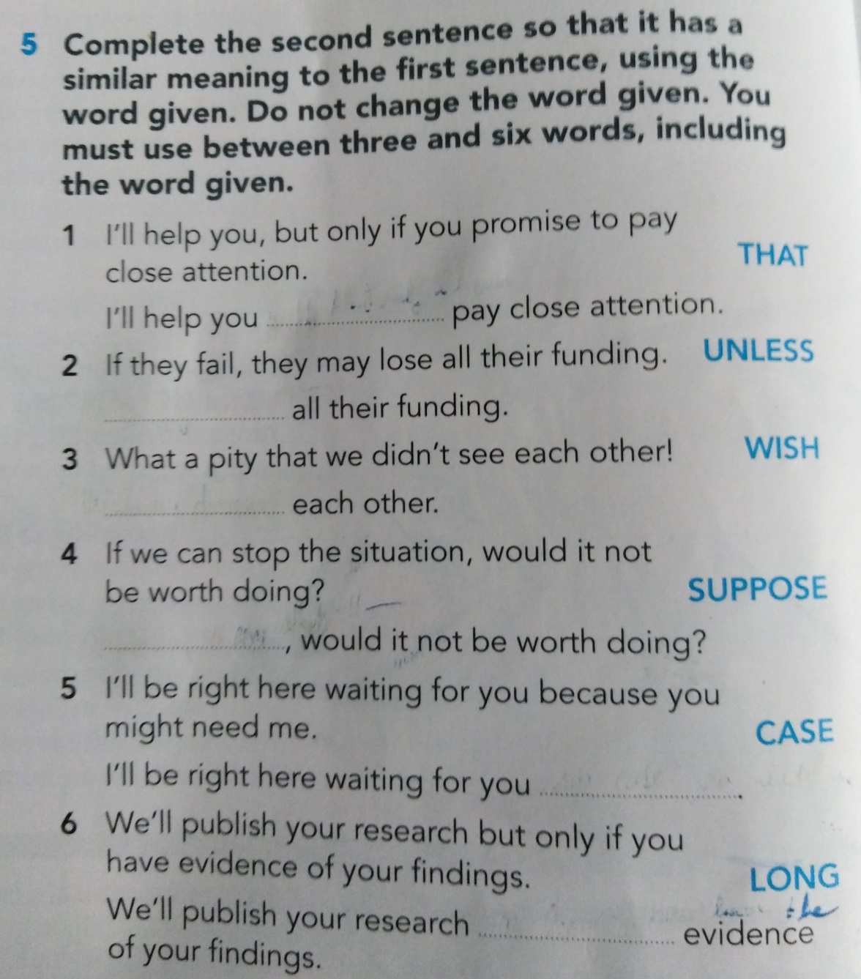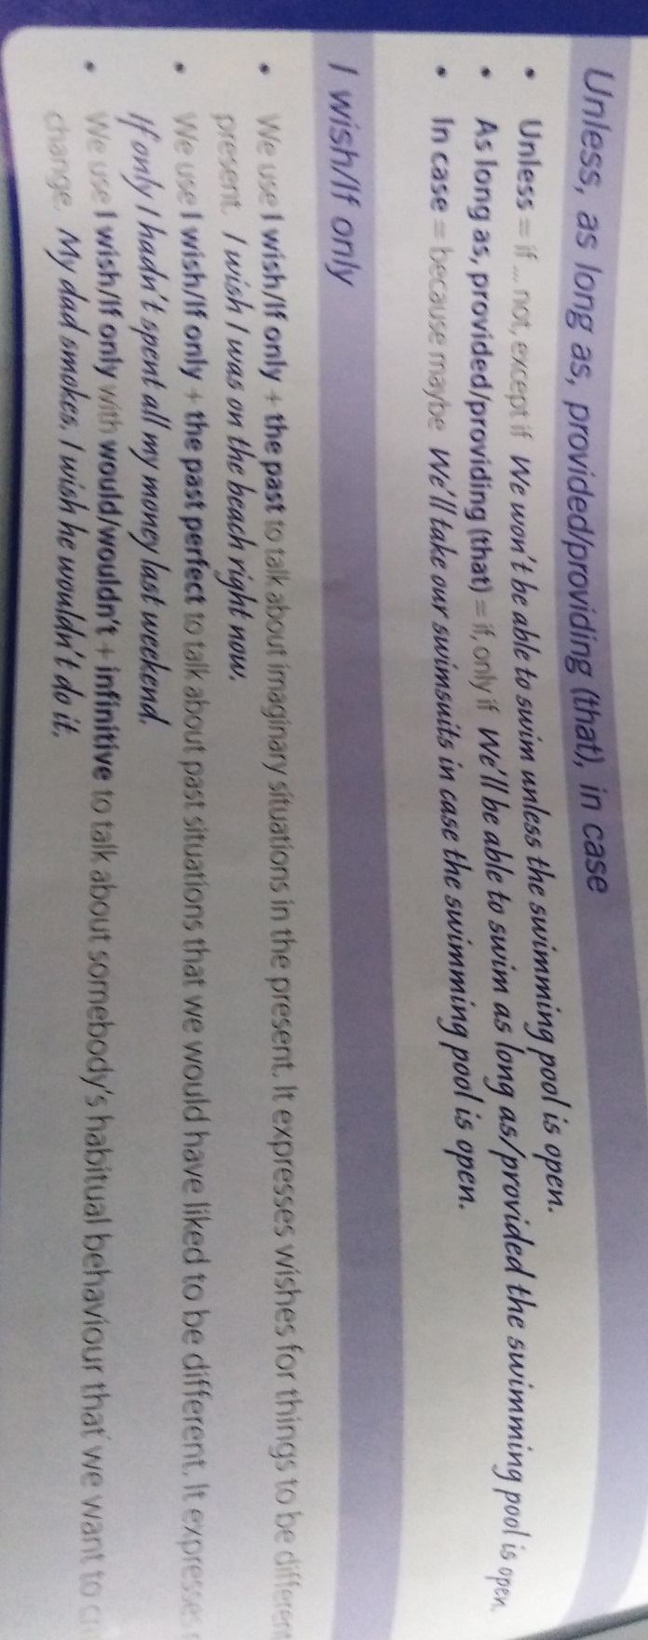

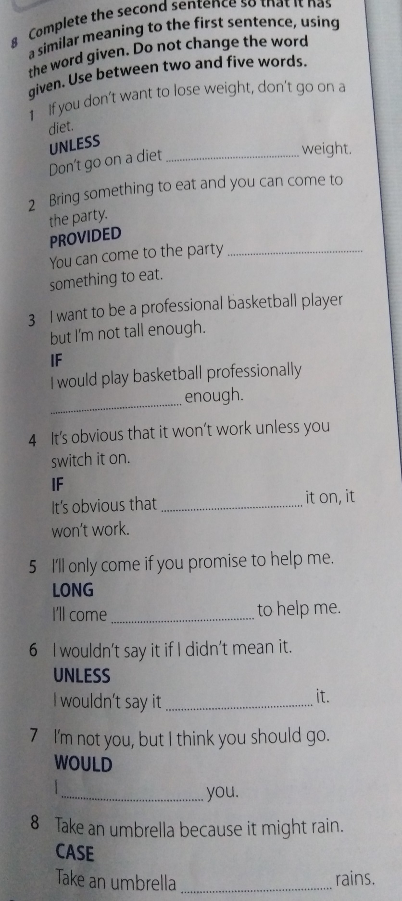

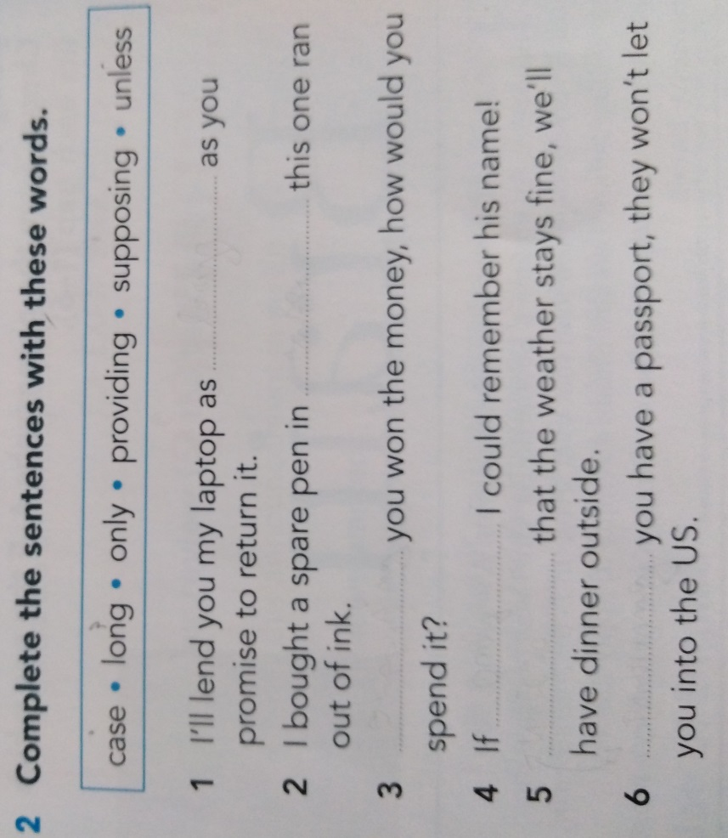

Causative:

1. The cleaner cleaned the house. (have)

We …

1. The taxi driver collected us. (have)

We

1. John arrived on time. (get)

I…

4) The mechanic had fixed the brakes. (have)

We …

5) The teacher has explained the lesson. (have)

We …

6) My husband will look after our children. (get)

I …

7) The waiter brought some water. (have)

We …

8) The nurse took your temperature. (have)

I …

9) The students has stopped sleeping in class. (get)

I …

10) The teenagers went to bed early. (get)

We …

Have something done

Your hair is too long. You need (it / cut).

I'm going to do my food shopping online and I (the food / deliver) to my house.

If you can't see properly, you should (your eyes / test).

Are they going to paint the kitchen themselves, or (it / paint).