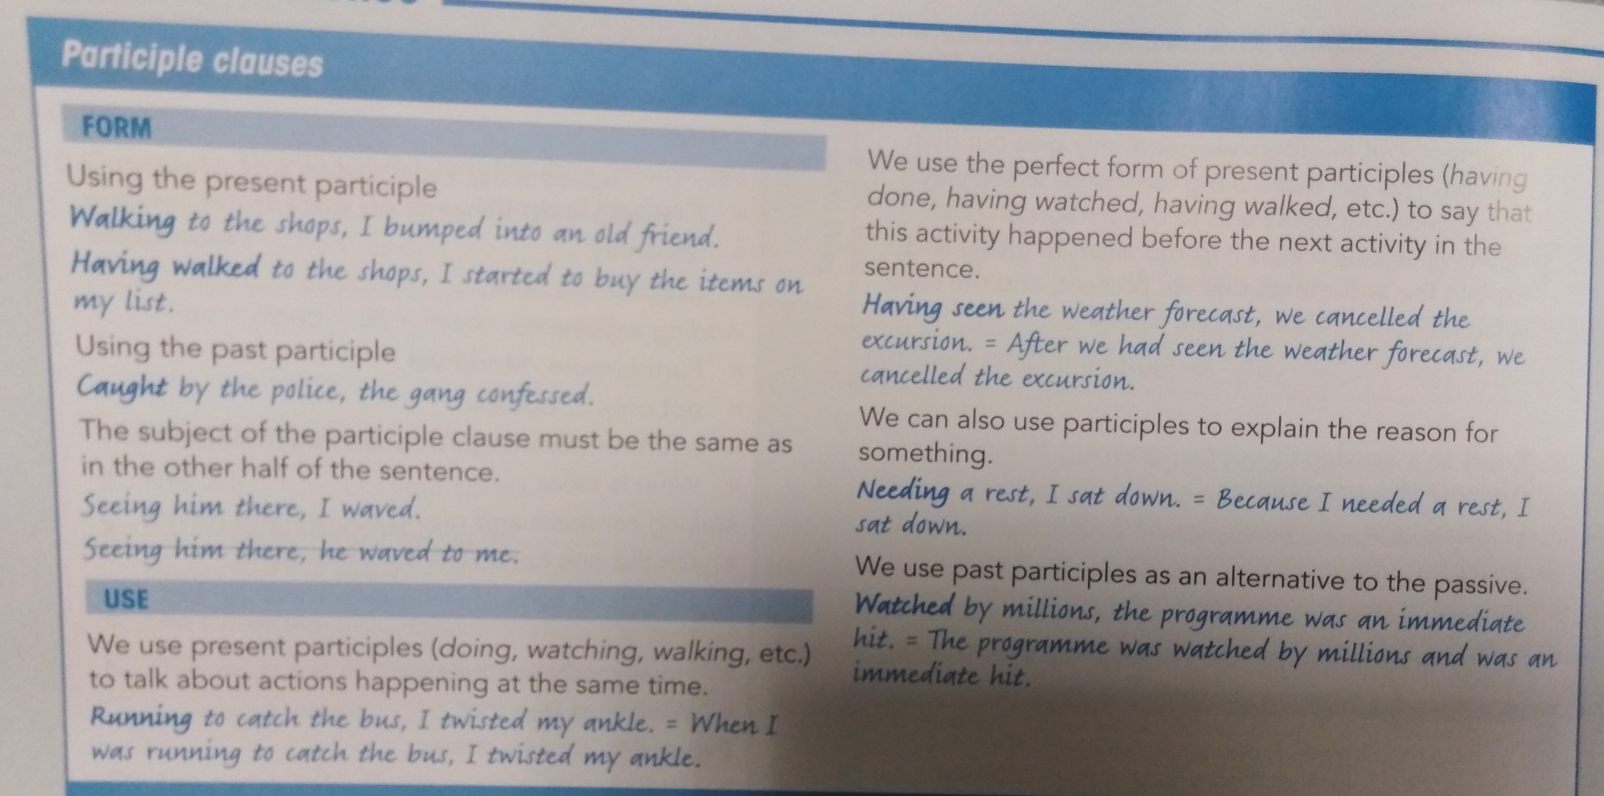

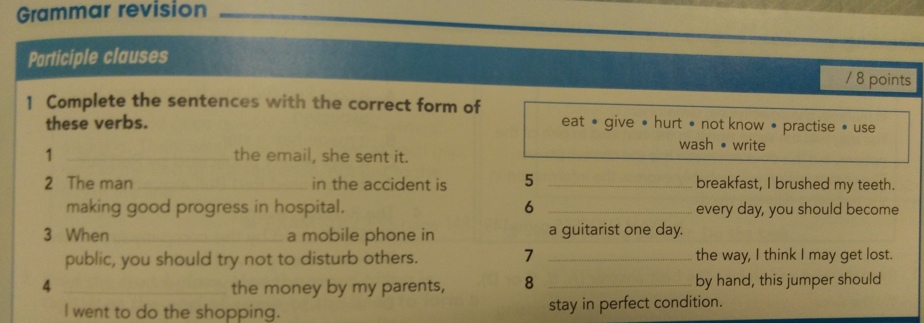

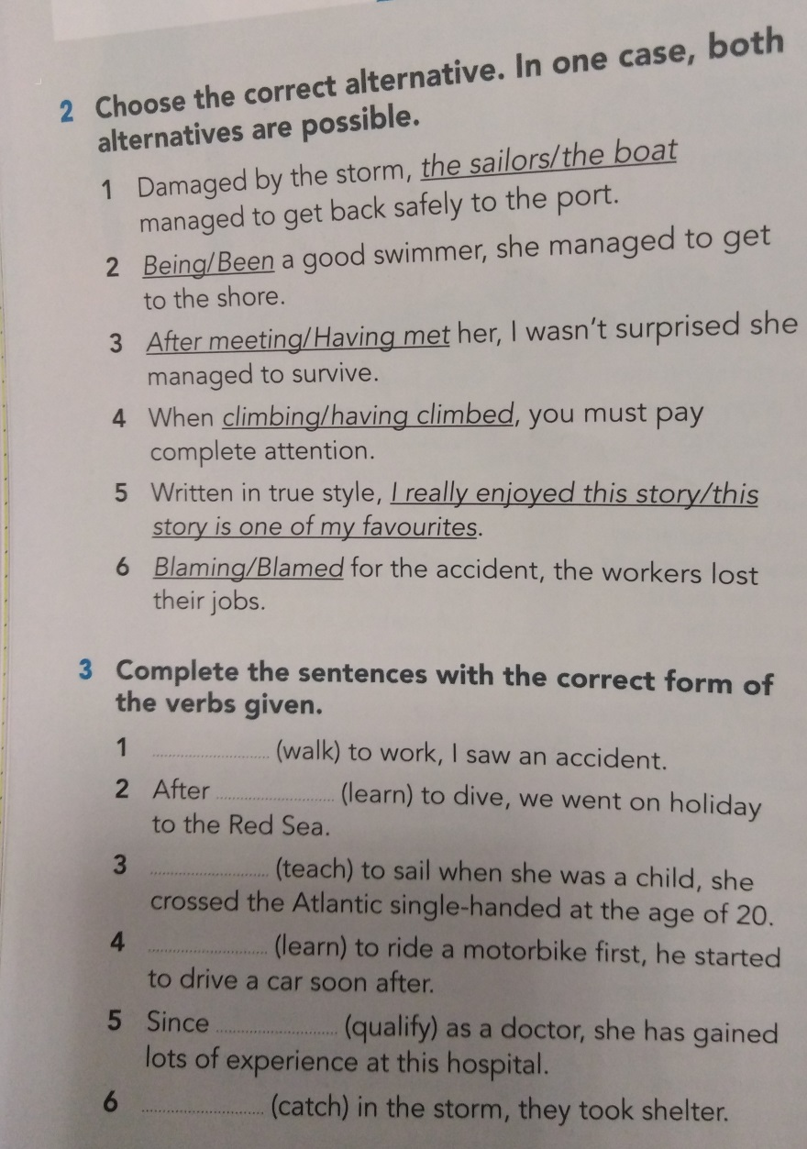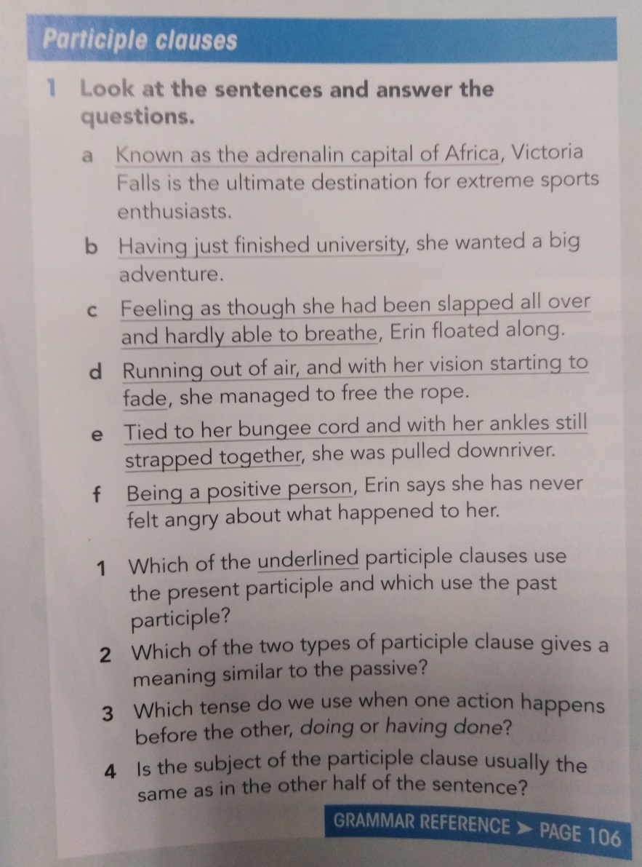

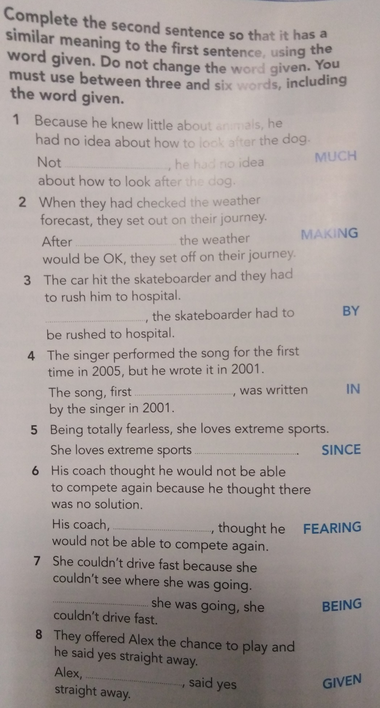

(search) for her gloves, she dug through the entire wardrobe.

(prepare) by the chef himself, the dinner will be a real treat.

(sing) by him, every song sounds just wonderful.

(whistle) a song, she danced through the house with the mop.

(sit) in the shade, we ate cake and drank coffee.

(leave) the party too early, we couldn’t see the fireworks anymore.

(finish) her phone call, she went back to work.

(run) to the bus stop, she lost her shoe.

(blind) by the sun, the driver didn’t see the stop sign.

(misuse) as a refuse dump, the place became more and more shabby.

(park) the car, we searched for the ticket machine.

(drink) one litre of water, she really needed to go to the toilet.

(lose) ten kilogrammes, Anne finally fit into her favourite dress.